JBrickBuilder flexible parts model
Developer's manual (v02-20150331)

This work is licensed under a Creative Commons Attribution 4.0 International License.
Thanks to:
Orion Pobursky, Don Heyse, Kevin Clague, Allen Smith – for LSynth creation and source code availability.
Willy Tschager, Philippe Hurbain, Steve Bliss, Chris Dee, Larry Pieniazek – for some part design used directly or modified in present model

Introduction
This brief paper explain how flexible parts definition and editing works in jBrickBuilder. jBrickBuilder uses LDraw part library, a well-known free to use LEGO® bricks model repository.
LDraw standard library includes some parts that are “flexible”, like soft axle (see part #32199), hose (see part #73590) or strings, in “straight” shape, but no standards or guidelines are defined for use flexible parts in different shape or “bent” as in most of the official sets.
There is an utility called LSynth (https://sourceforge.net/projects/lsynth/) that can be integrated in MLCad to generates some complex parts (like rubber band, electric cables, treads and flexible parts), but it is hard to integrate with other programming languages and platforms. With Java™ is really impossible, if you want to keep the “cross platform” feature.
So, JBrickBuilder starts from LSynth approach, from geometric and algorithms point of view, but it is completely “visual” and GUI based.
The model at the moment isn't complete, but there is room for improvements.

Changes to model

V02
Added a note on constraint snapping in examples.

V01
First version released.

Basic strategy
Flexible parts model uses features already implemented in JBrickBuilder libraries. It needs only two specific modules:
- (LdrawLib) LDFlexPart – main class that keep all the data related to known flexible parts. Data are in an XML file called “flexpartDefs.xml”, parsed by LDFlexPart class on init phase.
- (LDEditor) FlexPartPlugin – GUI class that allow user to place start and end point for flexible parts and defines constraint for complex shapes.
Placing a flexible part requires three step:
- Place the start (head) for part. In this phase the connection model helps to “snap” part in right position. An indicator show where the part will point when placed.
- Place the end (tail) for part. As for start, connection model helps to “snap”, an indicator for the “direction”, an “elastic band” for approximate shape and path for final part. Band is green if approximate length is less than real part length, and become red when path is too long. It is only an indication, program will not refuse to generate part, even if too long.
- Placing constraints (optional). A constraint is an oriented vector that define a fixed point in the path. Constraint can be added and removed, and can “snap” in a connection point.
After second step program can generate flexible part following path.
Generated part are seen as a custom subpart, like a normal custom part or submodel. No special tags or meta-commands are required or used. Exporting main model as MPD single file will export all needed parts and subparts to display and use model in other tools in LDraw toolchain.

Flexible parts definition
There are at the moment two type of part: continuous and segmented:
- Continuous part are uniform and symmetric respect to path. Flexible axle and pneumatic tubes are continuous type.
- Segmented parts are composed by smaller, fixed size subparts, like ribbed hose or braided strings.
All definitions are in “flexpartDefs.xml” file.
File structure consists in two sections: first where auxiliary parts are defined, last where flexible parts are properly described using this model.

Auxiliary parts definition
In this section are described parts that are needed to define flexible parts, when in the main LDraw library doesn't exists a suitable part (or group of parts).
- <?xml version="1.0" encoding="utf-8"?>
- <!--
- Flexible/bendable parts definition file
- Date: 24 mar 2015
- Mario Pascucci
- -->
- <flexparts>
- <auxparts>

- <auxp name="__hoseend.dat">
- 0 ~JBB Flex Hose ribbed head without tabs
- 0 Name: __hoseend.dat
- 0 Author: Mario Pascucci
- 0 !LDRAW_ORG Unofficial_Part
- 0 !LICENSE Redistributable under CCAL version 2.0 : see CAreadme.txt

- 0 BFC CERTIFY CCW

- 1 16 0 0 0 1 0 0 0 1 0 0 0 1 752.dat
- 1 16 0 0 0 1 0 0 0 -1 0 0 0 1 755.dat

- </auxp>

Previous lines are first lines of “flexpartDefs.xml” file. Opening tag flexparts is the beginning of file, and auxparts starting auxiliary parts definition list. Part are defined in the same language and standard used in ordinary LDraw library parts, enclosed in auxp tag. Attribute name defines a name used to identify these parts in the rest of file. Auxiliary part name MUST start with a double underscore “__” to avoid name collision with LDraw part library.
You can use all LDraw commands and line definitions, but you can use only official parts and primitives on line type “1”.

Part definition
Every part needs some data to correctly render path and appearance.
- <partlist>
- <!-- axle flex 7 -->
- <part name="32580.dat" type="cont" rigid="30" len="60">
- <start name="__faxlehead.dat" b="0,0,0" h="0,-10,0" />
- <mid name="__faxlemid.dat" b="0,0,0" h="0,1,0" overlap="0.25"/>
- <end name="__faxlehead.dat" b="0,0,0" h="0,-10,0" />
- </part>
- <!-- ribbed hose 7mm -->
- <part name="79.dat" type="segm" rigid="80" len="0">
- <start name="79.dat" b="0,-3.25,0" h="0,-10,0" />
- <mid name="80.dat" b="0,-3.25,0" h="0,3.25,0" overlap="1" />
- <end name="79.dat" b="0,-3.25,0" h="0,-10,0" />
- </part>

These are definition for two parts: a flexible axle (7 stud length) and a ribbed hose (7mm diameter, no limit length). All measure are in LDU, where not specified.
- <part> - starts definition. Attributes are:
  - name – defines official name for part. It MUST be a part that exists in official LDraw library, and the name MUST be identical
  - type – can be cont or segm for continuous and segmented parts
  - rigid – it is a measure on part “rigidity”. Greater values for more rigid parts. For better results, this value must be less than half of flexible part length, as defined in following sentence
  - len – is length of part flexible portion. A flexible axle has head and tail long 40 LDU each, so in a 7-stud axle (140 LDU) the flexible part is 60LDU long (140-2*40). Part length is only a visual limit: if you define a path longer than part length, program will only warn you using a red elastic band instead of green, but if you confirm path, program will generate flexible part without complaining. If len is zero in part definition, part can be any longer, and program will use always green band.
- <start> - it is “head” of flexible part. Attributes:
  - name – part name used for head. MUST be an official LDraw part or an auxiliary part defined in auxparts section
  - b and h – base and head of a vector that defines the direction where initial path for flexible part is oriented, relative to head part origin
- <mid> - for “middle section”, part flexible body, used to generate part itself. It is preferable that part longitudinal axis is oriented along X, Y, or Z main axes. Different orientation may lead to weird or visually poor part generation. For segmented part part will never be stretched, and will be used as is. In continuous part, middle section will be stretched by needed amount to smoothly follow path and curves. This means segmented parts used with low radius curved path may shows gaps between consecutive elements.
  - name – part name used for body. As for head part, MUST be an official LDraw part or an auxiliary part defined in auxparts section
  - b and h – base and head of a vector that defines the direction where body part segment is oriented, relative to part origin.
  - overlap – when generating a path, program will always use segment approximation, and this value specifies the amount of overlap for two consecutive segment, to avoid gaps between consecutive segments.
- <end> - it is “tail” of flexible part. Attributes:
  - name – part name used for tail. MUST be an official LDraw part or an auxiliary part defined in auxparts section
  - b and h – base and head of a vector that defines the direction where final path for flexible part is oriented, relative to tail part origin
In Fig. 1 you can see the head part of flexible axle. In green is displayed the direction vector for part path.
After placing head part, you will get tail part, with “elastic band” that shows the path for generated part (Fig. 2).
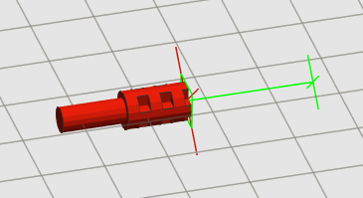Fig. 1: Head of flexible axle
Note the green band. If you go over the part defined length, band will become red (Fig. 3).
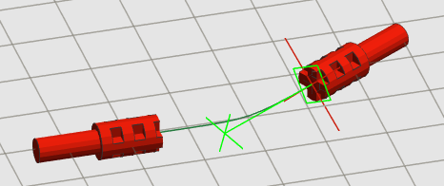Fig. 2: Placing tail
This not mean that program refuse to generate part: it only a warning to say “your part will be longer than real part, so keep in mind that in real model part may not appear as in digital model”.
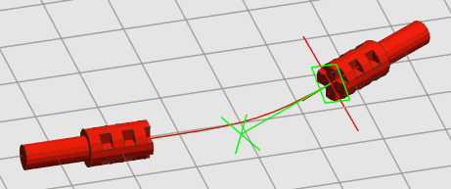Fig. 3: Part length is greater than defined length
After placing head and tail, program let you add constraint point. Constraint point can be placed everywhere in three-dimensional space, and orientation can be any. Constraint point, also, can “snap” to connection point in a part, so you can force a flexible part to go through a peg hole in a Technic™ brick or in a liftarm.
In Fig. 4 you can see a longer axle (19 studs) that need a constraint point for match real part length. The green arrow shows the placement and the direction for constraint point. Remember that direction is important for final result.
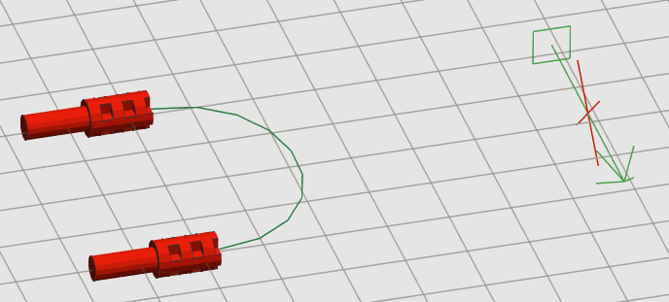Fig. 4: Adding a constraint
In Fig. 5 a constraint point is placed, so you have an idea of how final part will be. If you misplace a constraint point, or use wrong orientation, result can be weird (Fig. 6). Note that path is green: program will not checks for strange path or impossible bent, only path length.
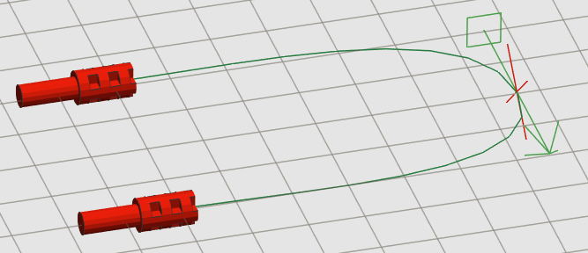Fig. 5: One constraint point placed
You can add or delete constraint point at your choice.
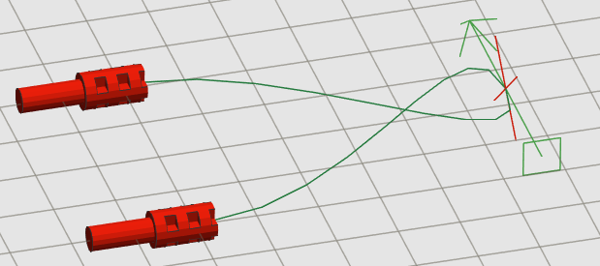Fig. 6: Wrong constraint point orientation
In Fig. 7 you can see final part.
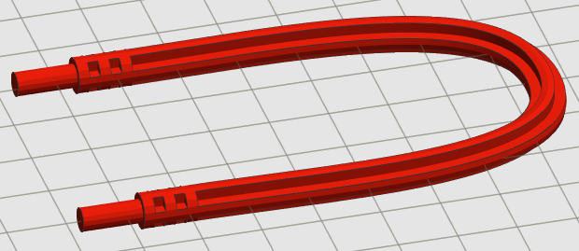Fig. 7: Generated flexible axle

