Name: Brickz Justine B. Baesa Course: BSCPE 2A Date: February 01,2025

**Matheda Report of Week 07**

In this report we will be having a very brief discussion on the analyzed data that has been presented to us along showing its results via bar graph or line chart.

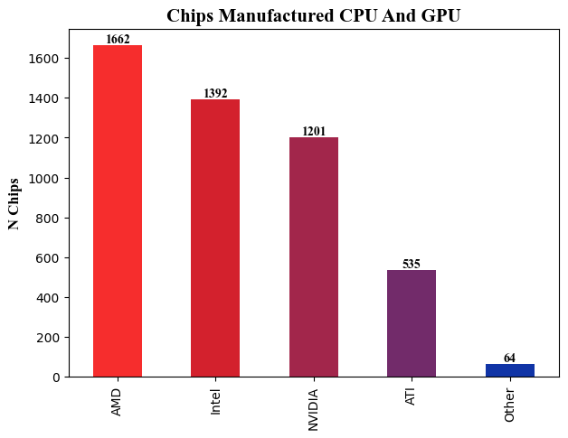

According to this graph, the AMD chips has the highest manufactured chips compared to the other chips indicating an increase number of demands for this kind of chip and the average mean of the manufactured chips should be somewhere around **970.8** chips.

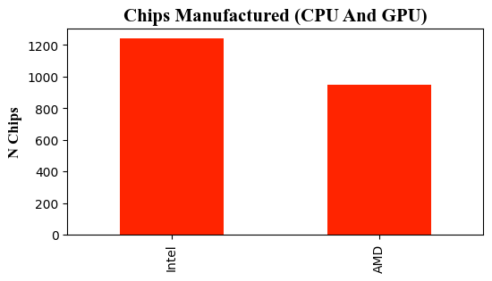

In the graph on the right represents

the chips manufacturer where Intel was

able to produce 1245 chips while AMD

was able to produce 950 chips.

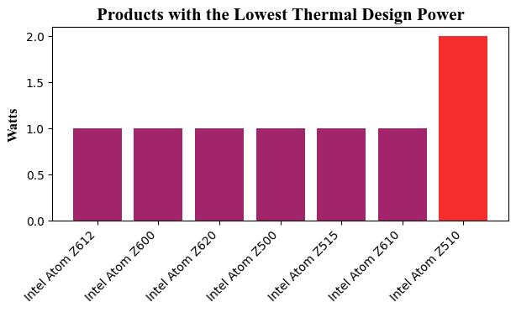

This bar graph shows the products with the lowest Thermal Design Power (TDP), with the first six products having the same wattage from left to right, indicating that these specific products are good for compact devices, whereas the Intel Atom Z510 has double the wattage of the other six products. Despite consuming more energy and emitting more heat, it enables a GPU to perform at higher levels.

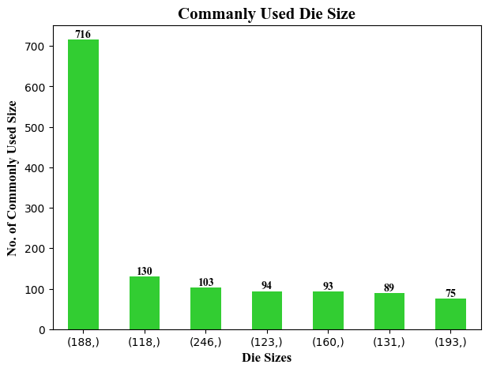

The data shown is the most used Die Size for the GPU’s or CPU’s

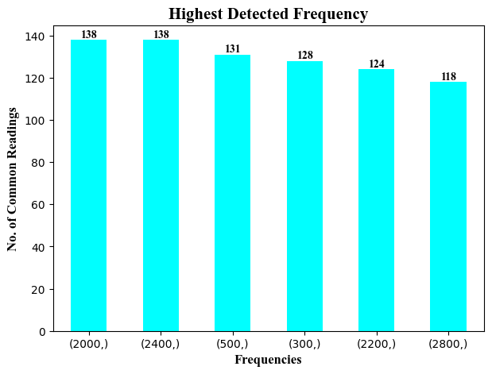

The graph above displays the common frequency that was detected from the given data, and it reveals that half of the data was greater than the average data of 129.5.

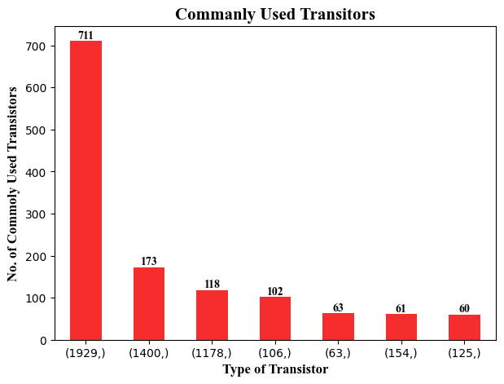



The graph shows that the 1929 transistors are currently the most commonly utilized transistors when compared to the other transistors shown on the graph.

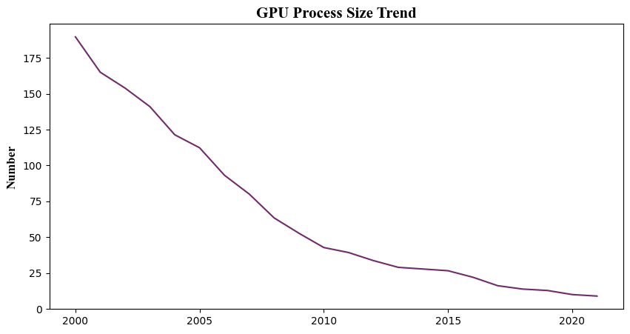

Based on the graph shown, the trend of the GPU's process size has been on the decline, and as this continues, the GPU process size will eventually become outdated due to the ever-evolving technology.