chapter_1_R_exercise.R

RYU

Tue Nov 13 09:15:48 2018

library(lubridate)

##   
## Attaching package: 'lubridate'

## The following object is masked from 'package:base':  
##   
## date

library(ggplot2)  
library(car)

## Loading required package: carData

library(forecast)  
  
# ex1_5  
t <- 1:100  
z1 <- 100 + rnorm(100)  
z2 <- 500 + rnorm(100)  
z3 <- 100 + rnorm(100, 0, 10)  
z4 <- 100 + t * rnorm(100)  
df <- data.frame(t,z1,z2,z3,z4)  
ggplot(data=df, aes(t)) +   
 geom_line(aes(y=z1, colour='z1')) +   
 geom_line(aes(y=z2, colour='z2')) +   
 geom_line(aes(y=z3, colour='z3')) +   
 geom_line(aes(y=z4, colour='z4')) +  
 ylab('z')

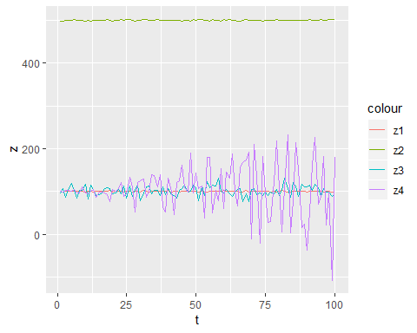

# ex1_6_1  
t <- 1:100  
e <- rep(100, 100)  
z <- 100 + rnorm(100)  
df <- data.frame(t, e, z)  
ggplot(data=df, aes(t)) + geom_line(aes(y=z, colour="Z")) + geom_line(aes(y=e, colour="E[Z]"))

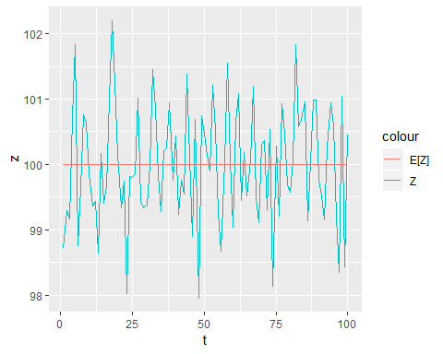

# ex1_6_2  
t <- 1:100  
e <- 100 + t  
z <- 100 + t + rnorm(100)  
df <- data.frame(t, e, z)  
ggplot(data=df, aes(t)) + geom_line(aes(y=z, colour="Z")) + geom_line(aes(y=e, colour="E[Z]"))

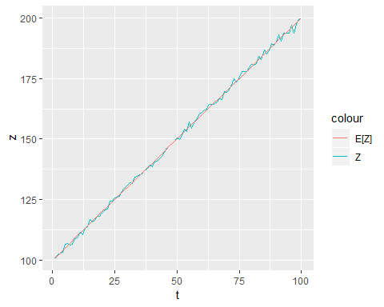

# ex1_6_3  
t <- 1:100  
e <- 100 + t + 2*t**2  
z <- 100 + t + 2*t**2 + rnorm(100)  
df <- data.frame(t, e, z)  
ggplot(data=df, aes(t)) + geom_line(aes(y=z, colour="Z")) + geom_line(aes(y=e, colour="E[Z]"))

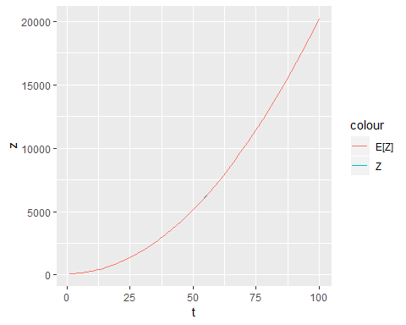

# ex1_6_4  
t <- 1:100  
e <- 100 + sin(2*pi*t/12) + cos(2*pi*t/12)  
z <- 100 + sin(2*pi*t/12) + cos(2*pi*t/12) + rnorm(100, 0, 5)  
df <- data.frame(t, e, z)  
ggplot(data=df, aes(t)) + geom_line(aes(y=z, colour="Z")) + geom_line(aes(y=e, colour="E[Z]"))

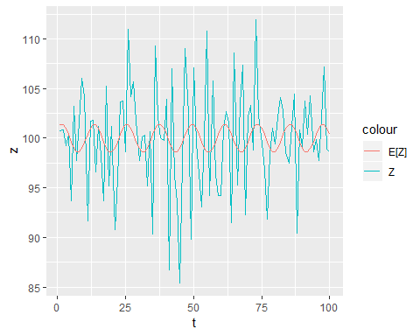

# ex1_6_5  
t <- 1:100  
e <- 100 + sin(2*pi*t/4) + cos(2*pi*t/4)  
z <- 100 + sin(2*pi*t/4) + cos(2*pi*t/4) + rnorm(100, 0, 5)  
df <- data.frame(t, e, z)  
ggplot(data=df, aes(t)) + geom_line(aes(y=z, colour="Z")) + geom_line(aes(y=e, colour="E[Z]"))

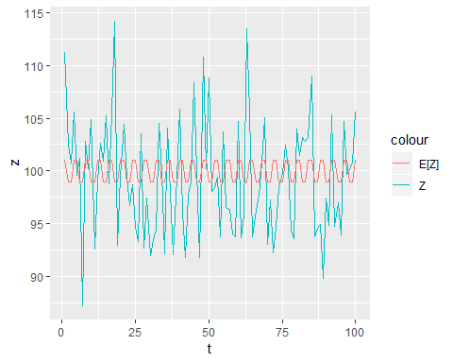

# ex1_6_6  
t <- 1:100  
e <- 100 + 0.3*t + sin(2*pi*t/12) + cos(2*pi*t/12)  
z <- 100 + 0.3*t + sin(2*pi*t/12) + cos(2*pi*t/12) + rnorm(100, 0, 5)  
df <- data.frame(t, e, z)  
ggplot(data=df, aes(t)) + geom_line(aes(y=z, colour="Z")) + geom_line(aes(y=e, colour="E[Z]"))

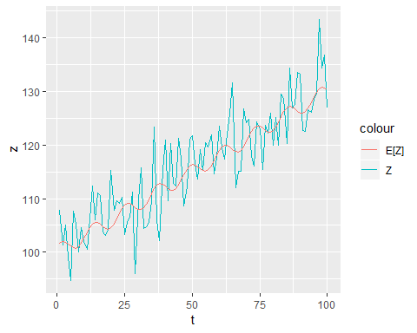

# ex1_6_7  
t <- 1:100  
e <- 100 + sin(2*pi*t/12) + cos(2*pi*t/12) + 0.8*sin(2*pi*t/6) + 0.7*cos(2*pi*t/6)  
z <- 100 + sin(2*pi*t/12) + cos(2*pi*t/12) + 0.8*sin(2*pi*t/6) + 0.7*cos(2*pi*t/6) + rnorm(100, 0, 5)  
df <- data.frame(t, e, z)  
ggplot(data=df, aes(t)) + geom_line(aes(y=z, colour="Z")) + geom_line(aes(y=e, colour="E[Z]"))

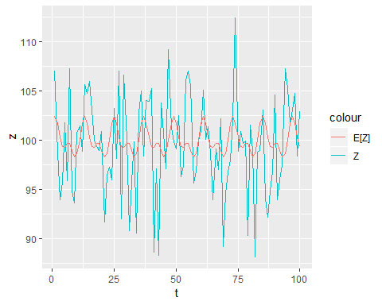

# ex1_6_8  
t <- 1:100  
e <- rep(250, 100)  
z <- 250 + rnorm(1)  
for(i in 2:100) {  
 z[i] <- 100 + 0.6*z[i-1] + rnorm(1)  
}  
df <- data.frame(t, e, z)  
ggplot(data=df, aes(t)) + geom_line(aes(y=z, colour="Z")) + geom_line(aes(y=e, colour="E[Z]"))

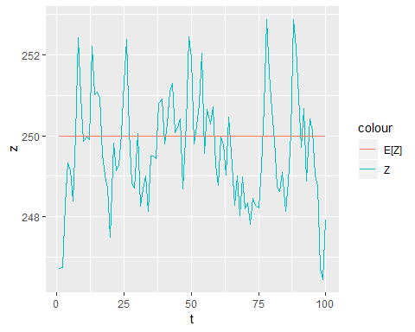

# ex1_6_9  
t <- 1:100  
e <- rep(100/1.2, 100)  
z <- 50 + rnorm(1)  
z[2] <- 100 + 0.5*z[1] + rnorm(1)  
for(i in 3:100) {  
 z[i] <- 100 + 0.5*z[i-1] - 0.7*z[i-2] + rnorm(1)  
}  
df <- data.frame(t, e, z)  
ggplot(data=df, aes(t)) + geom_line(aes(y=z, colour="Z")) + geom_line(aes(y=e, colour="E[Z]"))

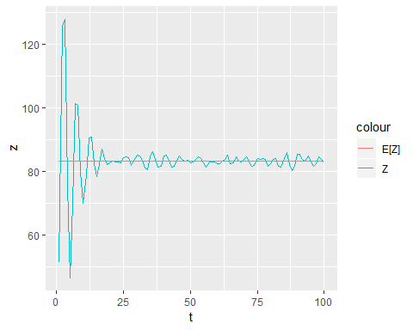

# ex1_6_10  
t <- 1:100  
eps <- rnorm(101)  
e <- rep(100,100)  
z <- 100 + eps[2:101] + 0.8*eps[1:100]  
df <- data.frame(t, e, z)  
ggplot(data=df, aes(t)) + geom_line(aes(y=z, colour="Z")) + geom_line(aes(y=e, colour="E[Z]"))

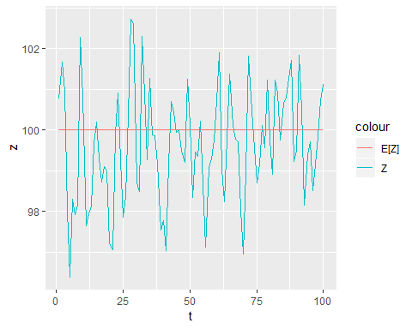

# ex1_6_11  
t <- 1:100  
eps <- rnorm(101)  
e <- rep(100,100)  
z <- 100 + eps[2:101] - 0.8*eps[1:100]  
df <- data.frame(t, e, z)  
ggplot(data=df, aes(t)) + geom_line(aes(y=z, colour="Z")) + geom_line(aes(y=e, colour="E[Z]"))

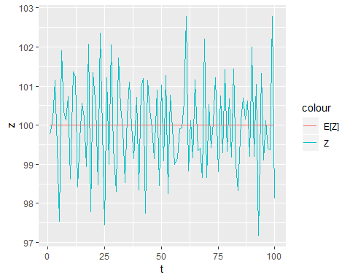

# ex1_7_1  
data <- read.csv('../timedata/female.txt', sep='', header=FALSE)  
z <- na.omit(c(t(data)))  
t <- 1:length(z)  
df <- data.frame(t, z)  
ggplot(data=df, aes(t, z)) +   
 geom_line(color="darkblue") +  
 xlab("months") +  
 ylab("female workers(unit: 100thou)")

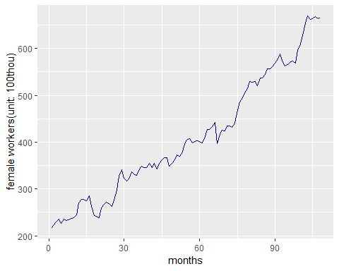

# ex1_7_2  
data <- read.csv('../timedata/build.txt', sep='', header=FALSE)  
z <- na.omit(c(t(data)))  
t <- 1:length(z)  
df <- data.frame(t, z)  
ggplot(data=df, aes(t, z)) +   
 geom_line(color="darkblue") +  
 xlab("months") +  
 ylab("pemission")

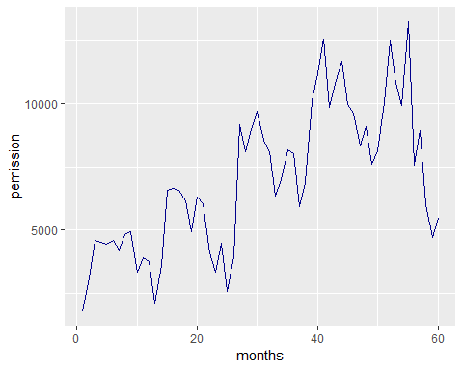

# ex1_7_3  
data <- read.csv('../timedata/export.txt', sep='', header=FALSE)  
z <- na.omit(c(t(data)))  
t <- 1:length(z)  
df <- data.frame(t, z)  
ggplot(data=df, aes(t, z)) +   
 geom_line(color="darkblue") +  
 xlab("months") +  
 ylab("sales(unit: $100m)")

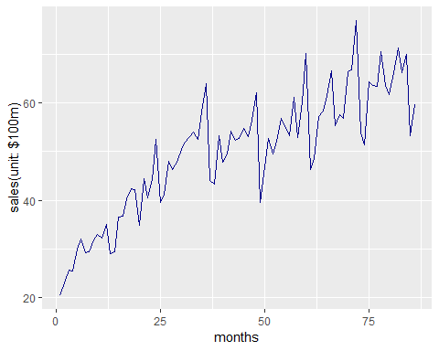

# ex1_7_4  
data <- read.csv('../timedata/usapass.txt', sep='', header=FALSE)  
z <- na.omit(c(t(data)))  
t <- 1:length(z)  
df <- data.frame(t, z)  
ggplot(data=df, aes(t, z)) +   
 geom_line(color="darkblue") +  
 xlab("months") +  
 ylab("flight customers(unit: 1thou)")

