chapter_1_R_intro.R

RYU

Tue Nov 13 09:15:25 2018

library(lubridate)

##   
## Attaching package: 'lubridate'

## The following object is masked from 'package:base':  
##   
## date

library(ggplot2)  
  
# figure 1.1  
t <- 1:100  
z <- 5000 + rnorm(100, mean=0, sd=sqrt(20))  
df <- data.frame(t, z)  
ggplot(data=df, aes(t, z)) + geom_line(color="darkblue")

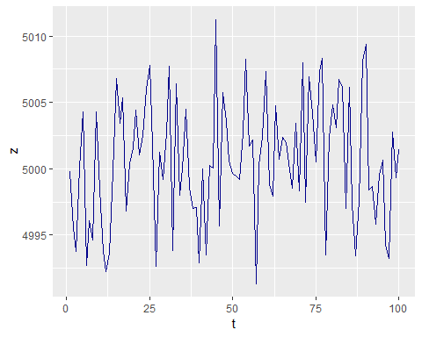

# figure 1.2  
t <- 1:100  
z <- 0.5 * t + rnorm(100, 0, sqrt(10))  
df <- data.frame(t, z)  
ggplot(data=df, aes(t, z)) + geom_line(color="darkblue")

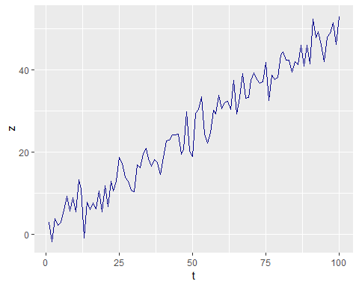

# figure 1.3  
t <- 1:120  
z <- 10 + 3 * sin(2 * pi * t / 12) + rnorm(120, 0, 0.8)  
df <- data.frame(t, z)  
ggplot(data=df, aes(t, z)) + geom_line(color="darkblue")

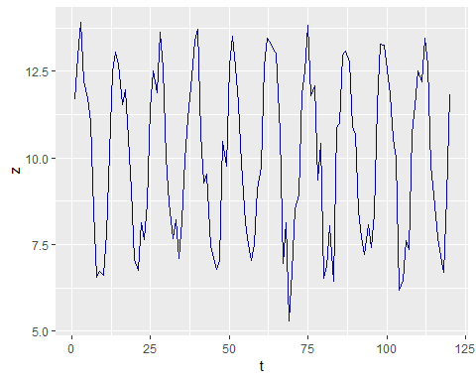

# figure 1.4  
data <- read.csv('../timedata/depart.txt', sep='', header=FALSE)  
z <- na.omit(c(t(data)))  
date <- ymd("940101") + months(1:length(z)-1)  
x <- 2.701573 + 0.000409 * as.numeric(date)  
df <- data.frame(date, z, x)  
ggplot(data=df, aes(date)) + geom_line(aes(y=log(z), colour="z")) +   
 geom_line(aes(y=x, colour="x")) +   
 scale_x_date(date_breaks="1 year") + ylab("sales")

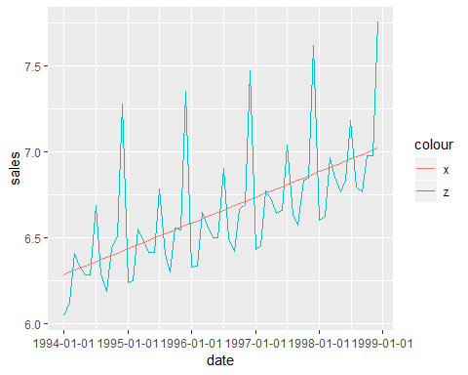

# figure 1.5  
data <- read.csv('../timedata/koreapass.txt', sep='', header=FALSE)  
z <- na.omit(c(t(data)))  
date <- ymd("810101") + months(1:length(z)-1)  
df <- data.frame(date, z)  
ggplot(data=df, aes(date, z)) + geom_line(color="darkblue")

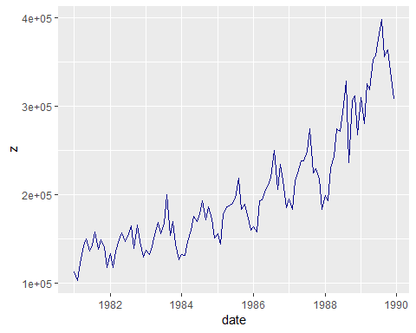

# figure 1.6  
t <- c(0.5*1:60, 2*15:74)  
z <- t + rnorm(120, 0, 1)  
date <- ymd("850101") + months(1:length(z)-1)  
df <- data.frame(date, z)  
ggplot(data=df, aes(date, z)) + geom_line(color="darkblue")

