chapter_3_R_exercise.R

RYU

Tue Nov 13 09:18:56 2018

library(lubridate)

##   
## Attaching package: 'lubridate'

## The following object is masked from 'package:base':  
##   
## date

library(ggplot2)  
library(forecast)  
  
# exercise 3.5  
# female  
data <- read.csv('../timedata/female.txt', sep='', header=FALSE)  
female <- na.omit(c(t(data)))  
date <- ymd("860101") + months(1:length(female)-1)  
  
femaleTS <- ts(female, start=1986, frequency=12)  
hwt <- HoltWinters(femaleTS, alpha=0.89, beta=0.89, gamma=F)  
plot(hwt)

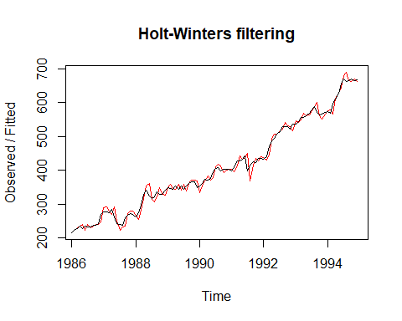

autoplot(forecast(hwt, h=6))

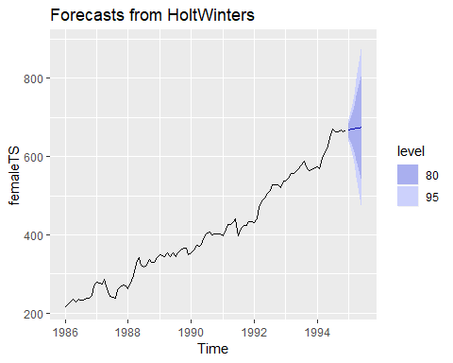

df <- data.frame(date, as.numeric(hwt$x-c(hwt$fitted[1:2],hwt$fitted[,1])))  
colnames(df) <- c('date', 'residual')  
ggplot(data=df, aes(x=date)) +   
 geom_line(aes(y=residual)) +  
 geom_hline(yintercept=0)

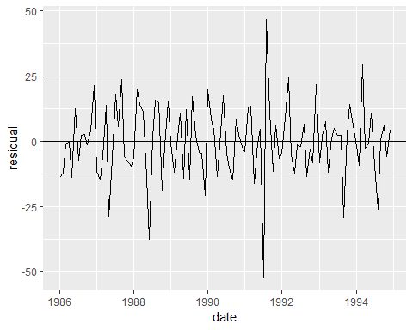

# build  
data <- read.csv('../timedata/build.txt', sep='', header=FALSE)  
build <- na.omit(c(t(data)))  
date <- ymd("860101") + months(1:length(build)-1)  
  
buildTS <- ts(build, start=1986, frequency=12)  
hwt <- HoltWinters(buildTS, alpha=0.89, beta=0.89, gamma=F)  
plot(hwt)

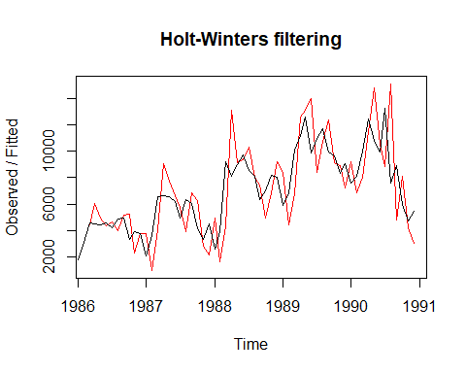

autoplot(forecast(hwt, h=6))

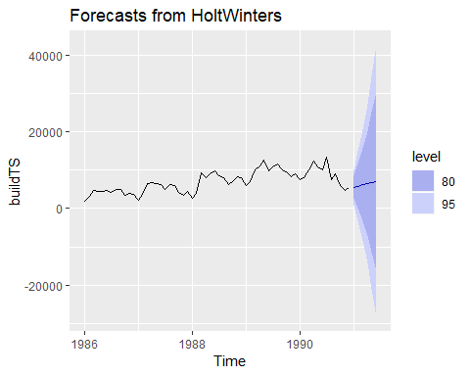

df <- data.frame(date, as.numeric(hwt$x-c(hwt$fitted[1:2],hwt$fitted[,1])))  
colnames(df) <- c('date', 'residual')  
ggplot(data=df, aes(x=date)) +   
 geom_line(aes(y=residual)) +  
 geom_hline(yintercept=0)

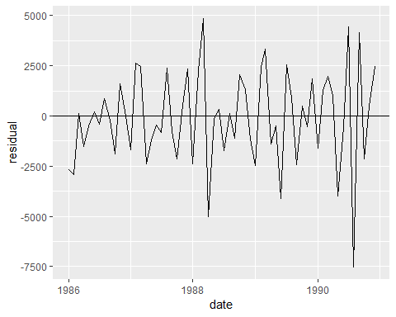

# export  
data <- read.csv('../timedata/export.txt', sep='', header=FALSE)  
export <- na.omit(c(t(data)))  
date <- ymd("860101") + months(1:length(export)-1)  
  
exportTS <- ts(export, start=1986, frequency=12)  
hwt <- HoltWinters(exportTS, alpha=0.89, beta=0.89, gamma=F)  
plot(hwt)

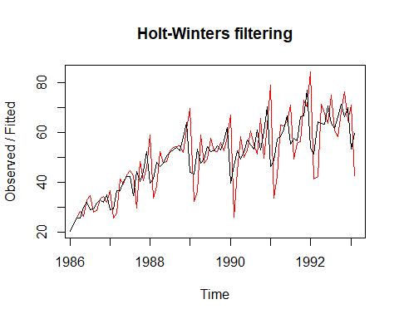

autoplot(forecast(hwt, h=6))

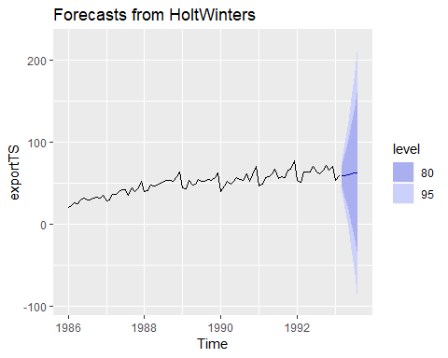

df <- data.frame(date, as.numeric(hwt$x-c(hwt$fitted[1:2],hwt$fitted[,1])))  
colnames(df) <- c('date', 'residual')  
ggplot(data=df, aes(x=date)) +   
 geom_line(aes(y=residual)) +  
 geom_hline(yintercept=0)

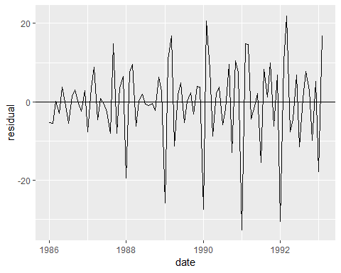

# usapass  
data <- read.csv('../timedata/usapass.txt', sep='', header=FALSE)  
usapass <- na.omit(c(t(data)))  
date <- ymd("860101") + months(1:length(usapass)-1)  
  
usapassTS <- ts(usapass, start=1986, frequency=12)  
hwt <- HoltWinters(usapassTS, seasonal='mult')  
plot(hwt)

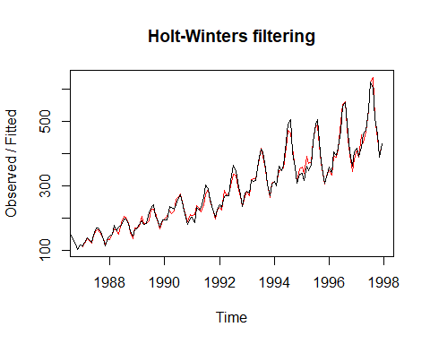

autoplot(forecast(hwt, h=6))

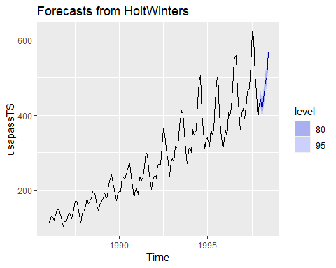

df <- data.frame(date, as.numeric(hwt$x-c(hwt$fitted[1:12],hwt$fitted[,1])))  
colnames(df) <- c('date', 'residual')  
ggplot(data=df, aes(x=date)) +   
 geom_line(aes(y=residual)) +  
 geom_hline(yintercept=0)

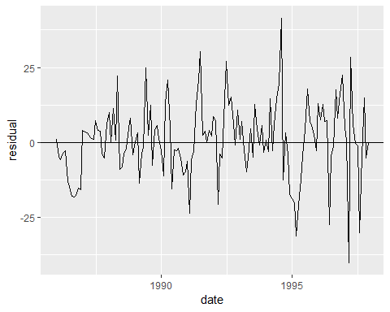

# depart  
data <- read.csv('../timedata/depart.txt', sep='', header=FALSE)  
depart <- na.omit(c(t(data)))  
date <- ymd("860101") + months(1:length(depart)-1)  
  
departTS <- ts(depart, start=1986, frequency=12)  
hwt <- HoltWinters(departTS, seasonal='mult')  
plot(hwt)

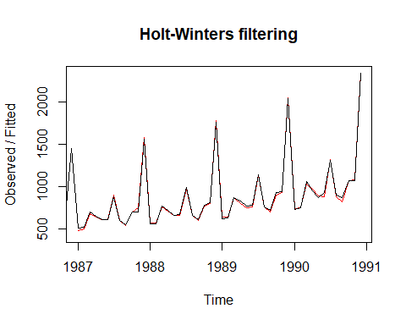

autoplot(forecast(hwt, h=6))

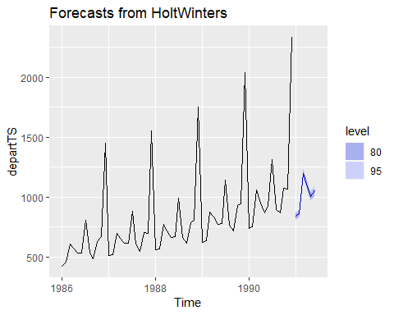

df <- data.frame(date, as.numeric(hwt$x-c(hwt$fitted[1:12],hwt$fitted[,1])))  
colnames(df) <- c('date', 'residual')  
ggplot(data=df, aes(x=date)) +   
 geom_line(aes(y=residual)) +  
 geom_hline(yintercept=0)

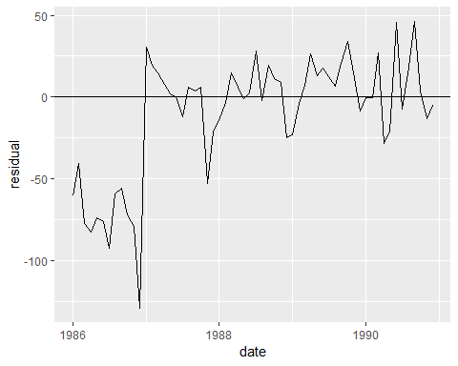

# stationery  
data <- read.csv('../timedata/stationery.txt', sep='', header=FALSE)  
stationery <- na.omit(c(t(data)))  
date <- ymd("860101") + months(1:length(stationery)-1)  
  
stationeryTS <- ts(stationery, start=1986, frequency=12)  
hwt <- HoltWinters(stationeryTS, alpha=0.89, beta=F, gamma=F)  
plot(hwt)

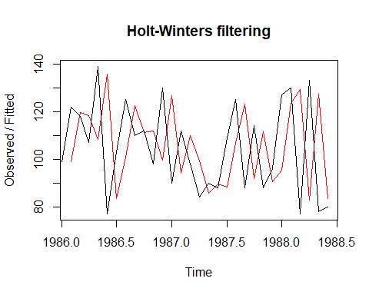

autoplot(forecast(hwt, h=6))

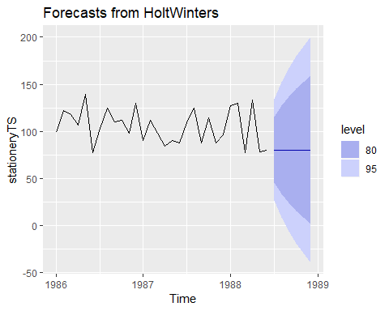

df <- data.frame(date, as.numeric(hwt$x-c(hwt$fitted[1],hwt$fitted[,1])))  
colnames(df) <- c('date', 'residual')  
ggplot(data=df, aes(x=date)) +   
 geom_line(aes(y=residual)) +  
 geom_hline(yintercept=0)

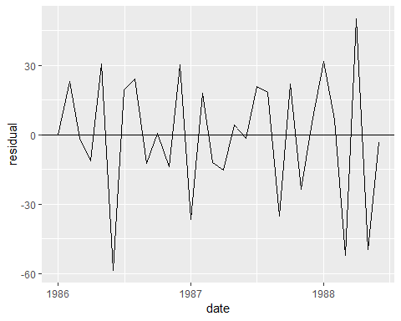

# book  
data <- read.csv('../timedata/book.txt', sep='', header=FALSE)  
book <- na.omit(c(t(data)))  
date <- ymd("860101") + months(1:length(book)-1)  
  
bookTS <- ts(book, start=1986, frequency=12)  
hwt <- HoltWinters(bookTS, alpha=0.89, beta=0.89, gamma=F)  
plot(hwt)

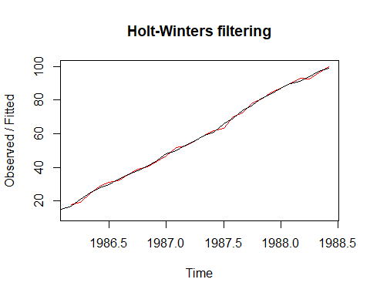

autoplot(forecast(hwt, h=6))

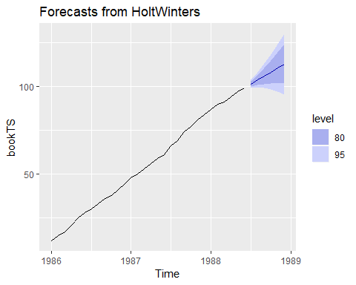

df <- data.frame(date, as.numeric(hwt$x-c(hwt$fitted[1:2],hwt$fitted[,1])))  
colnames(df) <- c('date', 'residual')  
ggplot(data=df, aes(x=date)) +   
 geom_line(aes(y=residual)) +  
 geom_hline(yintercept=0)

