chapter_3_R_intro.R

RYU

Tue Nov 13 09:19:07 2018

library(lubridate)

##   
## Attaching package: 'lubridate'

## The following object is masked from 'package:base':  
##   
## date

library(ggplot2)  
library(forecast)  
  
# example 3.1: Simple Exponential Smoothing  
data <- read.csv('../timedata/mindex.txt', sep='', header=FALSE)  
mindex <- na.omit(c(t(data)))  
date <- ymd("860101") + months(1:length(mindex)-1)  
  
w <- c(0.1,0.2,0.3,0.4,0.5,0.6,0.7,0.8,  
 0.81,0.82,0.83,0.84,0.85,0.86,0.87,  
 0.88,0.89,0.90,0.91,0.92,0.93,0.94,  
 0.95,0.96,0.97,0.98,0.99)  
  
sse <- c(1460.371,1012.6626,779.00814,648.75022,  
 570.4980,521.570,491.440,475.1534,  
 474.1885,473.3390,472.6044,471.9842,  
 471.478,471.0859,470.8079,470.6749,  
 470.5947,470.661,470.842,471.1406,  
 471.5567,472.0919,472.7475,473.525,  
 474.4263,475.4532,476.6078)  
  
df <- data.frame(w, sse)  
ggplot(data=df, aes(x=w)) +   
 geom_line(aes(y=sse, colour='sse'))

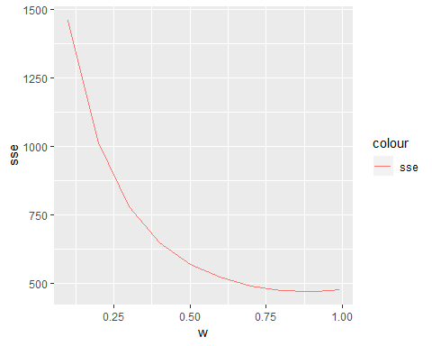

mindexTS <- ts(mindex, start=1986, frequency=12)  
hwt <- HoltWinters(mindexTS, alpha=0.89, beta=F, gamma=F)  
plot(hwt)

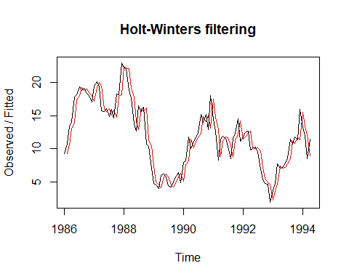

autoplot(forecast(hwt, h=6))

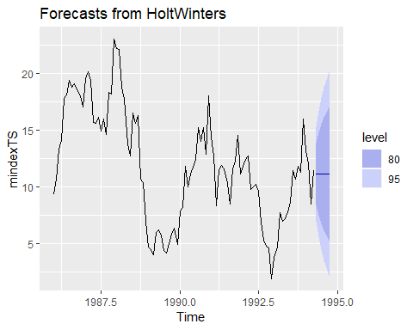

df <- data.frame(date, as.numeric(hwt$x-c(hwt$fitted[1],hwt$fitted[,1])))  
colnames(df) <- c('date', 'residual')  
ggplot(data=df, aes(x=date)) +   
 geom_line(aes(y=residual)) +  
 geom_hline(yintercept=0)

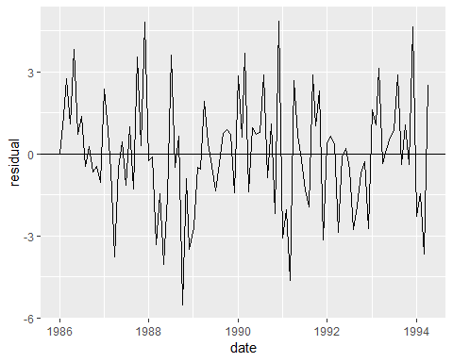

hwt <- HoltWinters(mindexTS, alpha=0.2, beta=F, gamma=F)  
plot(hwt)

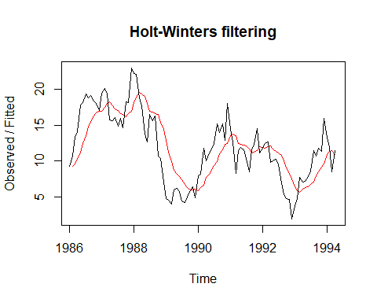

autoplot(forecast(hwt, h=6))

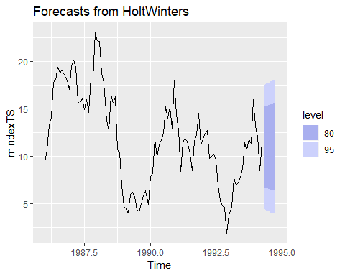

df <- data.frame(date, as.numeric(hwt$x-c(hwt$fitted[1],hwt$fitted[,1])))  
colnames(df) <- c('date', 'residual')  
ggplot(data=df, aes(x=date)) +   
 geom_line(aes(y=residual)) +  
 geom_hline(yintercept=0)

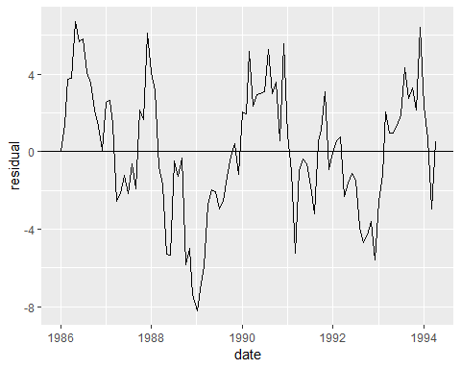

# example 3.2: Double Exponential Smoothing  
data <- read.csv('../timedata/stock.txt', sep='', header=FALSE)  
stock <- na.omit(c(t(data)))  
date <- ymd("840101") + months(1:length(stock)-1)  
  
stockTS <- ts(stock, start=1986, frequency=12)  
hwt <- HoltWinters(stockTS, alpha=0.6, beta=0.6, gamma=F)  
plot(hwt)

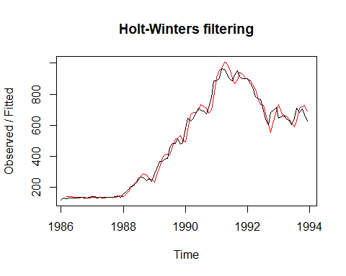

autoplot(forecast(hwt, h=6))

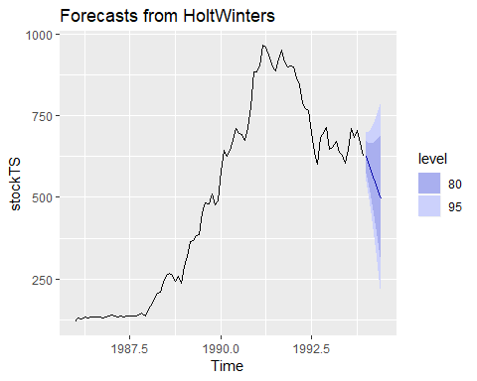

df <- data.frame(date, as.numeric(hwt$x-c(hwt$fitted[1:2],hwt$fitted[,1])))  
colnames(df) <- c('date', 'residual')  
ggplot(data=df, aes(x=date)) +   
 geom_line(aes(y=residual)) +  
 geom_hline(yintercept=0)

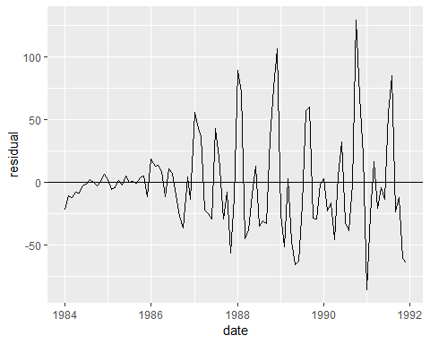

# example 3.3: Winters Seasonal Exponential Smoothing  
data <- read.csv('../timedata/koreapass.txt', sep='', header=FALSE)  
koreapass <- na.omit(c(t(data)))  
date <- ymd("810101") + months(1:length(koreapass)-1)  
  
koreapassTS <- ts(koreapass, start=1986, frequency=12)  
hwt <- HoltWinters(koreapassTS, alpha=0.4, beta=0.1, gamma=0.7)  
plot(hwt)

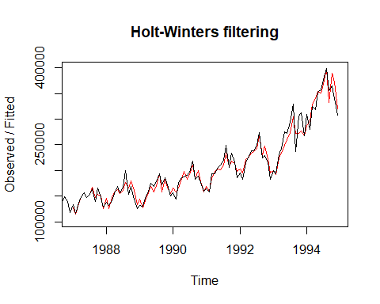

autoplot(forecast(hwt, h=12))

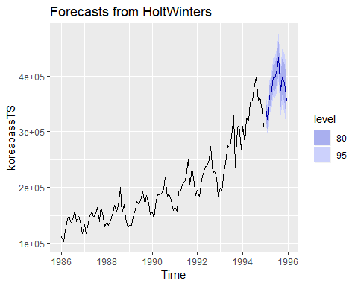

df <- data.frame(date, as.numeric(hwt$x-c(hwt$fitted[1:12],hwt$fitted[,1])))  
colnames(df) <- c('date', 'residual')  
ggplot(data=df, aes(x=date)) +   
 geom_line(aes(y=residual)) +  
 geom_hline(yintercept=0)

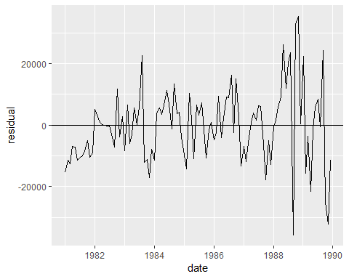

koreapassTS <- ts(koreapass, start=1986, frequency=12)  
hwt <- HoltWinters(koreapassTS, alpha=0.5, beta=0.1, gamma=0.4, seasonal='mult')  
plot(hwt)

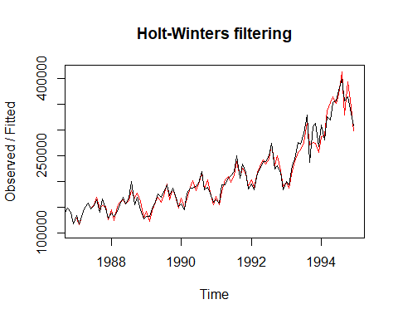

autoplot(forecast(hwt, h=12))

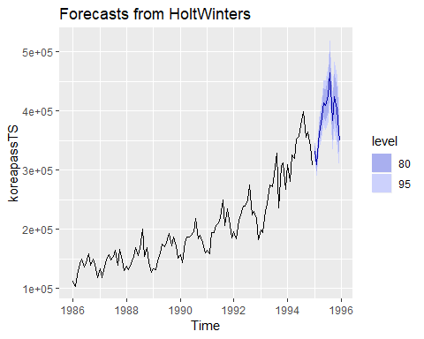

df <- data.frame(date, as.numeric(hwt$x-c(hwt$fitted[1:12],hwt$fitted[,1])))  
colnames(df) <- c('date', 'residual')  
ggplot(data=df, aes(x=date)) +   
 geom_line(aes(y=residual)) +  
 geom_hline(yintercept=0)

