chapter_4_R_intro.R

RYU

Tue Nov 13 09:19:45 2018

library(lubridate)

##   
## Attaching package: 'lubridate'

## The following object is masked from 'package:base':  
##   
## date

library(ggplot2)  
library(car)

## Loading required package: carData

library(forecast)  
library(seasonal)  
  
# example 4.1  
data <- read.csv('../timedata/food.txt', sep='', header=FALSE)  
food <- na.omit(c(t(data)))  
date <- ymd("800101") + months(1:length(food)-1)  
i1 <- as.numeric(month(date) == 1)  
i2 <- as.numeric(month(date) == 2)  
i3 <- as.numeric(month(date) == 3)  
i4 <- as.numeric(month(date) == 4)  
i5 <- as.numeric(month(date) == 5)  
i6 <- as.numeric(month(date) == 6)  
i7 <- as.numeric(month(date) == 7)  
i8 <- as.numeric(month(date) == 8)  
i9 <- as.numeric(month(date) == 9)  
i10 <- as.numeric(month(date) == 10)  
i11 <- as.numeric(month(date) == 11)  
i12 <- as.numeric(month(date) == 12)  
t <- 1:length(food)  
  
df <- data.frame(date, food, t)  
reg1 <- lm(food~t, data=df)  
trend <- reg1$fitted.values  
adjtrend <- food/trend  
durbinWatsonTest(reg1)

## lag Autocorrelation D-W Statistic p-value  
## 1 0.4824937 1.017248 0  
## Alternative hypothesis: rho != 0

reg2 <- Arima(adjtrend, xreg=i1+i2+i3+i4+i5+i6+i7+i8+i9+i10+i11, order=c(13,0,0))  
seasonal <- as.numeric(reg2$fitted)  
irregula <- adjtrend/seasonal  
fitted <- trend*seasonal  
  
ggplot(data=df, aes(x=date, y=seasonal)) + geom_line()

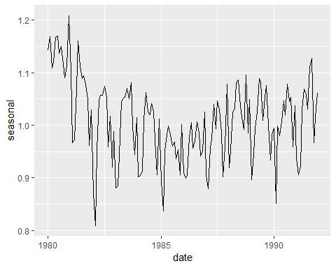

ggplot(data=df, aes(x=date, y=irregula)) + geom_line()

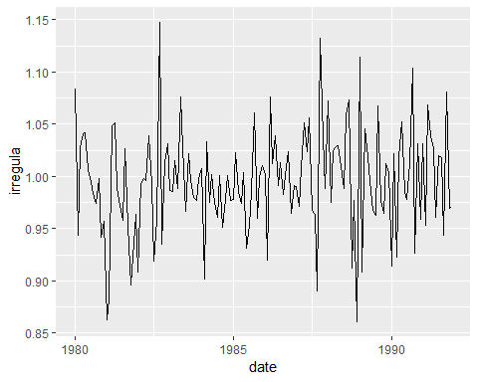

ggplot(data=df, aes(x=date)) +   
 geom_line(aes(y=food, colour='food')) +   
 geom_line(aes(y=fitted, colour='fitted')) +  
 theme(legend.position = c(0.05,0.9), legend.background=element_rect(fill="transparent"))

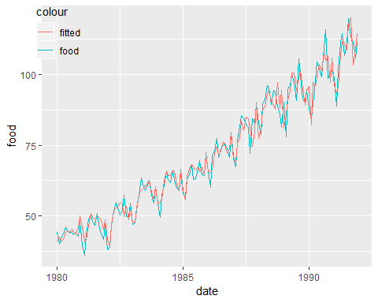

# example 4.2  
data <- read.csv('../timedata/mindex.txt', sep='', header=FALSE)  
mindex <- na.omit(c(t(data)))  
date <- ymd("800101") + months(1:length(mindex)-1)  
m3 <- ma(mindex, 3)  
m7 <- ma(mindex, 7)  
df <- data.frame(date, mindex, m3, m7)  
  
ggplot(data=df, aes(x=date)) +   
 geom_line(aes(y=mindex, colour='mindex')) +   
 geom_line(aes(y=m3, colour='m3')) +  
 theme(legend.position = c(0.05,0.9), legend.background=element_rect(fill="transparent"))

## Warning: Removed 2 rows containing missing values (geom_path).

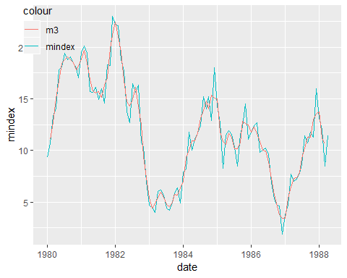

ggplot(data=df, aes(x=date)) +   
 geom_line(aes(y=mindex, colour='mindex')) +   
 geom_line(aes(y=m7, colour='m7')) +   
 theme(legend.position = c(0.05,0.9), legend.background=element_rect(fill="transparent"))

## Warning: Removed 6 rows containing missing values (geom_path).

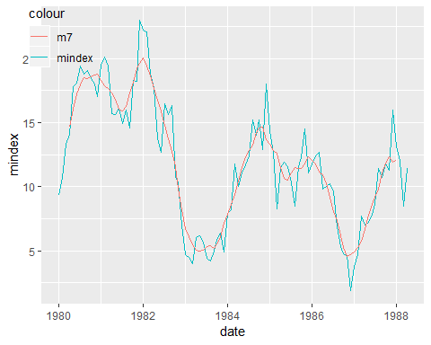

# example 4.3  
data <- read.csv('../timedata/food.txt', sep='', header=FALSE)  
food <- na.omit(c(t(data)))  
date <- ymd("800101") + months(1:length(food)-1)  
tsfood <- ts(food, frequency=12, start=c(1980,1))  
decom <- decompose(tsfood, type="additive") # moving average, season average,   
trend <- decom$trend  
seasonal <- decom$seasonal  
irregula <- decom$random  
adjseason <- decom$x - decom$seasonal  
df <- data.frame(date, food, trend, seasonal, irregula, adjseason)  
  
ggplot(data=df, aes(x=date)) +   
 geom_line(aes(y=food, colour='food')) +   
 geom_line(aes(y=trend, colour='trend')) +   
 theme(legend.position = c(0.07,0.91), legend.background=element_rect(fill="transparent"), legend.title=element_blank())

## Warning: Removed 12 rows containing missing values (geom_path).

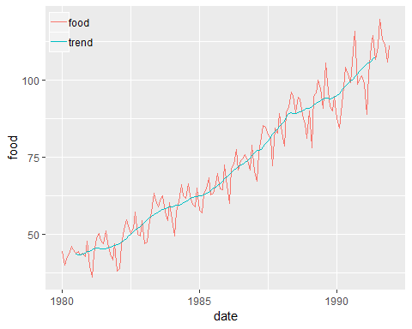

ggplot(data=df, aes(x=date)) +   
 geom_line(aes(y=food, colour='food')) +   
 geom_line(aes(y=seasonal, colour='seasonal')) +   
 theme(legend.position = c(0.07,0.91), legend.background=element_rect(fill="transparent"), legend.title=element_blank())

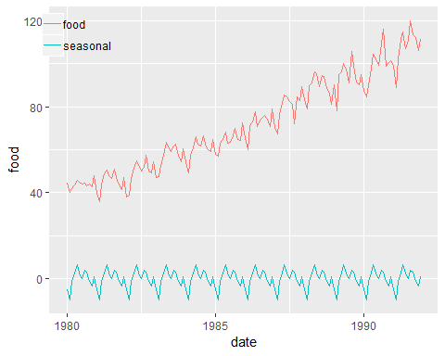

ggplot(data=df, aes(x=date)) +   
 geom_line(aes(y=food, colour='food')) +   
 geom_line(aes(y=irregula, colour='irregula')) +   
 theme(legend.position = c(0.07,0.91), legend.background=element_rect(fill="transparent"), legend.title=element_blank())

## Warning: Removed 12 rows containing missing values (geom_path).

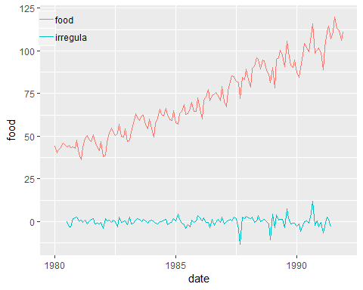

ggplot(data=df, aes(x=date)) +   
 geom_line(aes(y=food, colour='food')) +   
 geom_line(aes(y=adjseason, colour='adjseason')) +   
 theme(legend.position = c(0.07,0.91), legend.background=element_rect(fill="transparent"), legend.title=element_blank())

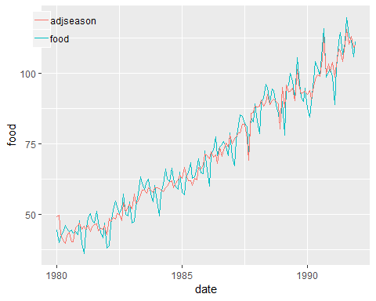

# decompose equivalent:  
# mafood <- ma(food, 12, centre=TRUE)  
# adjtrend <- food - mafood  
# season <- rep(0,12)  
# for(i in 1:12) {  
# season[i] <- mean(na.omit(adjtrend[0:11*12+i])) - mean(na.omit(adjtrend))  
# }  
# season <- rep(season, 12)  
# irr <- adjtrend - season  
  
z <- c(10,12,8,12,7,5,8,7,9,10,3,6,8,4,9,12,8,12,13,9)  
t <- 1:length(z)  
ma3 <- ma(z, 3)  
ma33 <- ma(ma3, 3)  
ma35 <- ma(ma3, 5)  
ma12 <- ma(z, 12, centre=F)  
ma122 <- ma(ma12, 2, centre=F)  
hendersn <- rep(0, length(z)-4)  
for(i in 1:(length(z)-4)) {  
 hendersn[i] <- sum(c(-0.073, 0.294, 0.558, 0.294, -0.073) * z[0:4+i])  
}  
hendersn <- c(rep(NA,2), hendersn, rep(NA,2))  
df <- data.frame(t,z,ma3,ma33,ma35,ma12, ma122,hendersn)  
ggplot(data=df, aes(x=t)) +   
 geom_line(aes(y=z, colour='z')) +   
 geom_line(aes(y=ma3, colour='ma3')) +   
 geom_line(aes(y=ma33, colour='ma33')) +   
 geom_line(aes(y=ma35, colour='ma35')) +   
 geom_line(aes(y=ma12, colour='ma12')) +   
 geom_line(aes(y=ma122, colour='ma122')) +   
 geom_line(aes(y=hendersn, colour='hendersn')) +   
 theme(legend.position = c(0.07,0.91), legend.background=element_rect(fill="transparent"), legend.title=element_blank())

## Warning: Removed 2 rows containing missing values (geom_path).

## Warning: Removed 4 rows containing missing values (geom_path).

## Warning: Removed 6 rows containing missing values (geom_path).

## Warning: Removed 11 rows containing missing values (geom_path).

## Warning: Removed 12 rows containing missing values (geom_path).

## Warning: Removed 4 rows containing missing values (geom_path).

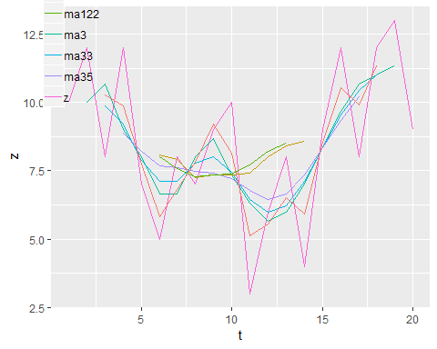

# example 4.4  
data <- read.csv('../timedata/food.txt', sep='', header=FALSE)  
food <- na.omit(c(t(data)))  
date <- ymd("800101") + months(1:length(food)-1)  
tsfood <- ts(food, frequency=12, start=c(1980,1))  
foodout <- seas(tsfood, x11="")  
autoplot(foodout)

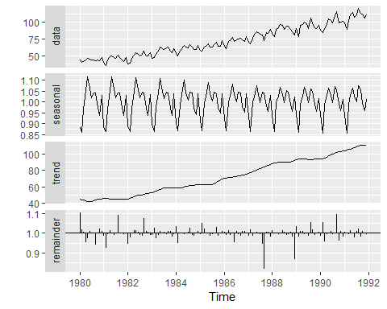

seasonal <- foodout$series$d10  
adjseason <- foodout$series$d11  
trend <- foodout$series$d12  
irregula <- as.numeric(foodout$series$d13)  
df <- data.frame(date, food, trend, seasonal, irregula, adjseason)  
df

## date food trend seasonal irregula adjseason  
## 1 1980-01-01 44.3 45.04499 0.8839964 1.1031738 49.69245  
## 2 1980-02-01 40.0 44.33508 0.8622656 1.0164146 45.06283  
## 3 1980-03-01 41.9 43.60959 0.9671077 1.0047106 43.81501  
## 4 1980-04-01 43.5 42.94207 1.0553515 0.9544809 40.98739  
## 5 1980-05-01 46.0 42.44375 1.1167038 0.9718888 41.25060  
## 6 1980-06-01 45.1 42.26421 1.0631885 1.0079174 42.59883  
## 7 1980-07-01 43.9 42.55669 1.0207380 1.0021197 42.64690  
## 8 1980-08-01 44.5 43.24334 1.0422970 0.9984656 43.17698  
## 9 1980-09-01 43.3 44.05061 1.0409810 0.9389691 41.36216  
## 10 1980-10-01 43.9 44.74653 0.9754886 0.9972870 44.62513  
## 11 1980-11-01 42.8 45.22287 0.9397741 1.0213318 46.18756  
## 12 1980-12-01 47.8 45.49770 1.0308404 1.0106115 45.98049  
## 13 1981-01-01 39.8 45.60851 0.8863513 0.9859203 44.96635  
## 14 1981-02-01 36.1 45.58628 0.8636748 0.9250884 42.17134  
## 15 1981-03-01 43.7 45.52943 0.9676460 0.9933063 45.22467  
## 16 1981-04-01 48.8 45.50423 1.0525589 1.0131640 46.10325  
## 17 1981-05-01 50.4 45.51707 1.1156391 1.0037285 45.68678  
## 18 1981-06-01 48.0 45.49312 1.0615531 0.9883525 44.96324  
## 19 1981-07-01 46.8 45.36584 1.0206096 1.0022924 45.46983  
## 20 1981-08-01 51.0 45.18061 1.0441766 1.0932711 49.39466  
## 21 1981-09-01 47.1 44.98549 1.0408136 1.0003077 44.99933  
## 22 1981-10-01 43.6 44.82293 0.9745301 0.9995429 44.80244  
## 23 1981-11-01 41.6 44.78345 0.9391132 0.9933202 44.48430  
## 24 1981-12-01 47.0 44.97829 1.0322668 1.0037837 45.14847  
## 25 1982-01-01 37.9 45.51627 0.8899621 0.9462040 43.06768  
## 26 1982-02-01 38.9 46.37718 0.8648397 0.9785207 45.38104  
## 27 1982-03-01 46.5 47.37499 0.9710398 1.0023143 47.48463  
## 28 1982-04-01 51.6 48.30188 1.0486053 1.0130521 48.93232  
## 29 1982-05-01 54.8 49.03810 1.1141922 1.0143096 49.73982  
## 30 1982-06-01 52.9 49.58113 1.0560990 1.0045991 49.80915  
## 31 1982-07-01 50.3 50.00160 1.0185265 0.9890591 49.45453  
## 32 1982-08-01 51.9 50.35343 1.0459575 0.9868127 49.68940  
## 33 1982-09-01 57.2 50.79739 1.0425960 1.0739813 54.55544  
## 34 1982-10-01 49.9 51.39525 0.9729243 1.0092117 51.86869  
## 35 1982-11-01 49.4 52.04775 0.9381914 1.0059853 52.35927  
## 36 1982-12-01 54.5 52.68234 1.0347231 0.9913898 52.22874  
## 37 1983-01-01 46.9 53.29967 0.8976754 0.9913175 52.83689  
## 38 1983-02-01 47.5 53.99114 0.8649795 1.0261852 55.40490  
## 39 1983-03-01 52.7 54.81274 0.9787697 0.9740602 53.39091  
## 40 1983-04-01 57.3 55.75396 1.0425549 0.9899457 55.19339  
## 41 1983-05-01 63.4 56.76662 1.1094838 1.0080585 57.22407  
## 42 1983-06-01 61.1 57.71735 1.0495515 1.0029728 57.88893  
## 43 1983-07-01 59.0 58.44906 1.0149726 1.0057822 58.78702  
## 44 1983-08-01 61.7 58.88833 1.0465227 0.9927604 58.46200  
## 45 1983-09-01 62.5 59.01332 1.0425567 1.0101558 59.61265  
## 46 1983-10-01 57.2 58.88098 0.9723394 1.0103850 59.49246  
## 47 1983-11-01 54.5 58.67380 0.9405857 0.9820012 57.61774  
## 48 1983-12-01 60.3 58.48210 1.0379692 0.9947646 58.17593  
## 49 1984-01-01 54.6 58.36622 0.9061949 1.0337606 60.33670  
## 50 1984-02-01 49.4 58.37928 0.8677579 0.9472598 55.30035  
## 51 1984-03-01 57.6 58.62103 0.9862783 0.9976543 58.48352  
## 52 1984-04-01 60.7 59.11628 1.0354855 0.9957927 58.86756  
## 53 1984-05-01 66.0 59.73756 1.1023750 0.9938121 59.36791  
## 54 1984-06-01 62.6 60.35760 1.0424572 0.9991152 60.30419  
## 55 1984-07-01 61.8 60.92674 1.0103511 1.0053533 61.25290  
## 56 1984-08-01 66.3 61.36486 1.0458203 1.0244102 62.86279  
## 57 1984-09-01 62.6 61.63772 1.0429287 0.9875926 60.87296  
## 58 1984-10-01 59.8 61.86345 0.9736563 0.9844610 60.90216  
## 59 1984-11-01 59.0 62.14510 0.9440816 0.9999855 62.14420  
## 60 1984-12-01 64.9 62.51212 1.0393600 1.0101788 63.14842  
## 61 1985-01-01 57.8 62.85750 0.9179132 0.9933590 62.44007  
## 62 1985-02-01 57.0 63.01004 0.8693213 1.0498934 66.15383  
## 63 1985-03-01 63.0 62.84130 0.9935019 1.0204940 64.12917  
## 64 1985-04-01 64.7 62.49555 1.0287969 1.0006533 62.53638  
## 65 1985-05-01 68.3 62.25934 1.0921583 0.9960193 62.01151  
## 66 1985-06-01 62.8 62.34437 1.0386284 0.9835738 61.32028  
## 67 1985-07-01 63.3 62.87613 1.0062475 0.9920881 62.37866  
## 68 1985-08-01 66.5 63.89764 1.0452058 0.9971156 63.71333  
## 69 1985-09-01 69.7 65.25754 1.0403513 1.0309877 67.27972  
## 70 1985-10-01 64.7 66.73193 0.9764309 0.9846145 65.70523  
## 71 1985-11-01 64.4 68.07584 0.9489440 1.0011144 68.15170  
## 72 1985-12-01 72.5 69.17583 1.0399311 1.0092285 69.81422  
## 73 1986-01-01 65.8 69.99475 0.9281797 1.0043048 70.29606  
## 74 1986-02-01 60.1 70.61478 0.8693027 0.9877982 69.75315  
## 75 1986-03-01 71.3 71.11184 0.9984568 1.0155519 72.21776  
## 76 1986-04-01 72.9 71.48168 1.0260023 0.9884223 70.65409  
## 77 1986-05-01 77.5 71.75538 1.0824698 0.9991757 71.69624  
## 78 1986-06-01 70.8 72.06811 1.0356810 0.9525669 68.64970  
## 79 1986-07-01 73.9 72.47208 1.0012366 1.0098903 73.18885  
## 80 1986-08-01 74.9 72.93022 1.0453580 0.9935576 72.46037  
## 81 1986-09-01 75.8 73.49162 1.0415262 0.9847348 72.36976  
## 82 1986-10-01 74.0 74.12408 0.9796534 1.0105018 74.90252  
## 83 1986-11-01 70.8 74.75588 0.9527834 1.0080880 75.36050  
## 84 1986-12-01 79.0 75.42551 1.0379413 1.0006293 75.47298  
## 85 1987-01-01 70.2 76.14858 0.9363777 0.9859042 75.07521  
## 86 1987-02-01 67.3 76.94181 0.8657714 1.0193184 78.42820  
## 87 1987-03-01 76.5 77.83662 1.0005362 0.9836829 76.56655  
## 88 1987-04-01 81.6 78.84864 1.0251726 1.0038228 79.15007  
## 89 1987-05-01 85.4 79.93388 1.0750931 1.0049968 80.33329  
## 90 1987-06-01 84.7 81.05889 1.0362269 1.0027347 81.28056  
## 91 1987-07-01 82.3 82.15918 0.9979451 0.9953464 81.77685  
## 92 1987-08-01 81.3 83.25091 1.0472278 0.9430706 78.51148  
## 93 1987-09-01 72.2 84.34968 1.0428412 0.8161945 68.84575  
## 94 1987-10-01 84.5 85.42138 0.9843646 1.0063398 85.96293  
## 95 1987-11-01 82.9 86.46188 0.9560773 1.0070900 87.07489  
## 96 1987-12-01 89.3 87.34416 1.0322554 0.9821270 85.78305  
## 97 1988-01-01 83.1 88.05977 0.9405094 1.0147151 89.35558  
## 98 1988-02-01 78.8 88.69545 0.8632990 0.9996850 88.66751  
## 99 1988-03-01 89.6 89.28442 0.9973545 0.9977460 89.08316  
## 100 1988-04-01 91.1 89.75213 1.0268441 0.9926600 89.09335  
## 101 1988-05-01 96.1 90.07533 1.0701183 0.9983808 89.92948  
## 102 1988-06-01 95.2 90.15317 1.0354700 1.0140901 91.42343  
## 103 1988-07-01 89.4 90.02421 0.9966291 1.0076934 90.71680  
## 104 1988-08-01 94.5 89.93288 1.0535522 0.9889958 88.94324  
## 105 1988-09-01 94.0 89.95767 1.0462760 0.9931195 89.33871  
## 106 1988-10-01 88.8 90.25215 0.9894263 1.0056706 90.76393  
## 107 1988-11-01 86.0 90.90407 0.9582489 0.9817364 89.24383  
## 108 1988-12-01 81.2 91.81856 1.0235925 0.8651850 79.44003  
## 109 1989-01-01 90.2 92.77494 0.9416945 1.0338947 95.91951  
## 110 1989-02-01 78.1 93.48184 0.8606360 0.9794104 91.55708  
## 111 1989-03-01 94.9 93.78571 0.9920311 1.0114431 94.85891  
## 112 1989-04-01 96.0 93.79850 1.0278934 1.0097922 94.71699  
## 113 1989-05-01 100.2 93.63510 1.0673993 0.9941211 93.08463  
## 114 1989-06-01 97.3 93.42269 1.0348457 1.0007901 93.49650  
## 115 1989-07-01 90.8 93.33169 0.9984627 0.9853911 91.96822  
## 116 1989-08-01 105.6 93.30017 1.0620521 1.0567515 98.59509  
## 117 1989-09-01 99.3 93.31302 1.0490445 1.0186959 95.05758  
## 118 1989-10-01 91.5 93.38858 0.9924361 0.9886333 92.32706  
## 119 1989-11-01 90.2 93.42503 0.9586750 1.0014517 93.56065  
## 120 1989-12-01 94.7 93.45601 1.0171925 1.0074497 94.15223  
## 121 1990-01-01 87.7 93.65115 0.9407342 0.9870900 92.44211  
## 122 1990-02-01 84.4 94.12782 0.8581513 1.0541951 99.22909  
## 123 1990-03-01 89.8 94.95022 0.9879426 0.9586479 91.02382  
## 124 1990-04-01 97.9 96.03686 1.0300620 0.9938316 95.44446  
## 125 1990-05-01 104.4 97.26659 1.0657020 0.9987072 97.14084  
## 126 1990-06-01 102.1 98.63704 1.0310692 1.0081596 99.44188  
## 127 1990-07-01 99.3 99.92535 0.9997939 0.9953448 99.46018  
## 128 1990-08-01 109.2 100.99540 1.0705046 1.0015431 101.15125  
## 129 1990-09-01 115.9 101.84582 1.0534164 1.0955819 111.58044  
## 130 1990-10-01 98.6 102.43519 0.9932619 0.9609508 98.43517  
## 131 1990-11-01 100.3 102.89983 0.9596977 1.0099734 103.92609  
## 132 1990-12-01 101.5 103.42998 1.0133225 0.9793901 101.29829  
## 133 1991-01-01 99.0 103.99902 0.9379006 1.0064363 104.66839  
## 134 1991-02-01 89.0 104.56100 0.8565901 1.0025538 104.82802  
## 135 1991-03-01 102.0 105.25614 0.9852406 0.9947048 104.69879  
## 136 1991-04-01 111.2 106.03336 1.0300779 1.0123957 107.34772  
## 137 1991-05-01 114.6 106.86430 1.0653955 0.9981098 106.66230  
## 138 1991-06-01 106.8 107.73921 1.0286651 0.9773006 105.29359  
## 139 1991-07-01 110.9 108.61354 1.0017360 1.0107214 109.77803  
## 140 1991-08-01 119.9 109.40330 1.0754916 1.0204511 111.64072  
## 141 1991-09-01 113.4 109.98741 1.0560569 0.9804245 107.83436  
## 142 1991-10-01 111.9 110.38333 0.9936502 1.0116499 111.66928  
## 143 1991-11-01 106.0 110.63859 0.9607963 1.0013809 110.79138  
## 144 1991-12-01 111.2 110.88051 1.0111925 0.9931759 110.12385

ggplot(data=df, aes(x=date)) +   
 geom_line(aes(y=food, colour='food')) +   
 geom_line(aes(y=trend, colour='trend')) +   
 theme(legend.position = c(0.06,0.92), legend.background=element_rect(fill="transparent"), legend.title=element_blank())

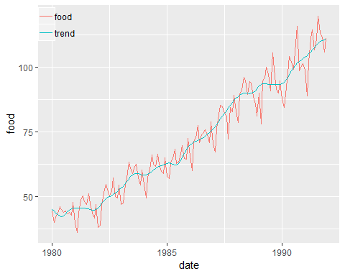

ggplot(data=df, aes(x=date)) +   
 geom_line(aes(y=irregula, colour='irregula')) +   
 geom_hline(yintercept=1) +   
 theme(legend.position = c(0.06,0.95), legend.background=element_rect(fill="transparent"), legend.title=element_blank())

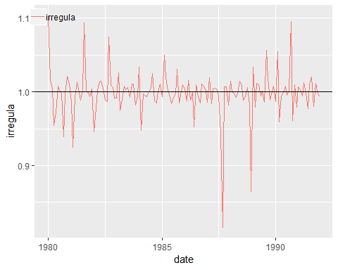

ggplot(data=df, aes(x=date)) +   
 geom_line(aes(y=food, colour='food')) +   
 geom_line(aes(y=adjseason, colour='adjseason')) +   
 theme(legend.position = c(0.08,0.92), legend.background=element_rect(fill="transparent"), legend.title=element_blank())

