chapter_5_R_exercise.R

RYU

Tue Nov 13 09:20:27 2018

library(forecast)  
library(ggplot2)  
  
#exercise 5.2  
z <- c(7,6,5,8,9,4,5,5,4,6,7,8,5,6,5)  
acfz_ <- acf(z, pl=F)  
print(acfz_)

##   
## Autocorrelations of series 'z', by lag  
##   
## 0 1 2 3 4 5 6 7 8 9   
## 1.000 0.094 -0.281 -0.125 -0.188 -0.250 0.094 0.313 -0.031 -0.063   
## 10 11   
## -0.031 0.000

autoplot(acfz_)

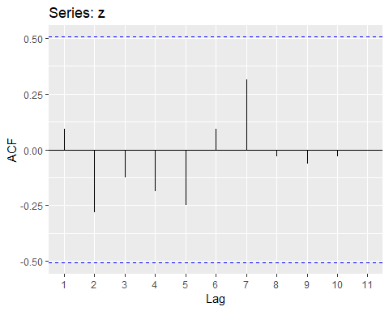

pacfz_ <- pacf(z, pl=F)  
print(pacfz_)

##   
## Partial autocorrelations of series 'z', by lag  
##   
## 1 2 3 4 5 6 7 8 9 10   
## 0.094 -0.293 -0.070 -0.275 -0.319 -0.051 0.091 -0.179 -0.049 -0.130   
## 11   
## 0.062

autoplot(pacfz_)

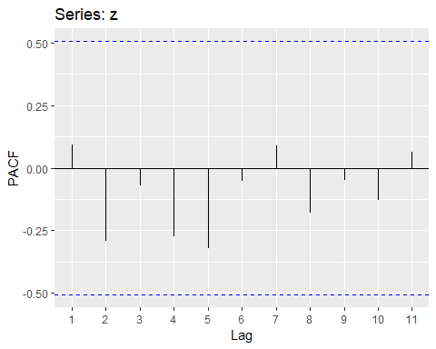

#custom function  
ACF <- function(z, nlag=11){  
 lenz <- length(z)  
 zbar <- mean(z)  
 gamma0 <- mean((z-zbar)**2)  
 acf_ <- 0  
 for(t in 1:nlag){  
 gammak <- sum((z[1:(lenz-t)]-zbar)*(z[(1+t):lenz]-zbar))/lenz  
 acf_[t] <- gammak/gamma0  
 }  
 lag <- 1:nlag  
 return(data.frame(acf=acf_, lag=lag))  
}  
  
PACF <- function(z, nlag=11){  
 lenz <- length(z)  
 pacfMat <- matrix(rep(0,nlag**2), nrow=nlag, ncol=nlag)  
 zbar <- mean(z)  
 gamma0 <- mean((z-zbar)**2)  
 gamma1 <- sum((z[1:(lenz-1)]-zbar)*(z[2:lenz]-zbar))/lenz  
 acf_ <- gamma1/gamma0  
 pacfMat[1,1] <- acf_[1]  
 for(t in 2:nlag){  
 gammak <- sum((z[1:(lenz-t)]-zbar)*(z[(1+t):lenz]-zbar))/lenz  
 acf_[t] <- gammak/gamma0  
 pacfMat[t, t] <- (acf_[t] - sum(pacfMat[t-1,1:(t-1)]*acf_[(t-1):1]))/(1-sum(pacfMat[t-1,1:(t-1)]*acf_[1:(t-1)]))  
 for(k in 1:(t-1)){  
 pacfMat[t,k] <- pacfMat[t-1,k] - pacfMat[t, t]*pacfMat[t-1,t-k]  
 }  
 }  
 lag <- 1:nlag  
 return(data.frame(pacf=diag(pacfMat), lag=lag))  
}  
  
testplot <- function(df){  
   
 if(!is.null(df$acf)) {  
 ylegend <- "ACF"  
 gplt <- ggplot(data=df, aes(x=lag, y=acf))  
 }  
 else if(!is.null(df$pacf)) {  
 ylegend <- "PACF"  
 gplt <- ggplot(data=df, aes(x=lag, y=pacf))  
 }  
 else {  
 stop('Given data frame must have acf or pacf')  
 }  
   
 gplt +   
 geom_hline(yintercept=0) +  
 geom_hline(yintercept=0.5, color="blue", linetype="dashed") +   
 geom_hline(yintercept=-0.5, color="blue", linetype="dashed") +   
 geom_segment(aes(xend=lag, yend=0)) +   
 xlab("Lag") +  
 ylab(ylegend) +   
 scale_x_continuous(breaks = seq(1, length(df$lag), by = 1))  
}  
  
acfz <- ACF(z)  
print(acfz)

## acf lag  
## 1 0.09375 1  
## 2 -0.28125 2  
## 3 -0.12500 3  
## 4 -0.18750 4  
## 5 -0.25000 5  
## 6 0.09375 6  
## 7 0.31250 7  
## 8 -0.03125 8  
## 9 -0.06250 9  
## 10 -0.03125 10  
## 11 0.00000 11

testplot(acfz)

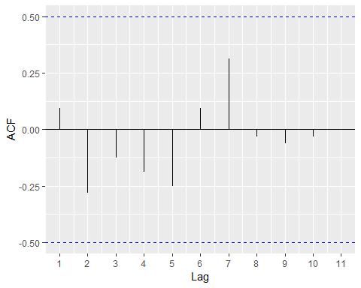

pacfz <- PACF(z)  
print(pacfz)

## pacf lag  
## 1 0.09375000 1  
## 2 -0.29261084 2  
## 3 -0.07004552 3  
## 4 -0.27526130 4  
## 5 -0.31926618 5  
## 6 -0.05111939 6  
## 7 0.09066504 7  
## 8 -0.17914378 8  
## 9 -0.04877966 9  
## 10 -0.13034288 10  
## 11 0.06233911 11

testplot(pacfz)

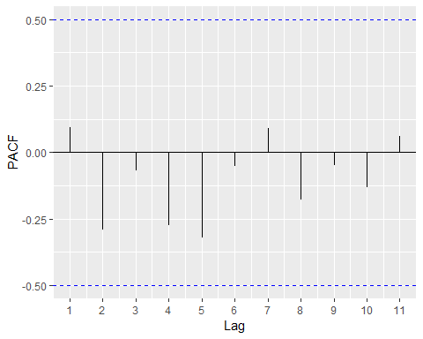

#exercise 5.3  
data <- read.csv('../timedata/ex5_3.txt', sep='', header=FALSE)  
z <- na.omit(c(t(data)))  
lenz <- length(z)  
t <- 1:lenz  
df <- data.frame(t, z)  
ggplot(data=df, aes(x=t)) + geom_line(aes(y=z))

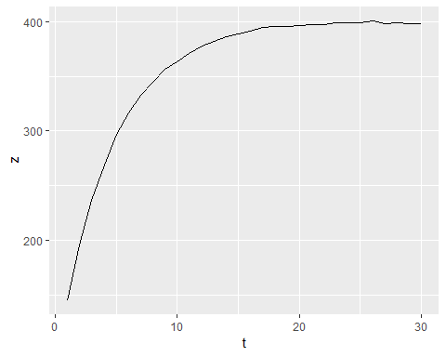

z1 <- z[1:(lenz-1)]  
z2 <- z[1:(lenz-2)]  
  
df2 <- data.frame(z=z[2:lenz], z1=z1)  
ggplot(data=df2, aes(x=z)) + geom_point(aes(y=z1))

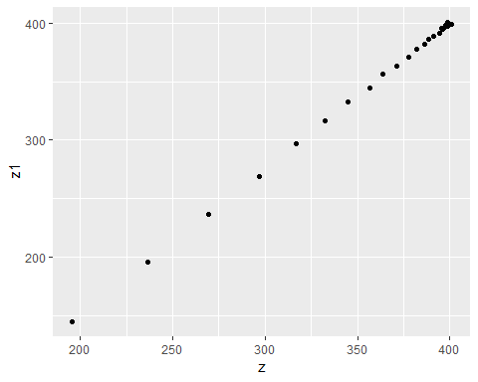

regz1 <- lm(z~z1, data=df2)  
regz1$coefficients["z1"]

## z1   
## 0.7996982

acfz <- ACF(z)  
acfz$acf[1]

## [1] 0.7867225

testplot(acfz)

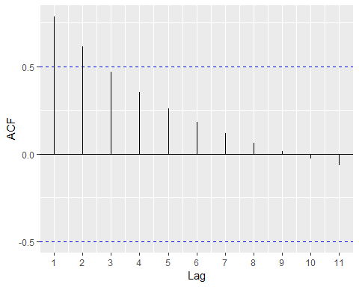

df3 <- data.frame(z=z[3:lenz], z2=z2)  
ggplot(data=df3, aes(x=z)) + geom_point(aes(y=z2))

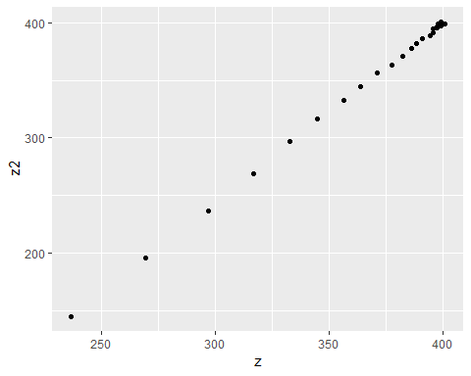

regz2 <- lm(z~z2, data=df3)  
regz2$coefficients["z2"]

## z2   
## 0.6394715

acfz$acf[2]

## [1] 0.6131091

pacfz <- PACF(z)  
testplot(pacfz)

