chapter_5_R_intro.R

RYU

Tue Nov 13 09:20:21 2018

library(ggplot2)  
  
#example 5.1  
t <- 1:100  
z <- 15  
for(i in 2:101){  
 z[i] <- 17 - 0.7*z[i-1] + rnorm(1)  
}  
z1 <- z[1:100]  
z <- z[2:101]  
z2 <- c(NA, NA, z[1:98])  
  
df <- data.frame(t, z, z1, z2)  
  
ggplot(data=df, aes(x=t)) +   
 geom_line(aes(y=z)) +   
 geom_hline(yintercept=10, color="grey50") +   
 scale_x_continuous(breaks = seq(0, 100, by = 10))

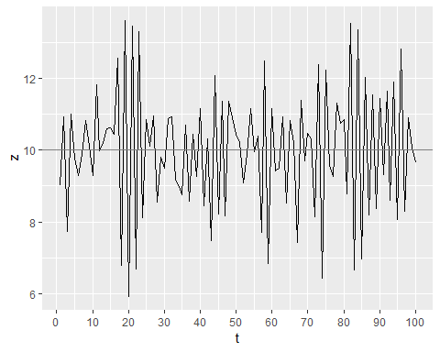

ggplot(data=df, aes(x=z)) +   
 geom_point(aes(y=z1)) +  
 geom_hline(yintercept=10, color="grey50") +   
 geom_vline(xintercept=10, color="grey50")

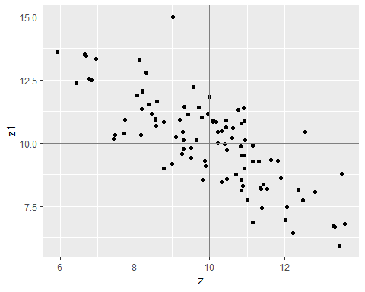

ggplot(data=df, aes(x=z)) +   
 geom_point(aes(y=z2)) +  
 geom_hline(yintercept=10, color="grey50") +   
 geom_vline(xintercept=10, color="grey50")

## Warning: Removed 2 rows containing missing values (geom_point).

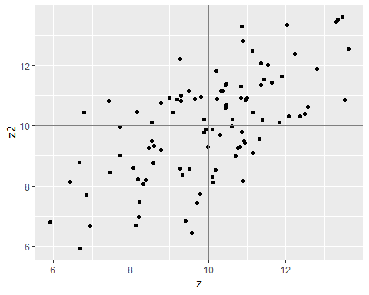

#figure 5.2  
t <- 1:300  
z <- rnorm(300)  
df <- data.frame(t, z)  
ggplot(data=df, aes(x=t, y=z)) + geom_line()

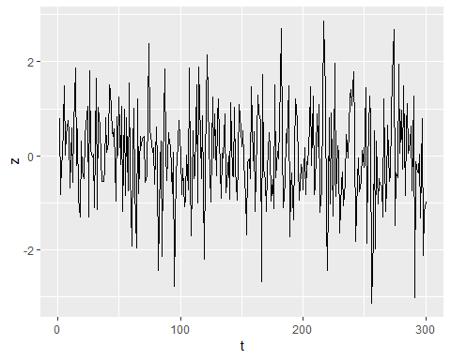

#figure 5.3  
t <- 1:300  
z <- 0  
for(i in 2:301){  
 z[i] <- z[i-1] + rnorm(1)  
}  
z <- z[2:301]  
df <- data.frame(t, z)  
ggplot(data=df, aes(x=t, y=z)) + geom_line()

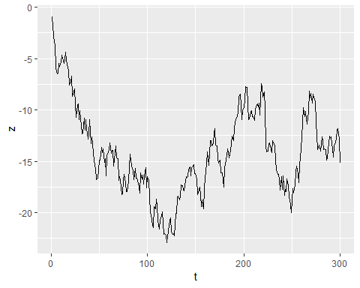

#figure 5.4  
t <- 1:300  
z <- 0  
for(i in 2:301){  
 z[i] <- 0.2 + z[i-1] + rnorm(1)  
}  
z <- z[2:301]  
df <- data.frame(t, z)  
ggplot(data=df, aes(x=t, y=z)) + geom_line()

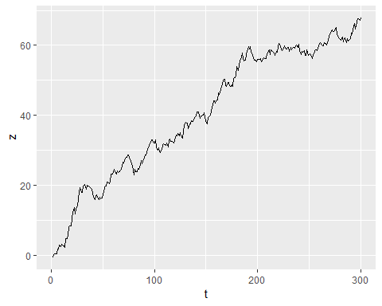

#example 5.2  
t <- 1:100  
a1 <- 0  
z <- 0  
for(i in 1:100){  
 a <- rnorm(1)  
 z[i] <- a + 0.8 * a1  
 a1 <- a  
}  
z1 <- c(NA, z[1:99])  
z2 <- c(NA, NA, z[1:98])  
z4 <- z - 0.4991*z1  
z3 <- (z2 - 0.4991*z1)  
df <- data.frame(t, z, z3, z4)  
  
ggplot(data=df, aes(x=t, y=z)) +   
 geom_line() +   
 geom_hline(yintercept=0, color="grey50") +   
 scale_x_continuous(breaks = seq(0, 100, by = 20))

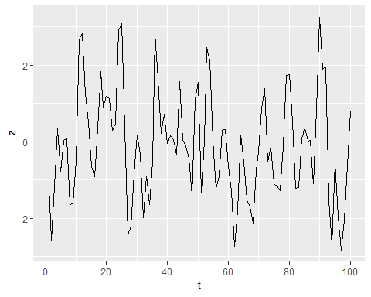

ggplot(data=df, aes(x=z3, y=z4)) +   
 geom_point() +  
 geom_hline(yintercept=0, color="grey50") +  
 geom_vline(xintercept=0, color="grey50")

## Warning: Removed 2 rows containing missing values (geom_point).

