chapter_6_R_intro.R

RYU

Tue Nov 13 09:20:58 2018

library(ggplot2)  
  
#figure 6.1  
t <- 1:100  
a <- rnorm(100)  
z <- rep(0, 100)  
y <- rep(0, 100)  
for(i in 1:99) {  
 z[i+1] <- -0.5*z[i] + a[i];  
 y[i+1] <- 0.5*y[i] + a[i];  
}  
  
df <- data.frame(t,z,y)  
  
ggplot(aes(x=t), data=df) +   
 geom_line(aes(y=y)) +   
 scale_x_continuous(breaks = seq(0, 100, by = 20)) +  
 geom_hline(yintercept=0)

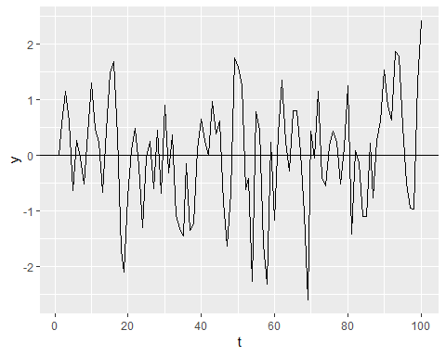

ggplot(aes(x=t), data=df) +   
 geom_line(aes(y=z)) +   
 scale_x_continuous(breaks = seq(0, 100, by = 20)) +  
 geom_hline(yintercept=0)

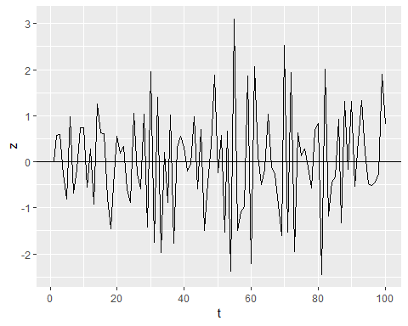

#figure 6.6  
t <- 1:100  
a1 <- 0  
z <- rep(0, 100)  
y <- rep(0, 100)  
for(i in 1:100) {  
 a <- rnorm(1)  
 z[i] <- a-0.6*a1  
 y[i] <- a+0.6*a1  
 a1 <- a  
}  
  
df <- data.frame(t,z,y)  
  
ggplot(aes(x=t), data=df) +   
 geom_line(aes(y=y)) +   
 scale_x_continuous(breaks = seq(0, 100, by = 20)) +  
 geom_hline(yintercept=0, color="grey10")

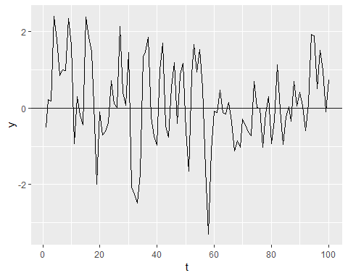

ggplot(aes(x=t), data=df) +   
 geom_line(aes(y=z)) +   
 scale_x_continuous(breaks = seq(0, 100, by = 20)) +  
 geom_hline(yintercept=0, color="grey10")

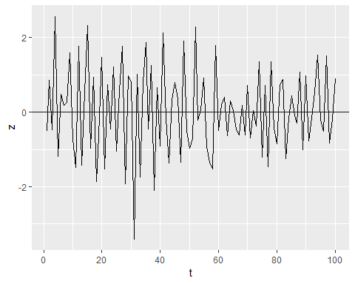

#figure 6.4  
testplot <- function(df, mode='acf'){  
   
 if(mode=='acf') {  
 if(!is.null(df$acf)) {  
 ylegend <- "ACF"  
 gplt <- ggplot(data=df, aes(x=lag, y=acf))  
 }  
 }  
 else if(mode=='pacf') {  
 if(!is.null(df$pacf)) {  
 ylegend <- "PACF"  
 gplt <- ggplot(data=df, aes(x=lag, y=pacf))  
 }  
 }  
 else {  
 stop('Given data frame must have acf or pacf')  
 }  
   
 gplt +   
 geom_hline(yintercept=0) +  
 geom_hline(yintercept=0.5, color="blue", linetype="dashed") +   
 geom_hline(yintercept=-0.5, color="blue", linetype="dashed") +   
 geom_segment(aes(xend=df$lag, yend=0), size=2, color="darkgreen") +   
 xlab("Lag") +  
 ylab(ylegend) +   
 scale_x_continuous(breaks = seq(0, length(df$lag), by = 1)) +  
 scale_y_continuous(limits=c(-1,1), breaks = seq(-1, 1, by=0.2))  
}  
  
fig6_4 <- function(phi, mode='acf') {  
 k <- 0:10  
 acf <- phi**k  
 pacf <- rep(0, 11)  
 pacf[2] <- phi  
 df <- data.frame(acf, pacf, lag=k)  
 testplot(df, mode)  
}  
  
fig6_4(0.6, 'acf')

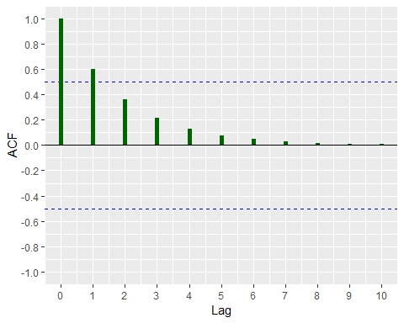

fig6_4(0.6, 'pacf')

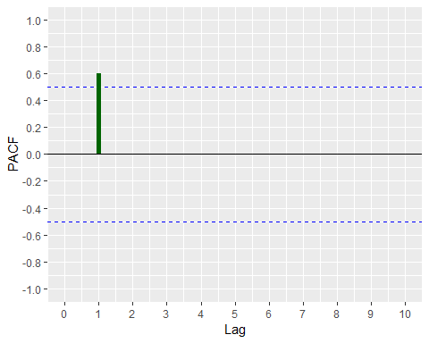

fig6_4(-0.6, 'acf')

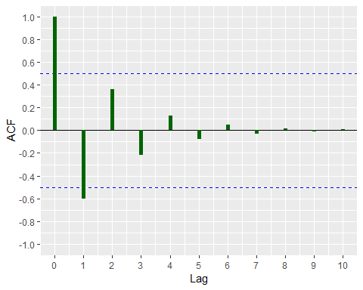

fig6_4(-0.6, 'pacf')

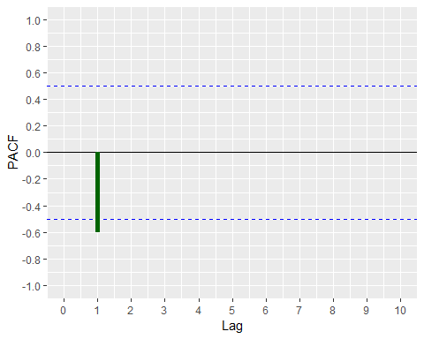

#figure 6.5  
fig6_5 <- function(phi1, phi2, mode='acf') {  
 k <- 0:10  
 acf <- rep(0, 11)  
 pacf <- rep(0, 11)  
 acf[1] <- 1  
 acf[2] <- phi1/(1-phi2)  
 acf[3] <- (phi1**2+phi2-phi2**2)/(1-phi2)  
 pacf[2] <- acf[2]  
 pacf[3] <- phi2  
 for(i in 3:10) {  
 acf[i+1] <- phi1*acf[i]+phi2*acf[i-1]  
 }  
 df <- data.frame(acf, pacf, lag=k)  
 testplot(df, mode)  
}  
  
fig6_5(-0.8, -0.7, 'acf')

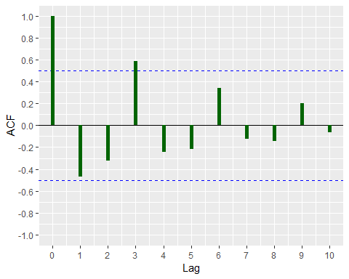

fig6_5(-0.8, -0.7, 'pacf')

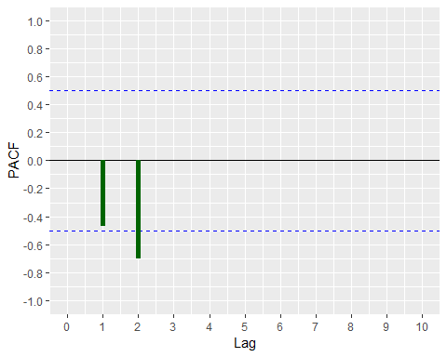

fig6_5(-0.5, 0.2, 'acf')

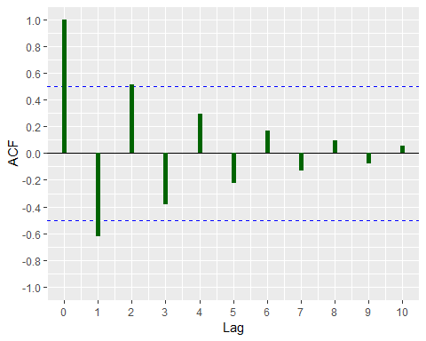

fig6_5(-0.5, 0.2, 'pacf')

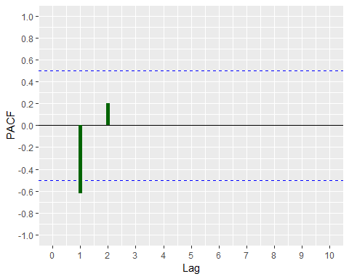

fig6_5(0.7, 0.2, 'acf')

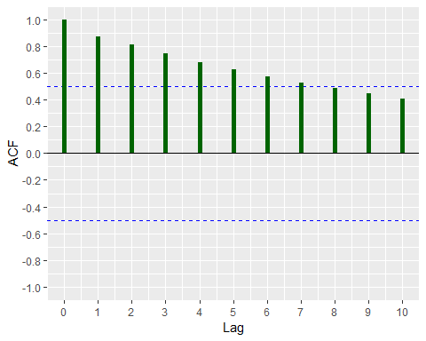

fig6_5(0.7, 0.2, 'pacf')

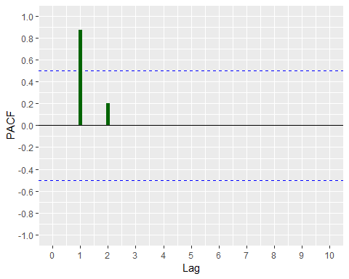

fig6_5(1.3, -0.5, 'acf')

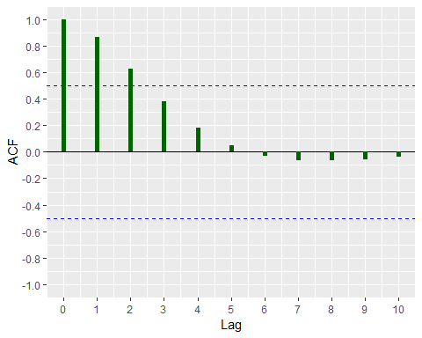

fig6_5(1.3, -0.5, 'pacf')

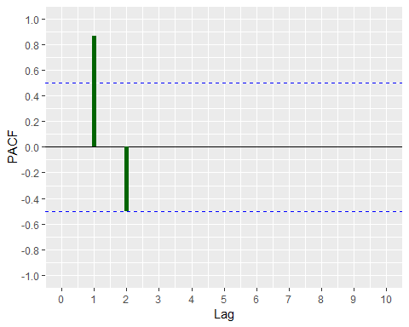

#figure 6.8  
fig6_8 <- function(theta, mode='acf') {  
 k <- 0:10  
 kk <- 2*(k+1)  
 acf <- rep(0, 11)  
 pacf <- rep(0, 11)  
 acf[1] <- 1  
 acf[2] <- -theta/(1+theta**2)  
 pacf <- -(theta**k)*(1-theta**2)/(1-theta**kk)  
   
 df <- data.frame(acf, pacf, lag=k)  
 testplot(df, mode)  
}  
  
fig6_8(0.9, 'acf')

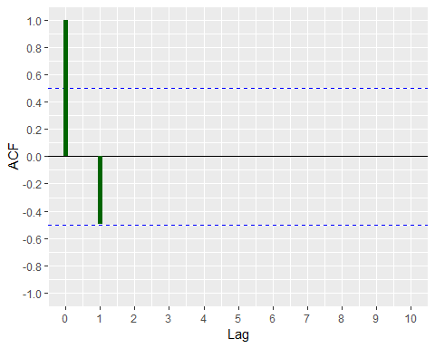

fig6_8(0.9, 'pacf')

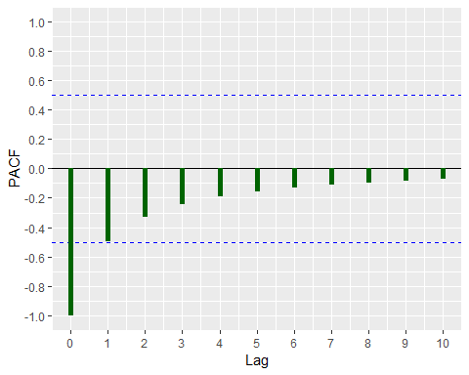

fig6_8(-0.6, 'acf')

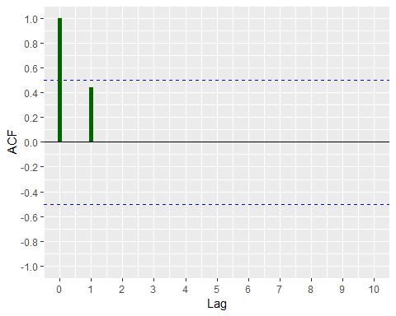

fig6_8(-0.6, 'pacf')

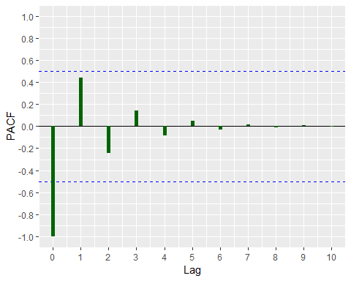

#figure 6.9  
fig6_9 <- function(theta1, theta2, mode) {  
 k <- 0:10  
 acf <- rep(0, 11)  
 pacf <- rep(0, 11)  
 acf[1] <- 1  
 acf[2] <- -theta1*(1-theta2)/(1+theta1**2+theta2**2)  
 acf[3] <- -theta2/(1+theta1**2+theta2**2)  
   
 df <- data.frame(acf, lag=k)  
 testplot(df, mode)  
}  
  
fig6_9(-1.6, -0.7, 'acf')

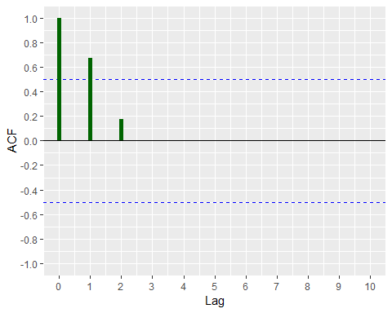

fig6_9(0.8, -0.7, 'acf')

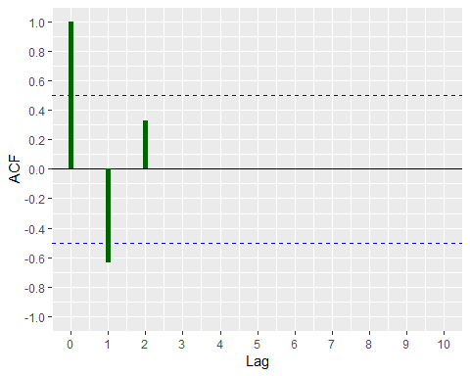

#figure 6.10  
fig6_10 <- function(phi, theta, mode) {  
 k <- 0:10  
 acf <- rep(0, 11)  
 pacf <- rep(0, 11)  
 acf[1] <- 1  
 acf[2] <- (phi-theta)*(1-phi*theta)/(1+theta**2-2*phi*theta)  
 for(i in 2:10) {  
 acf[i+1] <- phi*acf[i]  
 }  
 df <- data.frame(acf, lag=k)  
 testplot(df, mode)  
}  
  
fig6_10(-0.9, -0.5, 'acf')

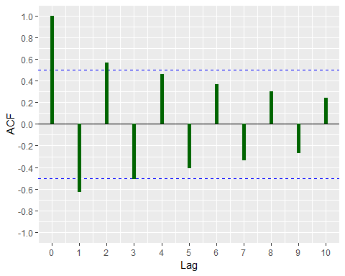

fig6_10(0.8, -0.7, 'acf')

