chapter_7_R_intro.R

RYU

Tue Nov 13 09:21:25 2018

library(ggplot2)  
library(scales)  
library(lubridate)

##   
## Attaching package: 'lubridate'

## The following object is masked from 'package:base':  
##   
## date

library(astsa)  
  
#example 7.1  
data <- read.csv('../timedata/depart.txt', sep='', header=FALSE)  
z <- na.omit(c(t(data)))  
lenz <- length(z)  
logz <- log(z)  
dif1 <- c(rep(NA,1),logz[2:lenz]-logz[1:(lenz-1)])  
dif1_12 <- c(rep(NA,13),dif1[13:(lenz-1)]-dif1[1:(lenz-13)])  
date <- ymd("840101") + months(1:lenz-1)  
  
df <- data.frame(z, logz, dif1, dif1_12, date)  
ggplot(data=df, aes(x=date, y=z)) +   
 geom_line() +   
 ylab("depart") +  
 scale_x_date(date_breaks = "1 year",  
 labels = date_format("JAN%y"))

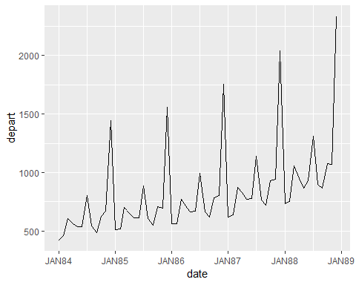

ggplot(data=df, aes(x=date, y=logz)) +   
 geom_line() +   
 ylab("lnZ") +  
 scale_x_date(date_breaks = "1 year",  
 labels = date_format("JAN%y"))

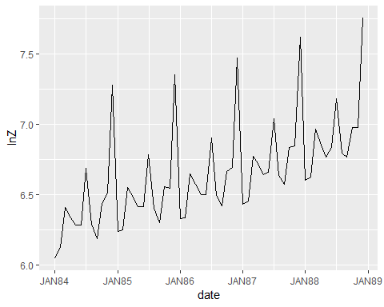

ggplot(data=df, aes(x=date, y=dif1)) +   
 geom_line() +   
 geom_hline(yintercept=0) +  
 ylab("d_lnZ") +  
 scale_x_date(date_breaks = "1 year",  
 labels = date_format("JAN%y"))

## Warning: Removed 1 rows containing missing values (geom_path).

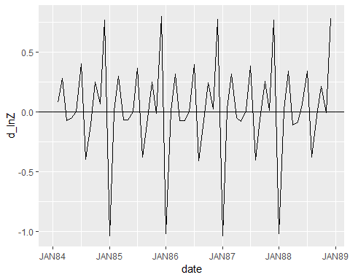

ggplot(data=df, aes(x=date, y=dif1_12)) +   
 geom_line() +   
 ylab("dd12_lnz") +  
 scale_x_date(date_breaks = "1 year",  
 labels = date_format("JAN%y"),  
 limits=c(date[13], date[lenz]))

## Warning: Removed 14 rows containing missing values (geom_path).

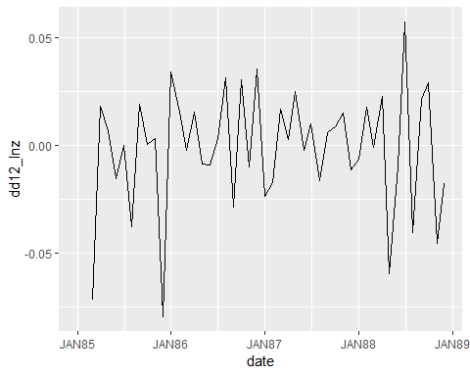

#figure 7.3  
data <- read.csv('../timedata/interest.txt', sep='', header=FALSE)  
interest <- na.omit(c(t(data)))  
date <- ymd("820401") + months(1:length(interest)-1)  
  
df <- data.frame(interest, date)  
ggplot(data=df, aes(date, interest)) +  
 geom_line() +  
 geom_vline(xintercept=ymd("911201"), color="grey55") +  
 scale_x_date(date_breaks = "1 year",  
 labels = date_format("JAN%y"))

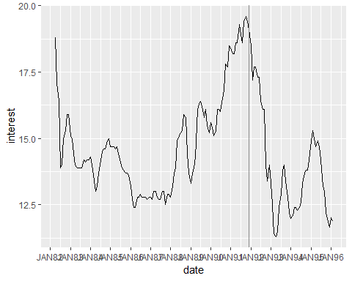

#figure 7.4  
t <- 1:300  
a <- rnorm(300)  
a[0] <- 0  
lenz <- length(z)  
z <- cumsum(a)  
dif1 <- c(rep(NA,1), z[2:lenz]-z[1:(lenz-1)])  
  
df <- data.frame(t, z, dif1)  
ggplot(data=df, aes(x=t,y=z)) +   
 geom_line() +  
 xlab("time")

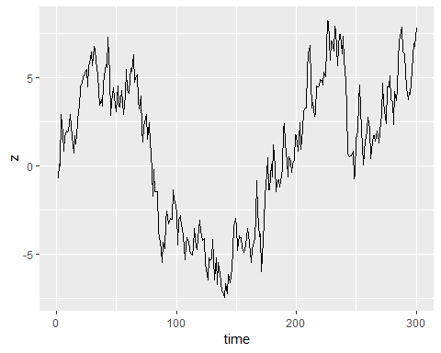

ggplot(data=df, aes(x=t,y=dif1)) +   
 geom_line() +  
 xlab("time") +  
 ylab("d_Z")

## Warning: Removed 1 rows containing missing values (geom_path).

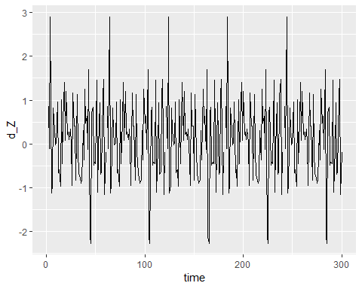

#figure 7.7  
t <- 1:300  
z <- rep(0,302)  
a1 <- rnorm(1)  
for (i in 1:300) {  
 a <- rnorm(1)  
 z[i+2] <- 1.8*z[i+1] - 0.8*z[i] + a - 0.5*a1  
 a1 <- a  
}  
z <- z[3:302]  
dif1 <- c(rep(NA,1), z[2:lenz]-z[1:(lenz-1)])  
df <- data.frame(t, z, dif1)  
  
ggplot(data=df, aes(x=t,y=z)) +   
 geom_line() +  
 xlab("time")

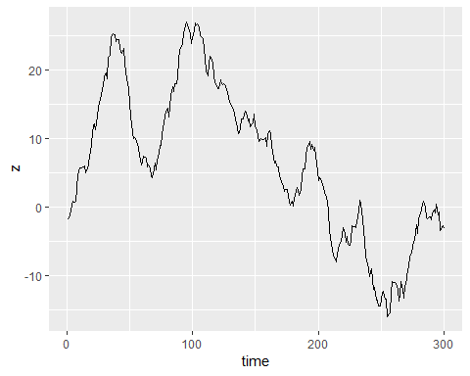

acf2(z)

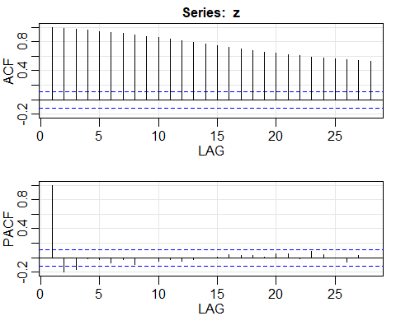

## ACF PACF  
## [1,] 0.99 0.99  
## [2,] 0.98 -0.20  
## [3,] 0.97 -0.16  
## [4,] 0.96 -0.01  
## [5,] 0.94 -0.02  
## [6,] 0.93 -0.07  
## [7,] 0.91 -0.03  
## [8,] 0.89 -0.10  
## [9,] 0.87 -0.01  
## [10,] 0.85 -0.05  
## [11,] 0.83 -0.03  
## [12,] 0.81 -0.05  
## [13,] 0.79 -0.03  
## [14,] 0.77 0.00  
## [15,] 0.74 0.00  
## [16,] 0.72 0.04  
## [17,] 0.70 0.03  
## [18,] 0.68 0.03  
## [19,] 0.66 0.01  
## [20,] 0.64 0.06  
## [21,] 0.62 0.05  
## [22,] 0.60 -0.01  
## [23,] 0.59 0.09  
## [24,] 0.57 0.04  
## [25,] 0.56 -0.01  
## [26,] 0.55 -0.06  
## [27,] 0.54 0.03  
## [28,] 0.52 -0.01

ggplot(data=df, aes(x=t,y=dif1)) +   
 geom_line() +  
 geom_hline(yintercept=0, color="grey20") +   
 xlab("time") +  
 scale_x_continuous(breaks=seq(0,300, by=100))

## Warning: Removed 1 rows containing missing values (geom_path).

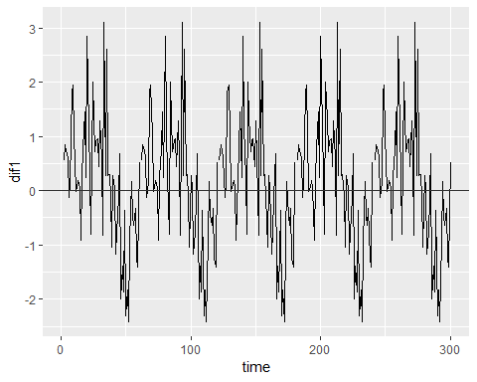

acf2(dif1)

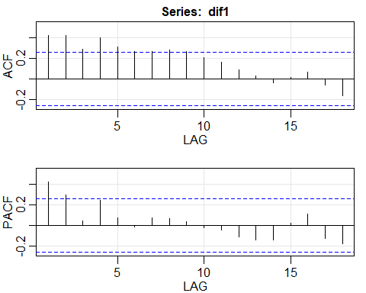

## ACF PACF  
## [1,] 0.42 0.42  
## [2,] 0.42 0.30  
## [3,] 0.28 0.05  
## [4,] 0.40 0.24  
## [5,] 0.31 0.07  
## [6,] 0.27 -0.02  
## [7,] 0.26 0.08  
## [8,] 0.28 0.07  
## [9,] 0.27 0.04  
## [10,] 0.21 -0.02  
## [11,] 0.16 -0.05  
## [12,] 0.09 -0.11  
## [13,] 0.03 -0.14  
## [14,] -0.04 -0.14  
## [15,] 0.02 0.02  
## [16,] 0.07 0.11  
## [17,] -0.06 -0.12  
## [18,] -0.16 -0.18