In our previous work we proposed a fog-based architecture in order to safeguard vulnerable road users from traffic accidents [1]. Testing the architecture in real environment and working towards the accuracy of GPS reading of smartphones were left as future works. This document reports what has been done on these issues. The outline of the document is given below.

**Part I: Improving accuracy of GPS**

* **Introduction**
* **Experimental setup**
* **Application Development**
* **Evaluation Result**

**Part II: Communication delay in real environment**

* **Introduction**
* **Experimental setup**
* **Evaluation Result**

**Part III: Collision detection Application**

* **System Overview**
* **System Architecture**
* **Server Application**
* **Client Mobile Application**
* **Evaluation result**

**Part I: Improving accuracy of GPS**

**Introduction**

Literatures have investigated the potential of smartphones as mobile sensors for active safety systems that are devoted to protecting vulnerable road users such as pedestrians, cyclists and motor cyclists. However, GPS readings of smartphones have to be improved in order to precisely predict and avoid traffic accidents between vehicles and vulnerable road users. There are a number of factors that affect accuracy of GPS receivers. Weather condition, obstructions, noise and interference are some of those factors that results in inaccuracy of GPS readings by delaying GPS radio signals. Smart phones employ a hybrid locational system combining three separate technologies to locate the owner [2]. Listed from the most accurate to least accurate they are assisted GPS (A-GPS), WiFi positioning, and cellular network positioning.

Even the most accurate GPS readings inaccuracy is 5m to 50m. This is inaccurate to use for safety applications like VRU collision prediction and avoidance. Even though GPS readings of latest smartphones have increased, we have worked towards improvement of GPS reading improvements.

The results indicate that the lateral and longitudinal accuracy is improved by _______ and _______ meters from _____________ and _______ respectively. Even though, as the result shows lateral deviations are still too high, the accuracy is good enough for many active safety applications. We have used artificial neural network with two hidden layers to train the system used to improve GPS accuracy. **…….Please add more and modify already written whenever necessary……**

**Experimental setup**

Locations chosen for GPS readings are urban area which is near buildings and clearly revealed plain area. In both locations the measurement is taken in both sunny (10 may 2017 at 16:00) and cloudy days (**……………..**) in the compound of ISAT, Nevers, France.

***We can put pictures of the locations***

The ground truth is measured using Real Time Kinematics (RTK) device (high performance GNSS receivers) with the following specification;

|  |  |
| --- | --- |
| **Parameter** | **Value** |
|  |  |
|  |  |
|  |  |
|  |  |

**Please fill the table with specification of the RTK device we used to measure GPS**

The setup of the instrument is shown in the figure below

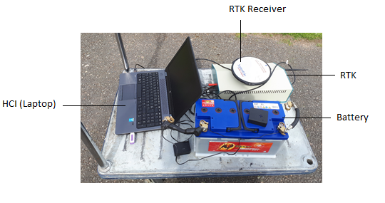

The receiver is kept two meters above the ground to get accurate measurement.

The smartphone device used to get actual measurements is **....specification of the smartphone used….**

The measurements are represented in the scatter plots displayed below

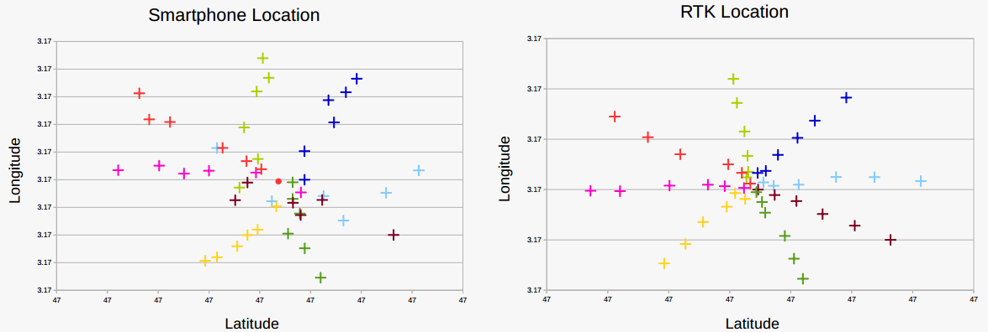Measurements taken in urban area on sunny day

RTK measurement almost the same for sunny and cloudy days (***am I correct?)***

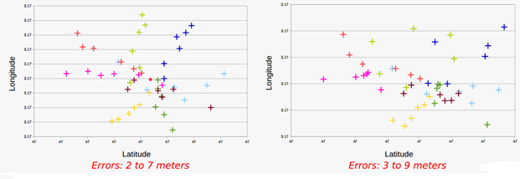

Measurement errors of smartphones on sunny date (left) and cloudy data (right) in urban area

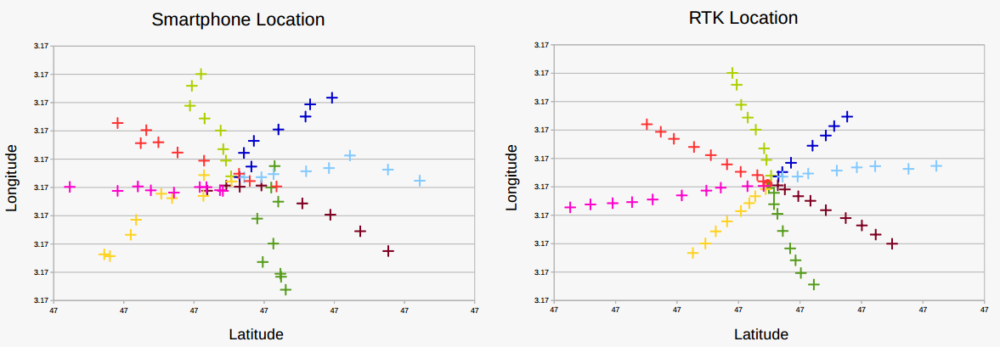

Measurements taken in plain area on sunny day

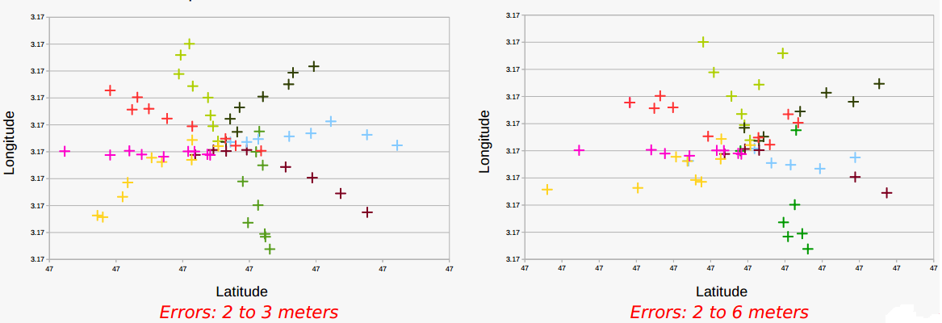

Measurement errors of smartphones on sunny date (left) and cloudy data (right) in plain area

There are two approaches to increase GPS accuracy; hardware approach and software approach. Hardware approach involves eliminating noise and interference using signal processing. ***……..deferential GPS (Base station approach)…. More***

Software approach uses map information to correct the location.

***Which approach have used***

***Please draft on***

* ***Increase horizontal accuracy***
* ***Direction errors***

***You can even write in French***

**Application Development**

***Detail of implementation of artificial neural network goes here***

***Feasibility of running the application that correct GPS readings on mobile devices***

**Evaluation Result**

***Evaluation result and discussion goes***

**Part II: Communication delay in real environment**

**Introduction**

Vulnerable road user safety solution proposed in [1] is evaluated in simulated environment for both Wi-Fi and LTE communication technologies and found to satisfy application requirements in terms of delay and packet delivery ratio. In this section we report the tests made in real environment.

***Please add the reason why we couldn’t test it using LTE (Just to convince the reviewers)***

**Experimental setup**

* ***Specification of the equipment’s used (Access point, the Wi-Fi, smartphone, the central server (fog-node))***
* ***Pictorial representation of the setup***
* ***Procedures followed to conduct the testing***

**Result and Discussion**

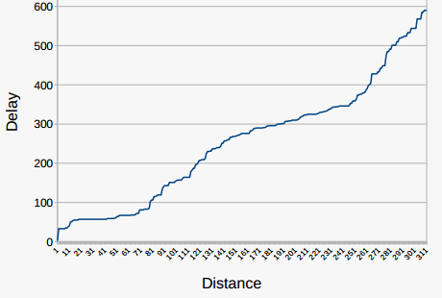

Wi-Fi communication delay over distance

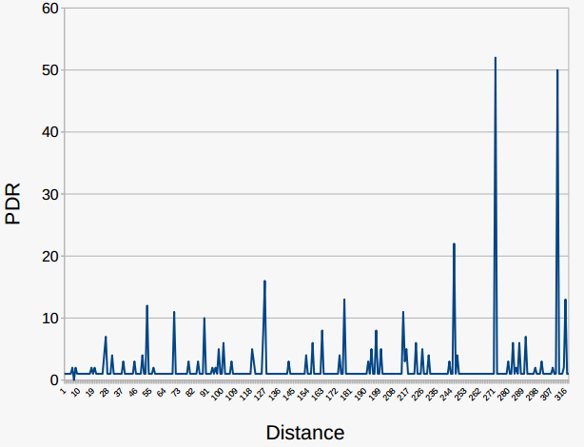

Packet delivery ratio over distance

**<<Explanation of the results will follow>>**

**Part III: Collision detection Application**

***[4] Can be used as a good guide to document this part***

**System Overview**

As it is described in previous sections, the goal of this work is to check the performance of the  
PV-Alert application in a real scenario in selected areas. ***…. The programming language used, editor used version, etc…***

***….diagram for Description of the system architecture after its deployment….***

**System Architecture**

***Includes***

* ***Software architectures with high level descriptions of components of the architecture***
* ***Hardware set-up used in the tests conducted***

**Server Application**

* ***Detail description of the application that performs treat analysis and sends warning messages to VRUs and drivers***
* ***And also about The algorithm used***

**Client Mobile Application**

* ***This is about the application installed on smartphones to send period geo-location, speed and heading data to fog server and receives the alerts sent from central server***

**Evaluation result**

* ***Testing procedure followed (how many pedestrians and vehicles involved, how many times is the test conducted, etc)***
* ***How accurate is the algorithm***

**References:**

1. PV-Alert: A Fog-based Architecture for Safeguarding Vulnerable Road Users, Esubalew et al., 2017
2. <https://communityhealthmaps.nlm.nih.gov/2014/06/30/how-accurate-is-the-gps-on-my-smartphone/>, 28 Jun 2017.
3. <https://www.windowscentral.com/gps-vs-agps-quick-tutorial>
4. V-Alert: Description and Validation of a Vulnerable Road User Alert System in the Framework of a Smart City, by Unai Hernandez-Jayo et al., 2015.