Paprika Nicolas

Overview

Description
This story follows Nicolas, a lonely and aimless young anthropomorphic bird, as he attempts to reconnect with friends and find purpose in his life.
Through a series of interactions with his acquaintances, including Nathan and Gerald, Nicolas hoes on a journey of self-discovery, friendship, and ultimately love.

Chapters
- Prologue: Gerald First Meeting
- Chapter 1: First Steps In Meeting People, Nathan
  - Scene 1.1: Rotting In Bed
  - Scene 1.2: Gerald Comes To Apt
  - Flashback: Late Nights Studying (University Days)
  - Scene 1.3: On The Street
  - Scene 1.4: Nathan's Shop
  - Scene 1.5: Dinner With Gerald (Connection Grows) - To be started
- Chapter 2: Searching For Work, Job Hunt
  - Scene 2.1: Thinking Of Jobs
- Chapter 3: Exploring New Connections, Anthony
  - Gerald stays over night (definitive)
- Chapter ? 1: Gerald…
  - Scene ?.?: Gay Bar Club Visit
- Chapter N-1: Confession And Beyond
- Chapter N: Epilogue – A New Chapter

Intermissions To Insert
Intermissions between chapters are all short flashbacks to Nicolas's past.
- Flashback: Texting Procrastination (Office Work Days)
- Flashback: Trying To Connect (Office Work Days)
- Flashback: Job Loss Reflection (Unemployment Days)
- Flashback: Rock Bottom Reflection (Unemployment Days)
- Flashback: Decision (Unemployment Days)

Characters

POV: Nicolas

Identity
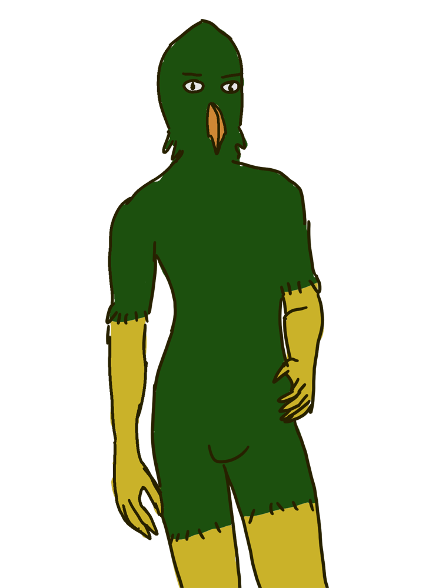
Full name: Nicolas Davis
Nicknames / Aliases: Nick, Nickle
Gender / Pronouns: Male, He/Him
Species / Race: Crowned Eagle, Anthropomorphic
Age / Birthday: 27 years old
Orientation: Gay
Occupation / Role: Protagonist
Job: Unemployed

Appearance
Height / Build: 1.72m, Average
Eye Color: Hazelnut eyes
Feather colors: Green and Golden
Beak color: Orange
Typical Clothing / Style: Checkered flannel, denim jeans

Personality
Core Traits: ain’t shy, just doesn’t know how to interact with people. Has lots to say, no idea how to handle and structure them. Paprika.
Strengths / Skills: Good speaker, ironically.
Weaknesses / Flaws: Socially awkward, indecisive, overthinks interactions.

Background
Family / Relationships: Got a crush on Gerald in the past, reason why he is a friend with him now.
History: Gerald and Nicolas went to the same University where Gerald would often see Nicolas around, helping him out for various things: study, social events, and projects. They did not interact much after a bit of time.
This is partly because Nicolas had a crush on Gerald but never acted on it, leading to some distance between them.
After years of theriopology education just to land at an office job he hated, he got fired due to downsizing. Has been unemployed since then, struggling to find purpose and direction in life.
Education: Theriopology degree, University graduate

Motivations & Goals
Short-term Goals: Find a job
Long-term Goals: Find purpose in life, Gerald's affection
Internal Conflicts / Dilemmas: How to express himself better, overcoming social anxiety
External Conflicts / Obstacles: Unemployment, navigating relationships

Relationships
Gerald: Friend, Unrequited crush.
Nathan: Acquaintance, forgotten about.

Sidekick: Gerald

Identity
Full name: Gerald Moore
Nicknames / Aliases: Gerry
Gender / Pronouns: Male, He/Him
Species / Race: Adaptaur bull, Anthropomorphic
Age / Birthday: 27 years old
Orientation: Bisexual
Occupation / Role: Protagonist, Sidekick, Love interest
Job: Fishmonger, unlike Nicolas, Gerald chose something tangible after university.
Contact name: Big Bull Gerald

Appearance
Height / Build: 1.84m, Stocky-Chubby
Eye Color: Brown
Fur: White and Brown Dark Green, short coat
Muzzle color: Orangey Pink
Distinguishing Features: Big, soft and warm
Typical Clothing / Style: Overalls

Personality
Core Traits: Soft but encouraging
Strengths / Skills: Naturally uplifting and attentive, Gerald has a way of bringing out the best in others without ever making them feel small.
Doesn't hold grudges towards Nicolas for not interacting or remaining distant. However, he becomes happier when Nicolas does connect with him. Internally, he too wonders about Nicolas's feelings towards him.
Weaknesses / Flaws: Can be a bit too soft-spoken, sometimes struggling to assert himself in situations that require a firmer stance.

Background
Family / Relationships: Friends with Nicolas, unknowingly reciprocal of love interest.
History / Past: Gerald and Nicolas went to the same University where Gerald would often see Nicolas around, helping him out for various things: study, social events, and projects. They did not interact much after a bit of time.
Education: Chemistry degree, University graduate

Relationships
Nicolas: Friend, love interest (unaware)
Nathan: Friend

Mom 1: Linda

Identity
Full name: Linda Davis
Nicknames / Aliases: Mom, Mama Linda
Gender / Pronouns: Female, She/Her
Species / Race: Eagle, Anthropomorphic
Age / Birthday: 24 years old at time of Nicolas's birth = approx. 46 years old
Orientation: Bisexual
Occupation / Role: Supporting character
Job: Nurse
Contact name: Mom

Appearance
Height / Build: 1.68m, Average
Eye Color: Hazel
Feather colors: Brown-Green and White
Beak color: Yellow
Typical Clothing / Style: Casual, comfortable clothing suitable for a nurse.

Personality
Core Traits: Caring, concerned, nurturing, supportive
Strengths / Skills: Good listener, empathetic, patient
Weaknesses / Flaws: Can be overprotective, worries easily

Background
Family / Relationships: Mother of Nicolas Davis, divorced from Nicolas's father. Remarried to a kindhearted female fox named Yasmine.
History: Linda has always been a caring and supportive mother to Nicolas. She works as a nurse, which has instilled in her a strong sense of empathy and concern for others. She often worries about Nicolas's well-being, especially given his recent struggles with unemployment and social isolation.
Education: Nursing degree

Relationships
Yasmine: Wife
Nicolas: Son
Divorced Husband: Ex-husband of Linda

Mom 2: Yasmine

Identity
Full name: Yasmine Smith
Nicknames / Aliases: Mom Yasmine, Mummy
Gender / Pronouns: Female, She/Her
Species / Race: Fox, Anthropomorphic
Age / Birthday: 43 years old
Orientation: Bisexual
Occupation / Role: Supporting character
Job: Politics / Athletics Coach
Contact name: Other Mom

Appearance
Height / Build: 1.65m, Athletic
Eye Color: Green
Fur colors: Reddish-orange with white underbelly
Typical Clothing / Style: Sporty and casual attire, often seen in athletic wear.

Personality
Core Traits: nurturing, careful
Strengths / Skills: Supportive, good communicator, empathetic
Weaknesses / Flaws: Talkative, can be over-involved, sometimes overly optimistic

Background
Family / Relationships: Stepmother of Nicolas Davis, married to Linda Davis.
History: Yasmine is a caring and supportive stepmother to Nicolas. She works in politics and as an athletics coach, which reflects her energetic and outgoing personality. Yasmine is known for her nurturing nature and her ability to connect with people, making her a positive influence in Nicolas's life, especially during his struggles with unemployment and social isolation.
Education: Masters in Political Science
Also: Dabbles in a bit of astrology as a hobby.

Relationships
Linda: Wife
Nicolas: Stepson

Nathan

Identity
Full name: Nathan Banks
Nicknames / Aliases: Nate
Gender / Pronouns: Male, He/Him
Species / Race: Pangolin, Anthropomorphic
Age / Birthday: 42 years old
Orientation: Gay
Occupation / Role: Deuteragonist – Protagonist
Job: Store clerk
Contact name: Nathan

Appearance
Height / Build: 1.75m, Average
Eye Color: Brown
Typical Clothing / Style: Orange

Personality
Core Traits: Calm, collected, thoughtful
Strengths / Skills: Patient, good listener, reliable
Weaknesses / Flaws: Can be overly cautious, sometimes reserved

Background
Family / Relationships: Single, has a few close friends, including Nicolas, Gerald.

Relationships
Nicolas: Acquaintance
Gerald: Friend

Anthony

Identity
Full name: Anthony Aldridge
Nicknames / Aliases: Tony
Gender / Pronouns: Male, He/Him
Species / Race: Komodo dragon, Anthropomorphic
Age / Birthday: 35 years old
Orientation: Omnisexual
Occupation / Role: Secondary character
Job: Chef
Contact name: "Chef"

Appearance
Height / Build: 1.90m, Muscular, became burly over time
Eye Color: Yellow
Scale color: Dark olive with black-ultramarine patterns
Muzzle color: Light olive
Distinguishing Features: Scar over left eye, burly build
Typical Clothing / Style: Chef's uniform, casual wear

Personality
Core Traits: Confident, passionate about cooking, friendly despite intimidating appearance and grumpy demeanor. Likes to cook, reason for becoming a chef.
Strengths / Skills: Excellent chef, skilled in various cuisines, good mentor.
Weaknesses / Flaws: Can be gruff and intimidating, sometimes struggles to express softer emotions.

Background
Fitness: Was a rather fit and muscular komodo dragon in his youth, but over time has become burly due being busy with work and life.
Family / Relationships: Has a close-knit group of friends and colleagues, but no known family. Close friends with Gerald.
History: Was a coworker with Nathan at an office job, but left to pursue his passion for cooking. Worked his way up from a line cook to a head chef at a popular restaurant. contact name in Nicolas's phone is "Chef" because when Nicolas was working with Anthony at the office job, he only knew him as "that chef guy" due to Anthony always bringing food to share with coworkers.
- Often visits The Beary Chub Club, owned by Fergus, where he enjoys the lively atmosphere.

Relationships
Nicolas: Customer, acquaintance, ex-coworker.
Gerald: Customer, close friend.

Owner: Fergus

Short Description
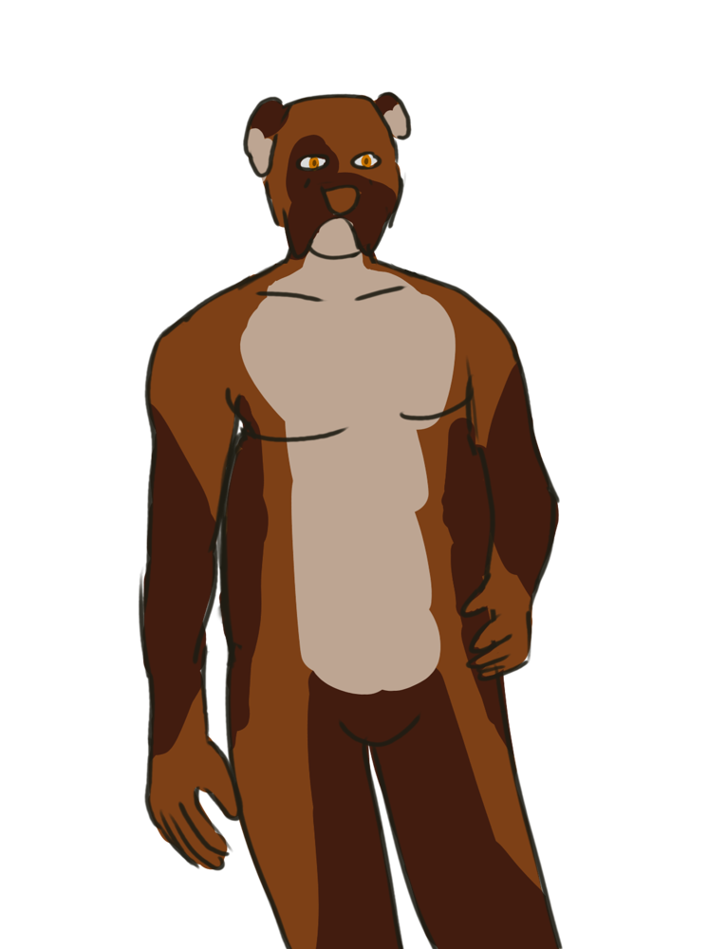
Sexy fat man.
Fergus is a middle-aged anthropomorphic boxer dog with a rounded, chubby build. He has amber eyes and typically sports a fish-on-a-hook earring on his right ear, which adds to his distinctive look.
Fergus often wears shirts with bust pockets and chinos pants, reflecting his practical yet approachable style.
As the owner of The Beary Chub Club, a popular gay bar in the city's Red Light District, Fergus is known for his grumpy demeanor and pouting resting face. Despite his seemingly unapproachable exterior, he cares deeply about his patrons and the success of his establishment.

Identity
Full name: Fergus Joel Austin
Nicknames / Aliases: Ferg, "papa bear"
Gender / Pronouns: Male, He/Him
Species / Race: Dog, Boxer~ mutt, Anthropomorphic
Age / Birthday: 48 years old
Orientation: Gay
Occupation / Role: Tertiary character
Job: Gay bar club owner of The Beary Chub Club

Appearance
Height / Build: 1.85m, rounded, chubby
Eye Color: Amber
Fur colors: Piebald, White, Brown with darker brown patches
Distinguishing Features: pouting resting face, grumpy demeanor
Typical Clothing / Style: Shirt with bust pockets, Chinos, fish-on-a-hook earring (Right ear)

Personality
Core Traits: Grumpy, distant, caring deep down.
Strengths / Skills: Good business sense, good at reading people.
Weaknesses / Flaws: Can come off as unapproachable, gruff demeanor.

Background
Origin / Short History: Grew up in a small town, moved to the city to pursue better opportunities. Started working in the nightlife industry and eventually saved enough to open his own gay bar club.
Key Life Events: Opened The Beary Chub Club five years ago, which has become one of the most popular spots in the Red Light District.
Family / Relationships: Single, no known family. Keeps personal life private.
Education: High school diploma, learned business through experience.
Notes: Is a boxer fan but it's not because he is a boxer dog or anything, totally unrelated.

Relationships
Anthony: Regular customer, acquaintance.

Locations

Great Location: City
The city is a bustling urban area with a mix of modern and historic architecture. It is home to a diverse population and offers a variety of amenities, including shops, restaurants, entertainment venues, and residential areas. The city is known for its vibrant nightlife, cultural events, and business opportunities.

Nicolas’s Apartment
Apartment where Nicolas lives. He rents it alone in a modest building. It is a small but comfortable space, reflecting his simple lifestyle.

Nicolas's Street
Street where Nicolas's apartment is located. A quiet residential area.

Gay Bar Club
Gay bar and club located in the city's Red Light District. A lively and colorful place known for its welcoming atmosphere, vibrant decor, and energetic music. It attracts a diverse crowd looking to unwind and have a good time.
- One ground level with a bar area, and seating.
- One underground level with private booths, VIP areas, another bar, another dance floor, and a stage for performances.
Name: The Beary Chub Club (Play off of "The Very Chubby Club")
Owner: Fergus

Red Light District
The Red Light District is a bustling area of the city known for its nightlife, entertainment venues, and vibrant atmosphere. It is home to various bars, clubs, and adult entertainment establishments, attracting a diverse crowd of locals and tourists alike.

Nathan's Shop
Nathan's Shop is a cozy, well-organized store located in a rather quiet part of town, still gets quite a lot of foot traffic from customers.

Oil Rig
An offshore oil rig located in the middle of the ocean, used for drilling and extracting oil from beneath the seabed. The rig is a large, complex structure with multiple levels, including living quarters for the crew, a control room, and various machinery and equipment necessary for oil extraction.
Owner: Fergus

Time

Year: Student Years
The years when Nicolas attended university and met Gerald. This period is significant as it marks the beginning of Nicolas's feelings for Gerald and the foundation of their relationship.

Year: 2026
The year the story takes place in. A near-future setting with slight technological advancements compared to the early 2020s.
Year was chosen because it is now when it is being written, and it allows for a familiar yet slightly advanced world for the characters to inhabit.

Concepts

Theriopology
- "Humanity" in this world is "Personhood"
- "Anthropology" in this world is "Theriopology"
Theriopology: an academic discipline focused on population behavior, social structures, and cultural practices of anthropomorphic animals in this world.
Personhood: term encompassing all the population of anthropomorphic species in this world

Outline

Chapter 1

Flashback: Prologue
- Nicolas in thought
University days… So many memories… So much work…” After high school, I wasn't sure what to do… I majored in Theriopology… I didn't know what else to take besides Theriopology…
Among the many faces I saw back then… I remember seeing Gerald for the first time… So furtively… A very small instant… But it was enough to make my heart jump…
He was so confident… So big… So strong… I wondered what it would be like to be with someone like him…
I sought him out… I wanted to know him more… But I was too shy… Too scared…
I learned of his name when I was walking down the hall one day… He was attending a class…
"Next up is Gerald with his talk on the molecular structures of proteins," The teacher said.
Gerald, then… Such a strong name… My solution was to slip a note under his dorm door… So I followed him after class… To his dorm…
I wrote:
"Hi Gerald, I’m Nicolas. I am in Theriopology. I think you’re really cool. Maybe we can hang out sometime? Here is my dorm room. - Nicolas"
- Nicolas slips the note under the door
I was so nervous… Not the best way to make a first impression… Not the next day, but some days later, I heard a knock on my door…
It was Gerald…
"Hey!" Said Gerald

Scene 1.1: Rotting In Bed
- Nicolas is awake but unmoving.
- Light leaks in. The room is quiet.
Yet, here I am… Looking at the ceiling of my room… Ruminating… Thinking about nothing…
Thinking about how nothing I am… I don’t know what I could be…
But… I am not nothing. I am something! I just… don’t know how to… how to say… How to make myself out there…
The only solution I can come up with is… Just to be reckless… Talk to anyone who looks interesting…
I have friends… I don’t know if they’ve moved on… Well… I suppose I can just text them… right now…
- Nicolas becomes anxious
Fuck! What if they moved on! What if I waited too long??? Still doesn't hurt to try, right?"
(I reach out to grab my phone on the nightstand…)
I don't think Gerald resents me for not talking for a long time. Maybe I should text him first."
- Nicolas sits up on his bed, phone in hand.
- When choosing for the first time:
Who do I text?
- When choosing again:
Now to figure out who else to text… Who do I text?
- Then texting contact choices are presented as they appear on Nick's phone:
Big Bull Gerald, Nathan, Chef

Mom Calls
As I am doing some light exercises my phone rings. It's my mom, or rather, one of my moms.
- Split screen, Nick on the left, Linda on the right. Yasmine appears in the background as she interjects sometimes
(I answer the call.)
"Hi, sweetheart! Just wanted to check in and see how you're doing." My mom, Linda, greets me.
"Hey Nicolas!" adds Yasmine, my other mom, aka Mummy.
"Hey, Mom. I'm doing as well as I can be."
"I'm glad to hear that. Have you thought more about your plans? Anything exciting coming up?" asks mom. "How are you feeling these days? Not too bummed out by you being fired, I hope?"
"Well, I reached out to friends. Gerald is going to my place tomorrow. So, I guess."
"That's wonderful!" comments Mom. "You've starting to get out of this rut, it seems. I'm proud of you, Nicolas."
"Yeah, don't give up ever, Nicolas!" says Mummy, in the background.
"Thanks, Mom. It means a lot."
"Gerald is a good friend. I'm sure you'll have a great time catching up."
"I hope so. It's been a while."
"Hey maybe you two can get together?" Mummy interjects. "I've read this in astrology columns. You seem to have good compatibility, because-"
Mom cuts Mummy off "Yasmine, dear, we should give Nicolas some space. Let's not push too hard."
"Oh, right. Sorry, Nicolas," apologizes Yasmine.
"It's okay, Mom. Mummy, thanks for your enthusiasm."
"Anytime, sweetheart. I'm always here for you."
"I appreciate that. I'll talk to you two later, okay?"
"Of course. Take care, Nicolas. Love you!" Mom says.
"Love you, Nicolas!" Mummy adds.
"Love you too. Bye!"
I hang up the phone

Phew… Mom's always so caring. I should probably call her more often.
What did Mom see in Yasmine that made her like her so much? Could this parallel with Gerald and me be something more…? Nah, probably just wishful thinking.
- Nicolas continues his light activities around his apartment after the call.

Flashback: Gerald Helps Nicolas Study
- Before the flashback begins:
He's helping now… Just like he helped back then…
- Flashback begins:
(It's late at night in our university dorm room. Books and papers are scattered across the desk. Gerald is sitting next to me, patiently explaining a difficult concept.)
Affection…
"Desire wants something from someone. Affection is… staying, even when you don’t," explained Gerald. "If you only stay because you want something, that’s not affection. Affection’s what’s left when wanting quiets down."
"That's all I know about it," concluded Gerald.
(Gerald smiled reassuringly as I finally grasp the concept.)
"That's… actually really helpful, Gerald. Thank you so much." I replied
Did he just… smile at me? Why did he smile like that? Was that… Affection?
- Flashback ends:
I stayed silent for too long… and yet he keeps helping. Does he want me? Was I ready?"
(I just pause, reflecting on the memory.)
"You coming, Nicolas?" shouts Gerald. "Yeah, just a sec."
(I sigh deeply, then stand up, ready to go meet Nathan with Gerald.)
Am I ready?

Chapter ? 1

Scene ?.?
- Before Entering
(The lights pulse to the beat of the musics of the many clubs of the district around us. The air is thick with the scent of sweat, alcohol, and anticipation.)
"Are you sure this is okay?" I ask. "Of course! This is just the kind of place we need to be right now," reassures Gerald. "Look all around us, many places for people like us to be themselves."
"I guess you're right. It's just... a bit overwhelming."
"How… How can red light districts even exist?" I stutter. "I mean, isn't there ongoing debates on exploitation and human trafficking? I've thought of going to such places before. I've searched online, but it just seemed… bleak."
"I get what you mean. But you don't have to worry about that here. This place is about freedom and acceptance. People come here to express themselves without judgment."
"I see. I guess I just need to let go of my preconceived notions."
"Exactly! Now, let's meet some new people and have fun!"
(We walked a bit further on the street, the neon lights reflecting off the wet pavement.)"
"The Beary Chub Club," Gerald reads on the sign. "This one seems nice."
"I guess so. Let's check it out."
- Entering The Club
(We enter the club, the bass from the music vibrating through the floor.)
Some random guy walks up to us. "Hey there stunning duo!" he says.
"Oh! Hi…" I greet.

