Schema :

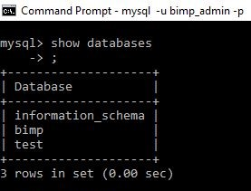

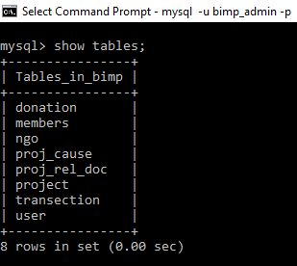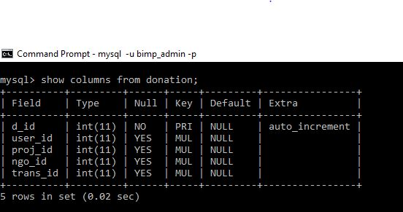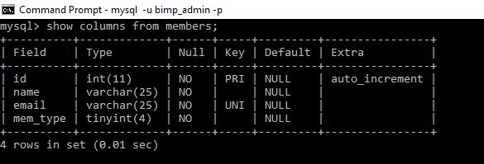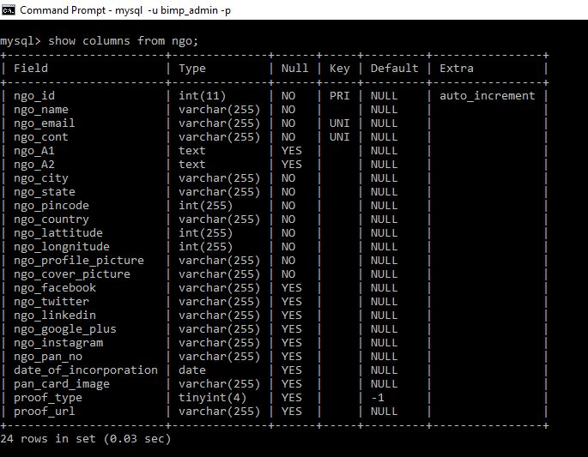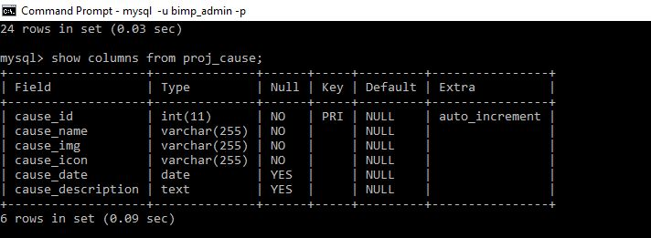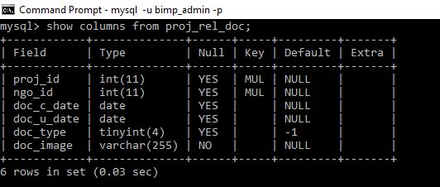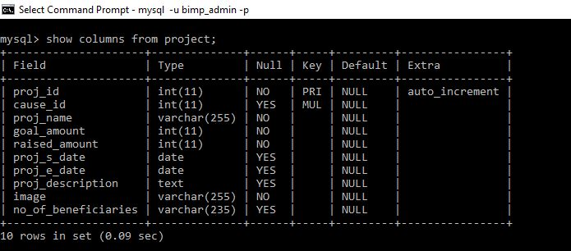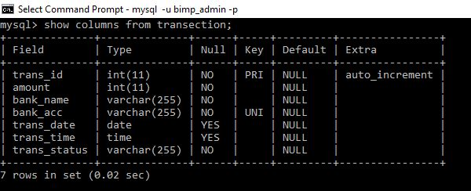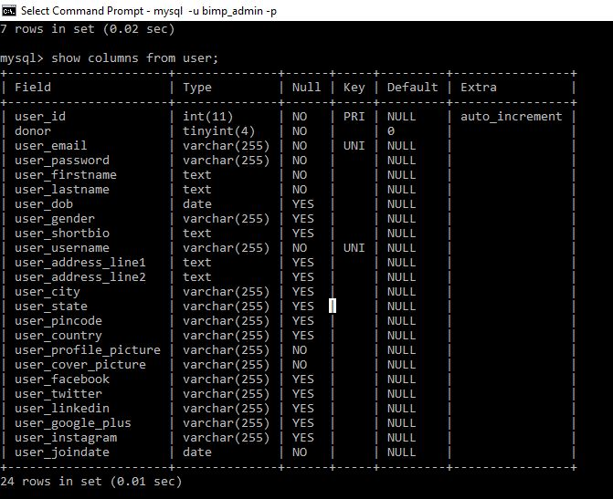

Home_page:

1. For trending cause: <http://.................../> trending_cause.php -1
   1. Input: nothing
   2. Output: json data of trending cause
2. For portfolio organization: http//……………../port_org.php -2
   1. Input: count.
   2. Output: json data of some org.

Cause_page:

1. For cause: call <http://.................../> cause.php -3
   1. Input: nothing
   2. Output: json data of cause.
2. For trending project: call <http://.................../> trending_proj.php -4
   1. Input: nothing
   2. Output: json data of trending project.
3. Onclicking filter: call call <http://.................../> filtered_proj.php -5
   1. Input: cause - ? , amount - ? , location - ?
   2. Output: json data of filter project.
   3. For (all) send input: null for three filters.
4. For portfolio organization: http//……………../port_org.php -2
   1. Input: count
   2. Output: json data of some org.

Org page:

1. For organization Details: http://……………../org.php -6
   1. Input: org_id
   2. Output: json data of org.
2. For trending project: <http://.................../> trending_proj.php -4
   1. Input: nothing
   2. Output: json data of trending project.
3. Onclicking filter: <http://.................../> filtered_proj.php -5
   1. Input: cause - ? , amount - ? , location - ?
   2. Output: json data of filter project.
   3. For (all) send input: null for three filters.
4. For donors: <http://...................../> donors. -7
   1. Input: org_id
   2. Output: json data of donors.