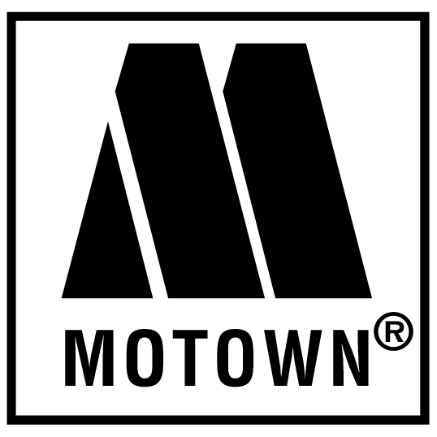

Yes…… you’ve “heard it through the grape vine” but if you have not sent in your reservation NOW IS THE TIME!!!! You won’t want to miss out on this evening of fun!

Motown Cabaret
Saturday, August 6, 2011
The Club House

6:00 p.m. – Delicious, hearty hors d’oeuvres, soft drinks provided.

7:00 p.m. SHARP – A most “soul” stirring concert featuring Motown’s greatest hits performed by our own favorite Twilight talent!

Cabaret reservation forms ($40/person, BYO) – checks and forms to Jacquie Elder’s mail box at the Gate House.

Childcare (6:00 to 9:00 p.m.) reservations -- See Annie Braunstein.

