The Jimmie Divine
Jazz Trio
Bob Rodriguez: Piano
Lee Marvin: Bass
Jim Martocci: Vocals
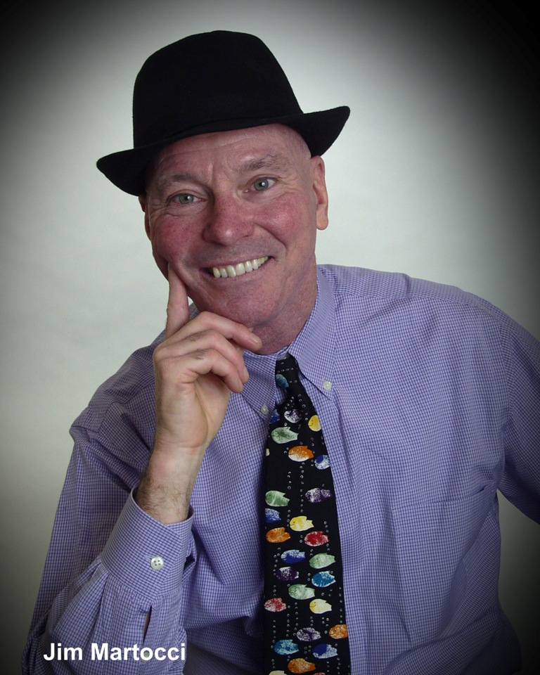

Saturday, July 25, 8 pm
The Astor House
Main Street – Tannersville NY
(518) 589-9500
A cool mix of jazz & pop standards under the
stars ! Wonderful desserts by Chris Cade !
No music charge !

