

PRESS RELEASE
FOR RELEASE: January 19, 2010
CONTACT: Greg Dayton, info@gemmagenazzano.com

Gemma Genazzano heats it up with debut album release on NBC’s Today Show.

Jazzy Latin Soul Goddess Gemma Genazzano performs“Take Me Away”on NBC’s Today Show January 29, 2010 at 9:00 AM

New York – January 19, 2010 – Gemma Genazzano debuts on NBC’s Today Show singing her jazzy Latin/ soul hit single, “Take Me Away” on January 29, 2010 at 9: 00 AM. Gemma’s performance on the Today Show coincides with the release of her highly acclaimed new album Si Me Quieres/ If You Love Me distributed by Clipped Records through Warner/ADA. CDs hit stores in the US on January 12 with a simultaneous worldwide digital release on all platforms in the UK, Canada, Japan and Europe. The video version of Take Me Away has aired on HBO Latino and HBO Zone and two singles from her album were featured on episodes of ABC's "All My Children” in September 2009.

Gemma Genazzano is a red hot Latina Cinderella story in the making and has created an entirely new crossover genre of music combining Spanish and English lyrics and sensual phrasing over pure soul. Born in Barcelona, Spain, Gemma delivers an empowering message of female sensuality She has performed at a number of festivals in Spain, and at popular New York City venues like Joe’s Pub and the Blue Note.

Si Me Quieres/ If You Love Me is produced and arranged by Marlon Saunders, who also co-wrote all the songs with Gemma and her band’s stellar lead guitarist, Greg Dayton. Saunders most recently appeared as the Calypso Singer in Disney’s Enchanted, singing the Academy Award-nominated song, “That’s How You Know” with Amy Adams. An acclaimed soul artist, he has recorded and toured with such artists as Michael Jackson, Sting, Billy Joel and Bobby McFerrin. One of the highlights of Si Me Quieres/ If You Love Me is "Show Me Who You Are," a love duet featuring Gemma and Marlon.
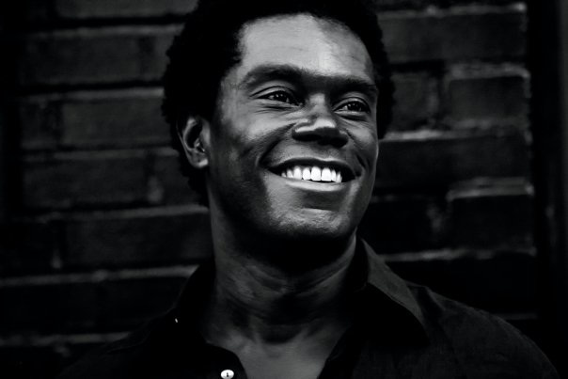

The New York Post raves, “She’s a total babe, has a velvety voice that melts men, and does her seducing in Spanish and English on this unpretentious yet sophisticated debut album. Echoes Magazine, UK has proclaimed her, “A Latin Soul Goddess.” And music websites from Europe to Brazil to Puerto Rico celebrate her tremendous cultural and musical crossover appeal. "I sing about love, romance, and passion," Gemma says, "because I feel it is a way to celebrate who I am. I think it is exciting when we as women bring out that inner beauty that I like to call the goddess within. It opens the door to our hearts and then we can share that with everyone. What could be better than that?"
www.gemmagenazzano.com

