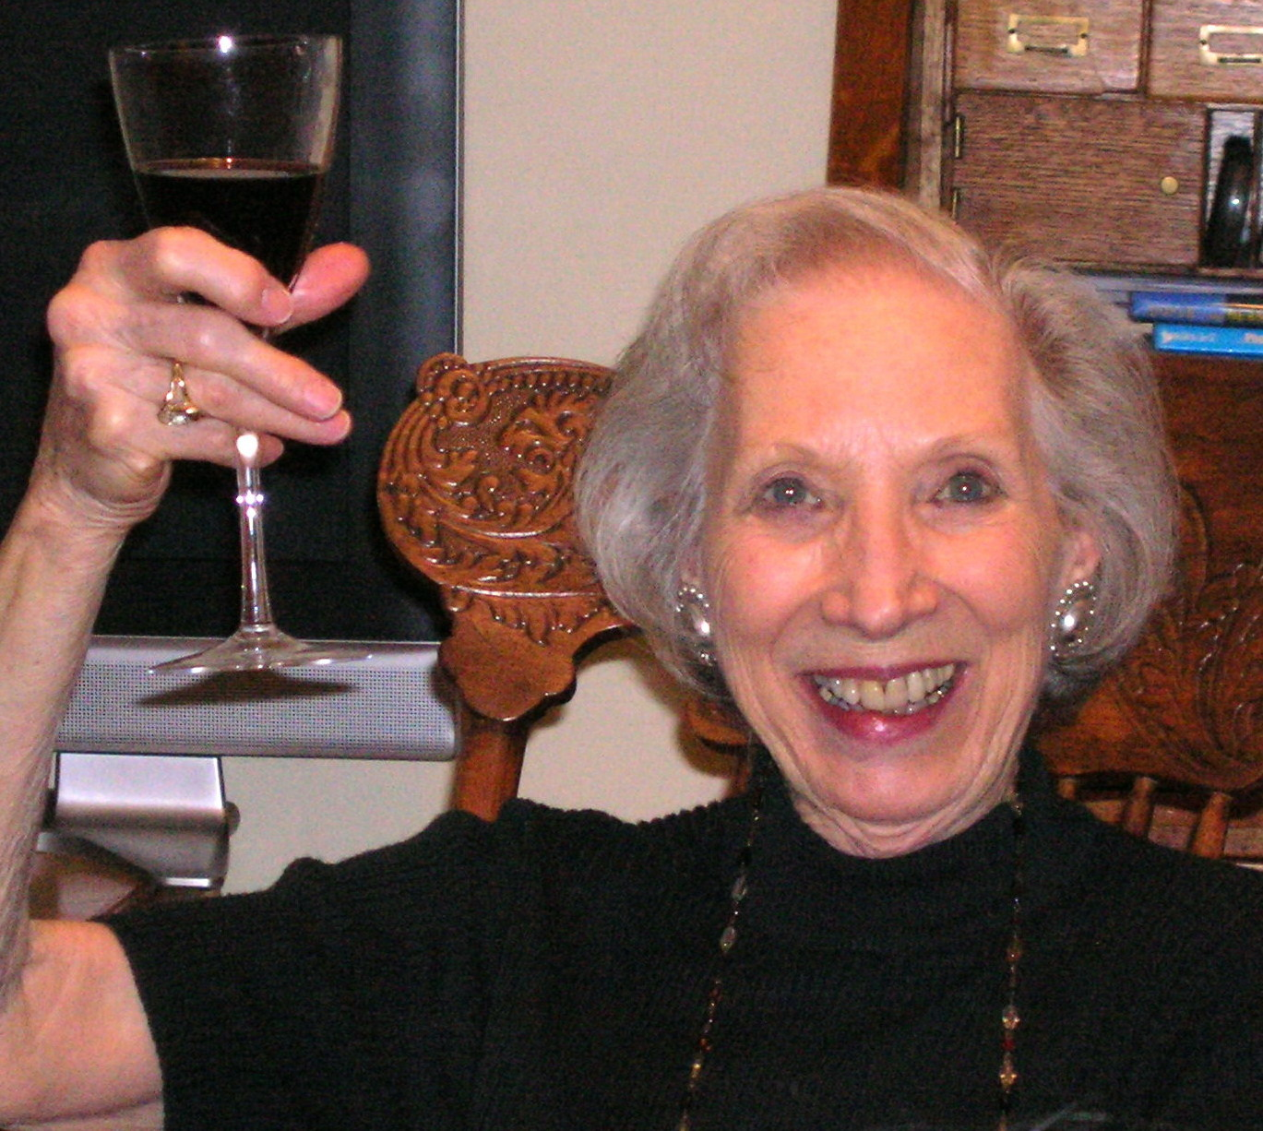

HELEN PRICE: REINE de la RUE des ARTISTES

Helen’s talents were evident throughout her life. This was so in her place of birth and early childhood, Kirkwood (St. Louis), Missouri where she, her brother and sister relished the spaciousness of “a large place with a vineyard, too far from the next houses to have many playmates.” It was equally so while living in New Orleans where her microbiologist father, Kenneth Burdon, transferred when Helen was ten years old. Indeed, her father thought she’d become a dress designer because she “invented” elegant paper clothes for her paper dolls.

But Helen had other dreams as she raced through school in New Orleans: “I always wanted to become a nurse,” she says. Helen “loved school” and was an avid reader so she was moved ahead “much too quickly,” landing in high school at the age of twelve, finishing at fifteen and feeling out of place because of her youth and lack of sophistication. Because her mother’s almost daily dictum was: “The world is waiting for the woman who is prepared,” she then rapidly completed a “short commercial school course including shorthand.”

Helen then became a pre-med undergraduate at Louisiana State University, acquiring her BS in three years, but couldn’t attend medical school after because her parents were already financially strapped paying for her brother’s tuition there. Happily for her future, she ended up at Johns Hopkins’ “wonderful school of nursing,” which featured a program for college graduates and attracted more serious students than earlier pre-college nursing programs which nearly discouraged her from being a nurse.

“One of the most interesting people I met at Johns Hopkins, as it happens, was John Bryan Price. That meant I was not particularly concerned about the fact that Johns Hopkins only gave me an RN and a second BS, not a Master’s at graduation, because by then, I was, in any case, on the M R S track. We were married in 1949 and I went on working as a nurse while JB completed his last year of medical school and internship. ” When they moved to Boston for JB to train in surgery, Helen became an instructor in Physiology, Nursing Arts and Pharmacology at Boston Children’s Hospital.

During the Korean war, JB joined the armed forces as a surgeon and, soon after, Helen joined him in Japan where he was stationed. Because nurses weren’t needed, Helen drew on her office skills to become a secretary to one of the doctors, and learned to love sharing a “charming house” with a Japanese family since the area where most servicemen lived had no housing available at first. She still lovingly recalls the warmth and welcome given them by this family.

When Helen and JB were able to return “stateside”, they brought with them the most precious souvenir from their “treasured experience” in Japan, their firstborn, Diane. They soon headed east, “when JB was accepted for a research program and eventually in the surgical residency program at Columbia Presbyterian in New York City. That was the beginning of his almost forty years there.” They chose to live, “not in the city but in Leonia, New Jersey with its first rate school system and especially parks and trees, the green surroundings to which I had always been accustomed.” Like so many women of her generation, Helen spent her time there as the mother of three, adding Jeannette and then Bryan (John Bryan III) to their family, and volunteering in the hospital auxiliary and multiple local activities. In the early 60s, Helen volunteered as a nurse at the St. Paul’s Episcopal Church nursery school in Leonia while her children attended pre-school there. Helen developed a friendship with the nursery school teacher, Grace Bohn and her husband Valentine. A kind invitation from the Bohn’s to visit their home in Twilight Park, New York, began 50 years of summers for the Price family on the mountain top.

Both in Leonia and after a later move to Rockland County, Helen took painting courses because she “always loved the feeling of the brush on canvas—the bounce of it.” In an early class, a neighbor arranged a still life and instructed students to “paint what you see, not what you know is there, but what you feel when you look at it,” advice which Helen passed along over the years. She first painted only “for fun” because she “was much too practical to think of art as a career and never thought painting for pleasure would turn into painting for dollars.” But that changed as viewers offered to buy her work and dealers began to vie for it. “You have to be willing to compete and eventually you gain not just competence but confidence, all of which helps you begin to build up a resume.” Helen’s resume included many major art awards, over thirty solo art exhibits and the continuing presentation of her work in museums, colleges and private collections.

Helen was an officer and then president in the 90’s of the prestigious National Association of Women Artists and managed an art gallery in Union Square. She demonstrated with every word her love and enthusiasm for that world, especially the artistic expression of nature. Listening to her description of the “important things” in art confirmed the breadth of her understanding of the act of creation: “When you walk up to a canvas, you come with an idea because much of the work of creation is done before you get to it. Indeed, you may spend more time in thinking ahead than in the actual doing. And while you are in front of that canvas, it is very important not to drop the thread of your idea even as you add and revise. When you are painting a scene, the question is really: ‘What are you abstracting from that scene? What do you register, invent and decide? What is in you?’
What Helen personified was joy in living and ongoing determination to get as much fun out of the artist’s life as she did before it became her career. “I wanted to try everything once in my life,” she says. No doubt, this also inspired Helen’s goal for the art group here at Kendal: to facilitate and inspire creative expression for personal enjoyment and community enrichment. “The art I’m interested in is the art that helps you know yourself better. Art is our dreams, a voyage of discovery for the brave.”

Helen Price died peacefully on September 15, 2012 surrounded by her family. She is survived by her husband, her children, and her grandchildren – Julia, John, Anna, Jack, Kate, Ben and Zack. All those lucky enough to experience her enthusiasm and joy of life and to be enriched by her love and wisdom, mourn her passing.

Note: Edited from a 2008 Kendal Crossings article written by Sue Phillips.

