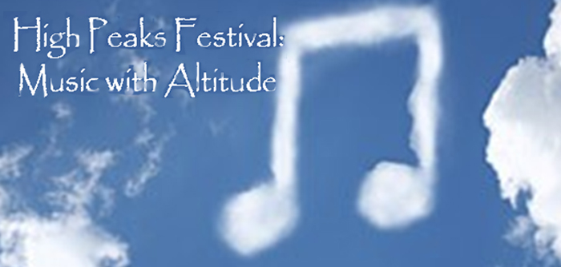

Dear Friends,

As many of you happily witnessed, during our recent ten-day High Peaks Music Festival (August 15-25), the mountaintop was alive with great music, the vitality of youth, and the passion for beauty and enlightenment. By the end of this period, the musicians had formed warm bonds with members of this unique community, foreign students from the Far East, Latin America and Europe had an intimate encounter with what America is, and home-grown students from Florida to California and New York to Arizona discovered the great natural beauty and appeal of upstate New York along with inspiring time spent on their artistic development. Our immersion included master classes with leading faculty artists, coaching in chamber music, and one-on-one attention for this exceedingly accomplished and advanced group of young players.

None of this success would have happened without the support of the Catskill Mountain Foundation as our presenter and the generosity of the Doctorow Foundation and the Friends of the Orpheum (FOTO) in funding in large part our performances at the Doctorow Center and the Orpheum, respectively. In addition, we are very appreciative of the generosity of the many individuals who made financial contributions. Finally, we are thankful for the warm hospitality extended by the culture-loving Onteora and Twilight residents who attended master classes and concerts and opened their homes to the artists and students.

We look forward to returning next August and bringing you again the finest performers and endearing and gifted students and to further building on the special camaraderie that has already blossomed between the festival and the mountain towns. We are also exploring the possibility of bringing a few exciting young prize-winners to the local schools during the winter to further our ongoing relationship.

"Classical Hollywood" (Doctorow, August 19) and "Fascinatin' Rhythm" (Orpheum, August 25) generated much enthusiasm and appreciation. Both performances will be broadcast over the course of the next few months on Classical Radio WMHT. Additionally, some of the excitement of these High Peaks concerts has been captured in recording and on video and will soon be available on Youtube.

We invite you to join us to help make next summer another memorable success. The plan is to augment the number of participants--both students and faculty--as well as to extend the festival by a few days, which will require a larger budget and a broader support base.

Wishing you an enjoyable holiday weekend and a pleasant descent from the High Peaks.

Yehuda Hanani, Artistic Director
Catskill High Peaks Festival

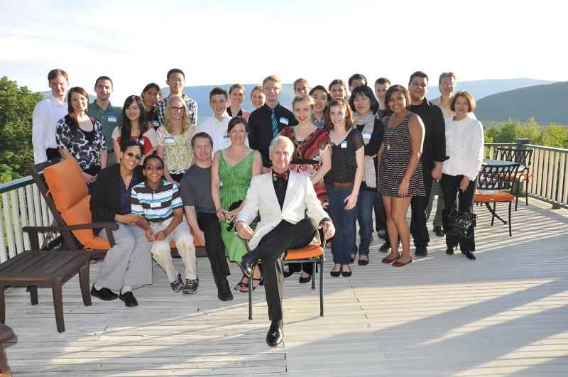


Close Encounters With Music
PO Box 34, Great Barrington, MA 01230
800.843.0778 www.cewm.org cewmusic@aol.com

Dear Friends,

As many of you happily witnessed, during our recent ten-day High Peaks Music Festival (August 15-25), the mountaintop was alive with great music, the vitality of youth, and the passion for beauty and enlightenment. By the end of this period, the musicians had formed warm bonds with members of this unique community, foreign students from the Far East, Latin America and Europe had an intimate encounter with what America is, and home-grown students from Florida to California and New York to Arizona discovered the great natural beauty and appeal of upstate New York along with inspiring time spent on their artistic development. Our immersion included master classes with leading faculty artists, coaching in chamber music, and one-on-one attention for this exceedingly accomplished and advanced group of young players.

None of this success would have happened without the support of the Catskill Mountain Foundation as our presenter and the generosity of the Doctorow Foundation and the Friends of the Orpheum (FOTO) in funding in large part our performances at the Doctorow Center and the Orpheum, respectively. In addition, we are very appreciative of the generosity of the many individuals who made financial contributions. Finally, we are thankful for the warm hospitality extended by the culture-loving Onteora and Twilight residents who attended master classes and concerts and opened their homes to the artists and students.

We look forward to returning next August and bringing you again the finest performers and endearing and gifted students and to further building on the special camaraderie that has already blossomed between the festival and the mountain towns. We are also exploring the possibility of bringing a few exciting young prize-winners to the local schools during the winter to further our ongoing relationship.

"Classical Hollywood" (Doctorow, August 19) and "Fascinatin' Rhythm" (Orpheum, August 25) generated much enthusiasm and appreciation. Both performances will be broadcast over the course of the next few months on Classical Radio WMHT. Additionally, some of the excitement of these High Peaks concerts has been captured in recording and on video and will soon be available on Youtube.

We invite you to join us to help make next summer another memorable success. The plan is to augment the number of participants--both students and faculty--as well as to extend the festival by a few days, which will require a larger budget and a broader support base.

Wishing you an enjoyable holiday weekend and a pleasant descent from the High Peaks.

Yehuda Hanani, Artistic Director
Catskill High Peaks Festival

