Memorial Church of

All Angels
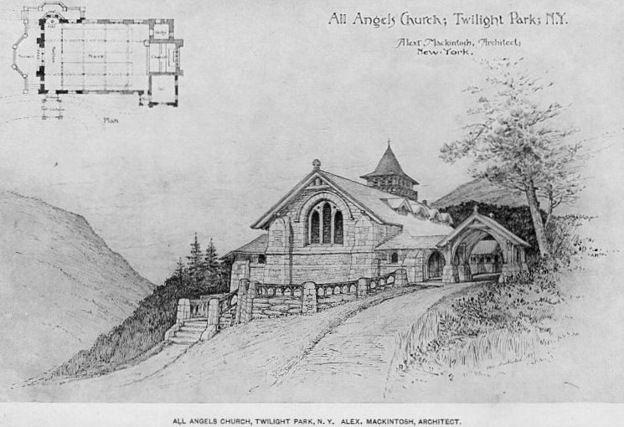

A Service of Thanksgiving

commemorating the

*Quasquicentennial Anniversary

of Twilight Park

10:30 A.M., July 7, 2013

- Interfaith service, The Rev. Fred Burnham presiding.
- Childcare provided for children under 6 years old.
- A large attendance is anticipated: arrive early for best seating.
- Period dress optional.
- Following the service, the 125th Anniversary Time Capsule will be installed in the church crypt.

*Adjective: pertaining to or marking a period of 125 years.
Noun: a 125th anniversary, a celebration marking such an anniversary.

