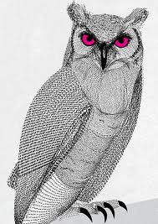

Please come for a very special Ladies Night
Featuring the beautiful glass beaded jewelry of Mary Tynes
(of Onteora Park.)
A portion of the proceeds from Mary’s sales will help to benefit
The Hurricane Irene Relief Fund
and
The Onteora Library.
6:30 pm, Wednesday, August 15
The Little House (3rd level)
Twilight Park
(home of Peter and Mel Bennett)
~Please bring your favorite appetizer~

