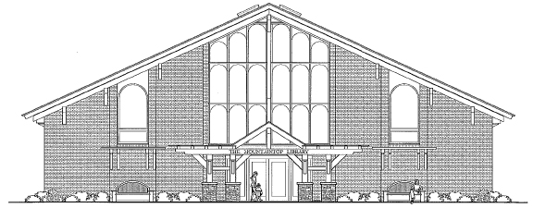
The Mountain Top Library & Learning Center
“The Future Home of The Haines Falls Free Library”

Donuts, Coffee…and Friends
It doesn’t get better than that.

Please join members of the Haines Falls Free Library Trustees and representatives of the Friends of the Library for breakfast on Sunday, May 24th, 10-11am at The Twilight Park Clubhouse.

In one hour you will:

- Get an update and progress report on the status of the new Mountain Top Library and Learning Center.

- Meet the President of our new, community based, Library Friends group and find out about the exciting events the Friends have planned for Spring/Summer 2009.

- Have an opportunity to give your input into what programs and services you would like to see at the new facility.

- Find out how to make sure the books you want to read this summer are available at the Haines Falls Free Library.

- That’s it!

