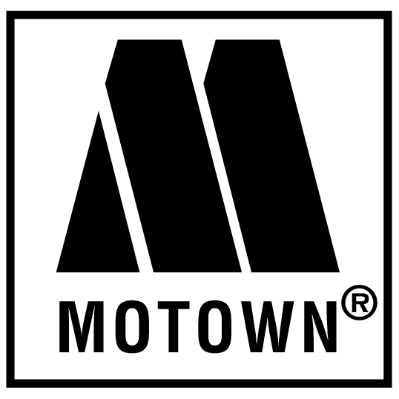

Have you got soul? If so, the hardest working band on the Mountaintop is looking for you. We’re gearing up for a night of the Motor City Sound, and we want you to sing along! On August Sixth, the Clubhouse will be grooving to the classics of Motown as the All Angels Auxiliary presents the 2011 Twilight Park Cabaret!

But we can’t do it without you! Yes, you! Soul’s nothing without its soldiers, and we need intrepid Twilighters to march on stage and sing out some of the biggest hits of all time. Impress your friends and neighbors with “My Girl,” “Shop Around,” or “ABC” as you join a chorus of joyful and outgoing performers. The only experience needed is healthy enthusiasm and a willing spirit!

If you’re interested in singing with Twilight’s own band of sensational soul cruisers, please contact Mack Elder at 7252. Get ready to groove and have some fun!

