Ronald Miles Decker - Obituary

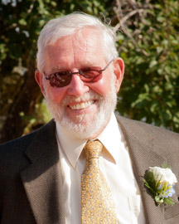
DECKER - Ronald Miles. Of Alpharetta, GA, and Haines Falls, NY, passed away on June 17 at his home in Georgia after a long illness. He was 80. Ron grew up in Forest Hills Gardens, New York, and attended Northfield Mount Hermon School. He graduated from Cornell University, was the President of Delta Upsilon fraternity, and later married Katherine Kindred. Ron had a lifetime career in management for Western Electric, a division of AT&T.

The Deckers bought a mountain home in Twilight Park in the Catskills in 1960. They soon became leaders in the community, Ron serving as President and Kay as the Treasurer of Twilight Park. Ron was active in the Mountaintop Historical Society and sought to preserve literary and art antiquities from the area. Hiking the Catskill Mountains energized Ron and motivated him to participate in two New York City marathon races. In addition, he traveled the world and participated in long distance sailboat cruising.

He was predeceased by his beloved wife of 45 years, Katherine Kindred Decker, and is survived by his dear wife of eight years, Viviane Khayatt Decker who was a devoted wife to him in his declining years. Ron, the father of three sons: William Miles Decker of Blue Ridge, GA, John Harrison Decker (Kari) of Sacramento, CA, and Alfred Cramer Decker (Liza) of Norwell, MA, and six grandchildren. He is survived by his brother, Douglas Alfred Decker of Pawleys Island, SC. A memorial service is planned for September 8, 2012 at All Angels Church, Twilight Park, Haines Falls, NY. The family asks that in lieu of flowers, memorial gifts be sent to the Arthritis Foundation or the Haines Falls Free Library.

June 22, 2012 Final

