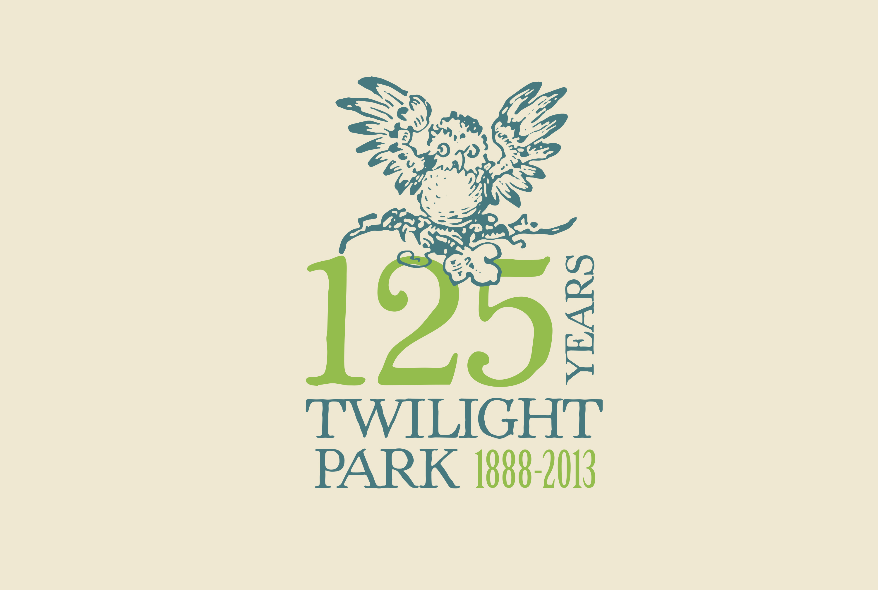

The Open Mic Night at the Clubhouse

changed to

This Friday July 5th at 7:30pm

BYOB

Come hear Greg Dayton’s new song in honor of Twilight Park at Open Mic Night at the Clubhouse on Saturday night at 7:30.

Greg will be hosting an open mic night for any and all Twilighters who would like to participate. Linda Nicholls will provide piano accompaniment.

Greg will be in the Park all week. Let him know if you are interested in participating, or just come down. His email is gdaytonguitar@gmail.com.

Suggested donation: $5

