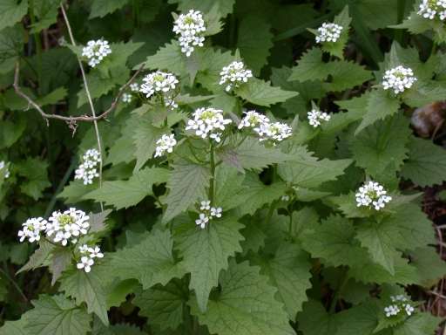

SPOTTED IN TWILIGHT PARK – an invasive and deadly (to our butterflies) spring blooming plant.

This plant has taken over the roadways and open areas in many neighboring southern counties.

Conservationists are actively engaged in getting rid of it.

WHY IT’S BAD

It crowds out native plants

A prolific grower, one plant can produce up to 6,000 seeds. It forms dense colonies and crowds out native plants such as bloodroot, wild ginger, and hepatica which are attempting to flower and produce seed at the same time.

It poisons butterfly larvae

Garlic mustard mimics another plant that butterfly larvae rely on for food. Unfortunately garlic mustard is toxic to the larvae.

IT’S EASY TO GET RID OF

Simply pulling it up by hand for two or three consecutive years (it’s a biennial and seeds can lie dormant for as long as 6 years) can do much to stop garlic mustard in its tracks.

TO HELP RID TWILIGHT OF GARLIC MUSTRD call Dianne Butt at 589-5259.

I’ll be happy to point it out to you and share tips on how easy it is to get rid of before it gets a real hold on our area.

