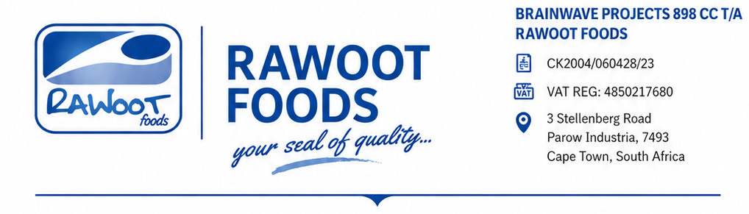
06/05/2026
The Director General
National Agency for Food and Drug Administration and Control (NAFDAC)
Attention: The Director
Food Safety and Applied Nutrition (FSAN) Directorate
Plot 1, Isolo Industrial Area
Apapa-Oshodi Expressway
Isolo, Lagos, Nigeria
Dear Sir/Madam,
RE: REQUEST FOR INSPECTION OF MANUFACTURING PREMISES FOR PRODUCT REGISTRATION
We refer to our application for the registration of the following products under the Food Supplement category on behalf of:
BRIDGECARE PHARMACEUTICALS LIMITED
LASCOFED Building, Plot 13, Isaacstan Close,
Off WEMPCO Road, Ojodu Ogba, Lagos, Nigeria
Tel: +2348122218470
Email: smith@bridgecarepharma.com
In line with the registration requirements, we hereby invite your esteemed Agency to inspect the manufacturing facility listed below for the necessary approval:
Site Name:
Brainwave Projects 898cc t/a Rawoot Foods
Address:
Unit No. 1, 3 Stellenberg Road,
Parow Industria, 7493,
Cape Town, South Africa

Please note that the nearest airport to the manufacturing site is Cape Town International Airport, which is approximately 25 km from the facility by road transportation.
Contact Person: Bharat Desai
Mobile No.: +27 648320910
Email: bharatcommodities6@gmail.com
We shall appreciate your kind consideration and look forward to your favorable response.
Thank you.
Yours faithfully,

__________________________
Director
MC Rawoot



