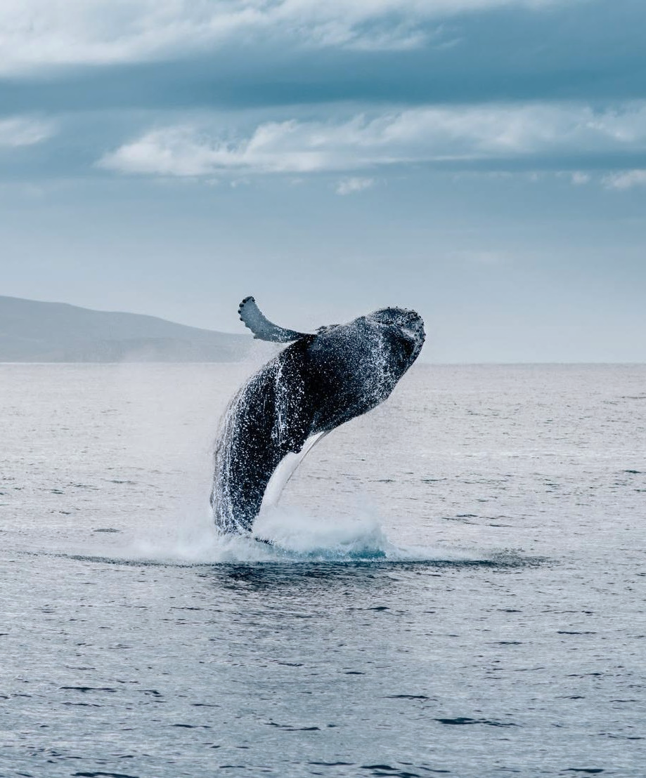

sounds
of the sea

The Whale's Song
Marina Robledo

Ensure your title is memorable and grabs the attention of readers. The title should clarify what the book is about and must be easy to say. Avoid complex-sounding titles that are difficult to pronounce or sound embarrassing when said out loud.
If you already have a specific title in mind, that’s great. But if you don’t, then you need to look at the goals of your book. For example, if you want to build your brand, then mention your brand in the title. If you want to establish yourself as an expert, then ensure your title sounds authoritative. If you just want to generate attention and sell copies, then make it provocative, exciting, or controversial.
The quality of the title determines the quality of the content. Therefore, ask yourself specific questions, such as: What value do I want to add to the reader’s life? What do they want to learn about? What are the goals of the target audience and how will this book help them achieve that? In essence, try to enter the mind of your audience.
When generating a list of potential titles, try to play around with relevant keywords that are popular on search engines. Think about your genre/target audience and then create an interesting title. For example, “Sounds of the Sea” or “Six Secrets of Closing a Million-Dollar Deal.” Avoid creating a title that is already popular as this will prevent your book from standing out. We will use the first example (Sounds of the Sea) to illustrate how to generate ideas for a book.

The Whale’s Song
(Capitalize first letter of each word in subtitle)
A good subtitle must provide deeper insight into the topic so that readers can understand exactly what is in the book. For example, a main title like “Sounds of the Sea” might benefit from a subtitle like, “The Whale’s Song.”
By
Marina Robledo

© Copyright 2023 by Printed Page Publishers - All rights reserved.
It is not legal to reproduce, duplicate, or transmit any part of this document in either electronic means or printed format. Recording of this publication is strictly prohibited.

This book is dedicated to: Teo Marinovic
Insert content here…
This section is optional and often personal in nature. Mention and thank one person or a group of people who are close to you or have supported you in your life. They can be family members, close friends, inspirational figures, etc.

Table of Contents
Introduction 1
PART I: Mysterious Music 2
Chapter One: An Ancient Song 3
Chapter Two: Song of the Humpback Whale 5
PART II: Blue Whale Ballads 7
Chapter Three: Finding a Mate 8
Chapter Four: Bridging the Gap 10
Chapter Five: Saving the Singers 11
Epilogue/Conclusion 12
Bibliography 13
Acknowledgments 14
About the Author 15

Introduction
Insert content here…
To write a good introduction, follow these steps:
Congratulate the reader on purchasing the book. (This is optional and only for the eBook version!)
Introduce the topic of your book.
Clarify the problem that the book will solve. You already know who your target audience is, so state the problem the reader has.
Provide snippets of something that the book offers. (For example, “This book explores never before theories on whale songs…”)
Highlight your credentials as an authority on the subject. If possible, use a personal/professional story to show how you gained your expertise. (For example, did you learn by studying marine life for decades? Did you learn from being part of a large organization that works with oceanic animals?)
Highlight the benefits of the book. (For example, “This information will help your understanding of the world’s largest mammals ...”)
Provide testimonials of the book’s benefits. State how the information has helped either you or someone else expand their knowledge.
Give a call to action to get them to read the book!!

PART I: Mysterious Music
(Capitalize first letter of each word in part title)
Begin a new part here…
For long books that cover a lot of detailed information, structure your book into parts. Dividing your book into parts is great for writing on historical or conceptual topics. Your book can have as many parts as necessary, with each part covering a different theme. However, all parts must point to the overall book title.
For presenting information in a step-by-step manner, arrange your parts in a logical sequence.
Part I of a book is generally introductory where you are essentially covering the basics of the topic. Sticking with the example used in the book title section, suitable title options for Part I include “Mysterious Music” or “The Mysterious Music of the Deep.”
Once you have decided on topics and content for each part of the book, create a list of relevant chapter titles. Take the time to plan out the whole book. Do research on the topic to know what to cover, what to leave out, and how to arrange your content so that it flows well.
You can have as many chapters as you want in a part. It is also okay if some parts have more chapters than others. Chapter lengths vary considerably as it’s difficult to maintain the same length for each chapter differing in content.

Chapter One: An Ancient Song
(Capitalize First Letter of Each Word in Chapter Titles)
Begin a new chapter here…
The first chapter introduces the topic to the reader. As an example, the title of the example book’s first chapter is “An Ancient Song.” Start off providing a brief overview of what the chapter contains and then transition smoothly into your supporting points. Try to keep the language simple and understandable to generate rapport with the reader and keep them engaged.
One way to generate rapport with readers is to start your chapter with a quote from a famous person. Make sure the quote is relevant to the chapter topic so that you can use it later to illustrate the key points made in the chapter. If you begin the first chapter with a quote, stay consistent and begin every successive chapter with a quote.
Alternatively, you can begin a chapter with “Did you know …?” Follow up with some statistics that most people may not be aware of. You can apply this technique in different sections of your book and not just in your introduction. Asking the reader questions (sometimes rhetorical) is a good way to keep them engaged and often entertained.
Another opening strategy is to ask the reader to imagine a specific situation. For example, “Imagine a world where humans only communicated through song …” The goal here is to draw the reader in from the get-go and hold their attention.
The key to starting each chapter is to do so consistently throughout.

A Mother’s Melody
(Capitalize First Letter of Each Word in Subheadings.)
Insert content here…
Divide your chapter into sections with relevant subheadings. Subheadings guide the reader through the chapter and help in showing how you perceive the topic. Always have more than one subheading per chapter and make sure they are always related to your chapter topic.
When researching content for a particular chapter, any key highlights you come across can act as a subheading. For example, Subheading 1 can be “A Mother’s Melody” You can use a real-life story and talk about the difference between a mother and baby whale’s song.

Love Songs
Insert content here…
An example for Subheading 2 is “Love Songs.” This chapter would talk about songs whales use during mating season.

Chapter Summary/Key Takeaways
Insert content here…
Remind the reader of the key points of the chapter in a short paragraph. Alternatively, use a bullet point format as shown below:
Whales communicate through a series of sounds, called phrases, when strung together create a song
Point 2 from your text…
Point 3 from your text…
etc.
In the next chapter, you will learn…
To logically transition smoothly from chapter to chapter, inform the reader of what is coming next. When ending your chapter, link the next chapter’s information with what has already been learned.

Chapter Two: Song of the Humpback Whale
Begin a new chapter here…
In the second chapter, go a little deeper into the book’s topic. As an example, the title of the example book’s second chapter is “Song of the Humpback Whale.” Start off by providing a brief overview of what the chapter contains and transition smoothly into your supporting points. Try to keep the language simple and understandable to generate a rapport with the reader and keep them engaged.

An Oceanic Chorus
Insert content here…
Divide your chapter into sections with relevant subheadings. Subheadings guide the reader through the chapter and help in showing how you perceive the topic. Always have more than one subheading per chapter and make sure they are related to your chapter topic.
When researching content for a particular chapter, any key highlights you come across can act as a subheading. For example, Subheading 1 for this chapter is “An Oceanic Chorus.” You can talk about how different species of whale songs differ from each other.

Phrases and Themes
Insert content here…
For Subheading 2, use a subtitle such as “Phrases and Themes.” This subsection explains the differences between the elements of whale songs, the role those elements play in mating, their familial groups, etc.

Chapter Summary/Key Takeaways
Insert content here…
Remind the reader of the key points of the chapter in a short paragraph. Alternatively, use a bullet point format as shown below:
Each familial group of whales can have their own “dialect”
Point 2 from your text…
Point 3 from your text…
etc.

In the next chapter, you will learn…
To logically transition smoothly from chapter to chapter, inform the reader of what is coming next. When ending your chapter, link the next chapter’s information with what has already been learned.

PART II: Blue Whale Ballads
Use successive parts to cover the more detailed or complex areas of the book’s topic. Since Part I defined the topic/problem, consider using this section to provide solutions. In this case, a suitable example title is “Blue Whale Ballads” or “The Singing Blue Whale.” Don’t forget that the chapters in this part of the book must align with the Part title you have chosen.

Chapter Three: Finding a Mate
Begin a new chapter here…
For the purposes of this example, this chapter’s title is “Finding a Mate.” This means that this chapter will be dealing with strategies for finding a sexual partner. Start off by providing a brief overview of the information contained in the chapter and then transition smoothly into your supporting points. Try to keep the language simple and understandable to generate a rapport with the reader and keep them engaged.

Call of the Wild
Insert content here…
Divide your chapter into sections with relevant subheadings. Subheadings guide the reader through the chapter and help in showing how you perceive the topic. Always have more than one subheading per chapter and make sure they are always related to your chapter topic.
When researching content for a particular chapter, any key highlights you come across can act as a subheading. For example, Subheading 1 for this chapter is “Call of the Wild.” Offer the reader insight into the necessity of whales to attract a mate.

Complexity and Frequency
Insert content here…
For Subheading 2, use a subtitle such as “Complexity and Frequency.” This example chapter provides visual examples of how whale songs travel in the ocean and are received by potential mates.

Chapter Summary/Key Takeaways
Insert content here…
Remind the reader of the key points of the chapter in a short paragraph. Alternatively, use a bullet point format as shown below:
Developing an attractive song is an important part of securing a potential mate
Point 2 from your text…
Point 3 from your text…
etc.

In the next chapter, you will learn…
To logically transition smoothly from chapter to chapter, inform the reader of what is coming next. When ending your chapter, link the next chapter’s information with what has already been learned.

Chapter Four: Bridging the Gap
Begin a new chapter here…
For the purposes of this example, this chapter’s title is “Bridging the Gap.” It covers the ideas and theories around human to animal communication. Start off by providing a brief overview of the information contained in the chapter and then transition smoothly into your supporting points. Try to keep the language simple and understandable to generate rapport with the reader and keep them engaged.

Communicating with Nature Through Music
Insert content here…
Divide your chapter into sections with relevant subheadings. Subheadings guide the reader through the chapter and help in showing how you perceive the topic. Always have more than one subheading per chapter and make sure they are related to your chapter topic.
When researching content for a particular chapter, any key highlights you come across can act as a subheading. For example, Subheading 1 for this chapter is “Communicating with Nature Through Music.” Offer the reader information and insight into new technologies allowing us to be closer than ever to communicating directly with animals.

Our Most Intelligent Species
Insert content here…
For Subheading 2, use a subtitle such as “Our Most Intelligent Species.” It provides fascinating facts on whale social life, emotions, etc.

Chapter Summary/Key Takeaways
Insert content here…
Remind the reader of the key points of the chapter in a short paragraph. Alternatively, use a bullet point format as shown below:
The more we learn about mammals, the more we learn about ourselves
Point 2 from your text…
Point 3 from your text…
etc.
In the next chapter, you will learn…
To logically transition smoothly from chapter to chapter, inform the reader of what is coming next. When ending your chapter with a paragraph, link the next chapter’s information with what has already been learned.

Chapter Five: Saving the Singers
Begin a new chapter here…
Assuming this is your last chapter in the book, create a title that is somewhat forward-looking, for example, “Saving the Singers.” Here, present an outlook of how the information in this book, as well as new scientific insights, will affect the future. Also discuss what the world will look like if we don’t do our part to keep the ocean clean.

Ocean Conservation
Insert content here…
Divide your chapter into sections with relevant subheadings. Subheadings guide the reader through the chapter and help in showing how you perceive the topic. Always have more than one subheading per chapter and make sure they are related to your chapter topic.
When researching content for a particular chapter, any key highlights you come across can act as a subheading. For example, Subheading 1 for this chapter is “Ocean Conservation” where you then discuss the importance of being eco-conscious and “green”, etc.

How to Volunteer
Insert content here…
For Subheading 2, use a subtitle such as “How to Volunteer.” Here, wrap everything up by discussing how all the strategies provided will ensure a better tomorrow for all.

Chapter Summary/Key Takeaways
Insert content here…
Remind the reader of the key points of the chapter in a short paragraph. Alternatively, use a bullet point format as shown below:
Taking care of our oceans is in the best interest of ourselves and the planet…
Point 2 from your text…
Point 3 from your text…
etc.

Epilogue/Conclusion
Insert content here…
Keep it short and sweet. Mention the key highlights of the book and the action steps to solve the problems. Remind the reader of how taking the said action steps will benefit them.

Bibliography
Below is an example of a list of works cited using APA style. Arrange your list of references alphabetically.
When citing books, use the format as shown in the following examples, applying Bibliography style to the format:
Author’s last name, first initial or initials. (Publication date). Book title. Additional information. City, State of publication: Publishing company.
King, S. (2000). On writing: A memoir of the craft. New York, NY: Pocket Books.
When citing online resources, use the format as shown in the following examples:
For internet documents
Author’s last name, first initial or initials. (Date of publication). Title of article. Title of work. Retrieved from full URL
Amir, N. (2018, October 17). 4 tips for staying on track with your writing. Write Nonfiction now! Retrieved from http://writenonfictionnow.com/tips-staying-track-writing/
For online periodicals
Author’s last name, first initial or initials. (Date of publication). Title of article. Title of Periodical, volume and page numbers. Retrieved from full URL
Brewer, R. L. (2018, October 4). How to write better titles: 7 effective title tips for books, articles, and conference sessions. Writer’s Digest. Retrieved from http://www.writersdigest.com/whats-new/how-to-write-better-titles
When citing magazines, use the format as shown in the following examples:
For magazines and periodicals
Author’s last name, first initial or initials. (Publication date). Article title. Title of periodical, volume number (issue number if available), inclusive pages.
McPhee, J. (2013, April 29). Draft No. 4. New Yorker, 89, 20-25.
For more details and guidelines, consult the APA Publication Manual.

Acknowledgments
Insert content here…
Thank the key people who inspired you and helped you throughout the process of writing and publishing your work. This is somewhat similar to the dedication page, except here you can elaborate and include more people.

About the Author
Insert content here…
Write this page in the third person. (For example, use “the author” or your name, not “I.”) The information within establishes your credibility with readers. Avoid being too wordy. Simply provide your background and expertise on the topic of your book, as well as other information that will build trust. For example:
Professional and personal achievements related to the topic at hand
List of other published works and a link to your website
Educational background
Mention other notable experts in the field that you have worked with
Your area of residence, family status, hobbies, etc.

