**MOHMMAD SOHAIL**

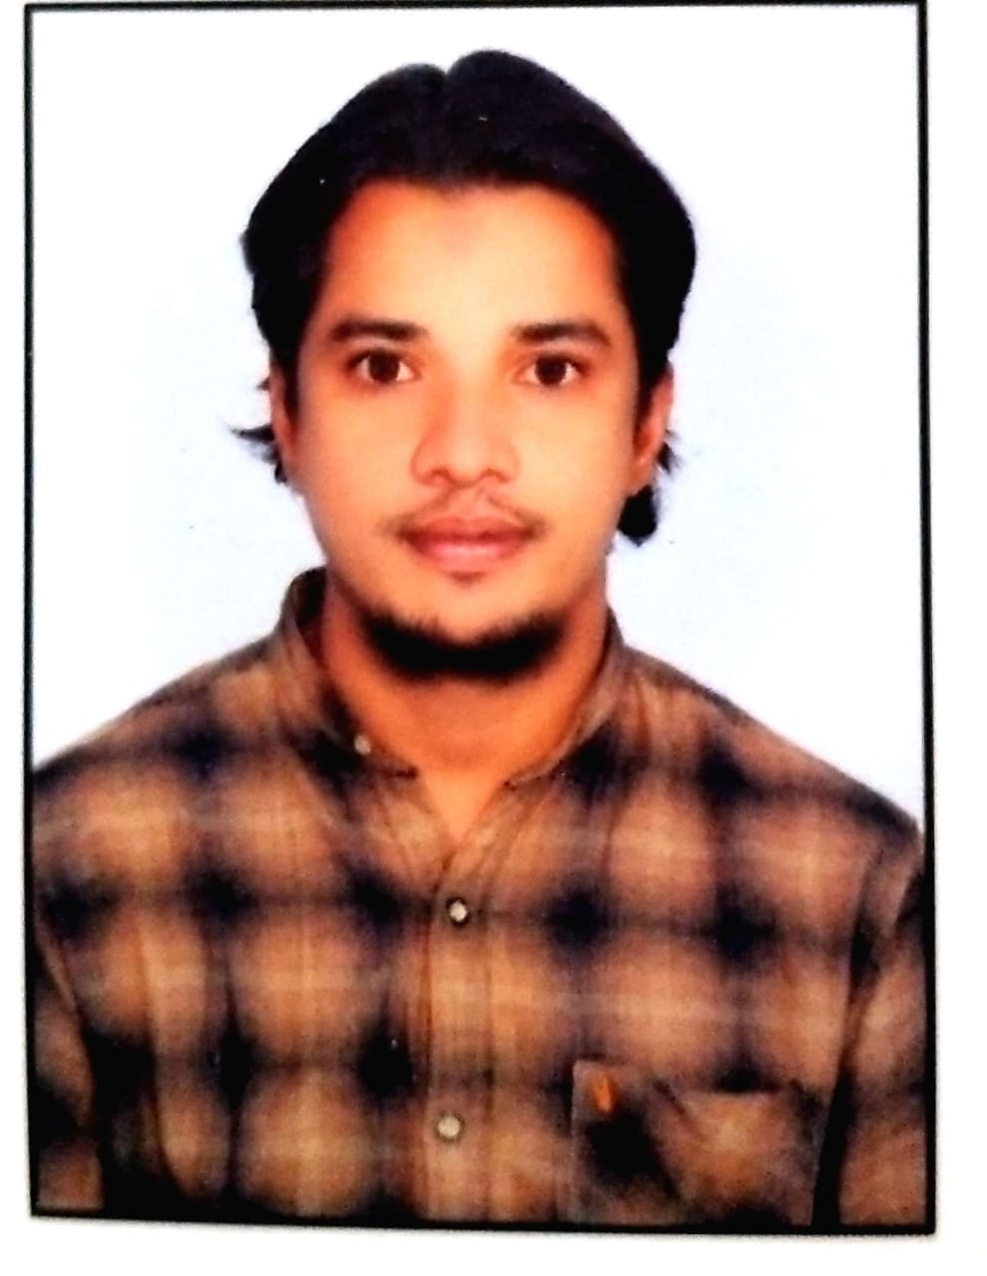

**Email: Sohail.mohmmad787 @gmail.com**

**Ph:7793917863**

**Mohammad Sohail**

Near Osmania Masjid

Jeedimetla, Hyderabad.



**Career Objective**

To obtain a responsible and challenging position with a progressive company, where my work experience will have valuable application and utilization of my opportunity for advancement.



**Work Experience**

* Total 1 yearof working experience **in C# .Net, MVC , Asp.Net MVC,SQL Server 2012 , CSS,HTML**
* Strong abilities in handling and understanding Client requirement.
* Good Knowledge of OOP’s Concepts.
* Always delivered within specified deadline
* Good communication and interpersonal skills.
* Strong motivator and always looking for challenging environment that provides generous opportunities for learning

**Technical Skills**

**C# .Net, ASP .Net MVC, SQL Server, HTML, CSS**



**Project**

1. **GODAIC**

**Client Name:** Satya Agency

**Tools and Technologies Used**

C# .NET, Web API, MVC, Web Technologies, SQL Server 2012,

**Team Size:** 8

**Project Description: -**

This is an Ecommerce Online Website.

This Project Consist of three main Modules.

* Admin
* Vendor
* Retailer

Admin is a Heart of this Project. It Controls for Vendor & Retailer module. Vendor is to entering data. Retailer sees the information from Retailer side.

**Roles and Responsibilities**

* Requirement gathering.
* Developing Database using Entity Framework.
* Writing API in C# .NET using Web API 2 Controller.
* Checking Client & Server Communication Using Web API 2.

**Key Achievements**

* I have achieved Application maintenance project life cycle in above project.
* I have understood and implemented the application to database connectivity using Entity Framework Connection String.



**Professional Experience**

**Co. Name:** JIGNASA TECHNO SOLUTIONS PVT LTD (HYDERABAD)

**Duration:** From Nov 2019 to Present

**Designation:** Junior Software Developer

**Co. Name:** Dream India Educational Management Solution PVT LTD

**Duration:** From Feb 2015 to DEC2018

**Designation:** IT Executive



**Education :**

* **B.Tech (CSE):** JNTU University
* **M.Tech (CSE):** JNTU University
* **12th:**Government Junior College
* **10th :**Alpha’s High School



**Strengths**

* Spontaneous and optimistic person
* Good Communication Skills
* Ability to work in team and independently
* Self-Learner and Sincere

**PERSONAL DETAILS**

* Passport **: Yes, I Had**
* Name : Mohammad Sohail :
* Place of Issue : Nalgonda.Telangana
* Marital Status **:** Single
* Languages Known : English, Hindi, and Telugu.
* Nationality : Indian
* Address : Balanagar, Jeedimetla Hyderabad.

**Declaration:**

I hereby declare that the above particulars are true to the best of my knowledge. I promise to work sincerely and prepared to do hard work dually abiding to organization.

**Date:**

**Place: Hyderabad**

**Thanking You**