**Aim : Data Warehouse Construction a) Real life Problem to be defined for Warehouse Design b) Construction of star schema and snow flake schema c) ETL Operations.**

**Steps to perform the above operations**

**Step 1: Start BIDS Environment**  
Click on Start Menu → Microsoft SQL Server 2008 R2 → Click SQL Server Business Intelligence Development Studio.

**Step 2: Start Analysis Services Project**  
Click File → New → Project → Business Intelligence Projects → Select Analysis Services Project → Assign Project Name → Click OK.

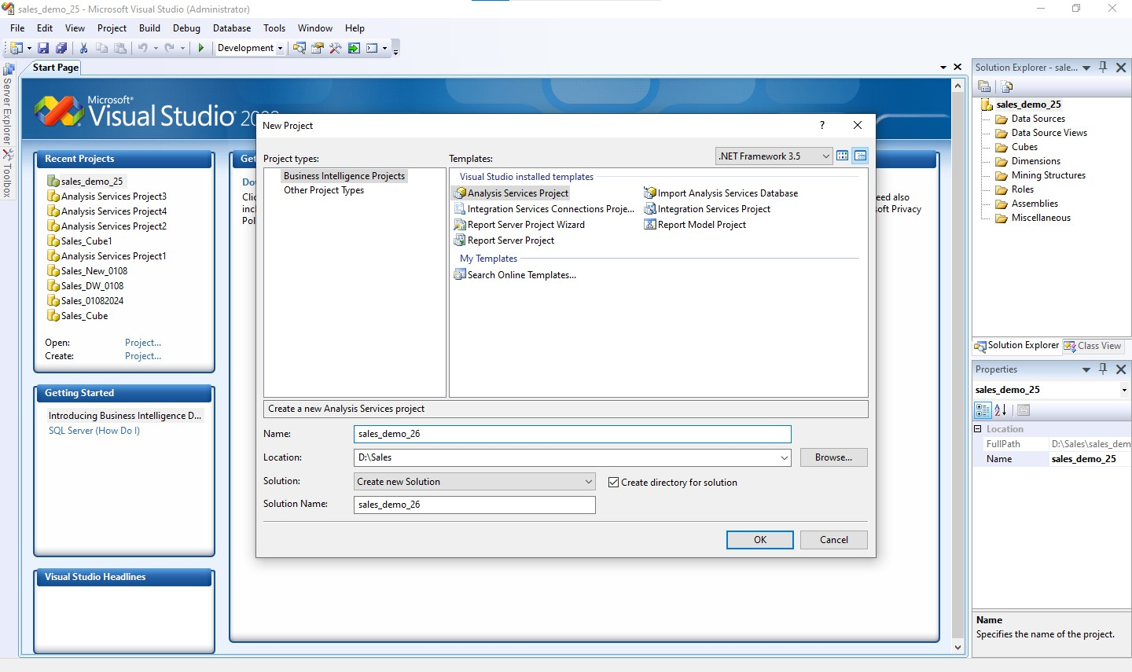fig. 1 : create the new **Analysis Services Project**

**Step 3: Creating New Data Source**  
3.1 In Solution Explorer, Right click on Data Source → Click New Data Source.

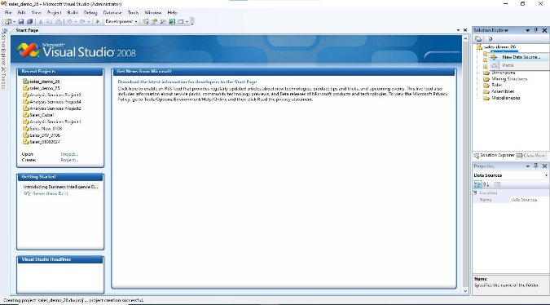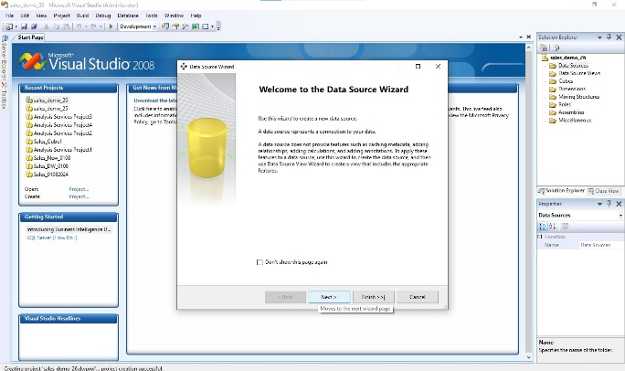

Fig. 2 creating new data source Fig. 3 click next

**Step 4 : Creating New Connection**

1. Specify your **SQL Server Name** where your Data Warehouse was created.
2. Select the radio button according to your **SQL Server Authentication** mode.
3. Specify your **Credentials** used to connect to your SQL Server.
4. Select the **sales_demo** database.
5. Click on **Test Connection** and verify its success.
6. Click **OK**.

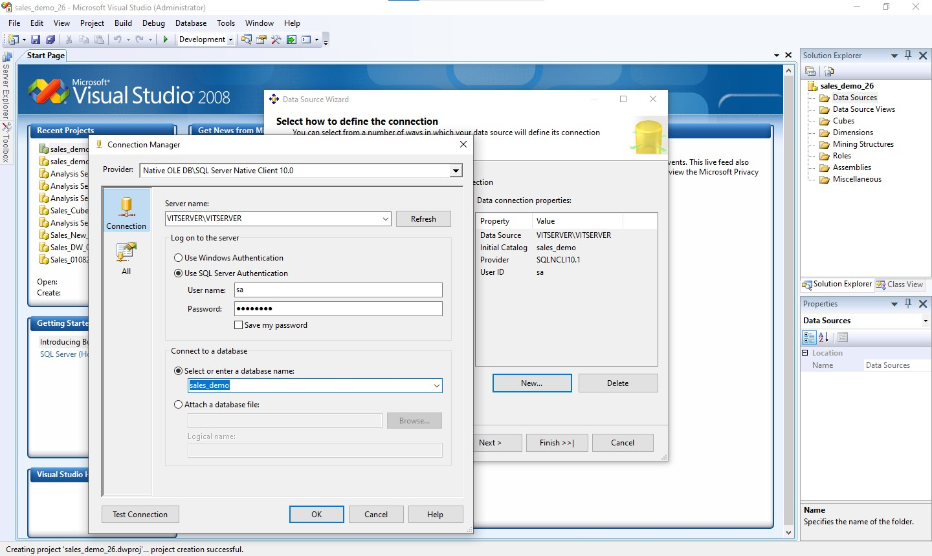

**Fig. 4 : Creating New Connection**

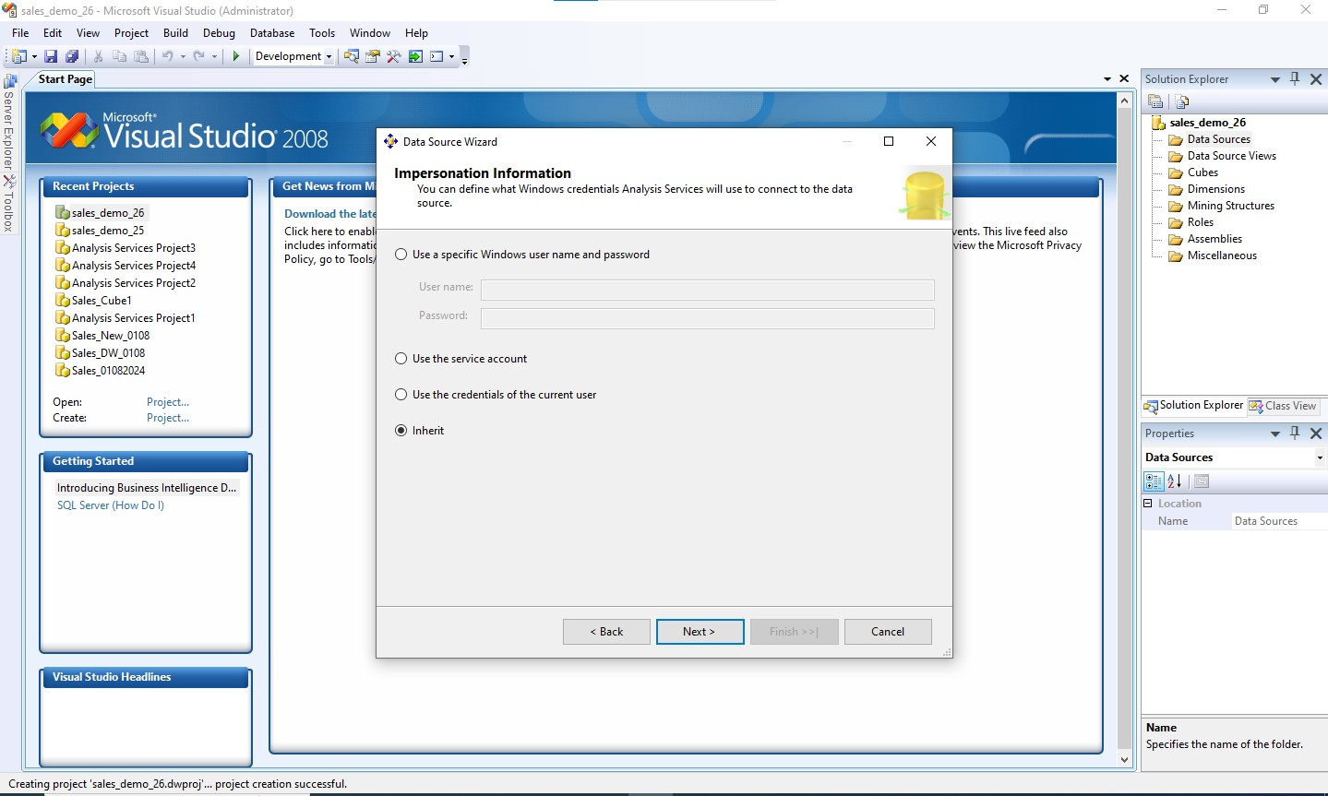

**Fig. 5 : Select Option Inherit**

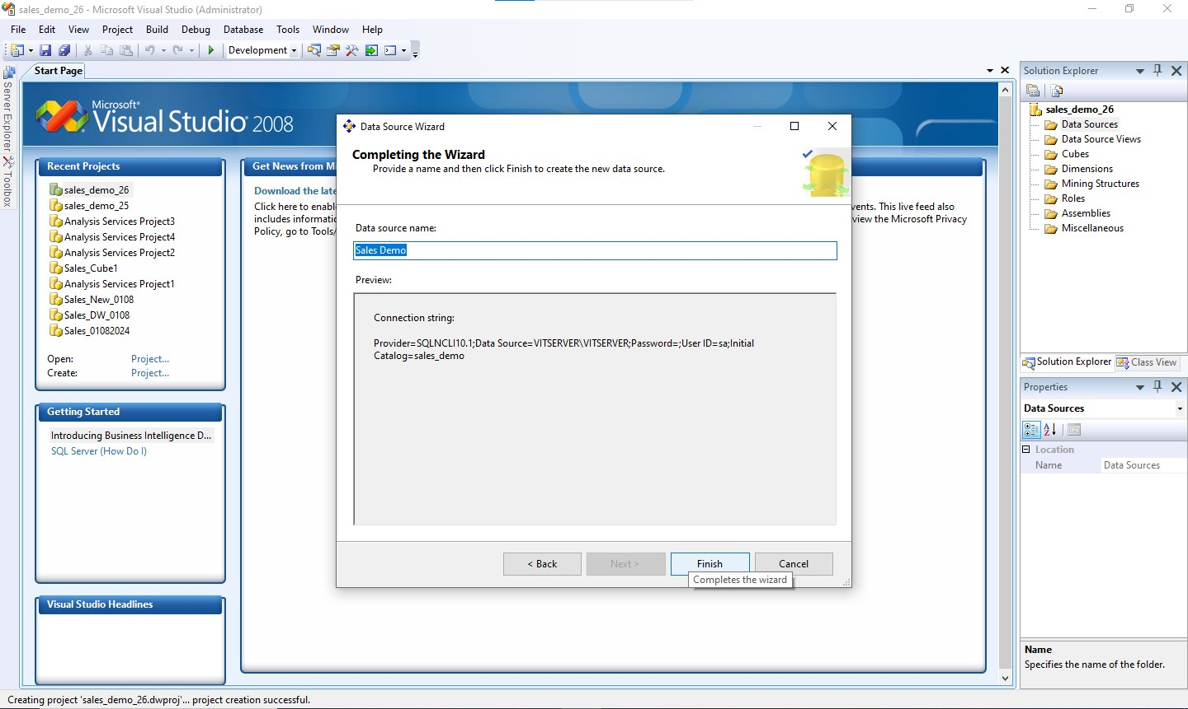

**Fig.6 : Click finish**

**Step 5: Creating New Data Source View**  
4.1 In the Solution Explorer, right-click on **Data Source View** → Click on **New Data Source View**.

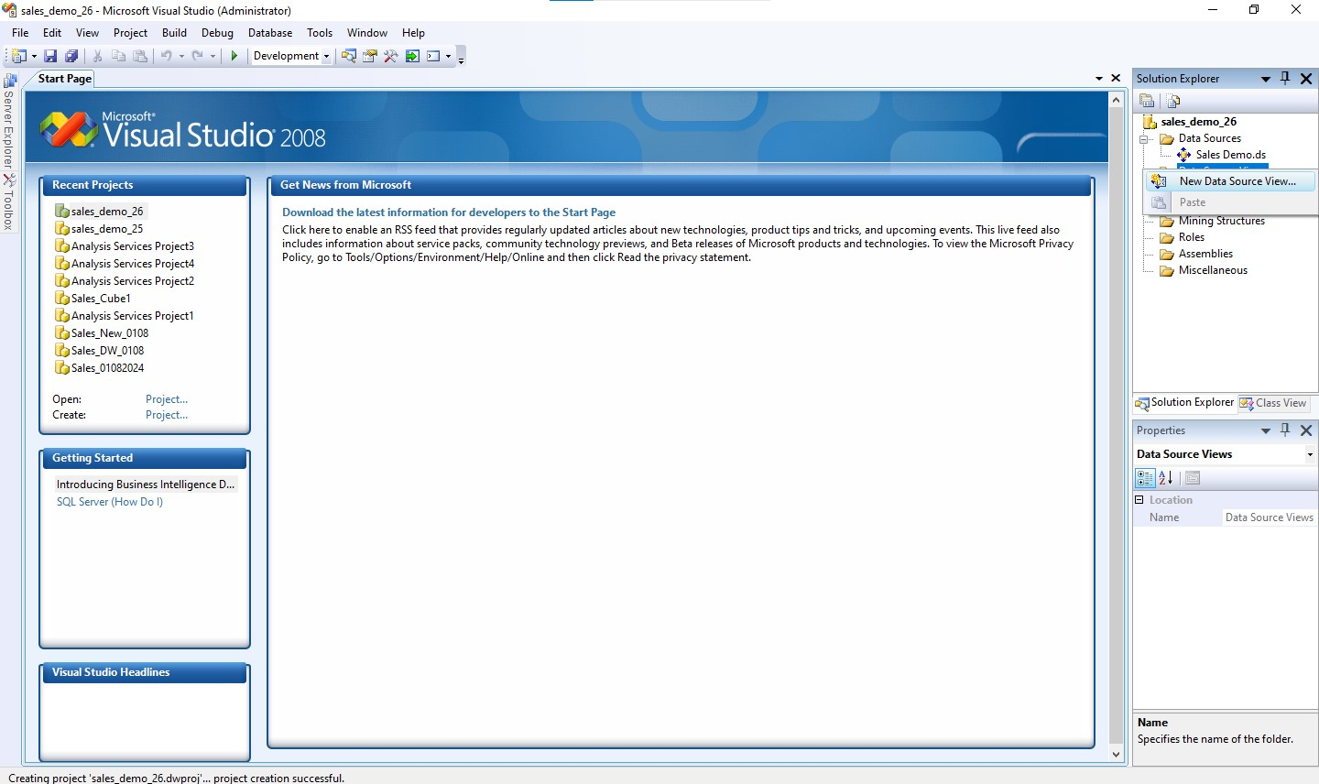

**Fig.7: Creating New Data Source View**

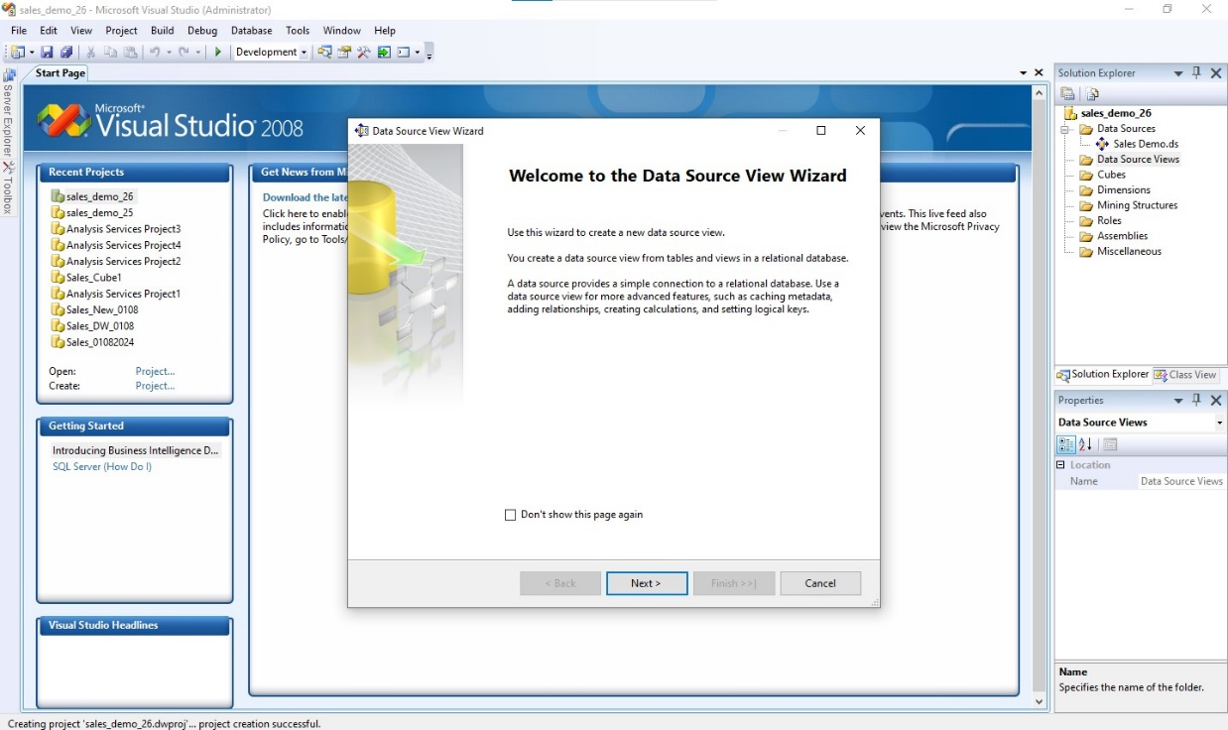

**Fig.8: Click Next**

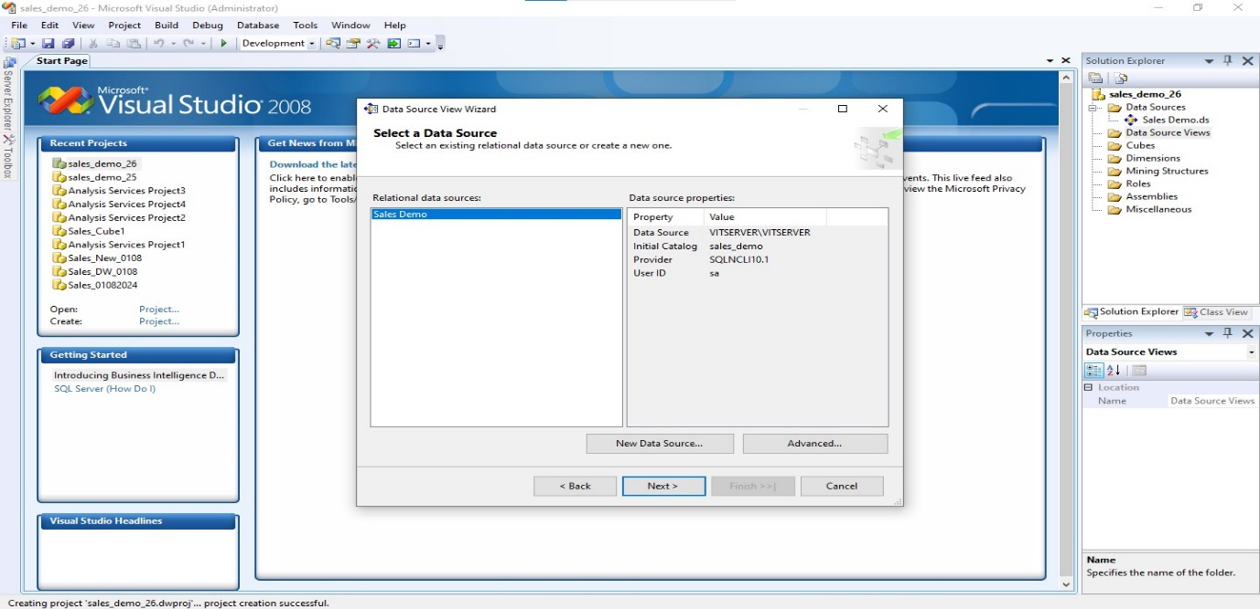

**Fig.9: Select relational data sources**

**Step 6 : Select the existing data set and create the relational data sources .**

Data Sources view wizard Next (Data source view wizard) -> Next (select data source) -> Next (name matching ) -> Finish .

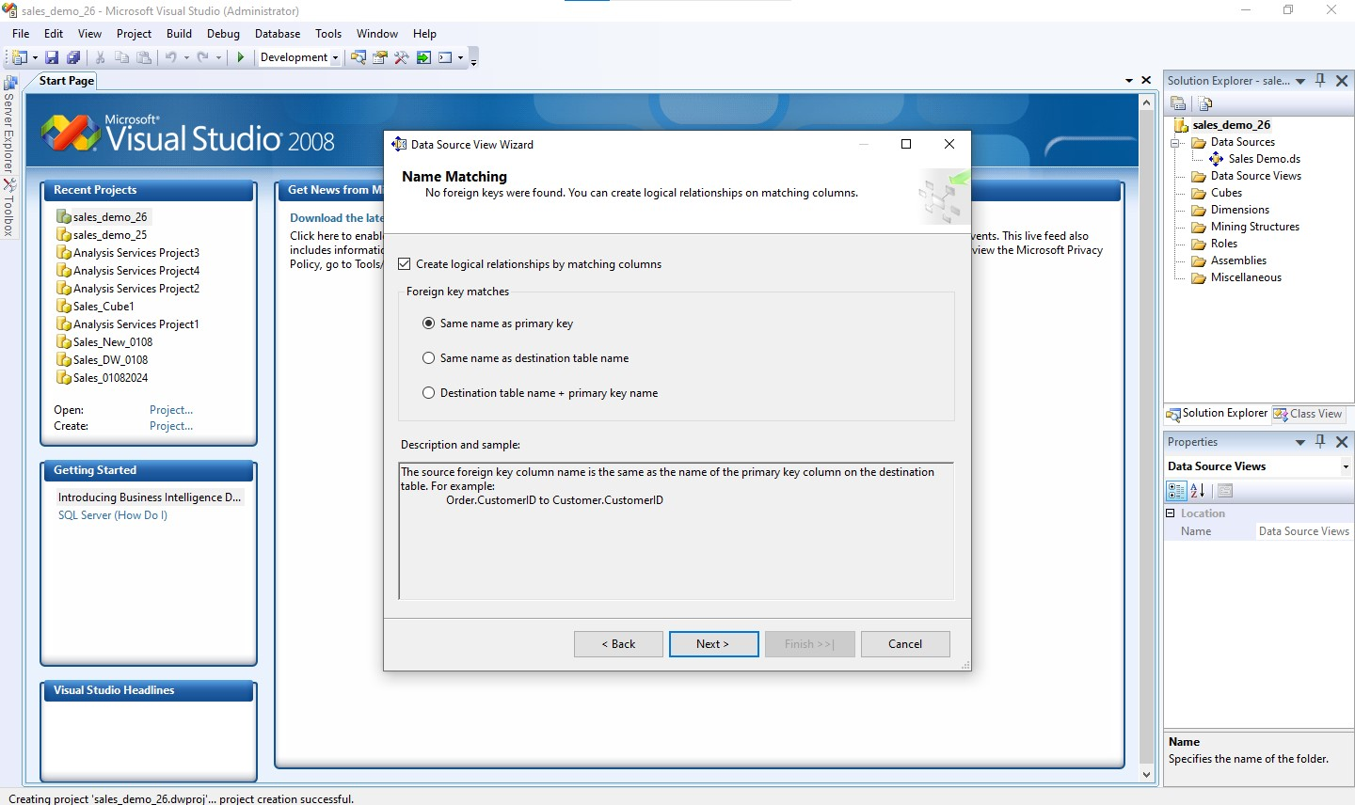

**Fig.10: Create the logical relationship with same name as primary key**

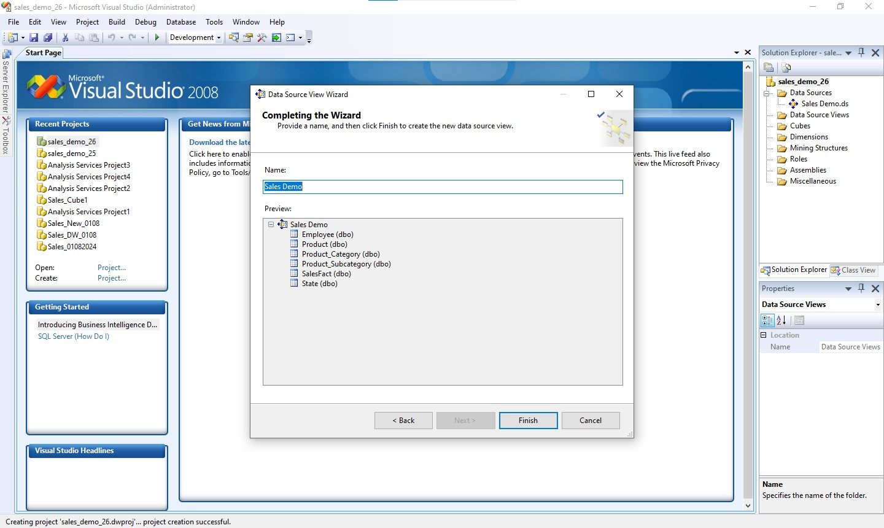

**Fig.10: Click finish**

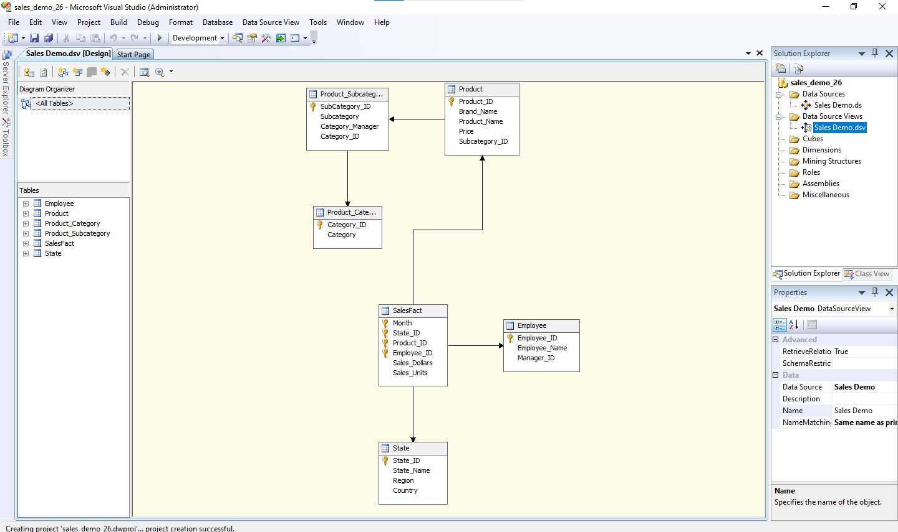

**Fig.10: The data source views**

We successfully completed the creation of a Data Warehouse for sales, addressing a real-life problem by designing an effective warehouse structure. We constructed a snowflake schema to organize the data and performed comprehensive ETL (Extract, Transform, Load) operations to populate and maintain the warehouse efficiently.