**Aim :- Construction of Cubes , OLAP Operations, OLAP Queries**

**Steps to perform the above operations**

**Step 1: Creating New Cube**

* 1. In Solution Explorer -> Right Click on **Cube->**Click**New Cube ->** Click**Next**
  2. Select Fact Table Name from**Measure Group Tables (SalesFact) ->**Click**Next**
  3. Choose**Measures**from the List which you want to place in your Cube --> Click **Next**
  4. Select All **Dimensions** here which are associated with your Fact Table-> Click **Next**
  5. Assign **Cube Name** (Sales ____ ) -> Click **Finish**
  6. Now your Cube is ready, you can see the newly created cube and dimensions added in your solution explorer.

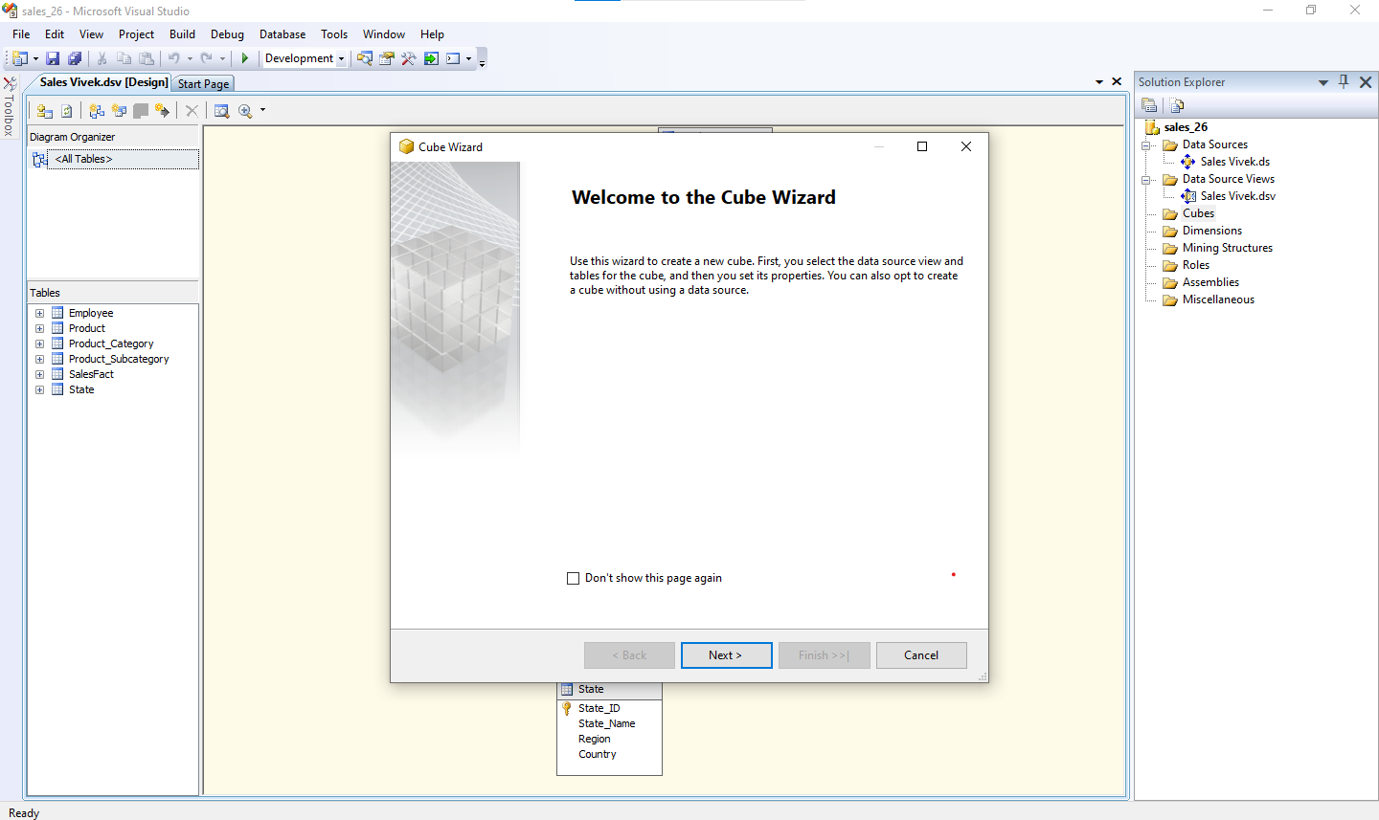

**Fig. 1 : Creating the new cube**

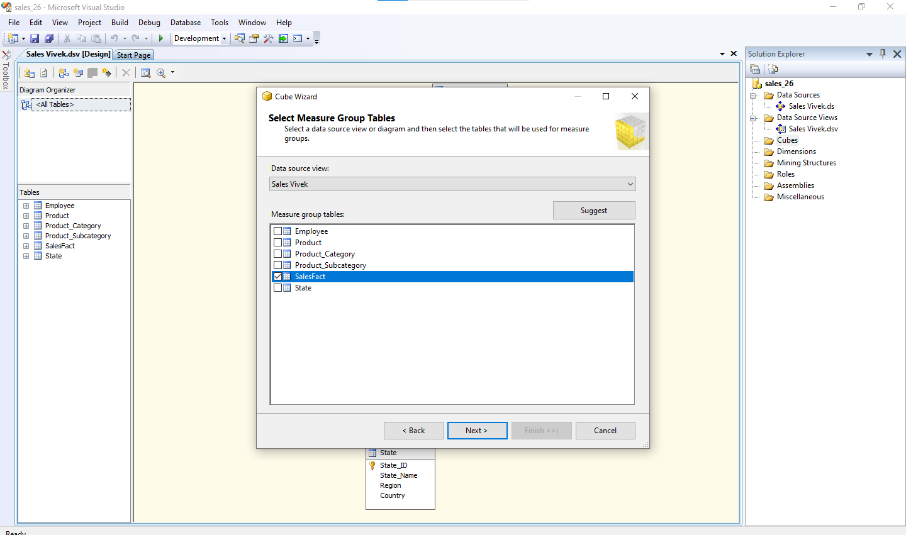

**Fig. 2 : Select the fact table (SalesFact)**

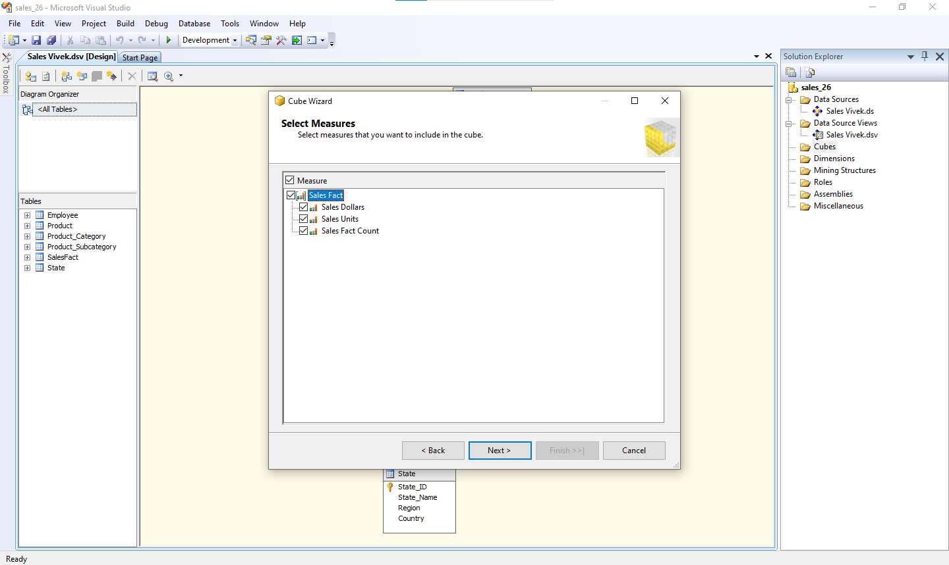

**Fig. 3 : Select the measures that want to include**

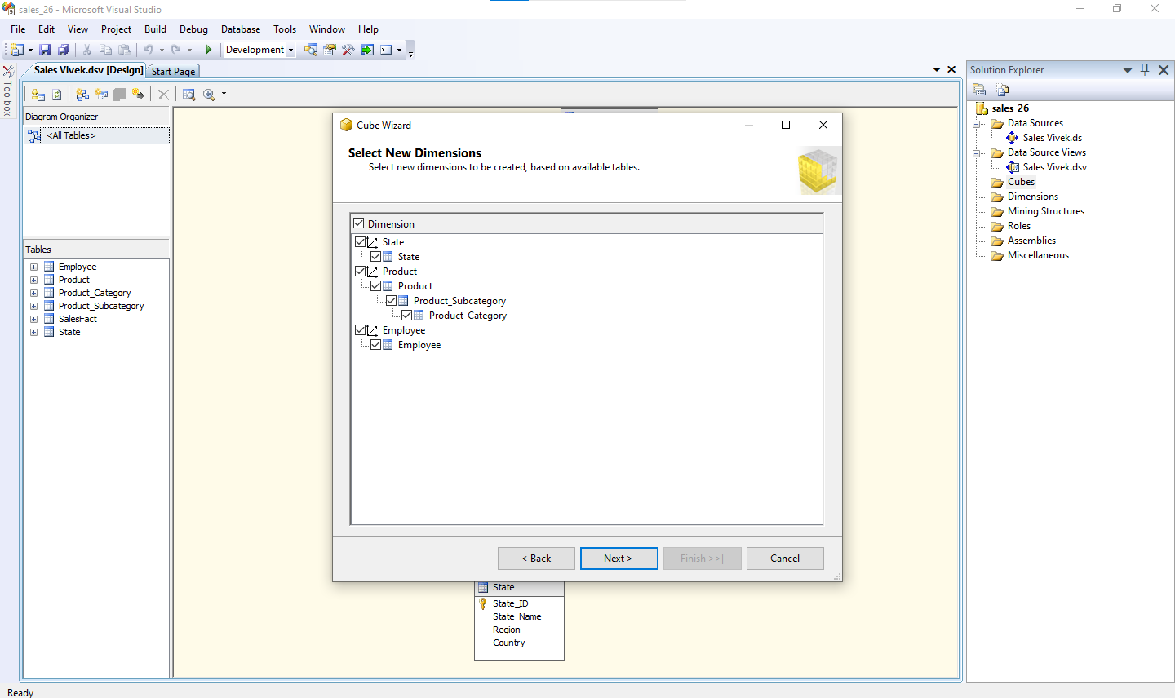

**Fig. 4 : Select the New Dimensions**

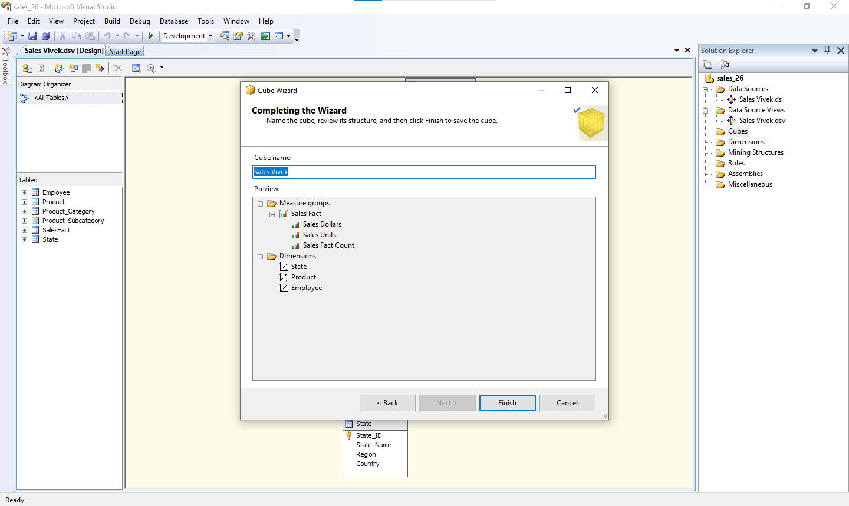

**Fig. 5 : Click to Finish the Wizard of creating the cube**

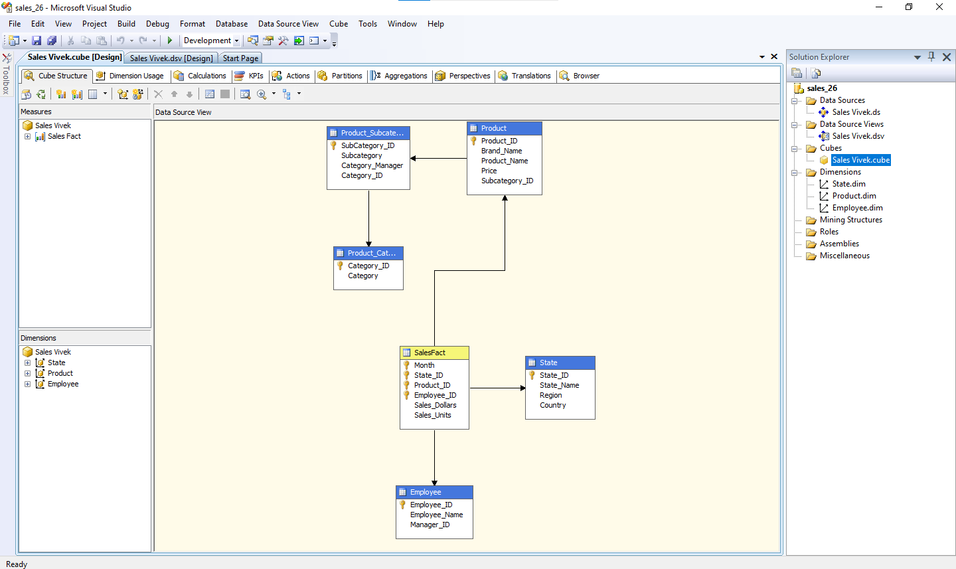

**Fig. 6 : Cube was ready for Dimension Modification**

**Step 2 : Dimension Modification**

2.1 In Solution Explorer, double click on dimension **Dim sales->**Drag and Drop Product Name from Table in Data Source View and Add in Attribute Pane at left side.

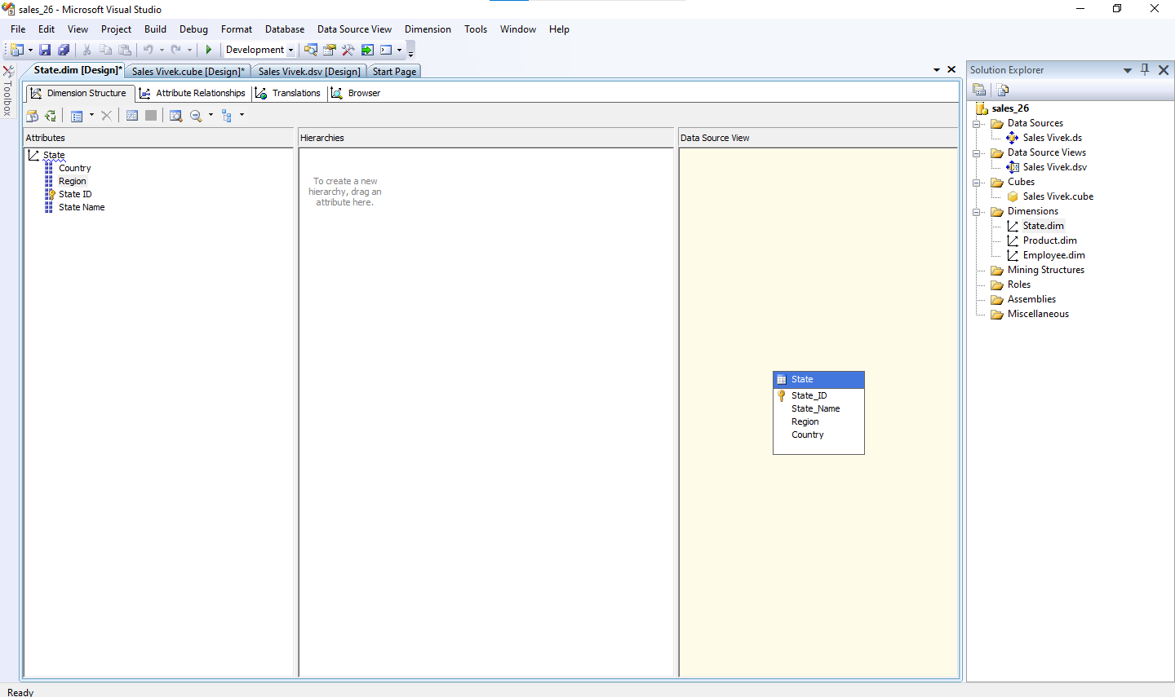

**Fig. 7 : Creating Attribute Hierarchy In State Dimension**

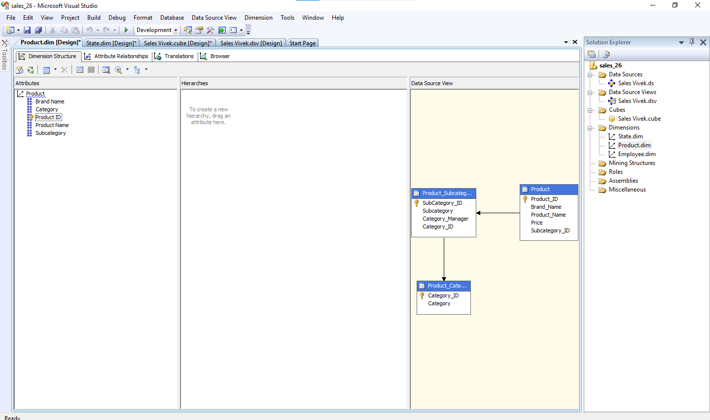

**Fig. 8 : Creating Attribute Hierarchy In Product Dimension**

**Step 3 : Creating Attribute Hierarchy In all Dimensions**

Double click On **State Dimension** dimension -> Drag and Drop Fields from Table shown.

Double click On **Product Dimension** dimension -> Drag and Drop Fields from Table shown.

Double click On **Employee Dimension** dimension -> Drag and Drop Fields from Table shown.

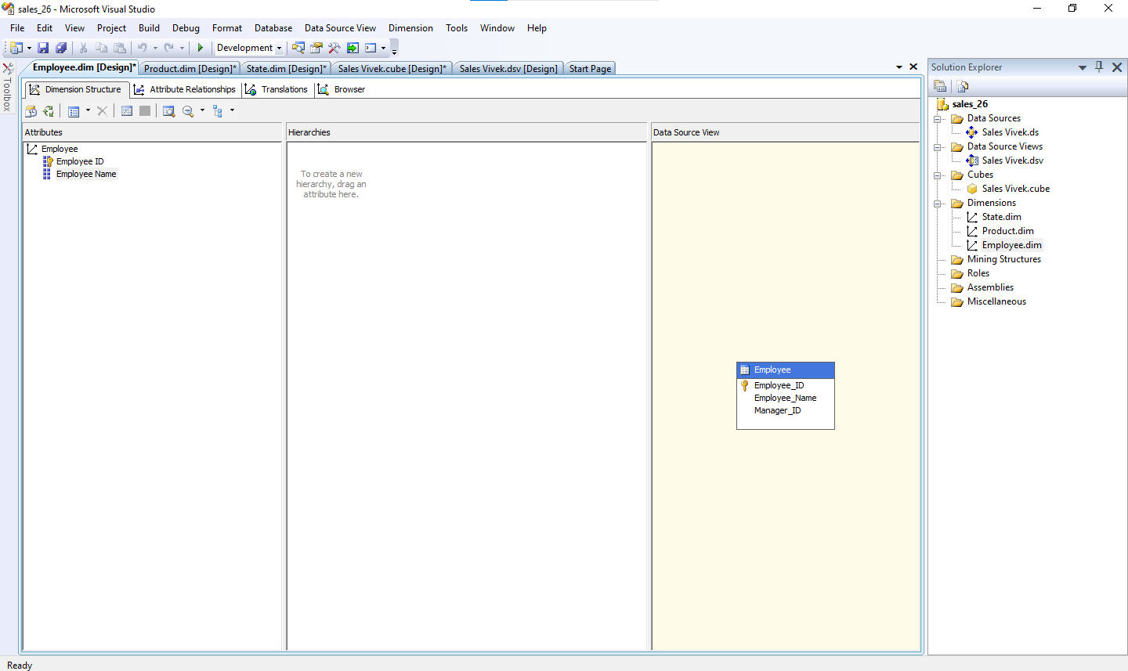

**Fig. 9 : Creating Attribute Hierarchy In Employee Dimension**

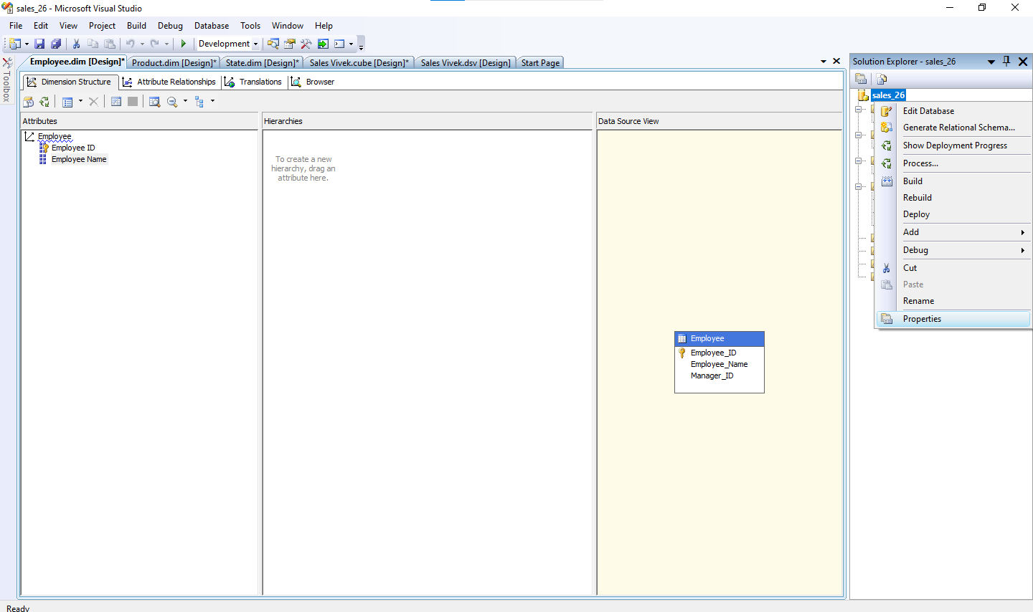

**Fig. 10 : Change the properties of your data**

**Step 4: Deploy the Cube**

8.1 first go to your sales_26 properties -> Deployment -> deploy all

8.2 In Solution Explorer, right click on Project Name (Sales______ )-> Click **Properties**-> **process.** -> **yes** -> **run .**

8.4 Once Deployment will finish, you can see the message**Deployment Completed**in deployment Properties.

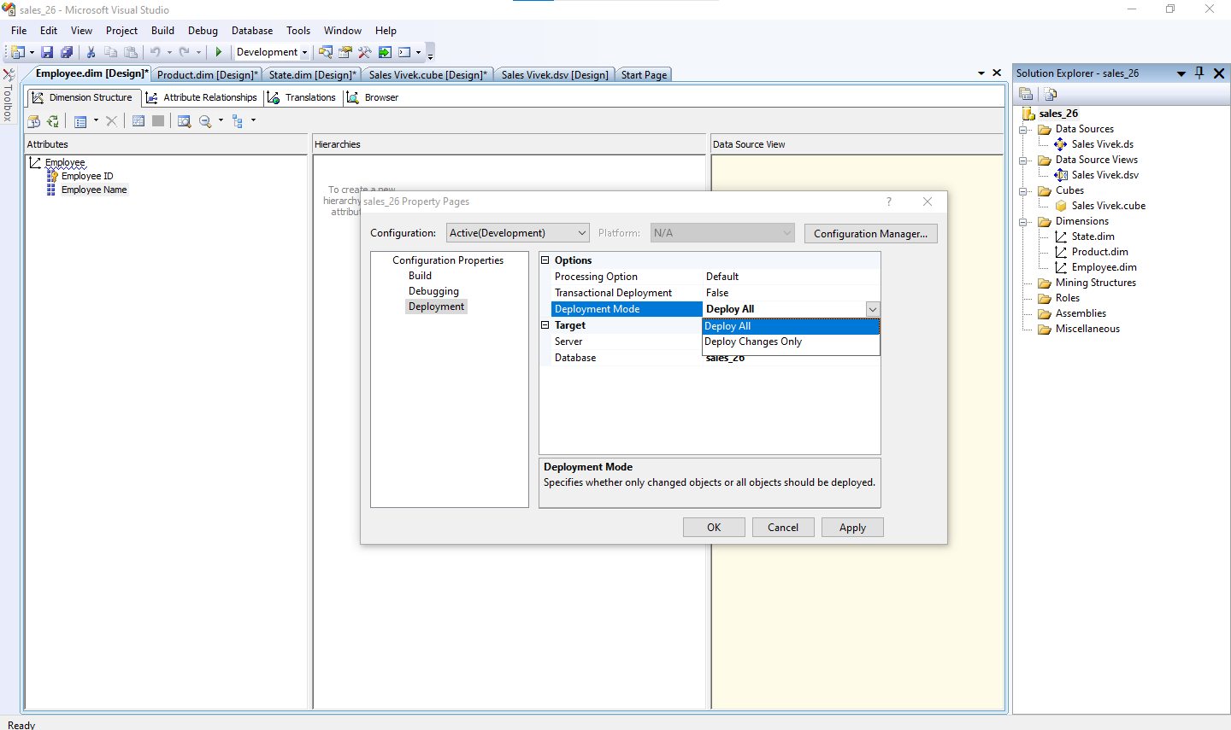

**Fig. 11 : Change the properties as Deploy all**

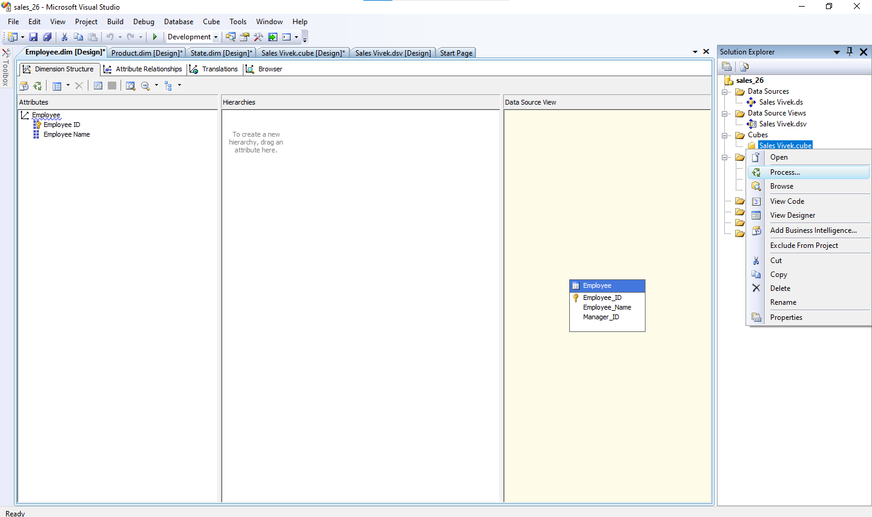

**Fig. 12 : Now process the cube**

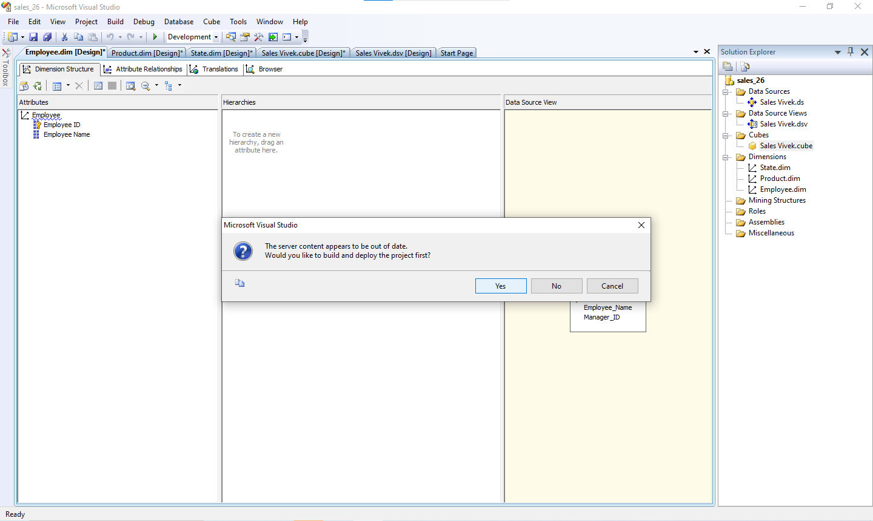

**Fig. 13 : Click Yes**

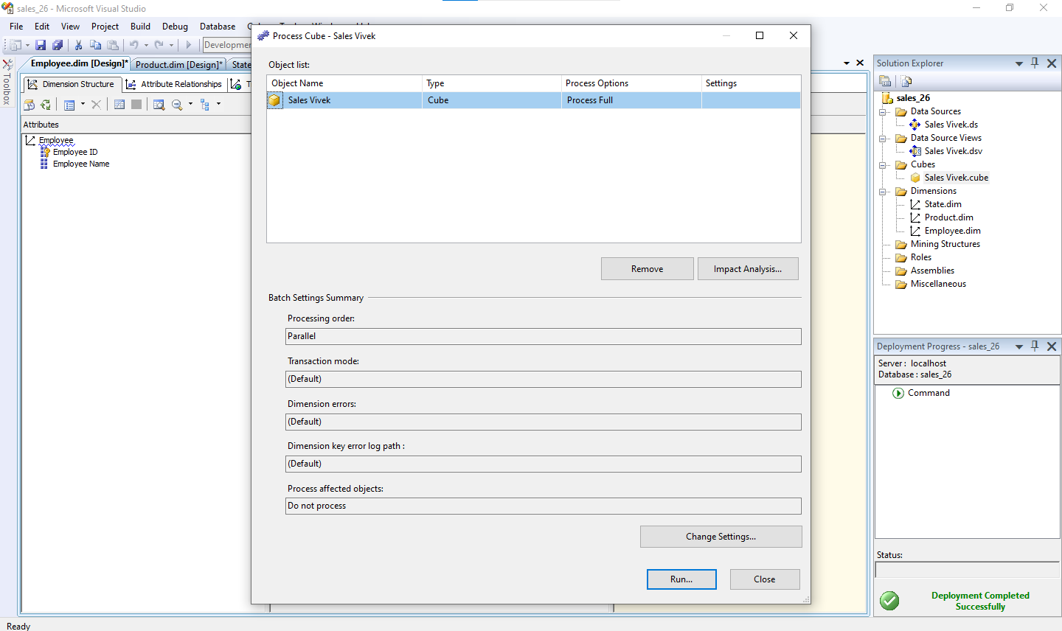

**Fig. 14 : run the process cube**

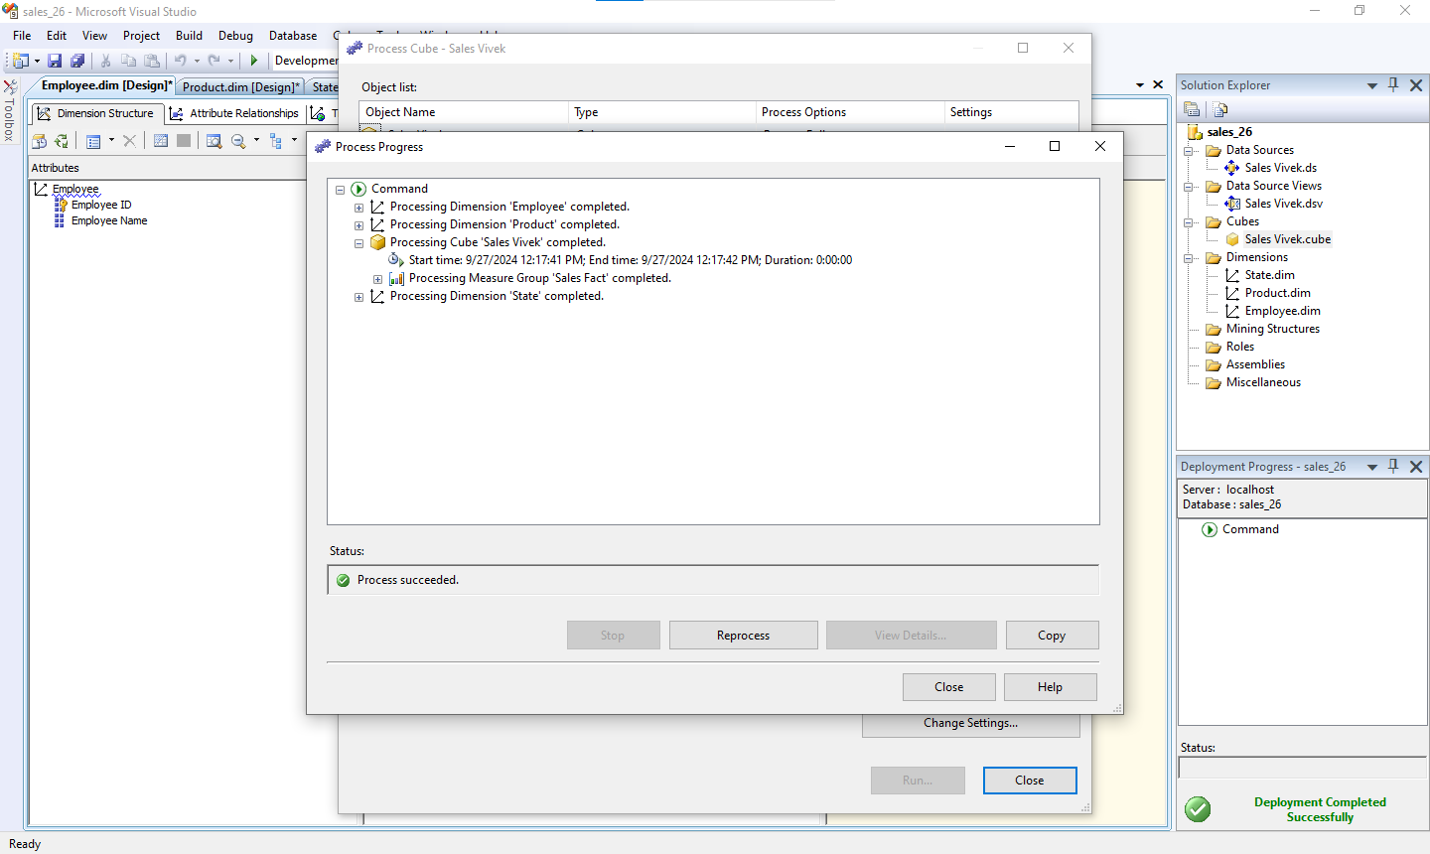

**Fig. 15 : if all correct than deployment completed successfully occurs**

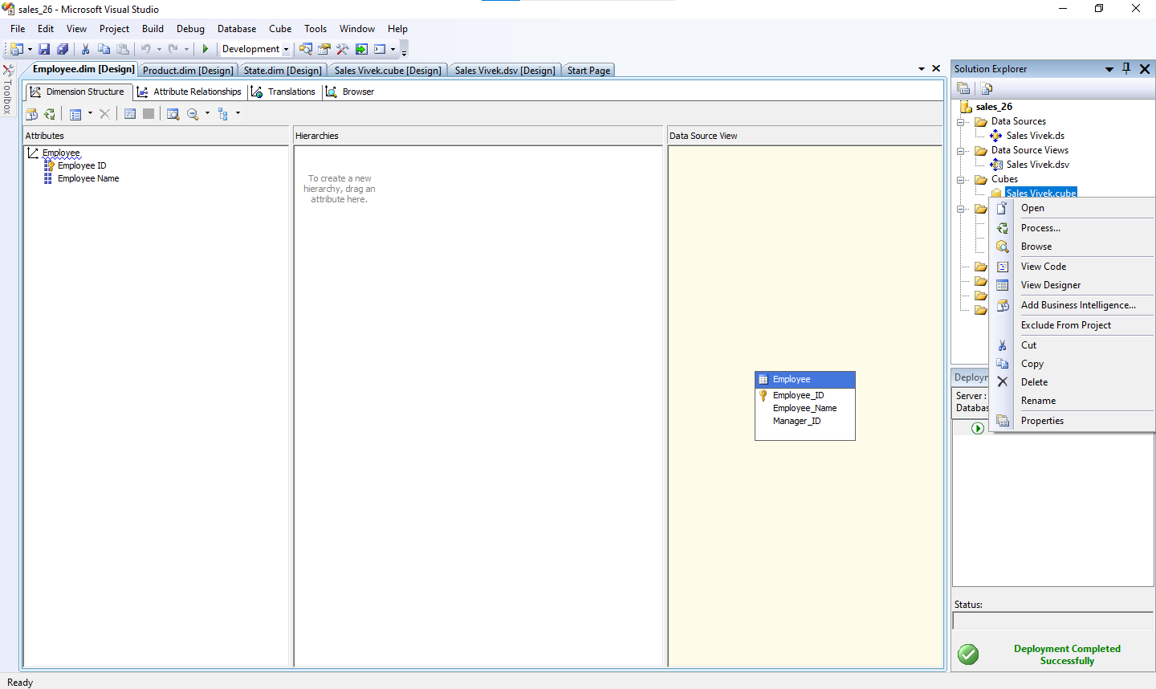

**Fig. 16 : Now browse the cube**

**Step 5: Browse the Cube for Analysis**

5.1 In Solution Explorer, right click on Cube Name (Sales_______ ) -- > Click **Browse**

5.2 Drag and drop measures in to Detail fields, & Drag and Drop Dimension Attributes in Row Field or Column fields. Now to **Browse Our Cube**

1. Product Name Drag & Drop into Column
2. Drag & Drop into Row Field sales fact count Drop this measure in Detail area

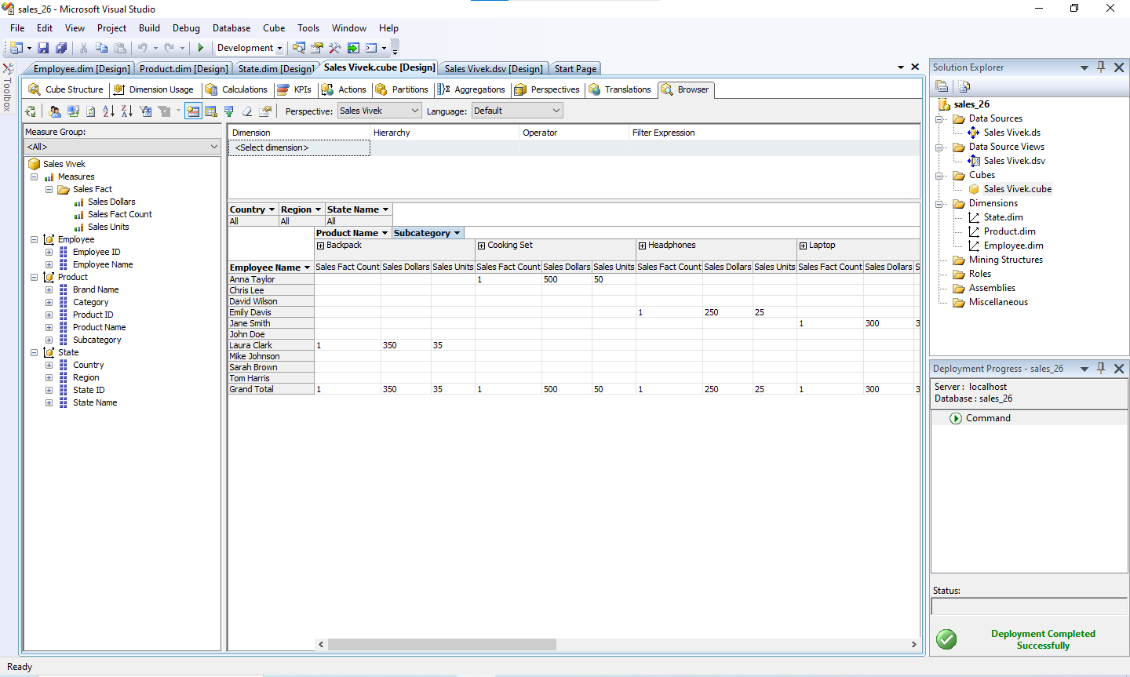

**Fig. 17 : as required Drag and Drop into the column and row field**