Thank you for giving us an opportunity to respond to the comments made by the reviewers for our We have taken the feedback we received into careful consideration and have amended our manuscript accordingly. We believe that our revised submission appropriately addresses the concerns raised by you and your reviewers during the initial review process. In many instances we have completed additional experiments to fulfil requests and improve the quality of our paper. Please find our direct response to each of the comments below. We hope you will now find our manuscript suitable for publication. If not, we welcome any further feedback you or your chosen reviewers may have.

Reviewer comments:

Reviewer #1 (Comments to the Author (Required)):

In this manuscript, Stephenson et al investigated the effects of in utero exposure to Environmentally Persistent Free Radicals (EPFR's) on growth, metabolism, energy homeostasis under the conditions of diet-induced obesity. One of the main conclusions of the report is gestational exposure to MCP230 results in a reduction in energy expenditure, partly through impaired mitochondrial metabolism in the skeletal muscle. This is an important paper and the work is performed to a high technical standard.

Comments:

The report did not show any signaling data to support alteration in skeletal muscle metabolism or growth. It will be helpful to include some Western blot on phospho-proteins which are regulated by insulin/ IGF1 (such as Akt and p70S6K).

We measured Akt phosphorylation on Ser473, S6K phosphorylation on Thr389, and AMPK phosphorylation on Thr172 from quadriceps lysates via western blotting. We have stated the lack of effects on these pathways in the revised manuscript as data not shown on Line XXX (page XX)

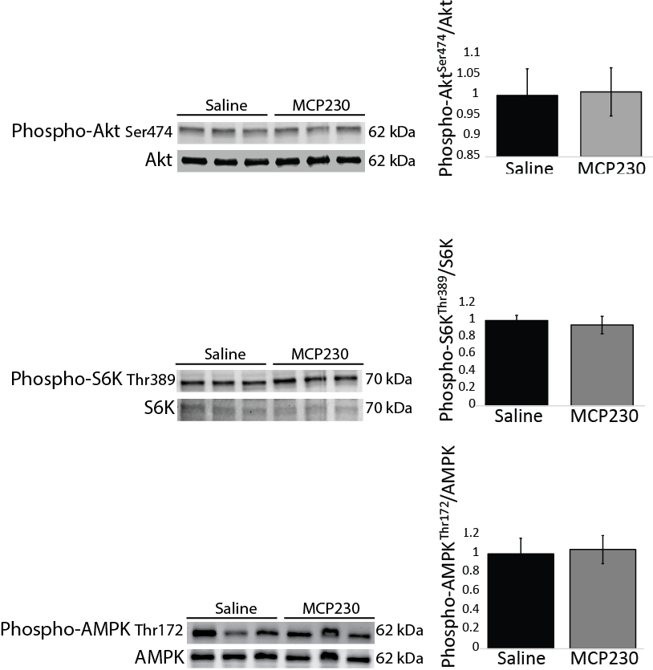

Does the alterations in "hunger hormones" alter the feeding pattern of mice in response to light-dark cycle? It will be interesting to include this data if it is available from the metabolic cage experiments. For example, did the mice eat more frequently (though cumulative food intake is unaltered)?

This is an interesting thought, and we thank this reviewer for bringing it to our attention. We analyzed the feeding bout data from the metabolic cage experiments and found that the MCP230-exposed mice ate slightly smaller meals over shorter feeding bout durations, but not more frequently. These changes primarily occurred during the light phase; however, since there was a great deal of variation within each group, neither of these parameters (time length of feeding bout or amount of food consumed per bout) were statistically different. We have mentioned the altered feeding behavior in the revised manuscript. A copy of the new text also appears here, for your convenience.

**“During the metabolic cage experiments the MCP230-exposed mice tended to eat less food per feeding bout, whereas each feeding bout also tended to be shorter in duration; however, neither of these parameters were statistically different (data not shown). There were no differences between groups for the frequency of feeding.”**

Despite the profound changes in ghrelin and GLP1 levels, MCP230 mice did not display any alteration in glucose and insulin levels, and the fat mass appear to be mildly affected. The authors should provide an explanation for this in the discussion.

All the groups of mice received high fat diet from ten weeks of age in order to induce obesity. The glucose and insulin values obtained for all groups after 12 weeks of high fat diet are elevated compared to that of chow mice of a similar age. Our interpretation is therefore that high fat diet did have an effect on glucose and insulin levels but that this was not modified by *in utero* particulate exposure. We have emphasized this point in our revised discussion.

The authors provided data which indicated impaired mitochondrial biogenesis. The authors should provide some data on the upstream regulators of mitochondrial biogenesis such as PGC1, PPAR or TFAM to strengthen the data.

We evaluated several upstream regulators of mitochondrial biogenesis (*Ppard, Ppargc1a, Ppargc1b, Nrf1, Nfe2l2 and Tfam,* by qPCR from quadriceps lysates and PGC-1a, by western blot) and found that the MCP230-exposed group had similar mRNA levels to the control group for *Ppargc1a, Nrf1, Nfe2l2 and Tfam* and similar PGC-1a protein abundance. We did observe a marked increase in both *Ppard* and *Ppargc1b* mRNA in the MCP230-exposed mice, which is an interesting finding given that the mitochondrial transcripts and proteins that we have measured are either down or unaltered by the treatment. Our interpretation is that these increases in *Pppard and Ppargc1b* mRNA levels are compensatory to impaired mitochondrial function in these muscles. We have described these data and our interpretations on Page XXX line XXX as:

We have included this new data as a new figure in our revised manuscript (Figure 6). This figure is also included here for your convenience.

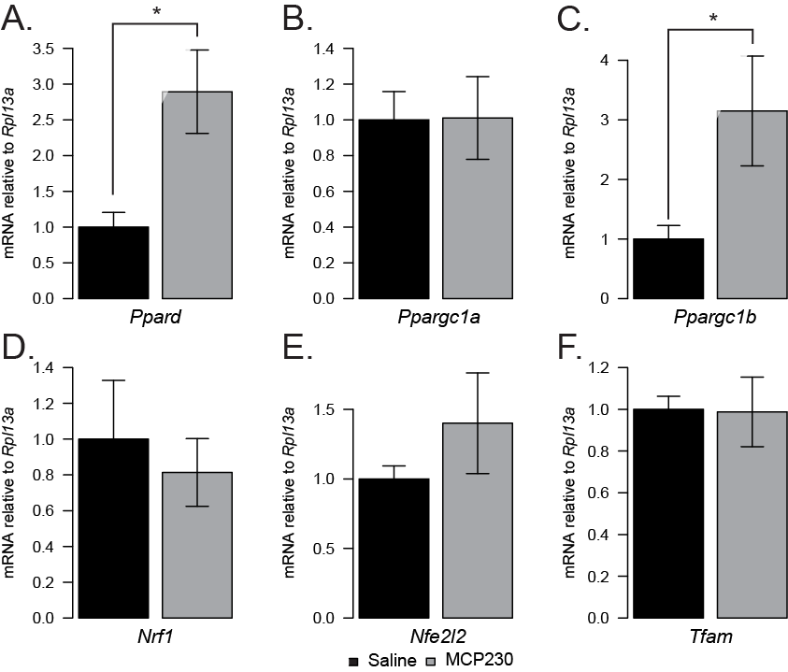

In Figure 5E, quantification of mitochondrial proteins revealed significant changes in NDUFB8 and ATP5A but the bands in the representative Western blot appeared unaltered (visually). Can the authors provide new analyses or blots which are more consistent? What is the significance that only NDUFB8 and ATP5A are elevated at protein level?

We previously increases in NDUFB8/ATP5A proteins that while reached statistical significance were very models. We repeated this analysis with a larger number of samples (n=XX up from previous n =), as well as blotting for PGC-1α, we found that there are no longer statistically significant differences between the groups for any of the mitochondrial OXPHOS proteins we have measured. We have amended the manuscript/Figure 6 D & E accordingly. We have removed all statements regarding reductions of these proteins. New representative blots and quantification are also included here for your convenience.

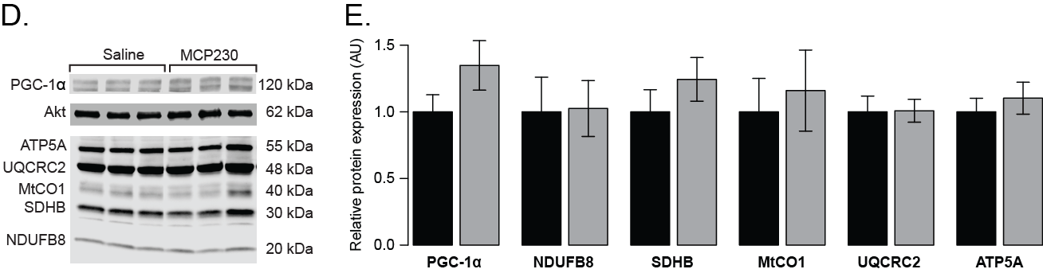

Reviewer #2 (Comments to the Author (Required)):

Stephenson and colleagues have shown that in utero exposure to environmentally persistent free radicals increases the adiposity of the offspring on chow, and on a high fat diet. Although these data are interesting, the dataset is missing important information and a number of major concerns exist.

Major

1) Functional measurements of insulin sensitivity are needed. A glucose tolerance test and insulin tolerance test would inform on whether the mice are metabolically compromised on the chow fed diet and high fat diet to match up with their increase in weight.

This is an interesting point, however we decided to focus our manuscript on changes in energy metabolism as. The lack of evidence of impaired insulin sensitivity with increased weight gain is interesting, but potentially confounded by the differences in fat mass. To indirectly address this point, we present data showing that Akt phosphorylation is unchanged (see response #1 to reviewer #1). We also now present data showing that the groups had similar HOMA-IR values (12.77 ± 1.29 for the control group versus 12.14 ± 0.96 for the MCP230 group; p=XX in Figure 3C). We acknowledge that this limits our ability to evaluate glycemia/insulin sensitivity in these mice and indicated this caveat in our revised results section (line XX on page XX):

**“Calculation of the HOMA-IR revealed that both the saline and MCP230-exposed groups had similar HOMA-IR values of 12.77 ± 1.29 and 12.14 ± 0.96 for Saline and MCP230, respectively; p>0.05, Figure 3C). Consistent with this, we observed no changes in the levels of fasted Akt phosphorylation in muscle tissue (data not shown)”**

In the discussion (line XX on page XX):

**“In contrast to previous studies that use chronic pollution models (1, 5, 9, 33, 35), we did not observe any indications that glycemic control was impaired to a greater extent in MCP230 exposed mice compared to the control groups (there were no differences in fasting glucose, insulin, HOMA-IR score or Akt phosphorylation in muscle tissue (Figure 3A-C). We did not measure insulin sensitivity directly, which limits our ability to make any strong conclusions about the effects of acute *in utero* PM exposure on insulin sensitivity. This suggests that the effects of acute gestational particulate exposure may not mimic the effects of chronic exposure, and the risk profiles and mechanisms associated with these exposures may differ.”**

Additionally, ex vivo measurements of muscle insulin-stimulated glucose uptake would inform on whether the increase adiposity alters skeletal muscle insulin sensitivity.

This is an interesting avenue of study for future studies in this area, we do not think that measurements of *ex vivo* skeletal muscle glucose uptake would substantially alter our conclusions. As described above, it is worth noting that skeletal muscle Akt phosphorylation was not different between the groups.

Also - how long was the fast for Figure 3 data?

Blood was collected in the fed state and again after a 16 hour fast.

2) It is unclear why the metabolic cage data is in chow fed mice while the mitochondrial experiments are in the HFD mice? It is currently inappropriate to try and explain the HFD mice skeletal muscle mitochondrial data with regards to the metabolic cage data. These seem to be completely different experimental groups and because of this, the proposed mechanisms are not supported by the data presented.

The metabolic cage experiments were performed in the same mice that received the high fat diet, only prior to these mice going on the high fat diet. Therefore, the VO2/energy expenditure phenotype was present in the MCP230-exposed mice prior to the induction of obesity. Whether MCP230-induced changes in mitochondrial function the pre-HFD is an interesting question, but we are not able to repeat those experiments in the time provided. We have noted this caveat in the revised discussion section

3) It is unclear why only VO2 is provided to explain energy expenditure. Please provide the Kcal data in addition to presenting the units in line 226-228.

Response: We have revised the manuscript to also include energy expenditure expressed in watts based on calculations now described in the methods section:

ADD

.The revised figure, now Figure 4C/D is presented here for your convenience.

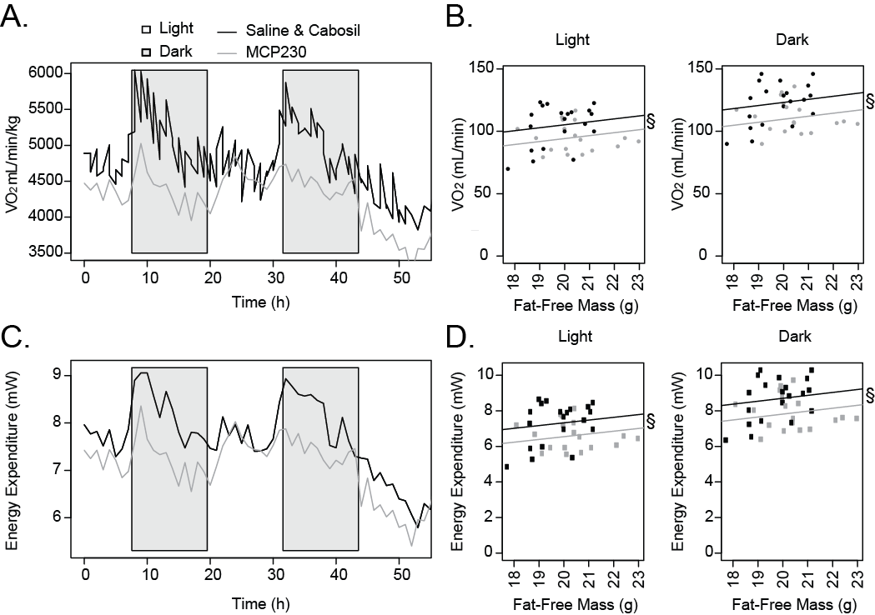

Also - considering energy expenditure is lower, analysis of uncoupling proteins in skeletal muscle and adipose depots may help inform on the mechanism.

We have looked at uncoupling proteins in the muscle and epididymal adipose tissue. We observed an increase in muscle *Ucp2* mRNA in the MCP230-exposed mice and a small decrease in *Ucp1* mRNA in the eWAT. There were no other changes in UCPs (*Ucp3* mRNA was not significantly altered in muscle lysates). Based on these new data, we do not think that decreases in UCP’s are able to explain the reduction in energy expenditure observed in the MCP230-exposed mice, as increased uncoupling in muscle would be expected to increase O2 consumption, rather than cause a reduction. As skeletal muscle *Ucp2* and *Ucp3* are relevant to our oxidative stress data (which we have expanded upon in the revised manuscript), we have included this data in our revised submission. The new figure is also reported here, for your convenience.

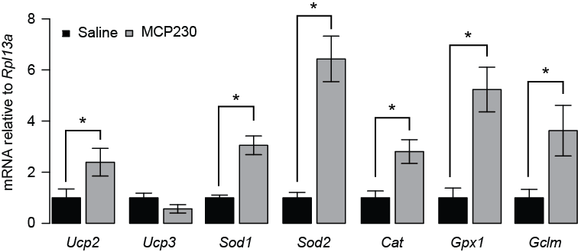

4) Based on the RER data - it seems that the Cabosil control alters energy metabolism independent of the EPFR as the Cabosil group and the MCP230 group both show increases in fat oxidation (or decreases in carbohydrate oxidation) compared to saline. Thus, it is pertinent to ensure that the Cabosil is not a confounding variable.

Where all three groups were studied, we have analyzed all three groups separately to ensure that there was no effect of cabosil. The only instance where cabosil responded differently to the saline group was for RER. Because of this, in the paper we have presented the RER data for the three groups individually. Where parameters were not different between cabosil and saline (all other measurements), we combined the groups in order to increase statistical power.

This is explicitly stated in the statistics paragraph of the methods section in our revised manuscript. As you can see from the figure below, the cabosil and saline group had similar responses for other metabolic cage measurements, and thus were combined in the figures we present in the manuscript.

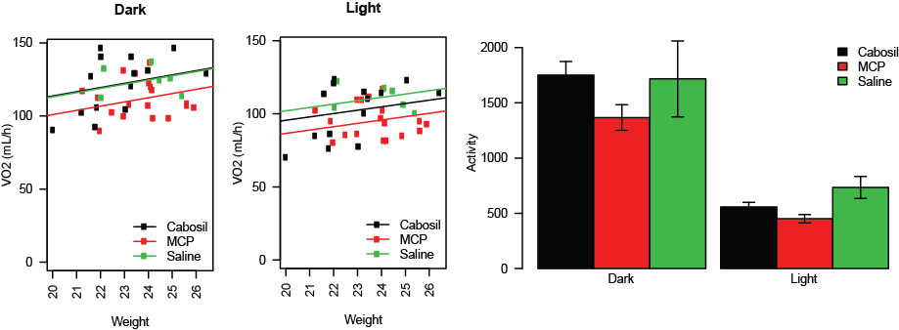

5) The fact that mitochondrial protein expression does not correlate with citrate synthase activity is interestingly and should be further addressed. Functional experiments in freshly isolated mitochondria or permeabilized myofibres would be important to investigate the functional significance of these differences.

We do not think that it is surprising that citrate synthase activity is reduced but the oxphos proteins are unchanged by MCP230 exposure. Enzyme activity can be modulated by many factors other than their level of protein expression. Indeed, it is known that mitochondrial enzymes are susceptible to post-translational changes that limit their activity, particularly during periods of cell stress. As described above (reviewer 1, comment 5) we have provided better data showing that OXPHOS protein levels are unchanged in these lysates. In our revised discussion we speculate that oxidative stress may alter the function of these proteins.

Minor

Figure 3A y-axis is unusual

We have amended the figure so that the axis extends out to 200 mg/dL.

What is the dose of EPFR compared to how much a human would be exposed to?

Each exposure is equivalent to a human breathing 200 ug/m3 (which is the amount a human would inhale on a typical day in a city such as Los Angeles). These values were obtained based on modeling calculations using MPPD software (version 2.0). For further details on how this is calculated, we refer you to the supplementary methods for Saravia *et al*., Mucosal Immunology (2014) 7, 694–704; doi:10.1038/mi.2013.88. This has been included in the revised discussion section as:

ADD

Reviewer #3 (Comments to the Author (Required)):

This is a very interesting article in which the investigators propose that in utero exposure to particulate matter (EPFR) will increase the risk of the offspring developing a form of metabolic disease. The manuscript is very well written and the overall presentation is strong.

Although, the hypotheses are important the submission suffers from an incomplete assessment of mitochondria and lacks any attempt to provide a mechanism to explain the outcome. It is further challenging to determine if the effect of EPFR is a direct or a secondary effect on the skeletal muscle.

This in its self is an interesting question, albeit one that is an entirely different question to the one we have set out to address. That said, it is still a question we have considered. As our protocol stands, it is the mothers of the mice we are studying that are treated directly with the particulate, not the offspring themselves. Thus, it is possible that all the effects we see in the muscle (and elsewhere) occur indirectly, as the particulate may not come into direct contact with the offspring at all. Whether or not the particulate crosses the placenta to exert its effects on the offspring is incredibly difficult to determine.. However, we did make an attempt to assess a candidate pathway in the muscle which might indicate if there were direct effects. We have stated this explicitly in the revised manuscript:

SAY SOMETHING ABOUT THIS CAVEAT

Overall, the manuscript is largely dependent on mRNA and protein measures as a surrogate for functional measures, which significantly reduces the enthusiasm for the ideas that drive the submission.

Our revised manuscript now provides new *in vivo*, functional data as well as the skeletal muscle mRNA and protein measurements.

No functional data provided for the mitochondria (i.e. mitochondrial respiration). When considering the defined hypotheses it would seem these measures are necessary.

We present citrate synthase activity as a functional measure of mitochondrial activity, which is congruent with changes in whole body energy expenditure. We acknowledge that this is not as thorough of an assessment of mitochondrial function as some other studies in the published literature; however such analyses are .not possible in the resubmission time frame. In the revised manuscript, we have provided more molecular data regarding mitochondrial biogenesis pathways, oxidative stress and mitochondrial protein levels, as described above. We have added the caveat of no direct measurements of isolated muscle function to the revised discussion:

ADD

In the same line of thinking, the discussion provides extended discussions on oxidative stress, yet the submission does not provide a single measure of oxidative stress.

We agree with this reviewer and have extended our findings in the revised manuscript to include measurement of genes known to be upregulated in response to oxidative stress.

Also, there is a disconnect between the mtDNA results and the results obtained using the OXPHOS antibody with no clear explanation over why this may have occurred. Functional data or EM imaging likely would clear this up.

We have added to our discussion about this disconnect and followed up with new analyses of the upstream regulators of mitochondrial biogenesis (see figure included in an earlier response here). As we explain above, we do not think additional functional experiments would provide us with any new information and cite the work of Siegel et al (2011) as to what we think is happening.

Providing some sort of intervention that targets the skeletal muscle mitochondria to prevent the overall phenotype induced by the EPFR would significantly strengthen the study.

We have a follow up study planned that tests our oxidative stress hypothesis and aims to prevent the phenotype we report in this manuscript. This newer work, while closely related, is well beyond the scope of the current study and we believe is better served as an entirely separate report. We have amended our discussion to state that while oxidative stress is one potential mechanism, this report does not conclusively prove that hypothesis to be true.

Finally, the purpose of the idea was to determine if the animals develop a form of metabolic disease after the EPFR exposure. Thus the authors provided the animals with a HFD, however based on the way the data are presented it is challenging to determine if the HFD actually had an effect. Specifically, there is no attempt to determine if the mice develop any sort of glucose intolerance or insulin intolerance while on the HFD.

All our mice were exposed to a high fat diet to induce obesity and our intention was to assess whether acute *in utero* MCP230 exposure would worsen select features of the obesity phenotype with a focus on chronic changes in energy balance. We found that all groups of mice responded similarly to the HFD with regards to fasting glucose and insulin concentrations (and HOMA-IR). These levels, while not different between the groups, were (at least in our hands) elevated compared to non-obese mice of a similar age on a standard rodent chow diet. We have presented new data regarding insulin sensitivity and limited our statements regarding metabolic syndrome in our responses above ()