Thank you for giving us an opportunity to respond to the comments made by the reviewers for our manuscript. We have taken the feedback we received into careful consideration and have amended our manuscript accordingly. We believe that our revised submission appropriately addresses the concerns raised by you and your reviewers during the initial review process. We have completed additional experiments to fulfil requests and improve the quality of our paper, including measuring the expression levels of the upstream regulators of autophagy, mitochondrial biogenesis, uncoupling, and oxidative stress response genes. Below is a point-by-point response to each of the comments. We hope you will now find our manuscript suitable for publication. If not, we welcome any further feedback you or the reviewers may have.

Reviewer comments:

Reviewer #1 (Comments to the Author (Required)):

In this manuscript, Stephenson et al investigated the effects of in utero exposure to Environmentally Persistent Free Radicals (EPFR's) on growth, metabolism, energy homeostasis under the conditions of diet-induced obesity. One of the main conclusions of the report is gestational exposure to MCP230 results in a reduction in energy expenditure, partly through impaired mitochondrial metabolism in the skeletal muscle. This is an important paper and the work is performed to a high technical standard.

Comments:

The report did not show any signaling data to support alteration in skeletal muscle metabolism or growth. It will be helpful to include some Western blot on phospho-proteins which are regulated by insulin/ IGF1 (such as Akt and p70S6K).

We measured Akt phosphorylation on Ser473, S6K phosphorylation on Thr389, and AMPK phosphorylation on Thr172 from quadriceps lysates via western blotting. We have stated the lack of effects on these pathways in the revised manuscript as data not shown (page 9 and 12). Representative western blots and their quantification are provided in Figure 1 of this document.

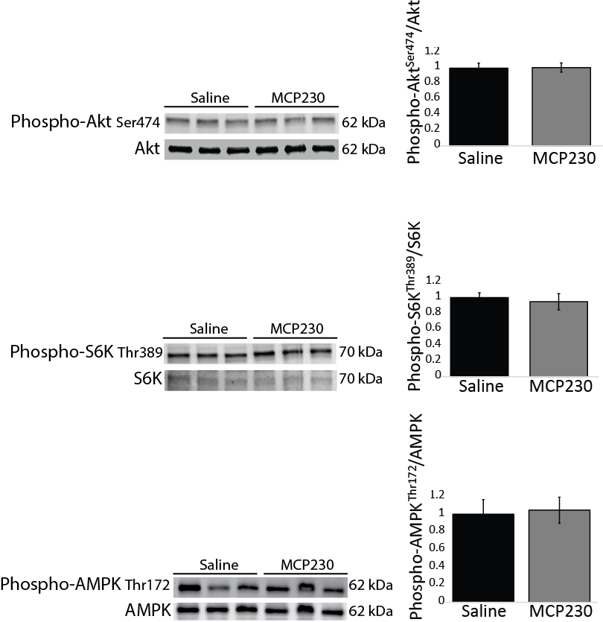

**Figure 1.** Representative western blots & relative quantification of the phosphorylation state of Akt, S6K and AMPK in quadriceps protein lysates from saline- or MCP230-exposed mice (n=10 per group). All antibodies used were from Cell Signaling Technologies (Cat. No’s. Phospho-Akt, #4060; Akt, #9272; Phospho-S6KT389, #9206; S6K, #2708; Phospho-AMPKT172, #2535S; AMPK, #2793S).

Does the alterations in "hunger hormones" alter the feeding pattern of mice in response to light-dark cycle? It will be interesting to include this data if it is available from the metabolic cage experiments. For example, did the mice eat more frequently (though cumulative food intake is unaltered)?

This is an interesting thought, and we thank this reviewer for bringing it to our attention. We analyzed the feeding bout data from the metabolic cage experiments and found that the MCP230-exposed mice ate slightly smaller meals over shorter feeding bout durations, but not more frequently. These changes primarily occurred during the light phase; however, since there was a great deal of variation within each group, neither of these parameters (time length of feeding bout or amount of food consumed per bout) were significantly different. This data is shown here in Figure 2 of this document. We have mentioned the altered feeding behavior in the revised manuscript on (page 8). A copy of the new text also appears here, for your convenience.

**“During the metabolic cage experiments, which occurred prior to HFD feeding, the MCP230-exposed mice tended to eat less food per feeding bout, whereas each feeding bout also tended to be shorter in duration; however, neither of these parameters were significantly different (data not shown). There were no differences between groups for the frequency of feeding bouts.”**

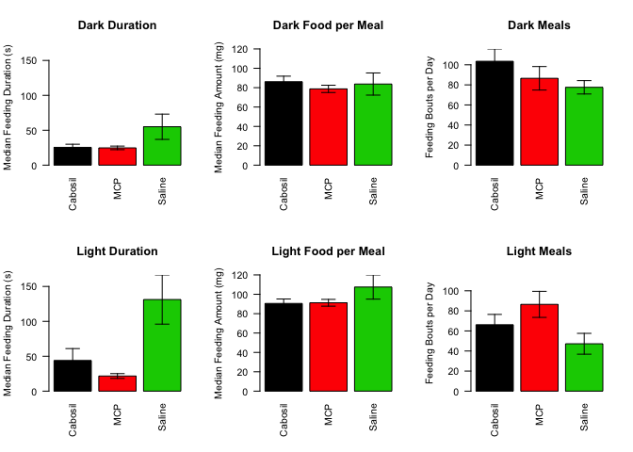

**Figure 2.** Feeding bout analysis. Mice were placed in a Columbus Instruments home cage-style Comprehensive Laboratory Animal Monitoring System with a scaled feeder. The number, duration and amout consumed during each feeding bout was recorded over several days. The median values are provided here, separated for the light and dark phases. There was no effect of *in utero* MCP230 exposure on any of the parameters measured.

Despite the profound changes in ghrelin and GLP1 levels, MCP230 mice did not display any alteration in glucose and insulin levels, and the fat mass appear to be mildly affected. The authors should provide an explanation for this in the discussion.

All the groups of mice received high fat diet from ten weeks of age in order to induce obesity. The glucose and insulin values obtained for all groups after 12 weeks of high fat diet are elevated compared to that of chow-fed mice of a similar age. These data are presented below (last comment of the third reviewer) Our interpretation is therefore that the high fat diet did have an effect on glucose and insulin levels but that this was not modified by *in utero* particulate exposure (see revised Figures 3A-C) in spite of a 10% increase in fat mass. We have emphasized this point in our revised discussion on (page 9) and results sections (page 14). A copy of the new text also appears here, for your convenience.

**“Taken together, these data indicate that while HFD did impair insulin sensitivity, there was no difference between these two groups.**

and

**“It should be noted that all of the mice in this study received the HFD in order to induce obesity and its metabolic effects and although we did not measure fasting glucose or insulin concentrations prior to the change in diet, the fasting glucose and insulin concentrations of all mice post-HFD were elevated compared to chow-fed mice of a similar age, regardless of exposures”**

The authors provided data which indicated impaired mitochondrial biogenesis. The authors should provide some data on the upstream regulators of mitochondrial biogenesis such as PGC1, PPAR or TFAM to strengthen the data.

We evaluated several upstream regulators of autophagy (LC3 processing) and mitochondrial biogenesis (*Ppard, Ppargc1a, Ppargc1b, Nrf1, Nfe2l2 and Tfam,* by qPCR from quadriceps RNA and PGC-1α, by western blot) and found that the MCP230-exposed group had similar mRNA levels to the control group for *Ppargc1a, Nrf1, Nfe2l2 and Tfam* and similar PGC-1α protein abundance. We report these data in the new Figure 6. We observed a marked increase in both *Ppard* and *Ppargc1b* mRNA in the MCP230-exposed mice, which is an interesting finding given that the mitochondrial transcripts and proteins that we have measured are either down or unaltered by the gestational treatment. Our interpretation is that these increases in *Ppard and Ppargc1b* mRNA levels are a response to the increased oxidative stress in the MCP230-exposed mice, as PPARδ is important for the induction of the antioxidant enzymes *Sod1* and *Sod2*, is induced in response to chemical stress, and it’s activation has been shown to reduce markers of whole-body oxidative stress (4–6, 9). Similarly,PGC-1β plays an important role in controlling antioxidant enzyme expression (3). We have described these data on (page 12):

**“To test whether reductions in mtDNA copy number and citrate synthase activity were due to lowered mitochondrial biogenesis, we evaluated the expression level of several known mitochondrial biogenesis genes. While we observed increases in the mRNA of *Ppard* and *Ppargc1b* (Figure 6A and C), there were no differences in the expression levels of *Ppargc1a*, *Nrf1*, *Nfe2l2* or *Tfam* (Figure 6B, D-F). “**

and on page 14:

**“We did, however observe marked increases in the transcripts of key enzymes of the antioxidant defense system (*Sod1*, *Sod2*, *Cat*, *Gpx1*), as well as increased expression of *Ucp2*, an uncoupling protein known to be up-regulated as a means to reduce endogenous ROS production (Figure 7;** (1, 2)**), and increases in both the nuclear receptor *Ppard* and the transcriptional co-regulator *Ppargc1β*, both of which are required for the induction of *Sod1* and *Sod2*** (3, 9)**.”**

We have also included this new data as a new figure in our revised manuscript (Figure 6, included as as Figure 3 of this document).

In Figure 5E, quantification of mitochondrial proteins revealed significant changes in NDUFB8 and ATP5A but the bands in the representative Western blot appeared unaltered (visually). Can the authors provide new analyses or blots which are more consistent? What is the significance that only NDUFB8 and ATP5A are elevated at protein level?

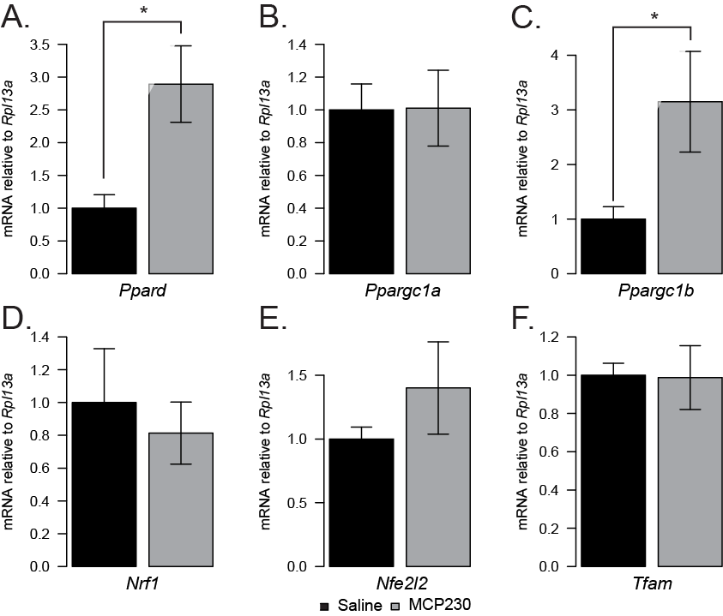

**Figure 3**. Relative expression the upstream regulators of mitochondrial biogenesis is either unchanged or elevated in quadriceps muscles from mice exposed to MCP230 *in utero*. cDNA was prepared from quadriceps RNA, amplified using the appropriate primer pair (see table 1 of manuscript for details) and quantified using a Light Cycler 480 with SYBRgreen dye. Values are mean ± SE, n=7-11/group. Asterisk indicates p<0.05 via Student’s *t*-test (A) or Wilcoxon-Rank Sum Test (C). This appears as Fig. 6 of the revised submission.

We previously reported increases in NDUFB8/ATP5A proteins that, while statistically significant, were quite modest. We repeated this analysis with a larger number of samples using a different loading control (n=10-12, up from previous n =7, total Akt as the loading control). These new data show that there are no statistically significant differences between the groups for any of the mitochondrial OXPHOS proteins we have measured. We have amended the manuscript/Figure 5 D & E accordingly. We have removed all statements regarding increases in these proteins. New representative blots and quantification are also included here for your convenience, as Figure 4 of this document.

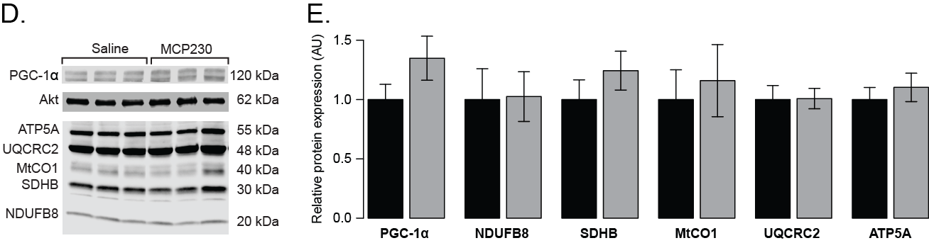

**Figure 4.** Representative blots for PGC-1α, the mitochondrial OXPHOS proteins, and their relative quantification. Protein lysates were separated using SDS-PAGE, transferred to nitrocellulose membranes and incubated over night at 4⁰C with the appropriate primary antibody. After 1 hr room temp incubation with anti-rabbit or anti-mouse, blots were visualized using a LiCOR Odyssey infrared imager and quantified using Image Studio Light software. Values are the mean ± SE, n=10-12/group. This appears as Fig. 5D & E of the revised manuscript.

Reviewer #2 (Comments to the Author (Required)):

Stephenson and colleagues have shown that in utero exposure to environmentally persistent free radicals increases the adiposity of the offspring on chow, and on a high fat diet. Although these data are interesting, the dataset is missing important information and a number of major concerns exist.

Major

1) Functional measurements of insulin sensitivity are needed. A glucose tolerance test and insulin tolerance test would inform on whether the mice are metabolically compromised on the chow fed diet and high fat diet to match up with their increase in weight.

This is an important point, however based on our data we decided to focus our manuscript on changes in energy metabolism, rather than insulin sensitivity. The lack of evidence of impaired insulin sensitivity with increased weight gain is indeed interesting. To indirectly address this point, we present data showing that Akt phosphorylation is unchanged (see response #1 to reviewer #1, Figure 1 of this document). We also now present data showing that the groups had similar HOMA-IR values (12.77 ± 1.29 for the control group versus 12.14 ± 0.96 for the MCP230 group; p=0.74 in a new Figure 3C). This indirect measure limits our ability to evaluate glycemia/insulin sensitivity in these mice and we have indicated this caveat in our revised manuscript in the results section (page 9):

**“Calculation of the HOMA-IR revealed that both the saline and MCP230-exposed groups had similar HOMA-IR values (12.77 ± 1.29 vs 12.14 ± 0.96 for Saline and MCP230, respectively; p=0.74, Figure 3C). Taken together, these data indicate that while HFD did impair insulin sensitivity, there was no difference between these two groups. Consistent with this, we observed no changes in the levels of fasted Akt phosphorylation in muscle tissue (data not shown)”**

And in the discussion on line page 14:

**“In contrast to previous studies that use chronic pollution models (1, 5, 9, 33, 35), we did not observe any indications that glycemic control was impaired to a greater extent in MCP230-exposed mice compared to the control groups following the HFD in spite of differences in fat mass as there were no differences in fasting glucose, insulin, HOMA-IR score (Figure 3A-C) or Akt phosphorylation in muscle tissue (data not shown). We did not measure insulin sensitivity directly, which limits our ability to make strong conclusions about the effects of acute in utero PM exposure on insulin sensitivity. That said, our data suggests that the effects of acute gestational particulate exposure may not mimic the effects of chronic exposure, and the risk profiles and mechanisms associated with these exposures may differ.”**

Additionally, ex vivo measurements of muscle insulin-stimulated glucose uptake would inform on whether the increase adiposity alters skeletal muscle insulin sensitivity.

This is an interesting avenue of investigation for future studies in this area; however, we do not think that measurements of *ex vivo* skeletal muscle glucose uptake would substantially alter our conclusions. As described above, HOMA-IR score and skeletal muscle Akt phosphorylation were not different between the groups at the end of the study, suggesting that skeletal muscle insulin sensitivity was likely not different between the experimental groups.

Also - how long was the fast for Figure 3 data?

Blood was collected in the fed state and again after an overnight (16 hour) fast. The timing was reported in the figure legend for Figure 3. We have now amended the manuscript to also include the timing in the methods section on (page 32).

2) It is unclear why the metabolic cage data is in chow fed mice while the mitochondrial experiments are in the HFD mice? It is currently inappropriate to try and explain the HFD mice skeletal muscle mitochondrial data with regards to the metabolic cage data. These seem to be completely different experimental groups and because of this, the proposed mechanisms are not supported by the data presented.

The metabolic cage experiments were performed in the same mice that received the high fat diet, only prior to these mice going on the high fat diet. Therefore, the VO2/energy expenditure phenotype was present in the MCP230-exposed mice prior to the induction of obesity. Whether the HFD exacerbates the effects of *in utero* MCP230-exposure on energy expenditure is an interesting question; but not central to our conclusions. Our aim was to investigate the conditions that pre-disposed these animals to increased weight gain. Similarly, whether the muscle mitochondrial deficits we observe in the MCP230 exposed mice post-HFD are present and responsible for the change in energy expenditure pre-HFD is an interesting question we hope to answer in future studies. As it stands, we can only speculate that the effect of MCP230 exposure on energy expenditure may be due to this mitochondrial deficit, and studies in which decreased baseline energy expenditure is “repaired” are needed to answer this question, but are outside the scope of this manuscript. We have noted this caveat in the discussion section (page 13).

**“Our current data are unable to distinguish whether reduced mitochondrial function is the primary cause of these reductions in energy expenditure or if this observation is secondary to a reduced propensity for physical activity or some other mechanism. However, our observations of reductions in mtDNA, citrate synthase activity and mRNA transcripts support the hypothesis that gestational exposure to EPFRs can affect skeletal muscle mitochondrial oxidative function, which would contribute to the overall changes we observe in energy expenditure.”**

3) It is unclear why only VO2 is provided to explain energy expenditure. Please provide the Kcal data in addition to presenting the units in line 226-228.

We have revised the manuscript to also include energy expenditure expressed in watts based on calculations now described in the methods section (page 5):

**“Energy expenditure was calculated using the Lusk equation (25) via the Oxymax software:**

**Heat = (3.815 + 1.232 * RER) * VO2.”**

The revised figure, now Figure 4C/D is presented here for your convenience.

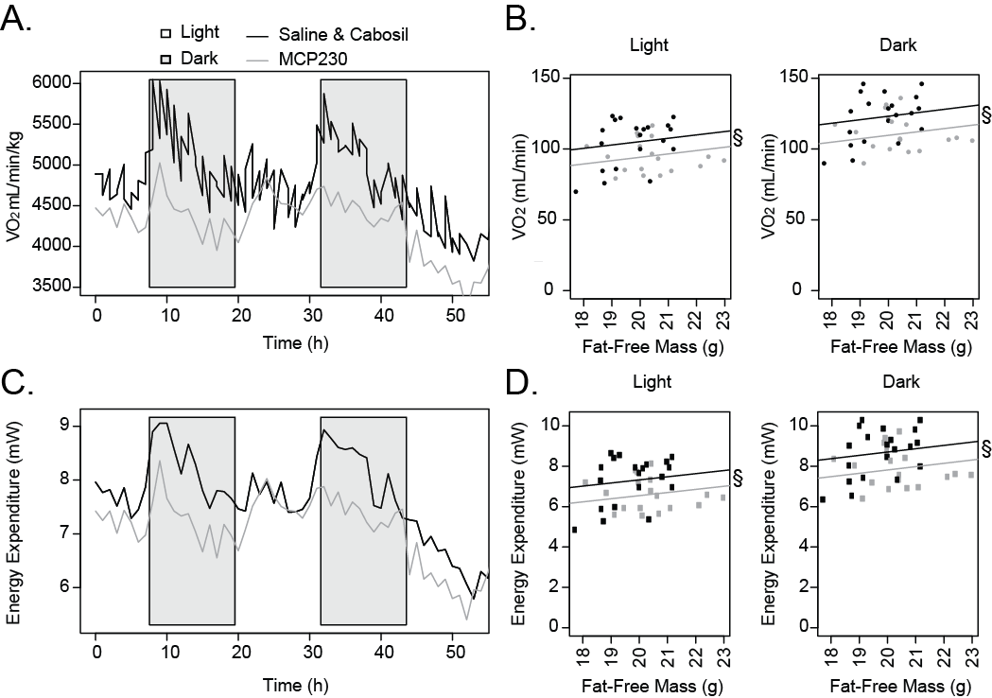

**Figure 5.** (A-B) O2 consumption (VO2) and (C-D) energy expenditure (mW) of control mice and mice exposed to MCP230 *in utero*. Energy expenditure was calculated using the Lusk equation. This appears in the revised manuscript as Fig. 4A-D.

Also - considering energy expenditure is lower, analysis of uncoupling proteins in skeletal muscle and adipose depots may help inform on the mechanism.

In the revised manuscript, we evaluated uncoupling proteins in the muscle and epididymal adipose tissue. We observed an increase in muscle *Ucp2* mRNA in the MCP230-exposed mice and a small but not significant decrease in *Ucp1* mRNA in eWAT (p=0.08).. Based on these new data, we do not think that decreases in UCP’s are able to explain the reduction in energy expenditure observed in the MCP230-exposed mice, as increased uncoupling in muscle would be expected to increase O2 consumption, rather than cause a reduction. As skeletal muscle *Ucp2* and *Ucp3* are relevant to oxidative stress responses (which we have expanded upon in the revised manuscript), we have included this data in our revised submission. The new figure is also reported here, for your convenience.

**B**

**A**

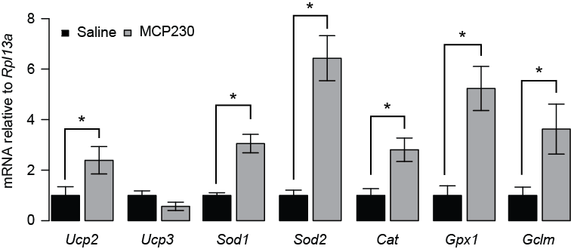

**Figure 6. (A)** Relative mRNA expression of genes involved in the oxidative stress response in the quadriceps muscle of mice after *in utero* MCP230-exposure and 12 wk HFD as adults. cDNA was prepared from quadriceps RNA, amplified using the appropriate primer pair (see table 1 of manuscript for details) and quantified using a Light Cycler 480 with SYBRgreen dye. Values are mean ± SE, n=7-11/group. Asterisk indicates p<0.05 via Student’s *t*-test (*Cat*), Welch’s *t*-test (*Sod1*, *Sod2*, *Gpx1*) or Wilcoxon-Rank Sum Test (*Ucp2*, *Gclm*). This appears as Fig. 7 of the revised mansucript. (B) *Ucp1* mRNA in epididymal white adipose tissue.

4) Based on the RER data - it seems that the Cabosil control alters energy metabolism independent of the EPFR as the Cabosil group and the MCP230 group both show increases in fat oxidation (or decreases in carbohydrate oxidation) compared to saline. Thus, it is pertinent to ensure that the Cabosil is not a confounding variable. Also, why is the VO2 graph and the ambulatory movement graph labelled as both Saline and Cabosil while the RER is labelled as 3 groups? It is unclear what is happening here.

Where all three groups were studied, we have analyzed all three groups separately to ensure that there was no effect of cabosil. The only instance where cabosil responded differently to the saline group was for RER. Because of this, in the paper we have presented the RER data for the three groups individually. Where parameters were not different between cabosil and saline (all other measurements), we combined the groups in order to increase our statistical power. This is now stated in the statistics paragraph of the methods section (page 7). As you can see from Figure 7 of this document, the cabosil and saline group had similar responses for other metabolic cage measurements (cabosil versus saline: VO2-Light, p=0.56; VO2-Dark, p=0.74; Heat-Light, p=0.49; Heat-Dark, p=0.85; Activity-Light, p=0.07; Activity-Dark, p=0.91), and thus were combined in the figures we present in the manuscript.

**“In cases where cabosil and saline treatment were not significantly different, these data were combined and designated as a single control group.”**

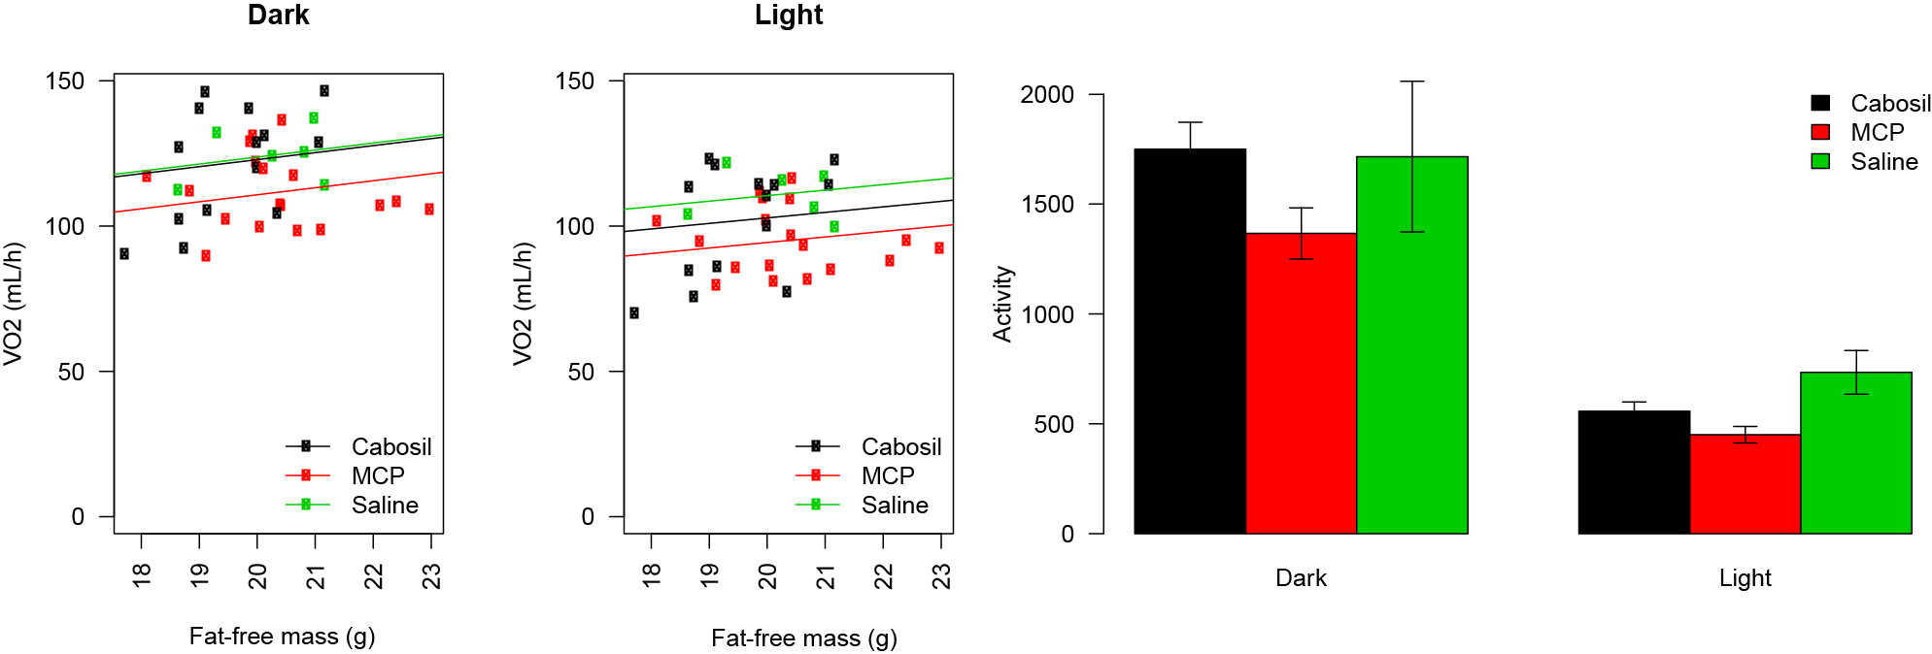

**Figure 7.** VO2 and activity of mice exposed to saline, cabosil or MCP230 *in utero*. The control groups responded similarly whereas the MCP230-exposed mice had reduced VO2 (left panel) and reduced activity (right panel).

5) The fact that mitochondrial protein expression does not correlate with citrate synthase activity is interestingly and should be further addressed. Functional experiments in freshly isolated mitochondria or permeabilized myofibres would be important to investigate the functional significance of these differences.

We do not think that it is surprising that citrate synthase activity is reduced but the oxphos proteins are unchanged by MCP230 exposure. Enzyme activity can be modulated by many factors other than their level of protein expression. Indeed, it is known that mitochondrial enzymes are susceptible to post-translational changes that limit their activity, particularly during periods of cell stress including oxidative stress. As described above (reviewer 1, comment 5) we have provided more robust data showing that OXPHOS protein levels are unchanged in these lysates. In our revised discussion we hypothesize that oxidative stress may alter the function of these proteins.

Minor

Figure 3A y-axis is unusual

We have amended the figure so that the axis extends out to 200 mg/dL.

What is the dose of EPFR compared to how much a human would be exposed to?

Each exposure is equivalent to a human breathing 200 ug/m3 PM2.5 (which is the amount a human would inhale on a typical day in a city such as Los Angeles). These values were obtained based on modeling calculations using MPPD software (version 2.0). For further details on how this is calculated, we refer you to the supplementary methods for (7). We have included a statement about this in the revised discussion section (page 12). The new text is also included here for your convenience.

**“Each exposure of MCP230 that the mothers received was the equivalent to a human breathing 200µg/m3, which is similar to what would be inhaled on a typical day in one of the major US cities** (7)**.”**

Reviewer #3 (Comments to the Author (Required)):

This is a very interesting article in which the investigators propose that in utero exposure to particulate matter (EPFR) will increase the risk of the offspring developing a form of metabolic disease. The manuscript is very well written and the overall presentation is strong.

Although, the hypotheses are important the submission suffers from an incomplete assessment of mitochondria and lacks any attempt to provide a mechanism to explain the outcome. It is further challenging to determine if the effect of EPFR is a direct or a secondary effect on the skeletal muscle.

This in its self is an interesting question, albeit one that is an entirely different question to the one we have set out to address. As our protocol stands, it is the mothers of the mice we are studying that are treated directly with the particulate, not the offspring themselves. Thus, it is probable that all the effects we see in the muscle (and elsewhere) occur indirectly, as we have no evidence at present that particulates come into direct contact with the offspring. Whether or not the particulate itself crosses the placenta to exert its effects on the offspring is difficult to determine. We have stated as much in our revised manuscript (page 14).

**“It should be emphasized that this exposure is indirect, through the mother, as there is no evidence at present that the particulate conjugated EPFR crosses the placenta to exert its effect on the muscle directly.”**

Overall, the manuscript is largely dependent on mRNA and protein measures as a surrogate for functional measures, which significantly reduces the enthusiasm for the ideas that drive the submission.

Our revised manuscript now provides *in vivo*, functional data (energy expenditure) as well as the skeletal muscle mRNA and protein measurements and enzyme activity determination as described above.

No functional data provided for the mitochondria (i.e. mitochondrial respiration). When considering the defined hypotheses it would seem these measures are necessary.

We present citrate synthase activity as a functional measure of mitochondrial activity, which is congruent with our findings of changes in whole body energy expenditure. We acknowledge that this is not a thorough of an assessment of mitochondrial function; however such analyses were not possible in the resubmission time frame. In the revised manuscript, we have provided more molecular data regarding mitochondrial biogenesis pathways, oxidative stress and mitochondrial protein levels, as described above. We have added this caveat to the revised discussion:

**“Similarly to previous reports on oxidative stress-induced mitochondrial dysfunction** (8)**, we did not see observe reductions in upstream regulators of mitochondrial biogenesis (Figure 6) or mitochondrial protein expression (Figure 5D and E) as part of the chronic effects of acute *in utero* MCP230-exposure…**

**…Future studies with direct measurements of mitochondrial function and the oxidative stress response will provide more mechanistic insight into this process.”**

We also cite the work of Siegel *et al*. (8), who have previously shown that mild oxidative stress reduces mitochondrial function *in vivo*, but *ex vivo* measurements of skeletal muscle respiratory capacity in these mice are not impaired, suggesting that the *in vivo* milieu is important for determining how oxidative stress regulates skeletal muscle mitochondrial function. Thus, while more functional data may prove useful to us, it is equally possible that data from *ex vivo* respirometry experiments may not provide us with a compelling answer. We expect to answer these important questions in future studies.

In the same line of thinking, the discussion provides extended discussions on oxidative stress, yet the submission does not provide a single measure of oxidative stress.

We agree with this reviewer and have extended our findings in the revised manuscript to include measurement of genes known to be upregulated in response to oxidative stress. We found that mRNA for the antioxidant genes *Sod1*, *Sod2*, *Cat*, *Gpx1* and *Gclm* were all increased in the mice exposed to MCP230, whereas *Ucp2*, an uncoupling protein known to be induced in response to oxidative stress as a means to reduce endogenous ROS production was also elevated. These new data are provided here as part of one of our earlier responses (reviewer #2, response 6, Figure 6 of this document, Figure 7 of the revised manuscript). We think these data, along with previous reports are compelling enough to support our hypotheses regarding oxidative stress.

Also, there is a disconnect between the mtDNA results and the results obtained using the OXPHOS antibody with no clear explanation over why this may have occurred. Functional data or EM imaging likely would clear this up.

The ambiguity regarding the very slight increases in mitochondrial protein levels and mtDNA has been partially resolved in the revised manuscript. We now show more robust data that OXPHOS protein levels are unchanged, in spite of reductions in mtDNA and citrate synthase activity. As described above, respirometry data or EM imaging are not possible with our current samples, and are not be possible within the revision time-frame.

Providing some sort of intervention that targets the skeletal muscle mitochondria to prevent the overall phenotype induced by the EPFR would significantly strengthen the study.

We have a follow up study planned that tests our oxidative stress hypothesis and aims to prevent the phenotype we report in this manuscript via the use of hSOD2 transgenic animal exposures. This work, while closely related, is beyond the scope of the current study and we believe is better served as an entirely separate study. We have amended our discussion to state that while oxidative stress is one potential mechanism, this report does not conclusively prove that hypothesis to be true.

Finally, the purpose of the idea was to determine if the animals develop a form of metabolic disease after the EPFR exposure. Thus the authors provided the animals with a HFD, however based on the way the data are presented it is challenging to determine if the HFD actually had an effect. Specifically, there is no attempt to determine if the mice develop any sort of glucose intolerance or insulin intolerance while on the HFD.

All our mice were exposed to a high fat diet to induce obesity and our intention was to assess whether acute *in utero* MCP230 exposure would worsen features of the obesity phenotype with a focus on chronic changes in energy balance. We found that all groups of mice responded similarly to the HFD with regards to fasting glucose and insulin concentrations (and HOMA-IR) as described in the new Figure 3 of the revised manuscript. These levels, while not different between the groups, were elevated compared to non-obese mice of a similar age on a standard rodent chow diet. We have presented new data regarding insulin sensitivity and limited our statements regarding metabolic syndrome in our responses above (reviewer 2, response 1).

**Figure 8.**  Comparison of body weight responses to different rodent diets and the body weight data from our current study. All mice were C58BL/6J males and 151-155 d of age at time of measurement. Where control diet or HFD was used, mice were switched from standard rodent chow to the appropriate diet at 70 d of age and maintained on that diet for 12 wk. The standard rodent chow contained 3.0 kCal/g and 17% kCal from fat (Harlan Teklad #8640), whereas the control diet was a semi pure diet providing 3.85 kCal/g and 10% kCal as fat (Research Diets #D12450H) and the high fat diet was a semi pure diet providing 4.73 kCal/g and 45% kCal as fat (Research Diets #D12451).

**References for this Response**

1. **Allister EM**, **Robson-Doucette CA**, **Prentice KJ**, **Hardy AB**, **Sultan S**, **Gaisano HY**, **Kong D**, **Gilon P**, **Herrera PL**, **Lowell BB**, **Wheeler MB**. UCP2 regulates the glucagon response to fasting and starvation. *Diabetes* 62: 1623–1633, 2013.

2. **Echtay KS**, **Roussel D**, **St-Pierre J**, **Jekabsons MB**, **Cadenas S**, **Stuart J a**, **Harper J a**, **Roebuck SJ**, **Morrison A**, **Pickering S**, **Clapham JC**, **Brand MD**. Superoxide activates mitochondrial uncoupling proteins. *Nature* 415: 96–9, 2002.

3. **Gali Ramamoorthy T**, **Laverny G**, **Schlagowski A-I**, **Zoll J**, **Messaddeq N**, **Bornert J-M**, **Panza S**, **Ferry A**, **Geny B**, **Metzger D**. The transcriptional coregulator PGC-1β controls mitochondrial function and anti-oxidant defence in skeletal muscles. *Nat Commun* 6: 10210, 2015.

4. **Kim HJ**, **Ham SA**, **Kim MY**, **Hwang JS**, **Lee H**, **Kang ES**, **Yoo T**, **Woo IS**, **Yabe-Nishimura C**, **Paek KS**, **Kim JH**, **Seo HG**. PPARδ coordinates angiotensin II-induced senescence in vascular smooth muscle cells through PTEN-mediated inhibition of superoxide generation. *J Biol Chem* 286: 44585–44593, 2011.

5. **Riserus U**, **Sprecher D**, **Johnson T**, **Olson E**, **Hirschberg S**, **Liu A**, **Fang Z**, **Hegde P**, **Richards D**, **Sarov-Blat L**, **Strum JC**, **Basu S**, **Cheeseman J**, **Fielding B a.**, **Humphreys SM**, **Danoff T**, **Moore NR**, **Murgatroyd P**, **O’Rahilly S**, **Sutton P**, **Willson T**, **David H**, **Frayn K**, **Karpe F**. Activation of Peroxisome Proliferator–Activated Receptor (PPAR)d Promotes Reversal of Multiple Metabolic Abnormalities, Reduces Oxidative Stress, and Increases Fatty Acid Oxidation in Moderately Obese Men. *Diabetes* 57: 332–339, 2008.

6. **San-segundo L**, **Guimarães L**, **Fernández C**, **Beltrán EM**, **Guilhermino L**, **Victoria M**. Alterations in gene expression levels provide early indicators of chemical stress during Xenopus laevis embryo development : A case study with per fl uorooctane sulfonate ( PFOS ). *Ecotoxicol Environ Saf* 127: 51–60, 2016.

7. **Saravia JS**, **You D**, **Thevenot P**, **Lee GI**, **Shrestha B**, **Lomnicki S**, **Cormier SA**. Early-life exposure to combustion-derived particulate matter causes pulmonary immunosuppression. *Mucosal Immunol* 7: 694–704, 2014.

8. **Siegel MP**, **Kruse SE**, **Knowels G**, **Salmon A**, **Beyer R**, **Xie H**, **van Remmen H**, **Smith SR**, **Marcinek DJ**. Reduced coupling of oxidative phosphorylation In Vivo precedes electron transport chain defects due to mild oxidative stress in mice. *PLoS One* 6, 2011.

9. **Wang P**, **Liu J**, **Li Y**, **Wu S**, **Luo J**, **Yang H**, **Subbiah R**, **Chatham J**, **Zhelyabovska O**, **Yang Q**. Peroxisome proliferator-activated receptor δ is an essential transcriptional regulator for mitochondrial protection and biogenesis in adult heart. *Circ Res* 106: 911–919, 2010.