**We thank the reviewers for their insightful and carefully considered comments. Considering and addressing these issues makes this a much clearer and more coherent manuscript. We have substantially revised the manuscript based on these suggestions, by providing extra data and/or more refined details in the manuscript for each of these comments. A point-by point response to each of these comments is presented below. Our comments are in bold, and direct quotes from the manuscript are shown in bold and red.**

## Reviewer 1

The aim of this study was to examine factors predicting weight gain on chow, a synthetic control diet, and a synthetic HFD in C57BL6/J mice. The authors report larger variation in weight gain in mice on HFD that was not present in leptin deficit models, that was unrelated to animal dominance. Weight gain was inversely related to pre-diet weight loss in response to a 16hour fast, please rationale why this was tested as a predictive factor in the introduction. Weight gain was not related to the measured appetite and glucoregulatory hormonal factors. There are a lot of small errors and omissions in this work throughout that require attention. I found some of the figures a bit confusing and don’t understand why some figures are supplementary and others are not.

1. Table 1 - the percentages given as fat, CHO and protein do not add up to 100% (67% for chow, 89 and 91% for CD and HFD so this leads me to believe that it is by weight with fibre missing from the calculation?

**We checked with the vendors and we have updated Table 1 accordingly. The percentages are given as % of calories, but maltodextran was accidentally omitted from the table. Now that it is included, the CD and HFD amounts add up to 100% of the calories. More details about these diets are available at the following links. Furthermore, NCD was erroneously presented as percent weight not percent calories. This has been rectified as well. We apologize for this error. Furthermore, we have indicated a note in the methods section and table legend specifying the seasonal variability in the Teklad diet:**

**Note that there are seasonal variations in the composition of the Teklad diet, and therefore these numbers are reasonable estimates on a batch to batch basis.**

**These changes have also altered the calculations shown in Supplementary Figure 1E, and we have updated both that figure, and the p-values obtained from the mixed linear models in the results section.**

1. But I cannot compute how a 45% fat by weight diet is only 0.7kcals/g less than the 5% by weight fat diet. Please check.

**These values have been now verified with the vendors.**

1. I disagree that a high fat content specifically causes weight gain, even if the calculations from table 1 are correct and there was no difference in energy intakes. Activity levels of mice were not assessed and so this claim should be removed.

**This statement was removed, as the reviewer makes and excellent point regarding our interrogation of energy expenditure without supporting data.**

1. Why was a 16h fast chosen? This should be discussed, this is prolonged and likely induces some stress, could stress susceptibility be a factor related to weight gain? Can cortisol be assessed?

**We chose to examine mice after a 16h fast in order to activate the full breadth of body weight defense mechanisms, outside of food intake. This includes activation of not only glucagon, but also cortisol, and growth hormone dependent catabolic pathways (see** [1, 2]**). At this stage, we did not observe substantial ingestion of the bedding materials, and we and others have previously used this duration of fast in other studies** [3]**. Although it is possible that we may observe altered effects with shorter or longer fasting times, we have not performed those studies. We have addressed this issue in the discussion section (note, references are numbered relative to this document):**

**We tested the effects of fairly prolonged food deprivation, as this duration will activate not only glucagon signaling, but also other catabolic signaling cascades including growth hormone and glucocorticoids** [1, 2]**. In this way, our protocol for food deprivation is likely to engage all of these pathways to defend body weight in the absence of food.**

**We also mentioned in the results section that hormones were altered during fasting in manner consistent with other reports:**

**Futhermore, the fasting/refeeding responses (decreases in total ghrelin, glucagon, GLP-1 and increases with insulin) are consistent with previous data, supportive of a normal fasting response** [4–7]**.**

1. Do the investigators consider that fasting levels of gut related peptides and one refed timpoint is sufficient for proper assessment of appetite related factors? Please discuss. Please clarify the re-fed time taken in the methodology.

**Refeeding was performed for 6h in these animals, as clarified in the methods section:**

**For re-feeding experiments, the indicated food was re-administered to fasted animals for 6 hours *ad libitum* along with water.**

**The reviewer brings up an excellent point regarding the timing of appetite related factors. Although we observed significant elevations in fasting ghrein and glucagon, and a modest elevation of GLP-1 between fasted and refed groups (see Supplementary Figure 2A), a thorough examination of the kinetics of these changes was not performed, and is beyond the scope of this study. These markers do however provide a context to the extent of fasting and re-feeding responses observed in Figure 2 (formerly Figure 3). This is mentioned in the results section as described above in comment #4 from this reviewer.**

**Furthermore, we clarify in both the results and discussion section that we determined total ghrelin and not active ghrelin.**

1. I am confused between cohorts 3-6 given in Figure S1 and Cohorts 1-4 in the text please reconcile.

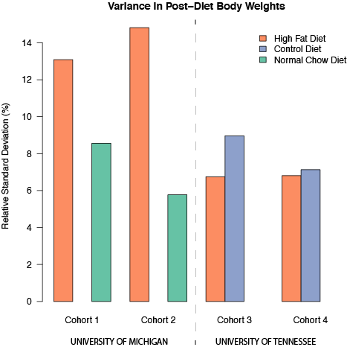

**Figure 1: Cohort and site-dependence of variations in end-point body weights.** We examined the relative standard deviation of each cohort/diet group separately. There was significantly more variation in both of the University of Michigan housed HFD fed animals, but **not** the Tennessee-housed HFD fed animals.

**This was a labeling error and has been fixed in both the manuscript and Figure S1.**

1. Since HFD animals gained more at one location than the other, I do not think it is appropriate to combine these. Do the results hold when HFD groups are separated into cohorts by location? Could this be reason for variability in weight gain on HFD? I am not sure what is meant by “minimal variation across cohorts”? From the figure to me it looks as if there is considerable variation across the HFD cohorts, but within the same cohort is smaller variation?

**We examined these cohorts separately, according to this very insightful suggestion. The reviewer is correct in noting that there may be differential variability between facilities. For reasons we do not quite understand, the increased variation in HFD animals was only present at one location, not the other. These separated data are presented in Figure 1 of this response.**

**This re-analysis has our interpretation of the altered variance. It is possible that one of these facilities is an outlier, and that there either is or is not increase variance in HFD-fed animals, but without repeating this at several other animal facilities we can not make any conclusive statements. We informally discussed this with several colleagues who have also done high fat diet treatment, and found that while there is some location-to-location variance, the enhanced variance present in cohorts 1 and 2 was especially high at the University of Michigan facility. As such we have removed what was Figure 1 from this paper, and any reference to the increase variation with high fat diet as we are not confident in these effects. We profusely thank the reviewer for his keen eye.**

**Notably, there is quite strong consistency between cohorts 3 and 4. In any case, to be careful, we re-examined all other figures in which multiple cohorts were combined. As stated in the methods section:**

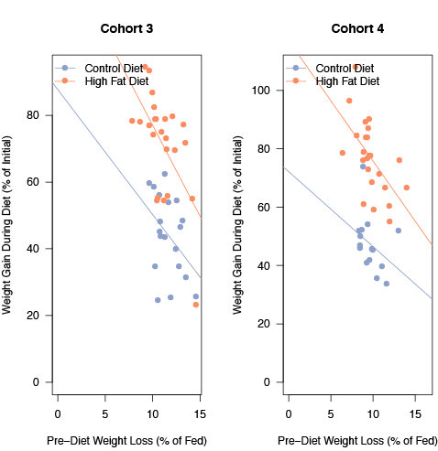

**Figure 2: Cohort separated effects of pre-diet fasting response to weight gain during HFD.** In both cohorts, the the relationship between pre-diet fasting response and weight gain by HFD was p<0.003 with a Rho2 of >0.33.

**When a difference or correlation was observed to be significant (or not to be significant) over multiple combined cohorts of mice we also examined each of these cohorts separately. If the combined trend agreed with all of these cohorts independently, we used the combined groups with its increased statistical power. If there was not agreement in all cohorts we do not report this effect as significant, even if the combined analysis suggested it was.**

**Importantly, the key finding of this paper in which pre-diet fasting responses correlated with eventual weight gain was highly siginificant in both cohorts tested. These data, separated by cohort are shown in Figure 2 of this response.**

1. Please also provide data as to all relationships between WL by fasting when given in grams rather than as % in Figure 3, do these results hold?

**We have now clarified throughout the manuscript both relative and absolute weight loss and weight gain, and which effects were significant. For Figure 3 (now Figure 2), we present only one set of graphs for space reasons, but describe weight loss in both absolute (g lost) or relative (% loss) terms throughout. For example:**

**Fasting responses, as measured by either absolute or percent reductions in body weight were stable within NCD fed male C57BL/6J mice over time (Figure 2A, Rho2<0.02, p>0.26), and only weakly correlated with the pre-diet weight fasting responses within mice in either relative or absolute terms (Figure 2B, Rho2<0.12, p<0.019 for HFD and Rho2<0.153,p<0.031 for CD).**

**Furthermore, we checked the data in Figure 1C (formerly 2C), and determined that there is no significant correlation between any of these hormones on either percent or absolute weight gain. This is noted in the results section as well:**

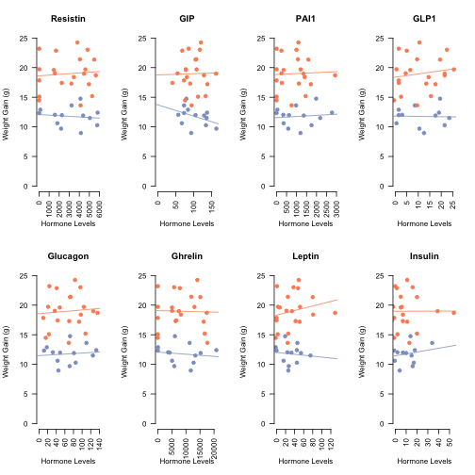

**Figure 3: Effects of fasted pre-diet hormone levels on absolute weight gain.** The correlations between these hormones and percent weight gain is still shown in Figure 2C. All correlations are p< 0.20 and Rho2 < 0.14

**We observed no significant correlation between pre-diet hormone levels and either percent or absolute weight gain in both HFD and CD fed mice (Figure 1C and Table 2).**

**Since absolute weight gain data are not included in the revised manuscript they are presented in Figure 3 of this response.**

**Finally, as noted below in comment #12, we examined weight gain and fasting response in grams rather than in percent for the data presented in Figure 3 (formerly Figure 4).**

1. Why were there 3 fasting weight loss periods reported in Figure 3A? This was only done twice 12 weeks apart?

**In addition to the 10-week and 22-week weights (which were part of the pre-diet and post-diet measurements), we also included an extra cohort, of only wild-type normal chow C57BL/6J that were untreated and left on a chow diet for an extended period of time. These mice make up the ~215 day old cohort shown in Figure 2A (formerly 3A). No other studies were performed on this cohort, and they were not used in any other analyses since they had no age matched HFD/CD cohort. We include this to demonstrate over a longer range of ages that fasting responses are quite stable at a population level. We indicated this in the results section where we clarify that these are NCD fed mice and in the methods section:**

**For the ~215 day old mouse cohort shown in Figure 2A, these mice were maintained on NCD for a longer duration than other cohorts, before fasting responses were measured.**

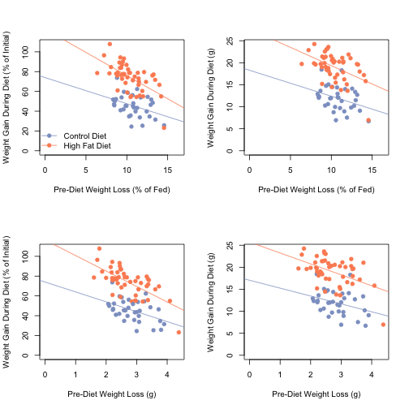

**Figure 4: Full set of comparisons between relative/absolute fasting response and relative/absolute weight gain.** These data compare the correlation between the pre-diet fasting response and the eventual weight gain during the dietary treatment. See Table 1 of t his response for correlation coefficients and p-values.

1. There were also 2 outliers, did results include these individuals?

**Yes, throughout the study all outliers were included in the analysis. As per this particular figure, there were several outliers. One of these was determined to be a data entry error, in one Control Diet animal’s pre-diet fasting response. This was corrected in the revised analysis. Removing the other actual outliers did not affect the results of this regression analysis. For percent weight loss upon fasting the Spearman's rank ordered test showed no significant correlation. (Rho=0.0427 Rho2= 0.0177 and p=0.2685) and with outliers removed (Rho=0.1772 Rho2= 0.0314 and p=0.1484). For total weight loss there was also no correlation (Rho=-0.093 Rho2= 0.0071 and p=0.4834) and with outliers removed (Rho=-0.0618 Rho2= 0.0038 and p=0.6167).**

1. Figure 3B can be deleted.

**We disagree, our findings show that fasting responses at ~10 weeks of age are quite predictive of weight gain, but that the fasting response of a mouse is not stable over time. This figure (now 2B, formerly 3B) is essential to this point as noted in the discussion section:**

**Of note it is interesting that fasting responses themselves are not stable throughout life on a per mouse basis (see Figure 2B). This suggests that either the fasting response is not causative of weight gain directly, or is only causal during a younger age. These data are consistent with reports that among adult human populations, basal metabolic rate is not reduced in obese individuals** [8, 9] **to the extent that reductions in metabolic rates in pediatric populations are predictive of obesity** [10, 11]**.**

**We therefore feel that this figure is essential to the interpretation of how fasting responses are established and when they exert their effects.**

1. The last 3 paragraphs of the results section could be shortened to one. Please clarify the relative contribution of fasting response and diet to weight gain.

**This paragraph was revised and shortened as suggested. To clarify the effects of fasting response to weight gain, we only included the effect of relative weight loss to relative weight gain on the diet. In our opinion this is the most direct answer to our question. We have removed from the manuscript the other potentially distracting correlates. The full set of potential comparisons between relative and absolute fasting responses and relative and absolute weight gain are presented here both in statistical (Table 1 of this response) and graphed form (see Figure 4 of this response):**

**Table 1: Correlation Coefficients as calculated by Spearman’s Rho between weight gain during the diet and fasting response prior to the diet**. Asterisk indicates p<0.05

|  |  |  |
| --- | --- | --- |
|  | **Pre Diet Relative Fasting Response** | **Pre Diet Absolute Fasting Response** |
| HFD - Absolute Weight Gain | -0.398* | -0.332* |
| HFD - Relative Weight Gain | -0.610* | -0.618* |
| CD - Absolute Weight Gain | -0.324 | -0.319 |
| CD - Relative Weight Gain | -0.335 | -0.418* |

**As these data show, the trend is quite consistent no matter how the data is analyzed. The description in the results section has now been clarified to read:**

**Both HFD and CD fed mice exhibited less weight gain when the pre-diet fasting response was elevated (Figure 3). We found a strong negative correlation between percent weight gain and relative fasting response (Rho=-0.61, Rho2 =0.373, p=6.6 x 10-6). For CD fed mice the same pattern was present, though the correlation did not quite reach statistical significance (Rho=-0.334, Rho2 =0.112, p=0.0538). These trends also reached statistical significance for all the combinations tested between both relative and absolute fasting responses and relative and absolute weight gain during HFD (p<0.03 and Rho < -0.33 for all comparisons). These data show that mice which resisted weight loss during the pre-diet 16 hour fast were far more susceptible to weight gain while on the experimental diet, and that this factor predicted weight gain much more comprehensively than hormonal factors, or pre-diet weight (Table 2 and Figure 3).**

1. Please be consistent with terminology utilising NCD or “chow”

**NCD is now used throughout the manuscript when referring to the normal chow diet rather than “chow”.**

1. Why use “trend” to described the reduction in food intake, this P was <0.05?

**The word trend was removed. The sentence now reads:**

**We found that food intake on both a per gram basis (Supplementary Figure 1D, p=0.0033) and a caloric basis (Supplementary Figure 1E, p=0.0038) decreased even as the mice gained weight.**

1. Figure 3B doesn’t match the listed figure should be 1C and 1D?

**This has been fixed, we thank the reviewer for noticing this error.**

1. Figures 2 is not significant and could be removed.

**Figure 2 (now Figure 1) is important even though there were no significant differences detected. Of course, the absence of proof is not proof of an absence, but these results, as well as those in Table 2 rule out some common possibilities of predictors of weight gain. We feel it is essential that these negative data are reported.**

1. Why were NCD not included on Figure 4?

**As noted in Supplementary Figure 1 and Figure 3 there are dramatic differences in the weight gain and feeding responses in NCD fed animals compared to CD fed animals. This is likely due to the different nature of the ingredients (grain for chow, chemically defined ingredients for CD/HFD). We therefore decided that it would be difficult to interpret fasting responses in this system, and that the appropriate control for HFD was the CD. We therefore did not perform these studies using animals kept on chow throughout. This is explicated in the results section as such:**

**Due to the dramatically different fasting responses observed in NCD mice compared with CD mice (See Figure 2C and E) we only performed these studies comparing the more chemically comparable CD and HFD diets**.

1. Data is not split in SFig2 for hormone/diet differences but is stated in the results section. Please include or remove entirely.

**Supplementary figure 2 now clearly indicates which diet/feeding status changes were statistically significant. We have clarified the meaning of the asterisks in the figure legend. We have also added more details regarding these hormonal changes being consistent with previous reports, and for which changes we observed statistically significant differences:**

**Significant differences of were detected between several hormones (resistin, total ghrelin, GLP-1 and leptin) as well as fasting glucose levels between these diets. These are consistent with previous reports of HFD induced changes relative to NCD diets for resistin and leptin** [12, 13]**.**

## Reviewer 2

In this manuscript the authors have described the physiological effects of dietary manipulation in a common inbred strain of laboratory mice. The aim of this study was to control the genetic background, environment and diet of these laboratory animals as closely as possible in order to assess the amount of variability that is not due to genetic differences. Although this work is compare different genetic mouse, the data presented are not novel and some results are not consistent with the conclusive statements of the Authors.

**Although, it was not specified which data are problematic, we believe that these very likely overlap with some of the comments and clarifications suggested by reviewer #1. This is especially true for reviewer 1’s comments 1, 3 and 7, which we have discussed in detail above.**

I saw this paper published on biorxiv already. <http://biorxiv.org/content/early/2014/04/23/004283>

**With respect to the previous publication issue, there is a quite simple explanation. Biorxiv is a pre-print server where publications under peer review can be placed to get more broad feedback from the scientific community. For example the comments listed in other changes were due to feedback on this public preprint. This is an emerging publishing theme in biological sciences, but is quite common in mathematics and physics** [14]**. Some recent examples of articles which started as preprints and then were subsequently accepted for publication in high impact journals include** [15, 16]**.**

**Based on data obtained from the SHERPA/RoMEO database (**[**http://www.sherpa.ac.uk/romeo/issn/2090-0708/**](http://www.sherpa.ac.uk/romeo/issn/2090-0708/)**) the Journal of Obesity allows posting of pre-prints. This pre-print is identical to the submitted version, and will be updated with this revised version(s). Upon acceptance of this manuscript, there will be a link to the official JOBE article indicating that the finished version of the manuscript is present there. This is not therefore a duplicate publication, but rather an attempt to engage in a less canonical model of publication and review.**

## Other Changes

* **Based on a suggestion of someone who read the article on biorxiv, we tested the assumption that the pre-diet hormones and body weight gain (both absolute and percent) fit a normal distribution. We did this via a Shapiro-Wilk test, and determined that the data were not normally distributed. Therefore rather than use Pearson’s R to calculate correlations we used Spearman’s Rank Order test, which does not presume normality between covariates. This alters the values in Table 2, and in the descriptions of Figures 1, 2 and 3 (formerly 2, 3 and 4). These changes are described in the methods section:**

**Correlations were determined using Spearman’s rho after testing whether the covariates were normally distributed (Shapiro-Wilk test p<0.05).**

## References

1. Ho, K. Y., Veldhuis, J. D., Johnson, M. L., Furlanetto, R., Evans, W. S., Alberti, K. G., and Thorner, M. O. (1988). Fasting enhances growth hormone secretion and amplifies the complex rhythms of growth hormone secretion in man. J. Clin. Invest. *81*, 968–975.

2. Luque, R. M., Park, S., and Kineman, R. D. (2007). Severity of the catabolic condition differentially modulates hypothalamic expression of growth hormone-releasing hormone in the fasted mouse: potential role of neuropeptide Y and corticotropin-releasing hormone. Endocrinology *148*, 300–9.

3. Lu, B., Bridges, D., Yang, Y., Fisher, K., Cheng, A., Chang, L., Meng, Z., Lin, J., Downes, M., Yu, R. T., et al. (2014). Metabolic Crosstalk: molecular links between glycogen and lipid metabolism in obesity. Diabetes.

4. Holst, J. J., Orskov, C., Nielsen, O. V, and Schwartz, T. W. (1987). Truncated glucagon-like peptide I, an insulin-releasing hormone from the distal gut. FEBS Lett. *211*, 169–74.

5. Kreymann, B., Ghatei, M. A., Williams, G., and Bloom, S. R. (1987). Glucagon-Like Peptide-1 7-36: A Physiological Incretin in Man. Lancet *330*, 1300–1304.

6. Tschöp, M., Weyer, C., Tataranni, P. a, Devanarayan, V., Ravussin, E., and Heiman, M. L. (2001). Circulating ghrelin levels are decreased in human obesity. Diabetes *50*, 707–9.

7. Tschöp, M., Smiley, D. L., and Heiman, M. L. (2000). Ghrelin induces adiposity in rodents. Nature *407*, 908–13.

8. Leibel, R. L., Rosenbaum, M., and Hirsch, J. (1995). Changes in energy expenditure resulting from altered body weight. N. Engl. J. Med. *332*, 621–8.

9. Ravussin, E., Lillioja, S., Anderson, T. E., Christin, L., and Bogardus, C. (1986). Determinants of 24-hour energy expenditure in man. Methods and results using a respiratory chamber. J. Clin. Invest. *78*, 1568–78.

10. Griffiths, M., Payne, P. ., Rivers, J. P. ., Cox, M., and Stunkard, A. . (1990). Metabolic rate and physical development in children at risk of obesity. Lancet *336*, 76–78.

11. Roberts, S. B., Savage, J., Coward, W. A., Chew, B., and Lucas, A. (1988). Energy expenditure and intake in infants born to lean and overweight mothers. N. Engl. J. Med. *318*, 461–6.

12. Steppan, C. M., Bailey, S. T., Bhat, S., Brown, E. J., Banerjee, R. R., Wright, C. M., Patel, H. R., Ahima, R. S., and Lazar, M. a (2001). The hormone resistin links obesity to diabetes. Nature *409*, 307–12.

13. Frederich, R. C., Hamann, A., Anderson, S., Löllmann, B., Lowell, B. B., and Flier, J. S. (1995). Leptin levels reflect body lipid content in mice: evidence for diet-induced resistance to leptin action. Nat. Med. *1*, 1311–4.

14. Desjardins-Proulx, P., White, E. P., Adamson, J. J., Ram, K., Poisot, T., and Gravel, D. (2013). The case for open preprints in biology. PLoS Biol. *11*, e1001563.

15. Kuntz, S. G., and Eisen, M. B. (2014). Drosophila embryogenesis scales uniformly across temperature in developmentally diverse species. PLoS Genet. *10*, e1004293.

16. Bloom, J. S., Ehrenreich, I. M., Loo, W. T., Lite, T.-L. V., and Kruglyak, L. (2013). Finding the sources of missing heritability in a yeast cross. Nature *494*, 234–7.