Bridges Evaluation Report Fall 2013

During the first semester of the Bridges project, we collected some baseline data from the students enrolled in 4 sections (1-4) of ITCS 2214 and ITCS 4155. During the first week of the semester, the ITCS 2214 students were assigned to take an Attitude toward Computing survey (25 items) and to self-report their confidence in retention in the major on a 1-5 scale. Those measures were again administered during the last week of the semester to measure any change in either computing attitude or confidence in retention, and in addition we surveyed the students attitude about their homework assignments (5 item survey) and the level of experience and number of hours required for the course and the homework assignments.

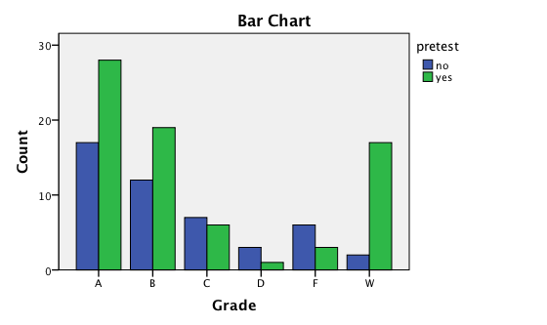Of the 204 students enrolled in ITCS 2214 only 82 (40%) filled out the pretest. Interestingly, filling out the pretest was related to course grade, Chi square (121, 5)= 12.81, p< .05. Of those with As&Bs, 61% took the pretest, for those with Cs or below, however, less than half took the pretest. Of the student who withdrew from the course, 90% took the test?

These data suggest that there was a high level of engagement early in the semester for those who do well in the course and this engagement separates them from the students who get Cs or less. Those who withdrew showed a much different data pattern, however, from those who got low grades in the class. They show a high level of engagement at the beginning of the semester.

Given this data pattern, we also looked at whether there were differences in response to the computing attitude scale and confidence by grade. In the figure below, Ws are coded with a -1. There were no differences in computing attitude across grade level F < 1. We also compared grade levels on each of the factor scores as well and similarly, there were no differences, Fs < 1. Confidence in the major was also not significantly different across grade levels, F < 1.

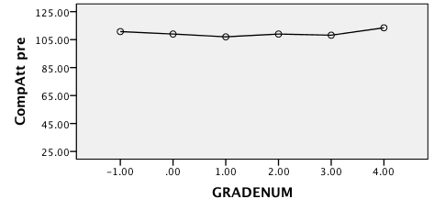

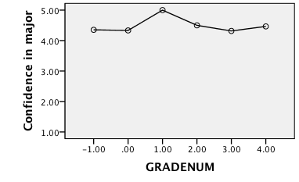

**GPA distribution of students who withdrew during Fall 2013 semester**.

Clearly among the 19 students who withdrew there are students who are low performing but also a handful of students who have high GPA? Would speculate that some withdrew to maintain high GPA. Noticed that there were several Ws on their transcript and they were trying to improve GPA.



**Pre vs Post comparison**

A comparison of the pre and post scores on the Attitude toward Computing scale and the confidence in retention in the major showed that there were no differences , ts < 1. However, there were only 31 students who took both pre and post surveys. So, for the student enrolled in ITCS 2214 during the Fall 2013 semester, their attitudes toward computing and their confidence in retention did not show any significant changes as a result of their participation in the course.

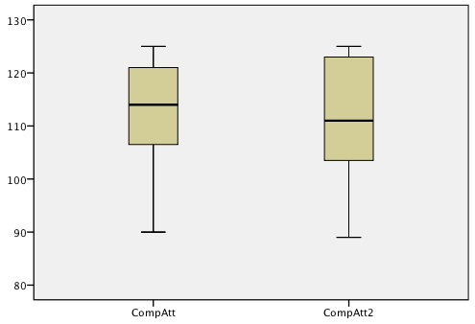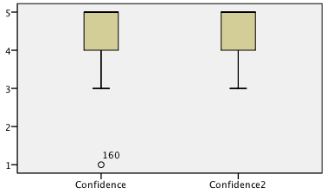

**Factor Analysis of the Attitude towards computing scale**

A principle components analysis with a varimax rotation was performed on the 25 items in the Attitudes Toward Computing Scale (with the additional 5 items added to measure self confidence) that was administered as the post survey scale. There were 59 students who completed the post survey. Results of the analysis identified 4 factors with robust coefficient alphas. Factor 1 which accounted for 23% of the variance consisted of 8 items that measured negative attitudes toward computing. Factor 2 (6 items) measured positive attitudes toward computing and accounted for 18% of the variance, while Factor 3 (4 items) measured men/women issues for 16% of the variance. Factor 4 measured career orientation for 13% of the variance and included 4 items.

The five additional items did not add anything to the variance accounted for and as a result were dropped from the data analysis.

**Factor 1 Negative attitude (α = .92)**

I have little self-confidence when it comes to computing courses.

I think computer science is boring.

My career goals do not require that I learn computing skills.

I do not think that I can learn to understand computing concepts.

The challenge of solving problems using computer science does not appeal to me.

I hope that I can find a career that does not require the use of computer science concepts.

I doubt that I can solve problems by using computer applications.

I do not like using computer science to solve problems.

**Factor 2 Positive attitude (α = .89)**

I am comfortable with learning computing concepts.

I hope that my future career will require the use of computer science concepts.

I can learn to understand computing concepts.

I like to use computer science to solve problems.

I am confident that I can solve problems by using computer applications.

The challenge of solving problems using computer science appeals to me

**Factor 3 Men and women in computer science (α = .86)**

Computing is an appropriate subject for both men and women to study.

Women and men can both excel in careers that involve computing.

Men and women are equally capable of solving computing problems.

Men and women can both excel in computing courses.

**Factor 4 Oriented toward career in Computer Science (α = .86)**

I think computer science is interesting.

I expect that learning to use computing skills will help me achieve my career goals.

I would voluntarily take additional computer science courses if I were given the opportunity.

Developing computing skills will be important to my career goals.

|  |  |  |  |  |
| --- | --- | --- | --- | --- |
|  |  |  |  |  |

**Regressions with final grades as the outcome measure**

Regression analyses were conducted with the pre/ post survey data to see which measures were related to final grades. The regression analysis with the pretest survey data were not found to be related to final grades F<1 .

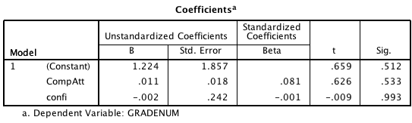

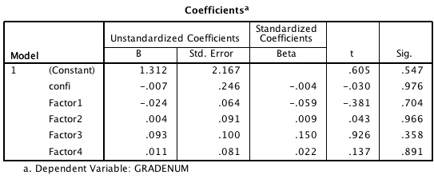

However, regressions with the post surveys measures were significantly related to final grades, F(8,46)= 4.67, p< .001, R2 = .45. Ratings on Assignments and Factor 2 (Positive Attitude toward computer science) were positively related to grades while Factor 4 (career orientation) and the number of hours spent on homework were negatively related to grades. See scatterplots below. (Exp= Experience with computing assignments. Sum of two items)

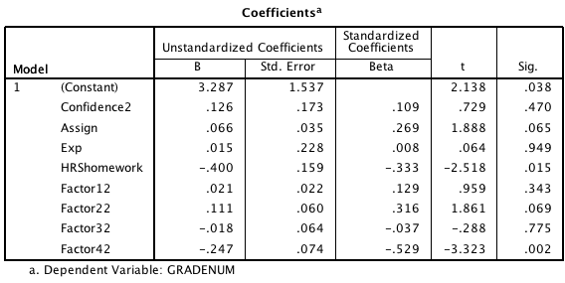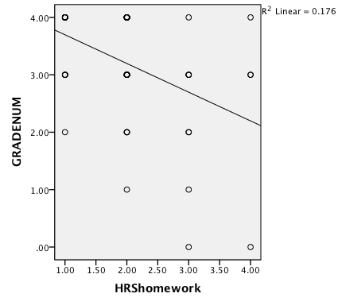

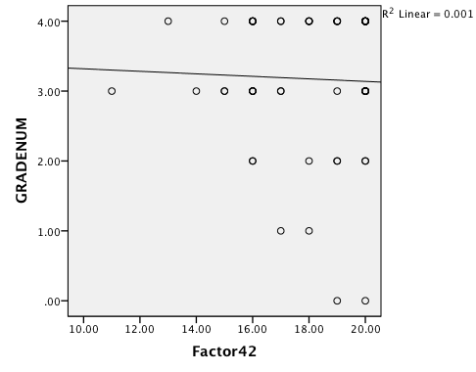

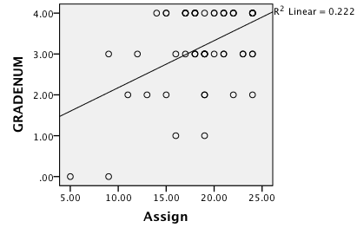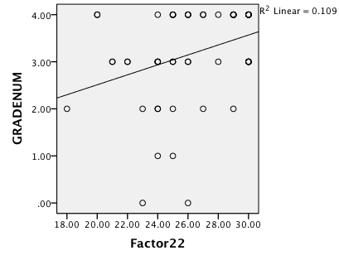

**Sample Characteristics**

We had grades for 200 students enrolled in one of four sections. From the number who filled out either or both of the surveys (101 students), only 13 were women and 67 were white. Of the 58 students who filled out the post survey, 16 reported spending 3 hrs or less on homework and 30 indicated an average of 4-6 hrs spent on homework. Only 12 indicated that they spent 7 or more hours on their homework assignments.

The ratings about the assignments were summed across five items with scores that varied between 5-24. Average score was 18.6 (SD = 4.17). Boxplot below shows the distribution of those ratings. There were a few extreme low scores.

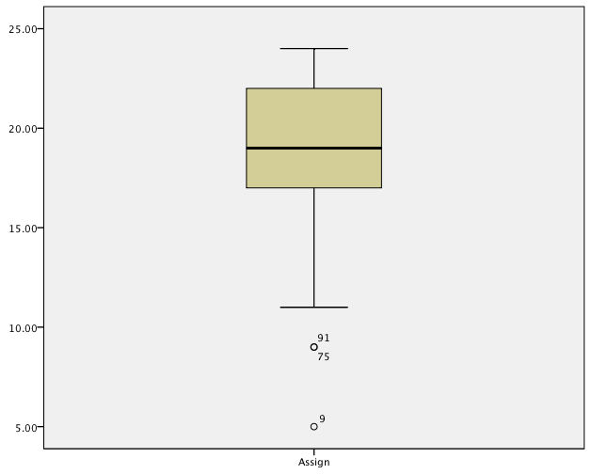

When asked to rate the level of experience required by the course and the assignments, 44% indicated that it was about right for their experience level while 45% thought that it required more experience than they had, and 11% thought that it required less.

**ITCS 4155 Post survey results**

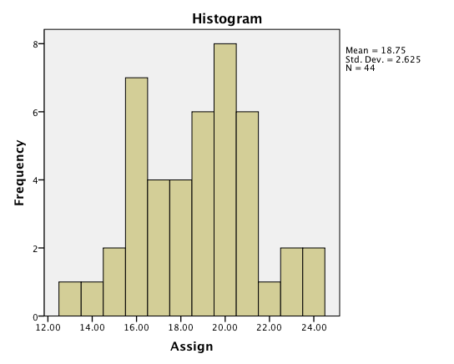There were 52 enrolled in the course and 45 of them responded to the survey during the last week of the semester. Of those who responded 5 were women and 26 White. Average age was 23 (SD = 3.6). 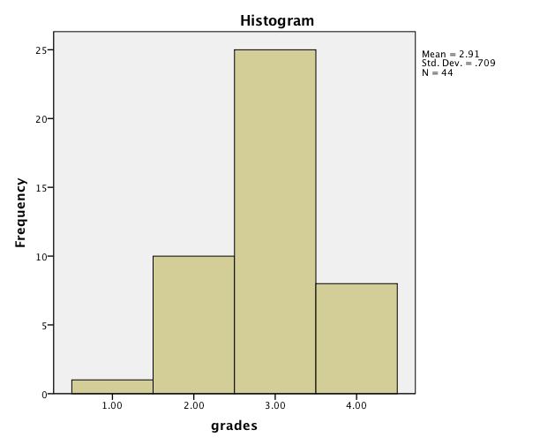

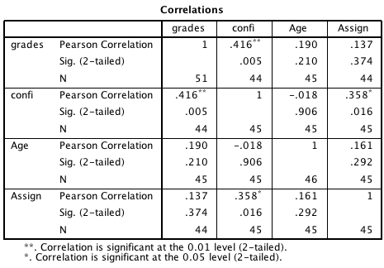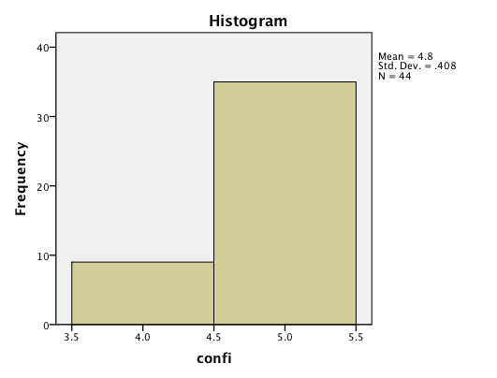

Confi=Confident that you will graduate with your chosen computing major.

