**Bridges Evaluation Report Fall 2014**

During the Fall 2014 semester, three Bridges exercises were included as homework assignments for the students enrolled in ITCS 2214 section 001 and there were a couple of joint meetings with some of the seniors from ITCS 4155. This was also the first semester that we administered the knowledge tests to measure gains in course material in both the sophomore ITCS 2214 and the senior ITCS 4155 courses. The knowledge tests were administered to all 5 sections of ITCS 2214 and ITCS 4415 during the first and last weeks of the semester. The students in all 5 sections of ITCS 2214 were also asked to take an Attitude toward Computing survey and to self-report their confidence in retention in the major on a 1-5 scale during the first week of the semester. These scales were used again in the survey during the last week of the semester together with a course engagement survey and items that measured the level of experience, and the number of hours required for the course and the homework assignments.

**Comparison of Bridges class to other sections of ITCS 2214**

The table below shows the mean scores of the students enrolled in section 001 (Bridges section coded as group 1) compared to the other sections on all of the measures taken during the first week of the semester including their GPA. The students in the two groups did not differ on any of the pretest measures. Their GPAs were similar as were their scores on the knowledge pretest. Similarly, their attitude toward computing as measured by the four factor scores shown below were similar and their confidence in retention in the computer science major.

|  |  |  |  |  |  |
| --- | --- | --- | --- | --- | --- |
| **Measures taken during first week of Fall 2014 semester** | | | | | |
|  | group | N | Mean | Std. Deviation | t test |
| GPA | 1.00 | 54 | 2.70898 | 1.014823 | <1 |
| 2.00 | 200 | 2.76453 | 1.032537 | . |
| Confidence | 1.00 | 50 | 4.48 | .814 | <1 |
| 2.00 | 115 | 4.53 | .729 |  |
| CApositive | 1.00 | 50 | 39.5600 | 4.59441 | <1 |
| 2.00 | 115 | 38.8087 | 4.63188 |  |
| CAnegative | 1.00 | 50 | 34.3400 | 4.50673 | 1.22, p = .22 |
| 2.00 | 115 | 33.2000 | 5.85677 |  |
| CAmale/femal | 1.00 | 50 | 18.9600 | 1.74917 | <1 |
| 2.00 | 115 | 18.6783 | 2.06282 |  |
| CAcareer | 1.00 | 50 | 18.0000 | 2.27677 | <1 |
| 2.00 | 115 | 17.9130 | 2.30394 |  |
| Knowledge pretest | 1.00 | 51 | 33.47 | 11.57 | <1 |
| 2.00 | 168 | 32.03 | 8086 |  |
|  |  |  |  |  |  |

Notes

Group 1 = Bridges, ITCS section 001

Group 2 = all other ITCS sections

CApositive= Computing Attitude Scale- positive attitude toward computing

CAnegative=Computing Attitude Scale-negative attitude toward computing

CAmale/female=Computing Attitude Scale-attitude toward men and women

CAcareer=Comuting Attitude Scale- Career oriented factor.

Similar to data collected in the previous semester, the average rating for confidence in retention in the major went down, t(57) = 2.09, p = .04 for all students enrolled in ITCS 2214 from pre to the post test, but there were no significant shifts in the factor scores of the Attitude toward the Computer Science Scale .

The table below compares the two groups (Bridges vs the other sections) on the measures taken during the last week of the semester. There were no differences in any of the factors associated with course engagement, confidence in retention in the major, or ratings about the homework assignments. However, there were significant between group differences in performance on the knowledge test and in the final course grades. Students in the Bridges group (group 1) scored higher on the knowledge posttest and, when these scores were adjusted for the knowledge scores in the pretest, they indicated a larger gain in test performance when compared to students enrolled in the other sections. In spite of showing greater gains in performance on the knowledge test, however, course grades in the Bridges section were significantly lower than in the other sections.

|  |  |  |  |  |  |
| --- | --- | --- | --- | --- | --- |
| **Measures taken during last week of Fall 2014 semester** | | | | | |
|  | group | N | Mean | Std. Deviation | t test |
| confidence | 1.00 | 29 | 4.14 | 1.156 | <1 |
| 2.00 | 58 | 4.24 | .904 |  |
| CApositive | 1.00 | 30 | 39.3667 | 5.96243 | 1.89, p=.06 |
| 2.00 | 59 | 36.9153 | 5.68812 |  |
| CAnegative | 1.00 | 30 | 34.0000 | 5.53360 | 1.59, p =.12 |
| 2.00 | 59 | 31.8644 | 6.19081 |  |
| CAmale/femal | 1.00 | 30 | 19.4000 | 1.13259 | 2.21, p= .03 |
| 2.00 | 59 | 18.3390 | 2.49558 |  |
| CAcareer | 1.00 | 30 | 18.1333 | 2.20866 | 1.35, p = .18 |
| 2.00 | 59 | 17.4237 | 2.41549 |  |
| Assignment | 1.00 | 30 | 16.5667 | 4.73930 | 1.88, p =.18 |
| 2.00 | 59 | 17.9661 | 3.94342 |  |
| Engage-skills | 1.00 | 30 | 29.5667 | 5.33488 | <1 |
| 2.00 | 58 | 28.8103 | 5.87130 |  |
| Engage-Emotional | 1.00 | 30 | 16.8667 | 4.50848 | 1.46, p= .15 |
| 2.00 | 58 | 15.3448 | 4.70368 |  |
| Engage-participation | 1.00 | 30 | 14.1333 | 4.17491 | -1.43, p=.16 |
| 2.00 | 58 | 15.7931 | 5.59059 |  |
| Engage- Performance | 1.00 | 30 | 9.0333 | 3.83705 | -1.43, p = .16 |
| 2.00 | 58 | 10.1034 | 3.04175 |  |
| Final Grade | 1.00 | 54 | 1.3519 | 1.54379 | -5.53, p <.001 |
| 2.00 | 200 | 2.6350 | 1.50436 |  |
| Knowledge posttest | 1.00 | 31 | 72.1613 | 18.00388 | 5.81, p <.001 |
| 2.00 | 131 | 54.8702 | 14.09277 |  |
| Knowledge gain | 1.00 | 29 | 36.7586 | 20.06357 | 4.21, p <.001 |
| 2.00 | 115 | 22.5739 | 15.13452 |  |

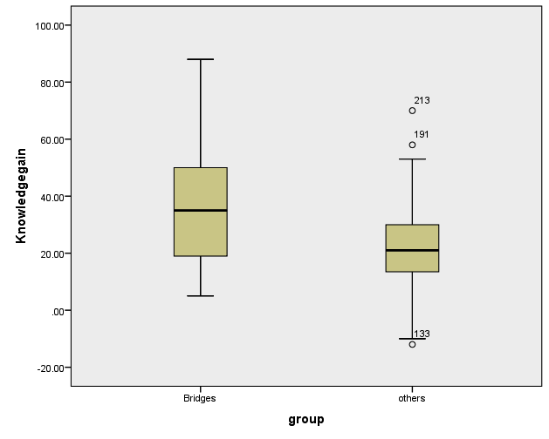

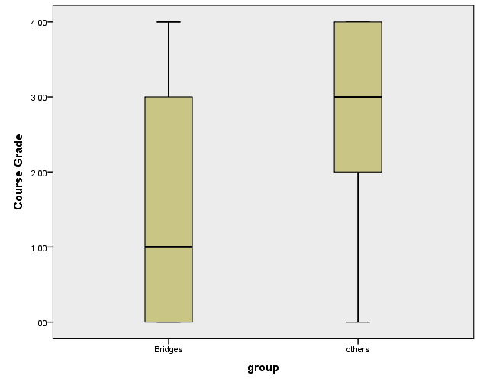

**Final Grades in ITCS 2215**

There were significant differences among the 5 sections in the distribution of the final grades, χ2(20, N=254)=101.87, p < .001. The table below shows that there were 29 withdrawals among the 254 students who were enrolled and 32 students with F grades.

|  |  |  |  |  |  |  |  |  |  |
| --- | --- | --- | --- | --- | --- | --- | --- | --- | --- |
| **SECTION * GRADE Crosstabulation** | | | | | | | | | |
|  | | | GRADE | | | | | | Total |
| A | B | C | D | F | W |
| SECTION | 001 | Count | 8 | 7 | 7 | 6 | 8 | 18 | 54 |
| % within SECTION | 14.8% | 13.0% | 13.0% | 11.1% | 14.8% | 33.3% | 100.0% |
| % within GRADE | 8.7% | 14.3% | 21.2% | 31.6% | 25.0% | 62.1% | 21.3% |
| % of Total | 3.1% | 2.8% | 2.8% | 2.4% | 3.1% | 7.1% | 21.3% |
| 002 | Count | 32 | 10 | 6 | 2 | 3 | 1 | 54 |
| % within SECTION | 59.3% | 18.5% | 11.1% | 3.7% | 5.6% | 1.9% | 100.0% |
| % within GRADE | 34.8% | 20.4% | 18.2% | 10.5% | 9.4% | 3.4% | 21.3% |
| % of Total | 12.6% | 3.9% | 2.4% | 0.8% | 1.2% | 0.4% | 21.3% |
| 003 | Count | 35 | 9 | 6 | 0 | 4 | 0 | 54 |
| % within SECTION | 64.8% | 16.7% | 11.1% | 0.0% | 7.4% | 0.0% | 100.0% |
| % within GRADE | 38.0% | 18.4% | 18.2% | 0.0% | 12.5% | 0.0% | 21.3% |
| % of Total | 13.8% | 3.5% | 2.4% | 0.0% | 1.6% | 0.0% | 21.3% |
| 004 | Count | 6 | 10 | 6 | 8 | 14 | 8 | 52 |
| % within SECTION | 11.5% | 19.2% | 11.5% | 15.4% | 26.9% | 15.4% | 100.0% |
| % within GRADE | 6.5% | 20.4% | 18.2% | 42.1% | 43.8% | 27.6% | 20.5% |
| % of Total | 2.4% | 3.9% | 2.4% | 3.1% | 5.5% | 3.1% | 20.5% |
| 005 | Count | 11 | 13 | 8 | 3 | 3 | 2 | 40 |
| % within SECTION | 27.5% | 32.5% | 20.0% | 7.5% | 7.5% | 5.0% | 100.0% |
| % within GRADE | 12.0% | 26.5% | 24.2% | 15.8% | 9.4% | 6.9% | 15.7% |
| % of Total | 4.3% | 5.1% | 3.1% | 1.2% | 1.2% | 0.8% | 15.7% |
| Total | | Count | 92 | 49 | 33 | 19 | 32 | 29 | 254 |
| % within SECTION | 36.2% | 19.3% | 13.0% | 7.5% | 12.6% | 11.4% | 100.0% |
| % within GRADE | 100.0% | 100.0% | 100.0% | 100.0% | 100.0% | 100.0% | 100.0% |
| % of Total | 36.2% | 19.3% | 13.0% | 7.5% | 12.6% | 11.4% | 100.0% |

The histogram below shows the GPA scores of those students who withdrew from ITCS 2214 this semester. Average GPA was a 2.79 but there was considerable range and 9 of the students had GPA’s above 3.0.

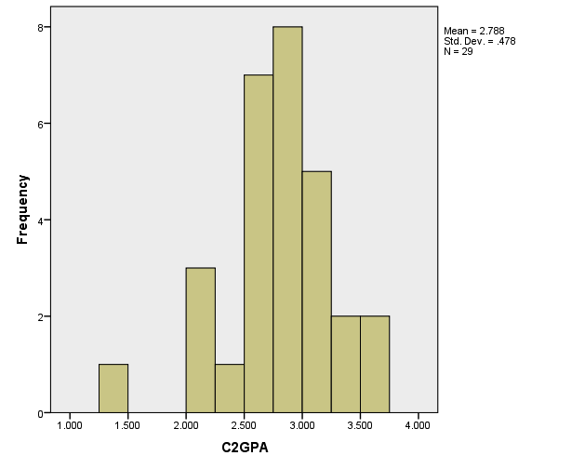

The students who withdrew had a higher average GPA than those who got Fs in the course. Below is the distribution of GPA of those students who flunked the course.

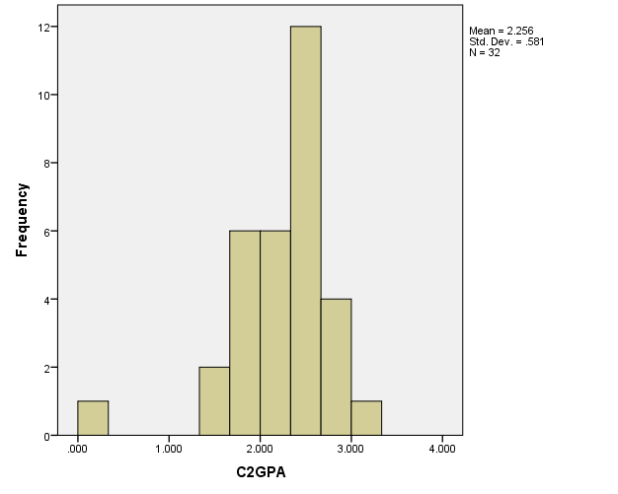

**Regression analysis with pre/post knowledge test gains as the outcome measure**.

In the first model, student’s sex, ethnic identity, GPA and knowledge pre test scores predicted 18% of the variation in the outcome measure. In the second model when Attitude toward Computing subscale scores and the confidence in retention in the major from the surveys collected during the first week of the semester were added in to the model, R2 increased significantly to explain an additional 41% of the variance in the outcome measure. When the measure collected in the survey at the end of the semester are added in (subscales of the Course Engagement Scale, ratings of experience required, groups, and the homework Assignment scores), R2 increased another 14% to explain a total of 73% of the variance in the outcome measure. Regression model with beta values are on the next page.

One of the most interesting predictors of the amount of knowledge gained is the Negative attitude subscale score of the Computing Attitude Scale taken during the first week in the semester. A graph showing the relationship is below.

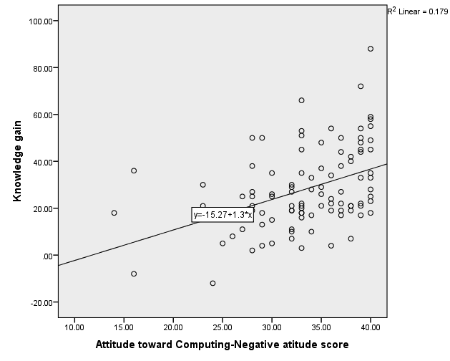

|  |  |  |  |  |  |  |  |  |  |
| --- | --- | --- | --- | --- | --- | --- | --- | --- | --- |
| **Model Summary** | | | | | | | | | |
| Model | R | R Square | Adjusted R Square | Std. Error of the Estimate | Change Statistics | | | | |
| R Square Change | F Change | df1 | df2 | Sig. F Change |
| 1 | .426a | .182 | .107 | 18.19275 | .182 | 2.442 | 4 | 44 | .061 |
| 2 | .768b | .589 | .494 | 13.69267 | .407 | 7.735 | 5 | 39 | .000 |
| 3 | .856c | .733 | .599 | 12.18696 | .144 | 2.462 | 7 | 32 | .039 |
| a. Predictors: (Constant), KnowScore, CGPA, ETHNICITY_CODE, Sexr | | | | | | | | | |
| b. Predictors: (Constant), KnowScore, CGPA, ETHNICITY_CODE, Sexr, f3mw, Confidence, f2NA, f4CO, f1PA | | | | | | | | | |
| c. Predictors: (Constant), KnowScore, CGPA, ETHNICITY_CODE, Sexr, f3mw, Confidence, f2NA, f4CO, f1PA, Engage2, Exp, group, Engage3, Assign, Engage4, Engage1 | | | | | | | | | |

|  |  |  |  |  |  |  |
| --- | --- | --- | --- | --- | --- | --- |
| **Coefficientsa** | | | | | | |
| Model | | Unstandardized Coefficients | | Standardized Coefficients | t | Sig. |
| B | Std. Error | Beta |
| 1 | (Constant) | 58.092 | 17.948 |  | 3.237 | .002 |
| ETHNICITY | 1.275 | 1.429 | .123 | .892 | .377 |
| Sex | -11.229 | 8.011 | -.193 | -1.402 | .168 |
| GPA | .132 | 2.524 | .007 | .052 | .959 |
| Knowledgepretest | -.627 | .236 | -.367 | -2.654 | .011 |
| 2 | (Constant) | 43.906 | 29.662 |  | 1.480 | .147 |
| ETHNICITY | .915 | 1.143 | .088 | .800 | .428 |
| Sex | -8.966 | 6.341 | -.154 | -1.414 | .165 |
| GPA | -1.130 | 2.011 | -.061 | -.562 | .577 |
| Knowledgepretest | -.543 | .182 | -.318 | -2.989 | .005 |
| Confidence | 2.114 | 2.374 | .109 | .890 | .379 |
| CA positive | -.663 | .667 | -.184 | -.995 | .326 |
| CA negative | 2.934 | .586 | .850 | 5.007 | .000 |
| CA men/wome | -2.995 | 1.772 | -.233 | -1.690 | .099 |
| CA career | -.548 | 1.367 | -.068 | -.401 | .691 |
| 3 | (Constant) | 42.763 | 31.421 |  | 1.361 | .183 |
| ETHNICITY | .035 | 1.119 | .003 | .032 | .975 |
| Sex | -10.601 | 7.003 | -.182 | -1.514 | .140 |
| GPA | -2.208 | 2.059 | -.120 | -1.072 | .292 |
| Knowledgepretest | -.675 | .176 | -.395 | -3.827 | .001 |
| Confidence | 2.257 | 2.339 | .117 | .965 | .342 |
| CA positive | -1.072 | .675 | -.298 | -1.588 | .122 |
| CA negative | 2.690 | .556 | .779 | 4.838 | .000 |
| CA men/wome | -3.089 | 1.638 | -.241 | -1.886 | .068 |
| CA career | .380 | 1.352 | .047 | .281 | .780 |
| Assign | .185 | .720 | .042 | .257 | .799 |
| Experience | 6.046 | 3.796 | .220 | 1.593 | .121 |
| Engage1 | .989 | .597 | .291 | 1.656 | .107 |
| Engage2 | .456 | .864 | .105 | .527 | .602 |
| Engage3 | -.826 | .601 | -.209 | -1.373 | .179 |
| Engage4 | 8.116E-006 | .813 | .000 | .000 | 1.000 |
| group | -8.918 | 5.311 | -.232 | -1.679 | .103 |
| a. Dependent Variable: Knowgain | | | | | | |

**ITCS 4415**

There were 58 students enrolled in ITCS 4415 during the Fall 2014 semester and, of those, 14 students were assigned as peer mentors to the students in the data structures course. Although the course times for the senior and the sophomore courses overlapped to allow for joint meetings, there were only a few occasions when the students from the two courses actually interacted.

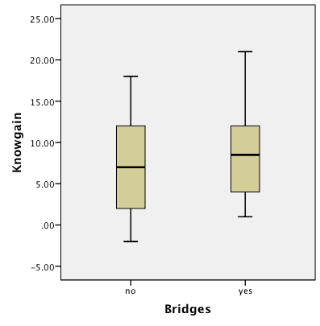The students took the knowledge test during the first and last weeks of the semester and the knowledge gained for those who participated as peer mentors for Bridges was similar to those who participated in other course related projects. All of the students showed significant gains in performance on the knowledge test across the semester.

| **Group Statistics** | | | | | |
| --- | --- | --- | --- | --- | --- |
|  | Bridges | N | Mean | Std. Deviation | T test |
| Knowgain | no | 37 | 6.5405 | 5.67448 |  |
| yes | 12 | 8.5833 | 5.93079 | -1.72000 |

The students were also surveyed at the end of the semester and asked to respond to a series of questions about the assignments and their confidence in graduating with a computer science major. The data is presented in the table below. There were no differences between the students who were peer mentors and the others in responding to any of the survey questions. When asked to use a Likert scale to indicate their agreement that the assignments increased their interest in computing, and showed how useful computing can be 80% of the students either agreed or strongly agreed. The only difference between the peer mentors and the other students was in their course grades. The peer mentors on average did not perform as well in the course.

| **Group Statistics** | | | | | |
| --- | --- | --- | --- | --- | --- |
|  | Bridges | N | Mean | Std. Deviation | t test |
| GradeN | no | 44 | 3.0455 | 1.07735 | 2.156, p=.046 |
| yes | 14 | 2.0000 | 1.70970 |  |
| Confidence in major | no | 24 | 4.83 | .381 |  |
| yes | 6 | 4.83 | .408 | <1 |
| Age | no | 24 | 24.13 | 4.079 |  |
| yes | 6 | 23.17 | 3.545 | <1 |
| GPA | no | 43 | 3.00691 | .574179 |  |
| yes | 14 | 2.99821 | .635345 | <1 |
| How many interesting computing assign | no | 24 | 3.25 | .794 |  |
| yes | 6 | 3.00 | .632 | <1 |
| Relevance of assign to career | no | 24 | 4.08 | .929 |  |
| yes | 6 | 4.17 | .753 | <1 |
| Course material relates to society | no | 24 | 3.96 | .908 |  |
| yes | 6 | 3.67 | 1.033 | <1 |
| Assign increased my interest in computing | no | 24 | 3.88 | .947 |  |
| yes | 6 | 3.67 | 1.033 | <1 |
| Assign show how useful computing can be | no | 24 | 4.08 | .974 |  |
| yes | 6 | 4.17 | .753 | <1 |