**Bridges Evaluation Report Spring 2014**

We continued with our baseline testing of the students who were enrolled in ITCS 2214 and ITCS 4155. As in the Fall, course grades were obtained and students were surveyed during the first and last weeks of the semester. Sophomores in ITCS 2214 took an Attitude Toward Computing Survey and self-reported their confidence about retention in the major during the first week. Those measures were administered for a second time during the last week of the semester to measure any change in either attitude or confidence in retention, and in addition we surveyed the students attitude about their homework assignments, level of experience required to complete assignments in the course, and number of hours spent on homework assignments. Lastly, a Bridges’ assignment was pilot tested in one of the ITCS 2214 sections toward the end of the semester and 8 of the students filled out a survey to measure their engagement in the exercise.

Student enrolled in the Senior course (ITCS 4155) were surveyed only during the last week of the semester to measure their attitudes about their course assignments, level of experience required to complete the assignments and number of hours spent on the assignments.

**ITCS 2214 Data Analysis**

A much larger percent of the students (74%) enrolled in the course during the first week took the pretest survey than in the fall semester. This was, most likely, because the instructors offered students extra credit for participation. Trends in the data were similar to the Fall results, such that the students who obtained As and Bs had a much higher rate of participation (>80%) than those who grades were lower. Lowest rate of participation (53%) was found in those who earned an F for the course. However, the relationship between filling out pretest was not found to be significantly related to course grades, Chi Square (140, 5) =10.55, *p* = .061.



These data are consistent with the Fall data in suggesting that there is a high level of engagement early in the semester for those who do well in the course and this engagement separates them for the student who get Cs or less. Thirty-six students withdrew from the course and their rate of participation was (64%) similar to the students who obtained a C in the course.

We also looked at whether Attitudes toward Computing and confidence in the major varied across those who received different course grades. The following bar graphs plot the mean score on each across grade levels. Although difference in attitudes and confidence are not apparent across course grade levels, it is interesting that of those who got Ds (seven of the nine) their scores on confidence about retention in the major were uniformly high (5 out of 5).

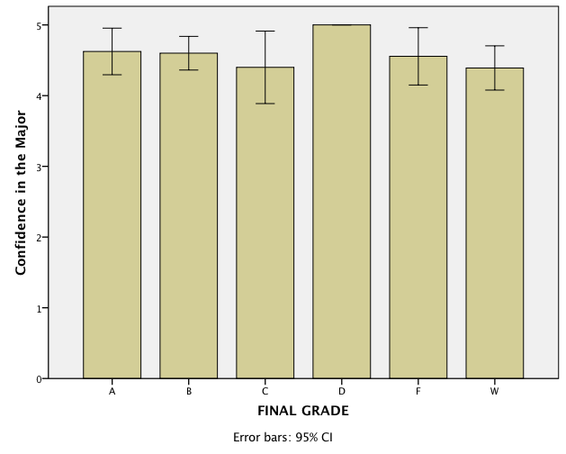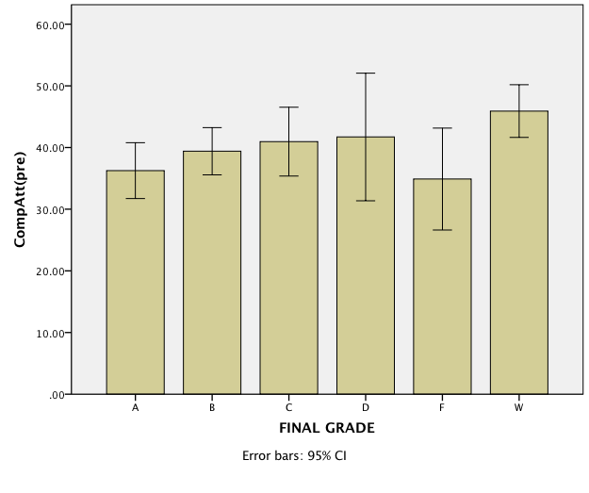

Pre *vs* Post comparison

Only 52 students took both the pre and the post test surveys. A comparison of the pre and post scores on the Attitude toward Computing scale and the confidence in retention in the major showed that there were no significant changes over the semester in the total score or in the subscale scores on these measures. Means and SD are presented in the Table below.

| **Paired Samples Statistics** | | | | | |
| --- | --- | --- | --- | --- | --- |
|  | | Mean |  | Std. Deviation | t value |
| Pair 1 | confiden pre | 4.63 |  | .627 | 1.72 |
| confidenpost | 4.38 |  | 1.013 |  |
| Pair 2 | CompApre | 39.9038 |  | 10.37202 | .97 |
| CompApost | 38.6154 |  | 9.92354 |  |
| Pair 3 | Factor1pre | 14.3269 |  | 5.54030 | 1.02 |
| Factor1post | 13.4423 |  | 4.25378 |  |
| Pair 4 | Factor2pre | 9.5962 |  | 3.00496 | .82 |
| Factor2post | 9.3269 |  | 2.62508 |  |
| Pair 5 | Factor3pre | 4.9615 |  | 1.77080 | .25 |
| Factor3post | 4.9038 |  | 1.70650 |  |
| Pair 6 | Factor4pre | 6.1346 |  | 1.88938 | .55 |
| Factor4post | 6.0385 |  | 1.66817 |  |

Factor1, 2, 3, 4 represent the subscale scores on the Attitude toward computing scale.

Confiden = Score on the Confidence in retention in major

Participation in the Survey at the end of the semester was related to Course grade, Chi square (140,5) = 63.89, p < .001. As expected those who withdrew did not participate and those who earned As and Bs had a higher participation rate than those with lower grades. The following table and figure show that data.

| **FINAL GRADE * Postsurvey Crosstabulation** | | | | | |
| --- | --- | --- | --- | --- | --- |
|  | | | Posttest | | Total |
| no | yes |
| FINAL GRADE | A | Count | 5 | 13 | 18 |
| % within FINAL GRADE | 27.8% | 72.2% | 100.0% |
| % within Posttest | 6.8% | 19.4% | 12.9% |
| % of Total | 3.6% | 9.3% | 12.9% |
| B | Count | 5 | 24 | 29 |
| % within FINAL GRADE | 17.2% | 82.8% | 100.0% |
| % within Posttest | 6.8% | 35.8% | 20.7% |
| % of Total | 3.6% | 17.1% | 20.7% |
| C | Count | 10 | 21 | 31 |
| % within FINAL GRADE | 32.3% | 67.7% | 100.0% |
| % within Posttest | 13.7% | 31.3% | 22.1% |
| % of Total | 7.1% | 15.0% | 22.1% |
| D | Count | 3 | 6 | 9 |
| % within FINAL GRADE | 33.3% | 66.7% | 100.0% |
| % within Posttest | 4.1% | 9.0% | 6.4% |
| % of Total | 2.1% | 4.3% | 6.4% |
| F | Count | 14 | 3 | 17 |
| % within FINAL GRADE | 82.4% | 17.6% | 100.0% |
| % within Posttest | 19.2% | 4.5% | 12.1% |
| % of Total | 10.0% | 2.1% | 12.1% |
| W | Count | 36 | 0 | 36 |
| % within FINAL GRADE | 100.0% | .0% | 100.0% |
| % within Posttest | 49.3% | .0% | 25.7% |
| % of Total | 25.7% | .0% | 25.7% |
| Total | | Count | 73 | 67 | 140 |
| % within FINAL GRADE | 52.1% | 47.9% | 100.0% |
| % within Posttest | 100.0% | 100.0% | 100.0% |
| % of Total | 52.1% | 47.9% | 100.0% |

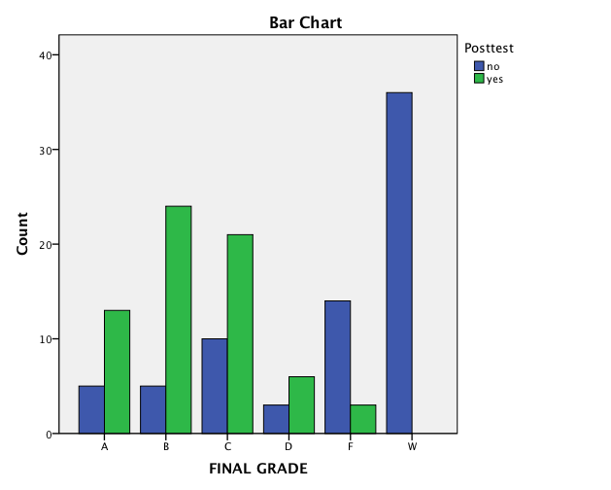

**Regressions with final grade as the outcome measure**

Regression analyses were conducted with the pre/post survey measures to determine if any were related to final grades. The regression analysis with the pretest survey data showed that when all of the the pretest measures were entered into a multiple regression there was no relationship to final grades, F (5, 94) = 1.69, *p* = 143, R2 = .083. However, when the “Negative Attitude” subfactor (Factor1) of the attitude toward computing scale was entered into the regression, it was inversely related to final grades.

| **Coefficientsa** | | | | | | |
| --- | --- | --- | --- | --- | --- | --- |
| Model | | Unstandardized Coefficients | | Standardized Coefficients | t | Sig. |
| B | Std. Error | Beta |
| 1 | (Constant) | 2.853 | 1.545 |  | 1.846 | .068 |
| confi | .025 | .258 | .010 | .096 | .924 |
| Factor1 | -.103 | .041 | -.299 | -2.503 | .014 |
| Factor2 | -.012 | .093 | -.020 | -.124 | .902 |
| Factor3 | -.016 | .111 | -.015 | -.141 | .888 |
| Factor4 | .057 | .148 | .060 | .384 | .702 |
| a. Dependent Variable: Gradenum  confi= Confidence in retention in the major  Factor1, 2, 3, 4= Factors of the Attitude toward Computing scale | | | | | | |

Regressions with the measures taken during the last week of the semester were found to be related to course grade, *F* (8,58) = 3.95, *p*=.001, R2 = .35. The negative attitude subfactor of the Computing Attitudes scale and the level of programming experience required for the course were both positively related to final grade.

| **Coefficientsa** | | | | | | |
| --- | --- | --- | --- | --- | --- | --- |
| Model | | Unstandardized Coefficients | | Standardized Coefficients | t | Sig. |
| B | Std. Error | Beta |
| 1 | (Constant) | -.321 | 1.079 |  | -.297 | .767 |
| Confidence | .134 | .119 | .145 | 1.129 | .264 |
| Factor1post | .053 | .025 | .253 | 2.065 | .043 |
| Factor2post | .040 | .077 | .146 | .516 | .608 |
| Factor3post | -.020 | .071 | -.048 | -.284 | .778 |
| Factor4post | -.064 | .123 | -.153 | -.520 | .605 |
| ASSIGN | .021 | .032 | .083 | .658 | .513 |
| Experience | .928 | .265 | .472 | 3.500 | .001 |
| hrs homework | -.089 | .158 | -.073 | -.567 | .573 |
| a. Dependent Variable: Gradenum | | | | | | |

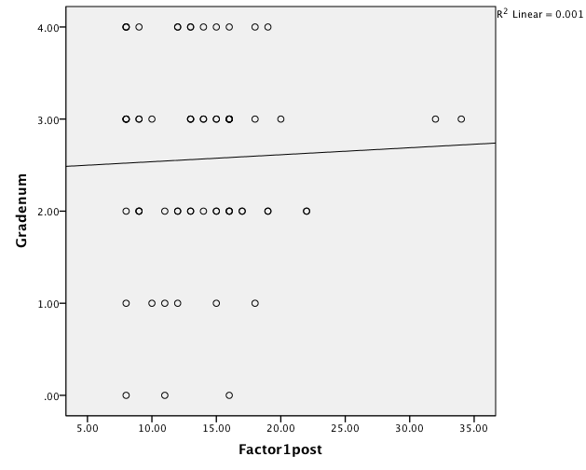

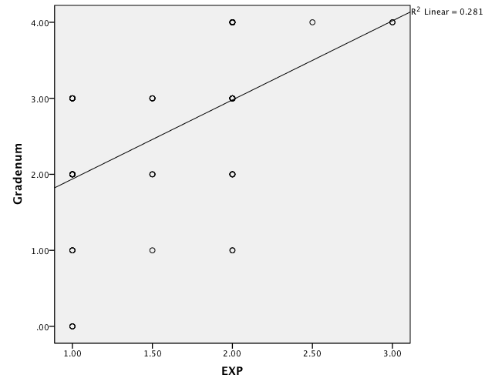

Experience measure was the average of the student’s response to two items on postsurvey

Compare your level of programming experience with the experience required by the ITCS 2214 course

Rate the level of experience required by your ITCS 2214 computing assignments relative to your experience.

Response scale

1. more programming experience than I have

2. about right for my programming experience level

3. less programming experience than I have

**Student Characteristics in ITCS 2214**

There were 140 students who completed ITCS 2214 during the Spring 2014 semester. From that group, there were only 18 (13%) women. Fifty-three percent were white, 14% African American, 10% Hispanic, and 10% Asian.

Of the 69 students who completed the post survey, 49% reported spending 4-6 hours on homework assignments. Twenty –eight percent reported spending less time and 16% reported spending 7-9 hours on average on homework assignments. Seven percent reported spending 10 or more hours on average.

The ratings about the assignments were summed across five items with scores that varied between 5-24. Average score was 19 (SD=4.11). Boxplot below shows the distribution of that measure across the sample.

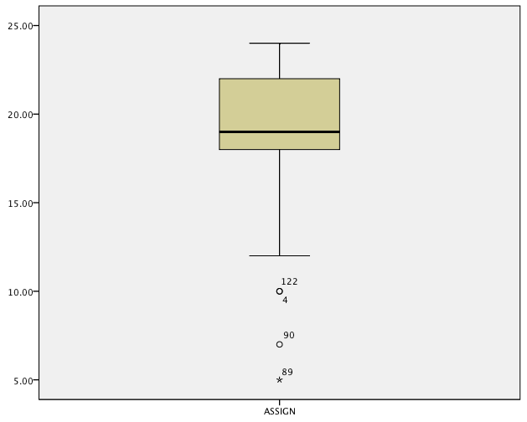

**Pilot test of the Bridges Exercise**

The 43 students enrolled in section 01 of ITCS 2214 pilot tested a Bridges Exercise during the last month of the semester. Eight of those students responded to a survey to report on their engagement in the pilot exercise. The engagement survey consisted of 10 items.

Seventy-five percent of the students agreed (25% undecided) that the exercise increased their interest in computing and approximately the same number disagreed with the statement that the assignment was trivial and not essential to learning about computing. Similarly when asked if the assignment was relevant to their career goals 50% agreed, and 12.50% disagreed.

When asked to rate the level of experience required 50% indicated that it was about right for their experience level while 35.5% indicated that it required more and 12.5% indicated that it required less experience than they had.

The following are their responses to the open ended items.

What is the essential concept(s)  that was learned by completing the assignment?

|  |
| --- |
| An interesting an concrete example of how a Graph data structure can be used. |
| Working with abstract data types, with lists, stacks, heaps, queues. |
| To show a visual representation of a conceptual graph. |
| How to use a hash map |
| Implementing a graph and breadth first search |
| I was able to see, in a more functional standing, how advanced loops could work in correlation with an  online program. It also gave a live a toon model of functioning heaps. |
| Just how the bridges program works. |
| Implementing the adjacency list method of graphs using hashmaps. Then using the graph to do DFS and BFS methods. |

**What is the essential concept(s)  that was learned by completing the assignment?**

|  |
| --- |
| An interesting an concrete example of how a Graph data structure can be used. |
| Working with abstract data types, with lists, stacks, heaps, queues. |
| To show a visual representation of a conceptual graph. |
| How to use a hash map |
| Implementing a graph and breadth first search |
| I was able to see, in a more functional standing, how advanced loops could work in correlation with an  online program. It also gave a live a toon model of functioning heaps. |
| Just how the bridges program works. |
| Implementing the adjacency list method of graphs using hashmaps. Then using the graph to do DFS and BFS  methods. |

Why is this important?

|  |
| --- |
| The Graph ADT is an important and widely used data structure in computing. |
| It facilitates extracting the information from raw data in a very efficient way. |
| To have a concrete example that I can think of when trying to use this data structure. |
| It is a fundamental part of data structures |
| Graphs are used for a variety of real-world problems |
| It's important to know how to build more advanced graphs than just bear bone graphs that are made it class.  It also gave a visual connection to an outward concept the students already knew. |
| It shows how we can use data structures rather than just learning about them. |
| Graphs are used in many useful types of coding like social networking and communication networks. |

**POST Survey results ITCS4155**

There were 65 students enrolled in two sections of the course and 46 of them responded to the survey during the last week of the semester. Of the student enrolled, there were 7 women and 28 were white with 4 Asian and 6 African American.

There was no relationship between responding to the survey and final course grade, Chi Square (65, 3) = 4.30, *p*= .23.

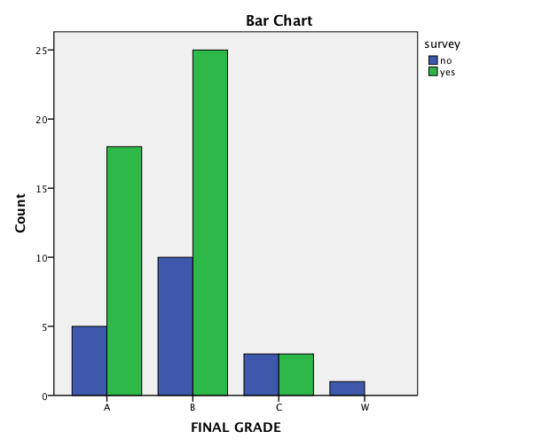

None of the measures in the survey were related to grade, F(4,41)= 1.13, p = .357, R2 = .10

| **Coefficientsa** | | | | | | |
| --- | --- | --- | --- | --- | --- | --- |
| Model | | Unstandardized Coefficients | | Standardized Coefficients | t | Sig. |
| B | Std. Error | Beta |
| 1 | (Constant) | .782 | 1.736 |  | .450 | .655 |
| confidence | .346 | .305 | .182 | 1.135 | .263 |
| age | -.001 | .014 | -.011 | -.071 | .944 |
| Assign | .028 | .022 | .188 | 1.258 | .215 |
| EXP | .191 | .198 | .144 | .961 | .342 |
| a. Dependent Variable: gradenum | | | | | | |

| **Correlations** | | | | | | |
| --- | --- | --- | --- | --- | --- | --- |
|  | | confi | age | Assign | EXP | gradenum |
| confi | Pearson Correlation | 1 | -.373* | .051 | -.024 | .192 |
| Sig. (2-tailed) |  | .011 | .739 | .876 | .200 |
| N | 46 | 46 | 46 | 46 | 46 |
| age | Pearson Correlation | -.373* | 1 | .029 | -.086 | -.086 |
| Sig. (2-tailed) | .011 |  | .847 | .568 | .569 |
| N | 46 | 46 | 46 | 46 | 46 |
| Assign | Pearson Correlation | .051 | .029 | 1 | .105 | .212 |
| Sig. (2-tailed) | .739 | .847 |  | .488 | .157 |
| N | 46 | 46 | 46 | 46 | 46 |
| EXP | Pearson Correlation | -.024 | -.086 | .105 | 1 | .161 |
| Sig. (2-tailed) | .876 | .568 | .488 |  | .286 |
| N | 46 | 46 | 46 | 46 | 46 |
| gradenum | Pearson Correlation | .192 | -.086 | .212 | .161 | 1 |
| Sig. (2-tailed) | .200 | .569 | .157 | .286 |  |
| N | 46 | 46 | 46 | 46 | 65 |
| *. Correlation is significant at the 0.05 level (2-tailed). | | | | | | |

The only significant correlation among the measures was an inverse relationship between age and confidence in retention in the major. Interestingly, we also found a significant relationship between those two variables with the Fall sample, but the relationship was in the opposite direction.

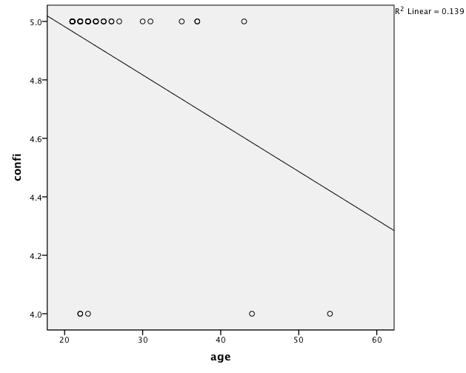

| **Descriptive Statistics** | | | | | |
| --- | --- | --- | --- | --- | --- |
|  | N | Minimum | Maximum | Mean | Std. Deviation |
| confidence | 46 | 4 | 5 | 4.89 | .315 |
| age | 46 | 21 | 54 | 25.50 | 7.102 |
| Experience | 46 | 1.00 | 3.00 | 1.8696 | .45258 |
| Assign | 46 | 8.00 | 24.00 | 18.7826 | 4.07111 |
| Valid N (listwise) | 46 |  |  |  |  |

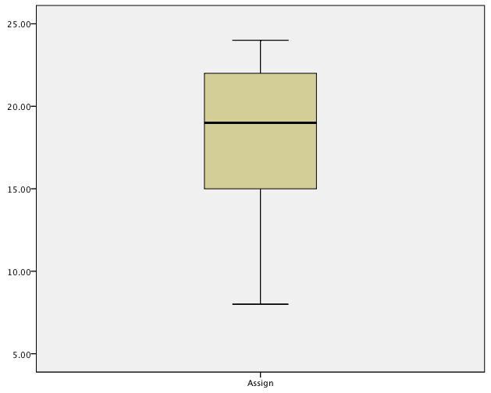

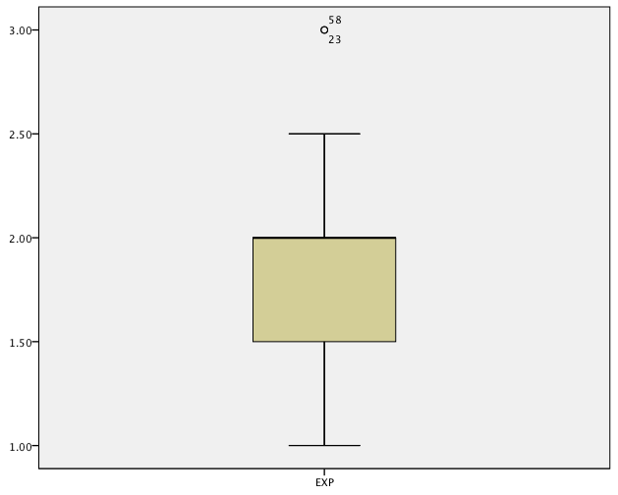

All of the students sampled in the survey indicated that they were confident about their choice of major with 89% reporting very confident.

Thirty-eight % reported spending 4-6 hours on homework with 15% indicating that they spent less time and 28% reported spending 7-9 hours and 19% reporting spending 10 hours or more.

The majority of students 68% reported that the course work is about right for their experience level. See box plot above.

Summary

The evaluation data collected during the first year of the Bridges project can be summarized as accomplishing two major objectives. First and foremost, we developed surveys that will be used during the first and last weeks of the semester to evaluate the success of the Bridges project; and we collected baseline data from the students enrolled in ITCS 2214 and ITCS 4155 to be used for comparison when we implement the Bridges exercises in these courses during the next two academic years.

The measures included in the survey that will be administered during the first week of the semester in ITCS 2214 are an Attitude toward Computing Scale that was adapted from a previous NSF supported REU project at UNC Charlotte, an item measuring confidence in retention in the major. These were also included in the survey at the end of the semester and in addition the survey included 5 items that measured attitudes toward the relevance/importance/understanding of the course assignments and 2 items that assessed the student’s perception of the level of programming experience required by the course and the homework. The survey for the senior students enrolled in ITCS 4155 will be administered at the end of the semester and it will include the items that measure the Attitude toward the course assignments, perception of the level of programming experience for homework and confidence in retention in the major. A Knowledge test that will be used for assessing pre and post course growth in mastery of data structures concepts was also developed and items were rated for appropriateness by 5 instructors who regularly taught the data structures course.

We treated the data collected regarding the Attitude toward computing scale from the students enrolled during the Fall 2013 and Spring 2014 semester with a principle components factor analysis with a varimax rotation and found 4 factors with robust coefficient alphas. Factor 1 which accounted for 23% of the variance consisted of 8 items that measured negative attitudes toward computing. Factor 2 (6 items) that measured positive attitudes toward computing and accounted for 18% of the variance, while Factor 3 (4 items) measured men/women issues for 16% of the variance. Factor 4 measured career orientation for 13% of the variance and included 4 items. We will use the factor scores to assess any change in computing attitude from the first to the last week of the semester in the students enrolled. We also pilot tested an item that measures confidence in retention in the major and demonstrated that students enrolled in ITCS 2214 did not change either their attitude toward computing or their confidence in retention in the major as a result of their experiences in the Data Structures course.

We recorded the course grades and found that there was a high rate of withdrawal from the course in both the Fall and Spring semester and 45% thought that the course required more experience than they had. We also found that those who did well in the course (As and Bs) were more willing to fill out the surveys at the beginning and end of the semester than those who did not (Cs, Ds & Ws) suggesting a difference in engagement may underlie some of the differences in course performance.