**Bridges Evaluation Report Spring 2016**

During the Spring 2016 semester, three Bridges exercises were included as homework assignments for the students enrolled in ITCS 2214 section 002, and two exercises were in used as homework assignments for students enrolled in one section of ITCS 2215. As in previous semesters, we administered the knowledge tests to measure gains in course material for students enrolled in all sections of ITCS 2214. The knowledge tests were administered to the sections during the first and last weeks of the semester. The students in all sections of ITCS 2214 were also asked to take an Attitude toward Computing survey and to self-report their confidence in retention in the major on a 1-5 scale during the first week of the semester.

**Comparison of Bridges class to three other sections of ITCS 2214 Pretest data**

The table below shows the mean scores of the students enrolled in section 002 (Bridges section) compared to the other three sections on all of the measures taken during the first week of the semester including their GPA. The students in the two groups differed on only one of computing attitude subscale scores (gender differences in computing). The Bridges group had a higher score, indicated a slightly more positive attitude toward women in computing. This difference in gender attitude was not a results of a difference in gender representation, because women made up 10% of the Bridges sample and 15% of the control group sample , χ(1, n=208) <1. Otherwise, computing attitudes both positive and negative were about the same in the two groups. Also, there were no group differences in self-reported confidence about graduating with a computer science major. For both groups, confidence was high with an average rating of over 4 out of a possible 5-point scale.

There were, however, some important group differences in GPA and in performance on the knowledge pretest. Overall, the control group has a higher GPA in comparison to the Bridges group, but surprisingly, they scored lower on the knowledge pretest.

|  |  |  |  |  |  |  |  |  |  |  |  |  |  |  |  |  |  |  |  |  |  |  |  |  |  |  |  |  |  |  |  |  |  |  |  |  |  |  |  |  |  |  |  |  |  |  |  |  |  |  |  |  |  |  |  |  |  |  |  |  |  |  |  |  |  |  |  |  |  |  |  |  |  |  |  |  |  |  |  |  |  |  |  |  |  |  |  |  |  |  |
| --- | --- | --- | --- | --- | --- | --- | --- | --- | --- | --- | --- | --- | --- | --- | --- | --- | --- | --- | --- | --- | --- | --- | --- | --- | --- | --- | --- | --- | --- | --- | --- | --- | --- | --- | --- | --- | --- | --- | --- | --- | --- | --- | --- | --- | --- | --- | --- | --- | --- | --- | --- | --- | --- | --- | --- | --- | --- | --- | --- | --- | --- | --- | --- | --- | --- | --- | --- | --- | --- | --- | --- | --- | --- | --- | --- | --- | --- | --- | --- | --- | --- | --- | --- | --- | --- | --- | --- | --- | --- | --- |
| | **Measures taken during the first week of Spring 2016 semester** | | --- |  | **Group Statistics** | | | | | | | --- | --- | --- | --- | --- | --- | |  | group | N | Mean | Std. Deviation | t test | | GPA | Bridges | 46 | 2.53983 | .625729 | -4.47, p< .01 | | Control | 156 | 2.99795 | .602625 |  | | Know  Score | Bridges | 44 | 38.4091 | 13.43947 | 3.66, p < .01 | | Control | 132 | 31.5000 | 9.82558 |  | | Confidence in Major | Bridges | 39 | 4.18 | .790 | -1.21, p = .228 | | Control | 67 | 4.37 | .795 |  | | Positive CA | Bridges | 40 | 38.2750 | 4.00633 | <1 | | Control | 67 | 37.7015 | 6.41025 |  | | Negative CA | Bridges | 40 | 32.8000 | 3.63177 | <1 | | Control | 67 | 32.4925 | 5.53056 |  | | Male/Female CA | Bridges | 40 | 19.2250 | 1.51043 | 2.29, p = .024 | | Control | 67 | 18.2537 | 2.86749 |  | | Career CA | Bridges | 40 | 17.2750 | 2.40712 | <1 | | Control | 67 | 17.1791 | 2.67381 |  | |

Notes

Positive CA= Computing Attitude Scale- positive attitude toward computing

Negative CA=Computing Attitude Scale-negative attitude toward computing

Male/female CA=Computing Attitude Scale-attitude toward men and women

Career CA=Computing Attitude Scale- Career oriented factor.

KnowScore= Score on the Knowledge pretest

| **Measures taken at the end of the Spring 2016 semester** |
| --- |

The table below compares the two groups (Bridges vs control sections) on the measures taken at the end of the semester. Although the Bridges group got higher scores on the knowledge test at the end of the semester and showed greater gains on the knowledge test (posttest minus pretest), their average grade in the course was significantly lower than the control group.

| **Group Statistics** | | | | | |
| --- | --- | --- | --- | --- | --- |
|  | group | N | Mean | Std. Deviation | t test |
| Knowpost | Bridges | 35 | 64.1143 | 17.80246 | 4.89, p<.01 |
| Control | 85 | 48.9059 | 14.45817 |  |
| gain | Bridges | 33 | 23.2727 | 15.85141 | 2.69, p= .008 |
| Control | 78 | 15.1026 | 14.08747 |  |
| Grade | Bridges | 45 | 2.0222 | 1.35661 | -2.95, p=.004 |
| Control | 138 | 2.7319 | 1.41700 |  |

Performance on the knowledge test showed significant gains for both of the groups. However, the box plot below shows that the Bridges group showed larger gains than the Control group. The differences in knowledge gains for the groups could be explained at least partially by the differences in instructor emphasis on the knowledge tests. The bridges instructor used the knowledge test for the final exam while the other instructor used it as a classroom exercise that did not count toward the final grade.

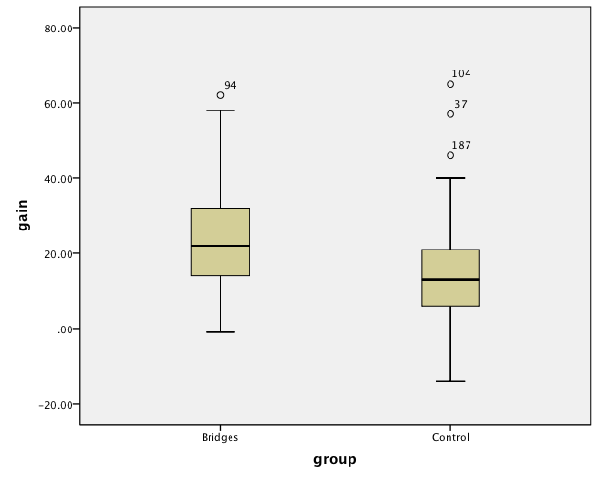

**Course Grades in ITCS 2214**

In spite of showing greater gains in performance on the knowledge test, course grades in the Bridges section on average were significantly lower than in the other sections of the course. However, there were significant differences among the 4 sections in the distribution of the final grades are shown in the Table below, χ2(15, N=208)=64.30, p < .001. Most notably, Section 3 had a large number of A grades relative to the other sections with fewer Ds, Fs, and Ws. The table below shows that there were 25 withdrawals among the 208 students who were enrolled and 26 students with F grades.

| **SECTION * GRADE** | | | | | | | | | | |
| --- | --- | --- | --- | --- | --- | --- | --- | --- | --- | --- |
|  | | | | GRADE | | | | | | Total | |
| A | B | C | D | F | W |  |
|  | 1 | Count | | 7 | 13 | 8 | 4 | 11 | 10 | 53 |
| % within SECTION | | 13.2% | 24.5% | 15.1% | 7.5% | 20.8% | 18.9% | 100.0% |
| % within GRADE | | 10.8% | 28.9% | 30.8% | 19.0% | 42.3% | 40.0% | 25.5% |
| 2 | Count | | 7 | 12 | 9 | 9 | 8 | 4 | 49 |
| % within SECTION | | 14.3% | 24.5% | 18.4% | 18.4% | 16.3% | 8.2% | 100.0% |
| % within GRADE | | 10.8% | 26.7% | 34.6% | 42.9% | 30.8% | 16.0% | 23.6% |
| 3 | Count | | 38 | 13 | 5 | 2 | 0 | 1 | 59 |
| % within SECTION | | 64.4% | 22.0% | 8.5% | 3.4% | .0% | 1.7% | 100.0% |
| % within GRADE | | 58.5% | 28.9% | 19.2% | 9.5% | .0% | 4.0% | 28.4% |
| 5 | Count | | 13 | 7 | 4 | 6 | 7 | 10 | 47 |
| % within SECTION | | 27.7% | 14.9% | 8.5% | 12.8% | 14.9% | 21.3% | 100.0% |
| % within GRADE | | 20.0% | 15.6% | 15.4% | 28.6% | 26.9% | 40.0% | 22.6% |
| Total | | | Count | 65 | 45 | 26 | 21 | 26 | 25 | 208 |
| % within SECTION | 31.3% | 21.6% | 12.5% | 10.1% | 12.5% | 12.0% | 100.0% |
| % within GRADE | 100.0% | 100.0% | 100.0% | 100.0% | 100.0% | 100.0% | 100.0% |

**Regression analysis with course grade as the outcome measure**.

We used a regression to determine which of the pretest measures would predict course grade. In the first step, 43% of the variance in course grade was accounted for by the GPA, and the pretest knowledge score. When the computing attitude subscale scores were added in model 2, however, that increased to 45% of the variance but it did not constitute a significant change in explained variance, F < 1.

|  |  |  |  |  |  |  |  |  |  |  |  |  |  |  |  |  |  |  |  |  |  |  |  |  |  |  |  |  |  |  |  |  |  |  |  |  |  |  |  |  |  |  |  |  |  |  |  |  |  |  |  |  |  |  |  |  |  |  |  |  |  |  |  |  |  |  |  |  |  |  |  |  |  |  |  |  |  |  |  |  |  |  |  |  |  |  |  |  |  |  |  |  |  |  |  |  |  |  |  |  |  |  |  |  |  |  |  |  |  |  |  |  |  |  |  |  |  |  |  |  |  |  |  |  |  |  |  |  |  |  |  |  |  |  |  |  |  |  |  |  |  |  |  |  |  |  |  |  |  |  |  |  |  |  |  |  |  |
| --- | --- | --- | --- | --- | --- | --- | --- | --- | --- | --- | --- | --- | --- | --- | --- | --- | --- | --- | --- | --- | --- | --- | --- | --- | --- | --- | --- | --- | --- | --- | --- | --- | --- | --- | --- | --- | --- | --- | --- | --- | --- | --- | --- | --- | --- | --- | --- | --- | --- | --- | --- | --- | --- | --- | --- | --- | --- | --- | --- | --- | --- | --- | --- | --- | --- | --- | --- | --- | --- | --- | --- | --- | --- | --- | --- | --- | --- | --- | --- | --- | --- | --- | --- | --- | --- | --- | --- | --- | --- | --- | --- | --- | --- | --- | --- | --- | --- | --- | --- | --- | --- | --- | --- | --- | --- | --- | --- | --- | --- | --- | --- | --- | --- | --- | --- | --- | --- | --- | --- | --- | --- | --- | --- | --- | --- | --- | --- | --- | --- | --- | --- | --- | --- | --- | --- | --- | --- | --- | --- | --- | --- | --- | --- | --- | --- | --- | --- | --- | --- | --- | --- | --- | --- | --- | --- | --- | --- |
| | **ANOVAc** | | | | | | | | --- | --- | --- | --- | --- | --- | --- | | Model | | Sum of Squares | df | Mean Square | F | Sig. | | 1 | Regression | 64.842 | 2 | 32.421 | 28.461 | .000a | | Residual | 86.576 | 76 | 1.139 |  |  | | Total | 151.418 | 78 |  |  |  | | 2 | Regression | 67.397 | 6 | 11.233 | 9.626 | .000b | | Residual | 84.021 | 72 | 1.167 |  |  | | Total | 151.418 | 78 |  |  |  | | a. Predictors: (Constant), Know, GPA  b. Predictors: (Constant), Know, GPA, CA subscale scores (F1,F2,F3,F4)  c. Dependent Variable: GradeN | | | | | | |  | **Coefficientsa** | | | | | | | | | --- | --- | --- | --- | --- | --- | --- | --- | | Model | | Unstandardized Coefficients | | Standardized Coefficients | t | Sig. | | | B | Std. Error | Beta | | 1 | (Constant) | -3.354 | .756 |  | -4.436 | .000 | | | GPA | 1.389 | .200 | .618 | 6.933 | .000 | | | Knowpre | .043 | .010 | .403 | 4.514 | .000 | | | 2 | (Constant) | -2.176 | 1.478 |  | -1.472 | .145 | | | CGPA | 1.350 | .212 | .601 | 6.377 | .000 | | | Knowpre | .044 | .010 | .412 | 4.413 | .000 | | | F1 | -.035 | .052 | -.119 | -.660 | .511 | | | F2 | .042 | .050 | .143 | .842 | .403 | | | F3 | -.082 | .066 | -.119 | -1.244 | .218 | | | F4 | .022 | .080 | .036 | .273 | .786 | | | a. Predictors: (Constant), knowpretest, GPA  b. Predictors: (Constant), knowScore, GPA, CA subscale scores (F1,F2,F3,F4)  c. Dependent Variable: GradeN | | | | | | | |

**ITCS 4415**

There were 71 students who were enrolled in the senior level course—13%(9) women. These students were offered the opportunity to mentor a sophomore student who was enrolled in the ITCS 2214 course. Twice during the semester, a time was set up for the peer mentoring session and both groups of students were invited to attend. Unfortunately, only a handful of sophomore and senior students showed up for the sessions. As a result, we were unable to evaluate the usefulness of the peer mentoring. We will need to develop more effective strategies for engaging both groups of students in the peer mentoring experience. Neither group felt that the experience that was offered provided sufficient benefit.

We did, however, administer the knowledge test established for the ITCS 2214 students in the beginning and end of the semester to measure whether there would be any gains in performance on this measure. The box plots shown below indicate that there was no significant difference in the senior students performance on the test. Scores on the Knowledge pretest (*M* = 50.5, *SD* = 15.54) were similar to the post test (*M* = 50.5, *SD* = 15.54), t < 1. The average gain was equal to 1 point on the test.

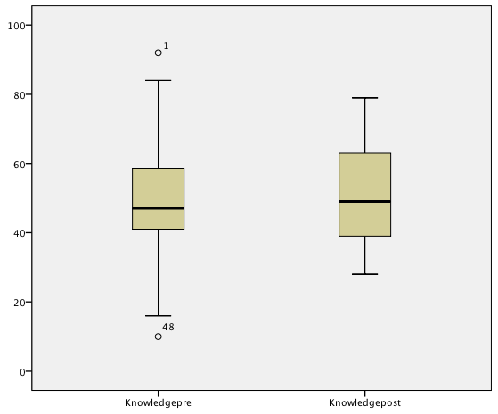

Moreover, course grade was not significantly correlated to scores on the knowledge pretest (r(47)= -.09, the knowledge post test, r(47) = .15, or on the gains r(47) = .28, p =.058.