Report on Pretest data Fall 2013 Bridges

|  |
| --- |

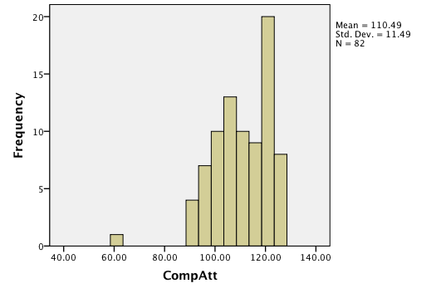

Correlation between CompAtt and confidence in major r(80) = . 35, p < .001

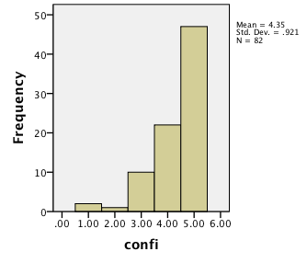

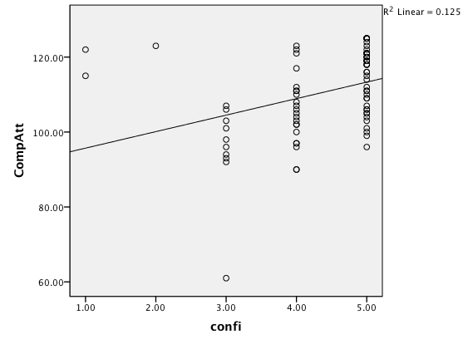

| **Group Statistics** | | | | | |
| --- | --- | --- | --- | --- | --- |
|  | 7 | N | Mean | Std. Deviation | Std. Error Mean |
| CompAtt | Male | 72 | 110.8889 | 11.86610 | 1.39843 |
| Female | 10 | 107.6000 | 8.18128 | 2.58715 |
| Confidence in major | Male | 72 | 4.3611 | .95395 | .11242 |
| Female | 10 | 4.3000 | .67495 | .21344 |

|  | | | | | |
| --- | --- | --- | --- | --- | --- |
|  | | Frequency | Percent | Valid Percent | Cumulative Percent |
| Valid | African American | 4 | 4.9 | 4.9 | 4.9 |
| Asian | 8 | 9.8 | 9.8 | 14.6 |
| Hispanic/Latino | 4 | 4.9 | 4.9 | 19.5 |
| Multi-ethnic | 6 | 7.3 | 7.3 | 26.8 |
| Native American/American Indian | 1 | 1.2 | 1.2 | 28.0 |
| Native Hawaiian/Pacific Islander | 1 | 1.2 | 1.2 | 29.3 |
| Other | 3 | 3.7 | 3.7 | 32.9 |
| White/Caucasian | 55 | 67.1 | 67.1 | 100.0 |

|  |  |  |  |  |  |  |  |  |  |
| --- | --- | --- | --- | --- | --- | --- | --- | --- | --- |
|  |  |  |  |  |  |  |  |  |  |
|  |  |  |  |  |  |  |  |  |  |
|  |  | Factor Analysis of Computing Attitude Scale | | | |  |  |  |  |
|  |  |  |  |  |  |  |  |  |  |
|  |  |  |  |  |  |  |  |  |  |
|  |  |  |  |  |  |  |  |  |  |
|  |  |  | Rotated Component Matrix(a) | | |  |  |  |  |
|  |  |  | Component |  |  |  |  |  |  |
|  |  | 1 | 2 | 3 | 4 |  |  |  |  |
|  | r3a | 0.709 | 0.335 | 0.008 | 0.358 |  |  |  |  |
|  | r3b | 0.441 | 0.812 | 0.008 | 0.046 |  |  |  |  |
|  | r3c | -0.005 | -0.021 | 0.063 | 0.759 |  |  |  |  |
|  | r3d | 0.759 | 0.383 | 0.351 | -0.002 |  |  |  |  |
|  | r3e | 0.752 | 0.327 | 0.043 | 0.38 |  |  |  |  |
|  | r3f | 0.049 | 0.246 | 0.783 | 0.052 |  |  |  |  |
|  | r3g | 0.379 | 0.851 | 0.007 | -0.002 |  |  |  |  |
|  | r3h | 0.286 | 0.042 | 0.729 | 0.036 |  |  |  |  |
|  | r3i | -0.102 | 0.161 | 0.308 | 0.588 |  |  |  |  |
|  | r3j | 0.66 | 0.149 | 0.258 | 0.346 |  |  |  |  |
|  | r3k | 0.515 | 0.292 | -0.042 | 0.478 |  |  |  |  |
|  | r3l | 0.372 | -0.289 | 0.516 | 0.468 |  |  |  |  |
|  | r3m | 0.206 | -0.096 | 0.379 | 0.49 |  |  |  |  |
|  | r3n | 0.759 | 0.344 | 0.339 | 0.093 |  |  |  |  |
|  | r3o | 0.813 | 0.309 | 0.29 | -0.06 |  |  |  |  |
|  | r3p | 0.756 | 0.255 | 0.2 | 0.271 |  |  |  |  |
|  | r3q | 0.266 | 0.057 | 0.781 | 0.241 |  |  |  |  |
|  | r3r | 0.344 | 0.858 | 0.086 | 0.016 |  |  |  |  |
|  | r3s | 0.381 | -0.229 | 0.55 | 0.488 |  |  |  |  |
|  | r3t | 0.782 | 0.246 | 0.284 | 0.222 |  |  |  |  |
|  | r3u | 0.752 | 0.298 | 0.103 | -0.098 |  |  |  |  |
|  | r3v | 0.259 | -0.052 | 0.664 | 0.394 |  |  |  |  |
|  | r3w | 0.389 | 0.875 | 0.073 | 0.024 |  |  |  |  |
|  | r3x | 0.692 | 0.069 | 0.338 | -0.104 |  |  |  |  |
|  | r3y | 0.825 | 0.289 | 0.242 | -0.035 |  |  |  |  |
|  | Extraction Method: Principal Component Analysis. | | | |  |  |  |  |  |
|  | Rotation Method: Varimax with Kaiser Normalization. | | | | |  |  |  |  |
|  | a. Rotation converged in 9 iterations. | | |  |  |  |  |  |  |
|  |  |  |  |  |  |  |  |  |  |
|  | % variance | 30.6 | 16.5 | 14.9 | 10.5 |  |  |  |  |
|  |  |  |  |  |  | 72% total variance | | |  |
|  |  |  |  |  |  |  |  |  |  |
|  | Factor 1. Positive attitude toward computer science | | | | Coefficient Alpha= .95 | |  |  |  |
|  | Factor 2. Men/women in computer science | | | | Coefficient Alpha= .91 | |  |  |  |
|  | Factor 3. Negative attitude toward computing | | | | CoefficientAlpha=.87 |  |  |  |
|  | Factor 4. Lack of self confidence with computing | | | | Coefficient Alpha= .50 | |  |  |  |
|  |  |  |  |  |  |  |  |  |  |