# Overview

The Snake Debate Chatbot is a chatbot with a purpose to help stop the spread of common myths and misconceptions about snakes. These misconceptions can cause people to be harmed or harm the environment. It is designed debate against and debunk most snake myths inputted by the user. The ideal user for Snake Debate Chatbot is somebody whom dislikes/doesn’t know very much about snakes. Whom may believe some of these myths and is open-minded to being corrected/educated. It utilizes the Distil Bert Text Classification model, NLTK’s tokenizers, a handwritten dataset, and handwritten responses. It doesn’t save any user information except for the inputted sentences they give (in a text file) and gives an explicit warning to the user as it’s first message to not put ANY private information they wouldn’t feel comfortable with in a public database. We chose not to save any information such as name/interests to help protect the user’s privacy. It does however internally keep a list of covered topics that they have discussed with the user to avoid having the same responses repeatedly.

# The Dataset

The handwritten dataset we created utilizing our class, discords, and friends with google forms. We got a total of 50ish responses of unique user inputs. This clearly wasn’t enough, so we used the internet to get as many snake myths/misconceptions as possible and write inputs in different ways/varieties to create a concrete dataset. We stopped at 330 observations, which is very small for text classification. Generally, they want a dataset of at least 1,000. However, there is another big obstacle of our dataset other than its size. We ended up with 51 different and unique categories, usually they want at most 10 or so. With this combination it gave our machine learning algorithms a huge challenge.

# The Model(s)

To start off with we looked at our Author Attribution assignment and mimicked those models with our dataset. To summarize, all the models were overall very poor. Our highest accuracy was Logistic Regression with an accuracy of 57% percent. These can all be seen in the notebook ‘testing_models.ipynb’ in our GitHub. This overall, was very unacceptable to us as it was borderline guessing on most of the inputs, and with new inputs it failed nearly all of them most of the time. This would make our chatbot very unusable. We concluded that for ML we would have to utilize some prebuilt models, as our limited dataset was inadequate by itself without the model having some pattern recognition of English/etc. First, I attempted to utilize sentence similarity with all-MiniLM-L6-v2 prebuilt model. Although in the end not only did it have a lower than 70% average accuracy, but it was very sensitive and would require a separate model for each category, so 51 models in total. This experiment can be seen in the notebook ‘Sentence_Similarity.ipynb’ in our GitHub. This would be very time and memory consuming, so we moved to Text Classification models. We avoided the Question-Answer Models because we felt they would achieve our goal too well by generating answers for us as well as the models had many warnings that they may produce disturbing/non-fact-based results. As the sources for the models are from the internet, and they clearly stated it shouldn’t be used for any fact-based information giving program. Which is exactly what Snake Debate Chatbot is meant to be, a snake fact giving chatbot. So, we settled on trying to use Text Classification, we choose the model DistilBert-Base-Uncased. We choose it because it was very flexible and impressive. Thankfully this model achieved an accuracy of about 70% which is much more usable and impressive given our impossible dataset. With our test input it actually had a slightly higher accuracy of about 80%! This can be seen in our notebook ‘MultiClass_Text_Classification.ipynb’ in our GitHub. We then decided to squeeze as much as possible out of our tiny dataset and create a final model in ‘Final_MultiClass_Text_Classification.ipynb’ where we didn’t split any data for test to get as much of our dataset as possible for use for our model to learn from. This gained a few more percent in accuracy overall!

# How the Snake Debate Chatbot Works

Our Snake Debate Chatbot has a simple flow. First, it gets input from the user through a Flask-based GUI, then processes the input, and finally predicts the topic category based on the input. Next it chooses a response based on the category, and then returns the response to the user using the Flask GUI.

## Getting & Processing Input

To get input our chatbot utilizes flask with html code to have a ‘Send’ button as a response and contact our Flask app’s chatbot_response() function which takes the request input using the code ‘msg’ from our html code. First it will add the input to the ‘new_inputs.txt’ file. From there it will take the user input and save it into a variable. Our python program will split the input using NLTK’s sentence tokenizer, for each sentence it will call the process_input function. This function checks if they are giving us their name, typing in a keyword for the topic, or an actual sentence we need to predict on. If it needs to predict it will call the predict_category given the input and then send that output to the get_response function and set this as the response. Otherwise, if they said ‘my name is <name>’ it will greet them but NOT store their name for privacy reasons. If they used a keyword, it will simply use the get_response function and bypass prediction with the given topic name. Then it will return the response back the chatbot_response function.

## Predicting on Input & Choosing Response

The predict_category function uses our final text classification model to predict the category code (cat code). From there it has a long if statement to return the topic category name. Next, the get_response function holds all our chatbot’s responses for each topic category, currently each category only has one response form. Some of them are quite lengthy and generally try to cover a broad topic. Giving us a total of 51 unique responses at this time. The function get_response also manages our list of categories, for each category response returned, it will add that category to the list and check each time it is called if it has already covered that category. This prevents it from repeating itself, it also checks if all categories have been covered. Note: it doesn’t keep track of all categories such as the Greeting, Goodbye, Generic, Name, and Understand. This is because these are general conversation topics and wouldn’t make sense to keep track of or limit. For example, if a user says ‘I understand’ or ‘Hello’ after each topic, our chatbot shouldn’t tell the user it has already covered the ‘Hello’ or ‘I understand’ topic categories.

## Returning Response to User

Once the process_input function gets the response as mentioned above and returns it to the chatbot_reponse function, the chatbot_reponse function will have an if statement. This if statement will make sure the chatbot isn’t repeating categories, or filler sentences such as if they have already covered the topic or an unnecessary comment/question that lacks context. This allows our chatbot to make more sense and not be awkwardly repetitive/unnatural sounding. Then it returns that response to the Flask html code which outputs our chatbot message in the dialog box. In the responses, and breaks between multiple responses, I made sure to add text breaks to make the text much more readable. Especially for lengthy responses covering multiple angles of a topic.

# Logic Diagram

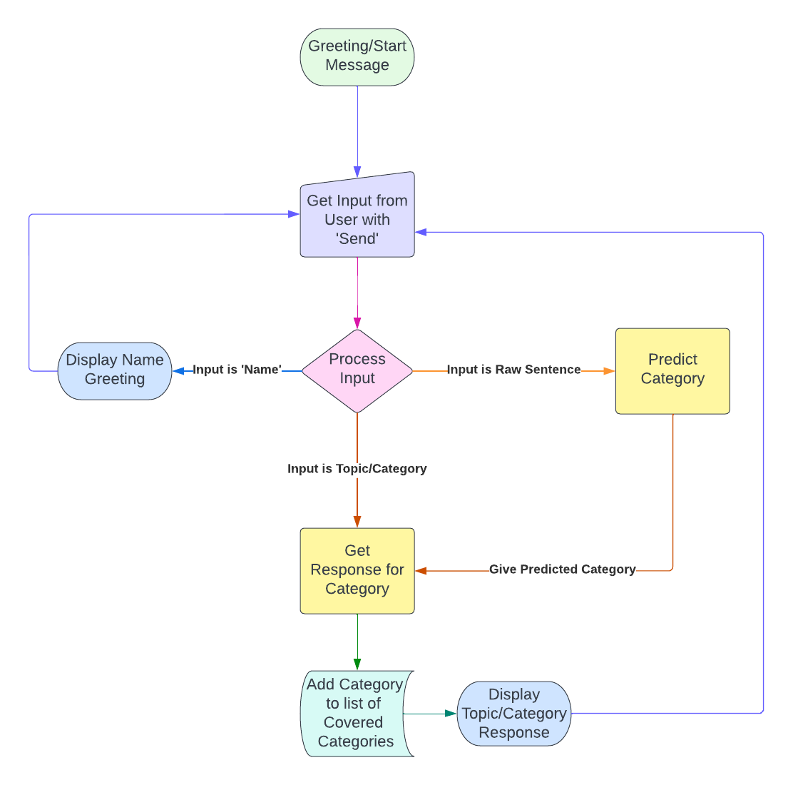

# Sample Dialog interactions

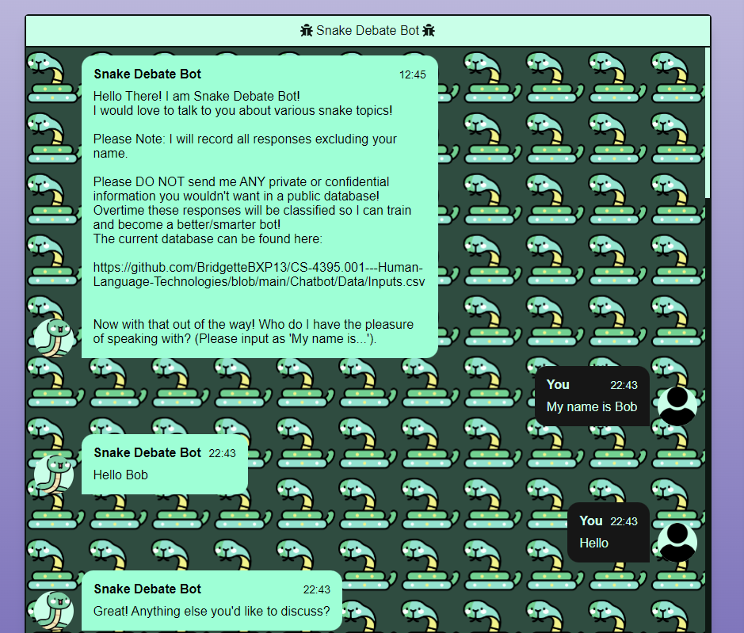

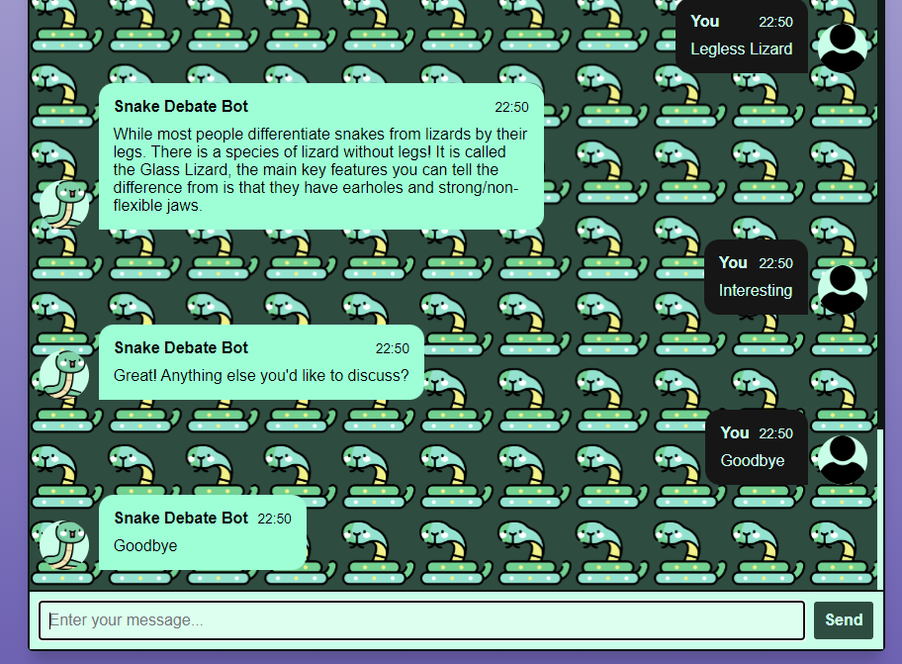

# Appendix A

Snake Debate Bot’s Knowledge Base

Snake Debate Bot’s Knowledge Base is limited to only 1 response per category. Although each response is handwritten, factual, and designed to cover all areas of each topic. We avoided web crawling or live lookup because based on the input/search you can find a lot of misinformation from the internet, and we wanted to guarantee our chatbot wouldn’t further spread information. Especially because this would directly conflict with its goal of debunking myths and correct misinformation about snakes. Which there is a ton of misinformation about online as they are heavily misunderstood by many.

# Appendix B

Sample User Models

Our Snake Debate Chatbot has a strange way of creating User Models. It avoids getting any information about the user for privacy information, it doesn’t even actually save their name but simply greet them with it. Instead, it keeps track of the covered categories with each user (it assumes each time the program is rerun it is a new user). In this way, it won’t repeat conversations but also won’t store unnecessary and private information about the user. It also saves all inputs, excluding their name or topic category inputs, from the user and warns them so with a disclaimer. By saving this into a text file, it allows us developers to add these inputs overtime to our database to hopefully get a large amount to greatly improve our chatbot’s responses and category prediction accuracy.

# Evaluation

Overall, we think our chatbot is a success! It has a lot of improvements and development to go. Although, most of its short comings come from the limited/tiny input dataset our model had to train on. We were surprised that our chatbot is as accurate and successful as it is with the large challenges our dataset had with the many categories/classes it had to predict on. We plan on continuing and improving this chatbot overtime to overcome it’s current weaknesses mentioned below.

## Strengths:

Our Snake Debate Chatbot covers many myths and misconceptions and present facts in an easy to understand and friendly way. It is easy to use once running and serves it’s designed purpose overall. Our chatbot thrives on sentences closely related to the input sentences in our dataset and can handle multiple topics when separated into sentences. It is also having a very good UI and would be easy for any non-tech savvy person to use whom understands how chatting online works. Our chatbot is also very kid-friendly and cute looking. Our chatbot is explicit with what it stores and why, it avoids storing any user information that could conflict with their privacy. It also stores inputs to be added to the dataset, giving us the ability to improve the chatbot overtime as we gain more data to add to our input dataset!

## Weaknesses:

It can get thrown off very easily with strangely/different phrased sentences/responses than it was trained on. It heavily struggles with complex sentences not separated by punctuation, and if you send your name with punctuation, it will take the punctuation as your name. Also, if somebody refreshes the page it doesn’t refresh the category list, so it is possible to have no categories unless you completely stop and rerun the flask app. Because of the limited dataset, it is likely that it will mis-categorize data not similar to the input data. This is seen above when asked ‘Are snakes good for the environment?’ it categorized that sentence as the category ‘Pet Snakes’ instead of ‘Snake Benefits’. It also has limited responses for each topic, limited to only 1 at this time.