# Bakery Project

Hello, I’m Brigida Hurley, mother of three boys, I love pets, animals, and nature. I

started three successful small businesses by doing what I love and it’s Art,

Computers and Music. Miguel Camarena Mexican Fine Art, Camarena Records,

LLC, and Camarena Productions. I love baking; Name of Bakery could be Trendy

Sugar Shack and a seating wireless area with a library books, screen television,

couches, table and chairs.

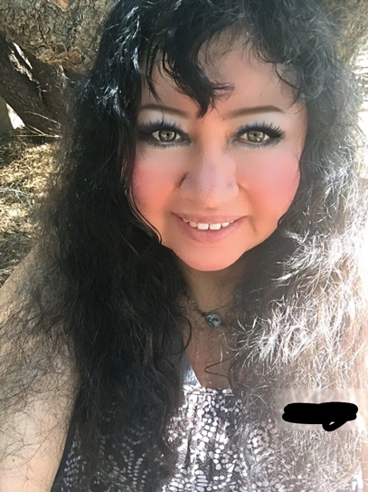 Art exhibit, art studio, Hispanic Vintage, a virtual window display for online

shopping, catering service, meal with a sandwich, fruit cup, nutrition bar and milk.

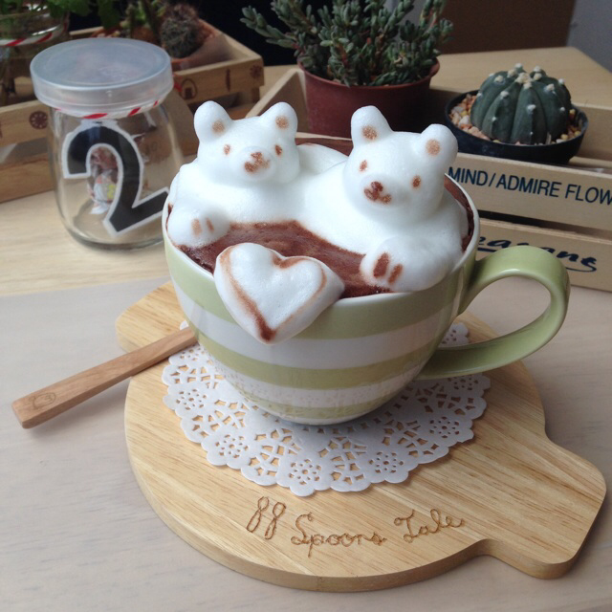

A Buffet restaurant with lots of food and drinks. This is appreciating the customer

and the team. Full- time employees, hospitality manager, training, rewards,

memberships and shopping online and with an app. Delivery service and

insurances. Im an a Digital Innovative Artist, Architect, Intern, Psychoanalysis,

Watterson College, Jungian Psychology, QuantumPathic. Business Administration

and writing.

Architectural Imagination, Flatiron School boot camp, Udacity, Nanodegree,

designer and Business English and Travel International and worldwide certified

Teacher👩‍🏫📚 I write stories on platforms and ebooks on publications like Kindle,

Amazon, Medium, Storify, and I have my own blog, web site, and I'm on Twitter,

Facebook, Google Plus+, Tagged, Skype and Hangouts.

I was born in Los Angeles, and at General Hospital. I went to HarvardX, edx.org.

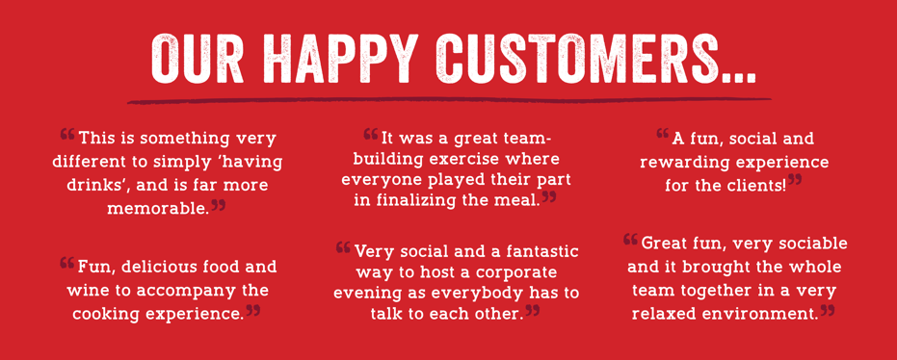

I'm interest in having my art studio, bakery, cafe seating wireless, nutrition meal,

vintage, library, catering, art gallery and residents in L.A. and for my three kids.

Also, start up in Arizona, and Las Vegas, NV.

I think a floral shop and buffet restaurant would fit with a chocolate store. Mixed

use, engage customers and a physical live platform for sales of services and

products not limited to cups, shirts, greeting cards and designs.

The environmental friendly Bakery would have a herb garden, small vegetable

and fruits plants and recycling of plastic and glass. Family and neighborhood

friendly. Meet ups and networking in the restaurant patio. Computers and

conference for business meetings

(spaces for office). Diversity and cultural are important elements.

The cost to run a startup like the Bakery Project is $120 million. Revenues grossly

after 2 years $40 million. Real estate purchase of location is recommended $8

million.

LB Innovative Bakery, Trendy Sugar Shack wants to help causes by coat drives, art

festivals, feed the hungry with free cookies, coffee and tea every day. Every Friday

would be a party with art show event serving salami and chicken sandwiches,

drinks (wine, apple cider, water bottle) and fudge candy, and pizza ( meat

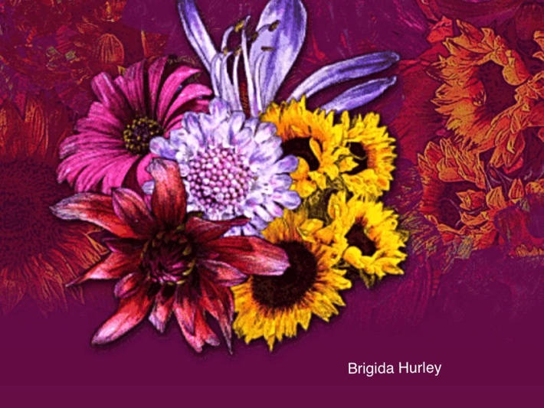

cheese).

Retail flex , multi purpose storefront with an office to have innovate teams to

have strategies, goals, plans, finances, book keeping, filing, organizing, technology

app, web site, blog and online shopping.

Muffins, bagels, pies and cookies. Satisfy a craving. Birthday cakes and holiday

pies.

Start Up not limited to muffins, cookies, Bagels and pie. There is also Coffee,

regular and decafeinated. Peach tea, raspberry tea, sweeteners, variety of creams

and milk. Drinks are water and milk.

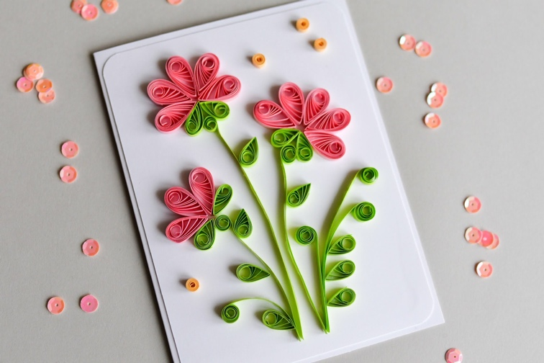

Strawberry, vanilla, chocolate cakes, cookies, cupcakes and banana and bran

muffins, plain bagels, blueberry and apple pies.

An important assumption when calculating our P&L is the increase in sales from

year to year. We are basing our assumptions on the financial success of Bakery.

They reported a 50% increase in sales the second year of business followed by a

30% increase the next year. We feel we can match, if not beat those sales,

considering the National Restaurant Association's analysis of the Bureau of Labor

Statistics Consumer Expenditure Survey states that Washington DC households

spend the most at restaurants per year.

It is also vital that we hold our food cost at 20% and 15% respectively for dine-in

desserts and POP, carry-out and weekly lessons. That will assure our gross margin

remains high.

Catering service for receptions, parties, companies and offices offering sweets.

Catalog of cakes, cookies, pies, bagels, cupcakes, donuts, muffins to order to go.

Brigida L. Hurley (Brigett)

June 23, 2018

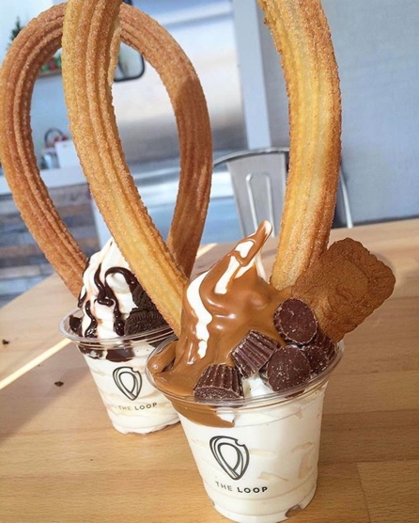The Bakery would have a main menu and selection for the customer first name

and email as well as rewards card. Discounted Bake Goods, daily fresh and each

day of the week special. Memberships with newsletter and sales of products and

services.

A database of customers and team members, gender, age and favorites. Selected

services offering delivery, tags with embroidered names as gifts on packages and

sets. Competitions on puzzle games, trivia, and recipe ingredients. Bakery book,

bakery kits for cupcake, mocha ice coffee, and strawberry cheese cake.

The cost of a cupcake would be $2.00 it would include coffee and two chocolate

candies, and potato sticks. Bags with dividers. Options of organic, gluten free

and regular bake goods.

I think ordering should be simple and reading a menu should be clear and easy to

understand like elementary school grade letters and numbers.



Remembering a name and they type in their email address. Previous orders and

check off what they want, recommendations and room for new orders.

Eating there bakery goods should be comfortable for eating at seat, chair, while

watching screen television, reading a magazine or taking it home.

No slippery floors or messy bakery goods. Plate set should be offered and for

purchase.

Celebrate seasons, Holidays, birthdays, office days, events, special occasions.

Offer iPads to check emails and internet. Kindles for reading and playing games.

Everyone is a winner. Come early for free coffee and cupcake. Mini bites and

samples free.

Social events, friendly people and General manager, manager and employees

available 24/7 and they wear uniforms. Staff, members and workers eat free,

receive rewards, gift certificates and lots of benefits and incentives. (Apps,

Shopping Online, store hours, truck delivery, and rules and regulations, ask

questions, FAQ, chat online service).

I think parking should be safe and convenient and inventory should never run out.

Front or side parking specifically for Bakery and always prepare for emergencies.

Disabled and special needs must be considered.

Working with nearby business offering coupons in a newsletter newspaper.

Purchasing gift certificates from small business owners in the neighborhood.

Working with business to business.

Advertising and marketing on publications, television and radio.

Text messaging phones for employees and managers.

Security and alarms, clocks and timers.

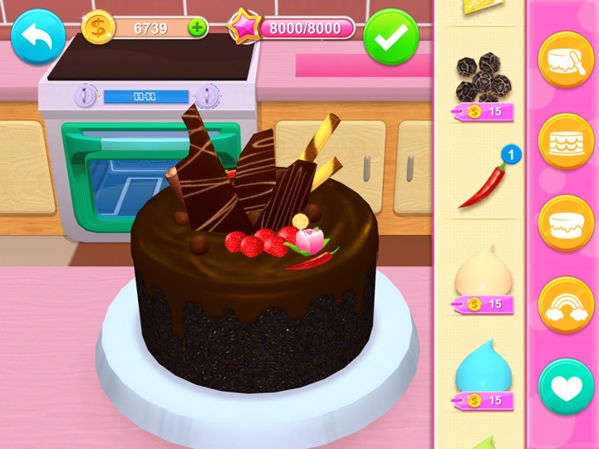

Easy flavor picks and names spelled out with stories, so fudge chocolate would be

Vangogh poor. Topping would be red, 2, and draining. ( cherries, nuts, and whip

cream). Name labels. Receipts, starting dates June, August and November. 2018-

2020. Stakeholders participation, funding and keeping contact with changes in

menu, updates, stationary, and design.

Article writing with content on Bakery, store hours, what sells most to least and

with stars and reviews. Creating mini shopping on social media for three products

or one service. Deliver cakes 8 a.m. to 10 a.m. (strawberry and chocolate).

Purchase red and black mugs on Tuesdays. Fill with coffee or hot tea.

Watch Titanic All day Thursday. Edible flowers with your cupcake and candy.

Coloring a cupcake day for a gift card. Offer coffees, shots, liquors, and

wheatgrass.