Brigham Michaelis
September 30th 2017
A00364835
Homework #3
Problem 1.(20 points) Suppose you are given an array A with n entries, with each entry holding a
distinct number. You are told that the sequence of values A[1], A[2], . . . , A[n] is unimodal:
For some index p between 1 and n, the values in the array entries increase up to position p
in A and then decrease the remainder of the way until position n. (So if you were to draw a
plot with the array position j on the x-axis and the value of the entry A[j] on the y-axis, the
plotted points would rise until x-value p, where they’d achieve their maximum, and then fall
from there on.)
You’d like to find the “peak entry” p without having to read the entire array – in fact, by
reading as few entries of A as possible. Show how to find the entry p by reading at most
O(log n) entries of A. In other words, design an O(log n) time algorithm to find the peak
entry p.
For example, let A = {1, 4, 6, 8, 11, 12, 10, 9, 7}, which is be a unimodal array. The peak entry
of A is 12. So the output of your algorithm is either 12 or the index of 12 in A.
Description
Before we begin we first discuss some special cases of a unimodal array. If the array is sorted in any order(decreasing or increasing) then that is a unimodal array, and we have to account for it. To take care of this we first do a linear scan on the array and check to see if every element is less than the element preceding it. If it is then the peak is the first value. Like wise we perform one more linear scan to see if every element is greater than the previous element, if it is then the peak is the last element in the array.
Otherwise, we solve this problem with the following algorithm.
This problem is easily solved with a modification to binary search.
We list the differences here:
Regular Binary Search | Modified Binary search for the Max value.
1. We know we are done when the key is found or (i == j). | 1. We are done when the value to the left of the max is less than the max and the value to the right of the max is less than the max.
2. If the place where we are currently searching is greater than the “key” then the (current location -1) becomes our new endpoint. | 2. If the value before our “current location” is greater than our current value. AND If the value after our “current location” is less than our current value.  Then the (current location -1) becomes our new endpoint.
3. If the place where we are currently searching is less than the “key” then the (current location +1) becomes our new startpoint. | 3. If the value before our “current location” is less than our current value. AND If the value after our “current location” is greater than our current value.  Then the (current location +1) becomes our new startpoint.
Because we know that we are dealing with a unimodal array, we can be certain that the “peak” value exists. And we do not have to have a check for a non existent peak.

PsuedoCode
Not needed.
Correctness
This algorithm is correct because we will find the peak in O(logn) time. Because we are only modifying binary search with constant work which will still provide O(log(n)) runtime.

Runtime
This algorithm is correct because we are only modifying binary search to find the “peak”. That is associated with the unimodal array input. In other words we are basically adding constant work to a O(logn) algorithm which still gives a runtime of O(log(n)).

Problem 2. (20 points) In the SELECTION algorithm we studied in class, the input numbers are divided into groups of five. Will the algorithm still work in linear time if they are divided into groups
of seven? Please justify your answer.

Problem 3. (20 points) Suppose you are consulting for an oil company, which is planning a large pipeline
(called the main pipeline) running horizontally from east to west through an oil field of n wells.
From each well, a spur pipeline is to be connected directly to the main pipeline along a shortest
path (going to either the north or the south), as shown in Figure 1.

Suppose there are n wells, represented by n points p1,p2 , . . . , pn in the plane. We are given
the x- and y-coordinates of the n wells p _{i} = (x _{i} , y _{i} ) for i = 1, 2, . . . , n. Note that the wells are
not given in any sorted order. Our goal is to pick an optimal location for the main pipeline
(i.e., find the y-coordinate of the main pipeline) such that the total sum of the lengths
of the spur pipelines is minimized. For simplicity, we assume no two wells have the same
x-coordinate or y-coordinate.
Design an O(n) time algorithm to compute an optimal location for the main pipeline.

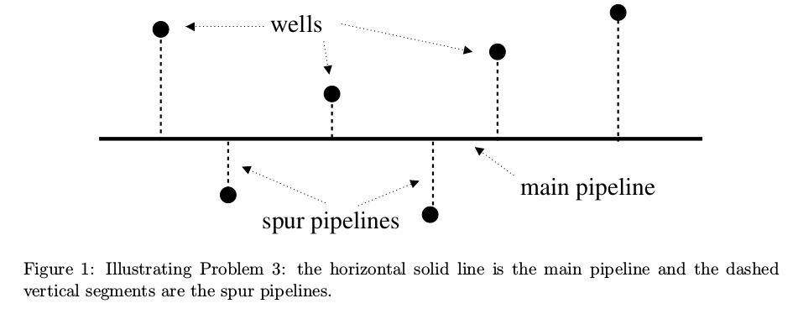

Description
This problem is easy, we just need the the correct i^{th} element’s value. Say we had an array of 10 values we would pick the y value of the “fifth” smallest element to place our main pipeline(ceiling((array.size())/(2))). In a more general sense we pick the “middleth” element’s y-value to place the pipeline. This can be done in liner time by using the selection algorithm we discussed in class. In this case we are just finding the “middleth” element in the array and taking it’s y-value as the location of the pipeline.
Psuedo Code
Not needed.

Correctness
This is correct because we can say the location of the pipe is somewhere in between the min and max. Carrying this idea further we can say the best location is between the second min and the second max. Going even further we can say it is between the nth min and the nth max until we hit the middle value.
Runtime
The runtime is linear O(n) because we are just finding an i^{th} smallest value in an array or (ceiling((array.size())/(2))) and the algorithm we developed in class (selection) can find an i^{th} smallest value in linear time.

Problem 4. (30 points) Here is a generalized version of the selection problem, called multiple selection.
Let A[1 · · · n] be an array of n numbers. Given a sequence of m sorted integers k ₁ , k ₂ , . . . , k _{m} ,
with 1 ≤ k ₁ < k ₂ < · · · < k _{m} ≤ n, the multiple selection problem is to find the k i -th smallest
number in A for all i = 1, 2, . . . , m. For simplicity, we assume that no two numbers of A are
equal.

(a) Design an O(n log n) time algorithm for the problem. (5 points)
This is easy, just sort the main array (A) then use the array (m) to find the needed elements in order. This will run in O(nlog(n)) time.

(b) Design an O(nm) time algorithm for the problem.
Note that this is better than the O(n log n) time algorithm if m < log n. (5 points)
For this problem we are just going to use the selection algorithm we developed in class (m) times. In other words we are going to find, in linear time, all the elements in m one at a time, one after the other. Which runs in O(n*m).

(c) Improve your algorithm to O(n log m) time,
which is better than both the O(n log n) time and the O(nm) time algorithms. (20 points)
Description
Imagine the m array, inside a balanced and sorted binary tree with the middle value of m at the root.
First we are going to find the root value of m in n. This This is done in linear time using the selection algorithm. Next we are going to give the left half of array n, to the left side of the balanced binary tree m. And we are going to to give the right side of array n to the right side of the balanced binary tree m.
We then do the same thing as before, recursively working our way down the tree. In this way we will perform log(m) linear scans on the array n.
PsuedoCode
Not Needed.
Correctness
This algorithm is correct because we are performing log(m) linear scans on the array n. This works because at the root of m we are calling selection which will divide the array n into two halves, split at the root value of m. we then perform this technique recursively throughout the balanced binary tree m.
Runtime
This algorithm runs in O(nlog(m)) time. It can be thought of in another way as performing log(m) linear scans on the array n.

