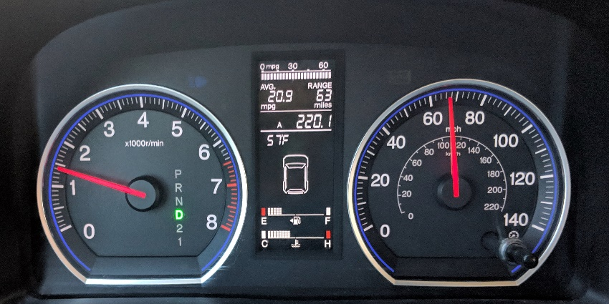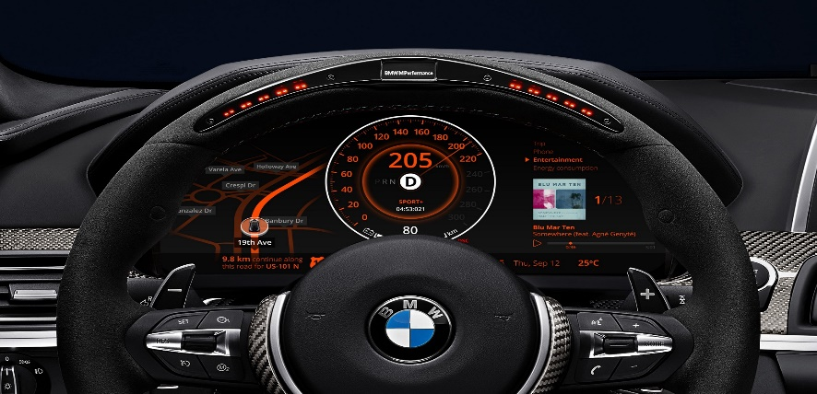

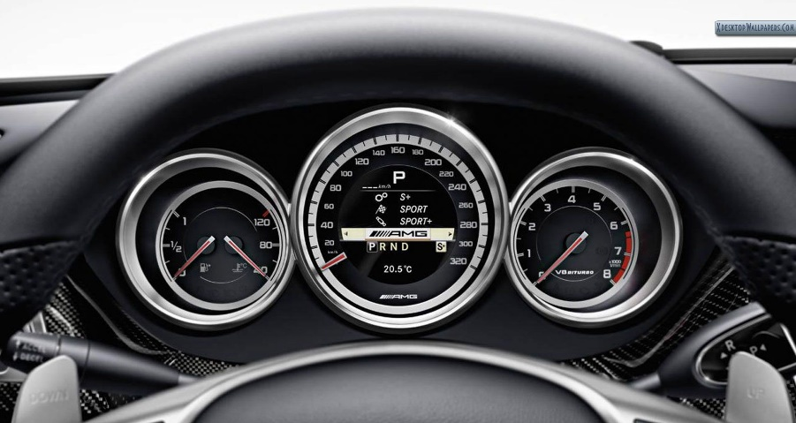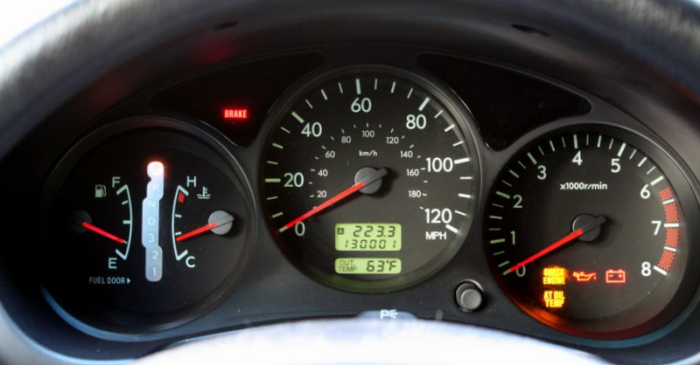

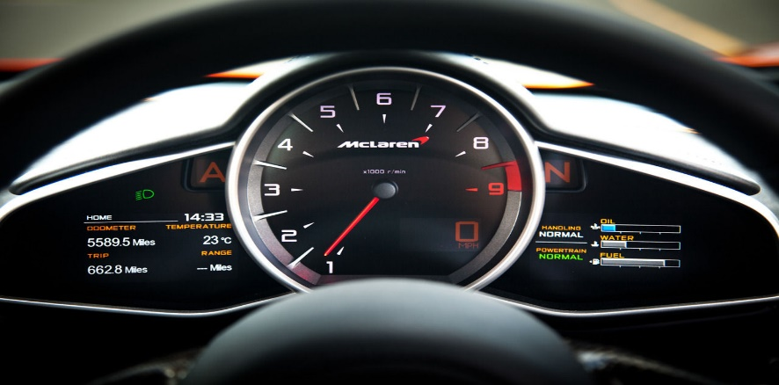

**Pros:**

1. **Essentials are in place, although each has a different way of doing them and has varying levels of importance.**

* Each car has a different type of user and the importance of each component has taken that into account

1. **They all have the most important information present in front of the driver.**

* This is good to have the speedometer be prominent since that is the main way that the driver can break the law

1. **Shows current used signals**

* Allows the user to see what the car is displaying outside of the car

**Cons:**

1. **Speedometers with dials**

* This may cause confusion of what the actual speed the car is going

1. **RPM dials with sub marks**

* The sub marks are useless and confusing since RPM is based by the thousands

1. **Unlabeled number tally’s**

* In some of the dashboards there are numbers being displayed with no label accompanying them, making it confusing for the user to understand what said numbers mean

1. **Temperature Bars**

* The temperatures being displayed with bars and dials are unlabeled and useless, with C and H not meaning anything to the user.

**Common Features:**

* Displays Speed
* Displays RPM
* Shows Gear
* Shows Fuel
* Shows Temperature
* Displays Warnings
* Displays Signals
* Display Mileage

**Rare Uses:**

* Mile Per Gallon
* Miles Left Until Fuel Is Drained
* Breaks in Use
* Display Music
* Display GPS

**Controls User Interacts With:**

Directly:

* Dials
* Through resetting dials to base

Indirectly:

* Dials
* Through changing speeds
* Gas Dial
* Refueling

**Common Mistakes:**

* Temperatures are dials or meters with little to no labels
* Mileage and other numbers left ambiguous
* Actual speed not displayed
* Dials having useless sub marks

**Improvements:**

* Label Necessities
* No ambiguous numbers
* Actual number displays attached to dials

**Sketch:**

The main changes I had made to the design is the addition of displayed numbers and the change from a fuel dial to more of a gauge. The reason for the display of numbers is that it is way more practical to show the actual numbers than to have the user guess what the exacts are. As for the gauge there does not really have to be numbers in the first place, just a visual way to see how much fuel is left hence the addition of color coordinated levels. As for minor changes I moved cruise control onto the speedometer since that’s what is affected by cruise control and I put all my warning symbols between the left and right turn signals.