**Seminar2**

**EE58 wyz**

**PART1 Three-Phase Full Bridge Rectifier (Thyristor)**

1. **three-phase full bridge rectifier without E in load**
   1. **Simulation preparation**
2. Model of the circuit1



Fig.1(a) Rectification Mode

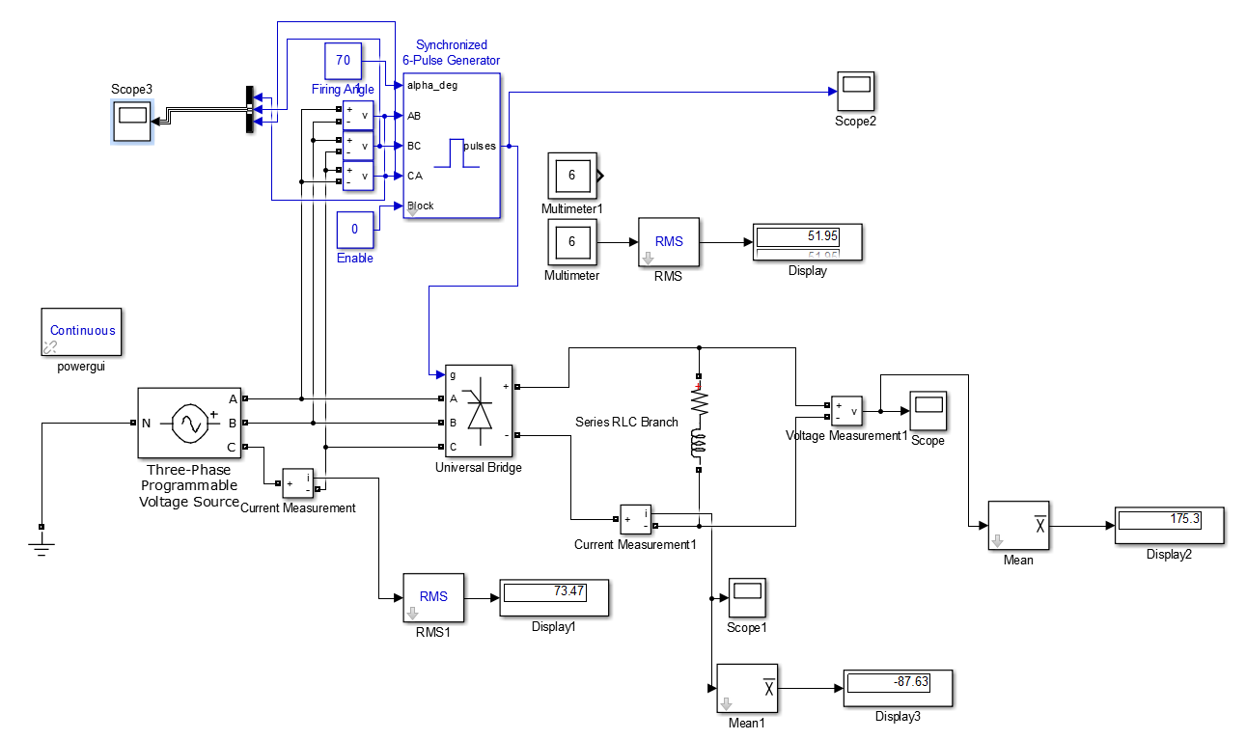

In the whole model there are two parts which are very key to the system:

1. synchronized 6-pulse generator

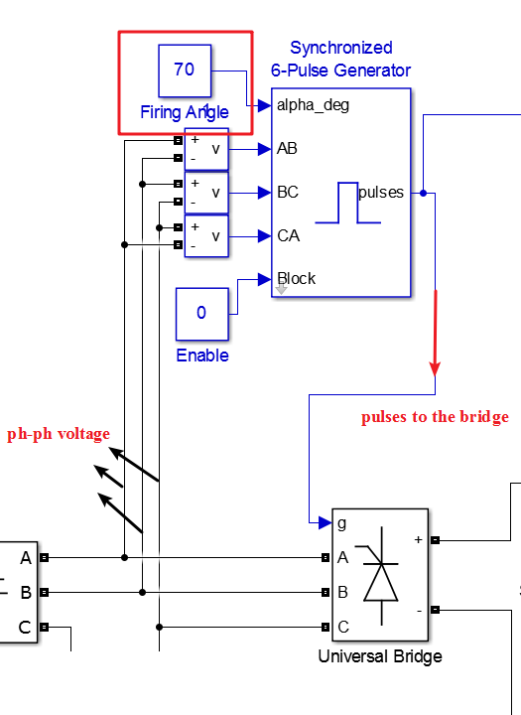

1. universal bridge

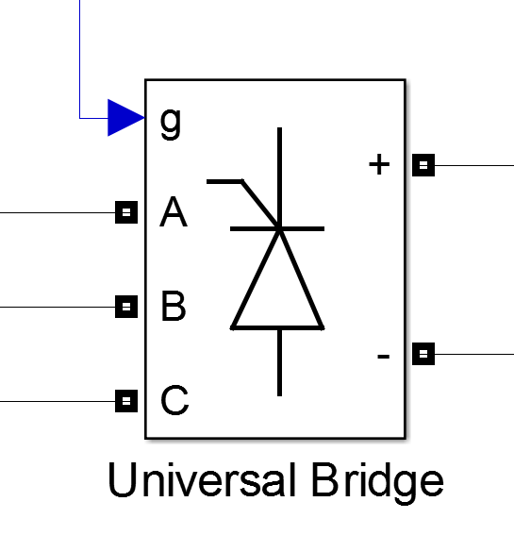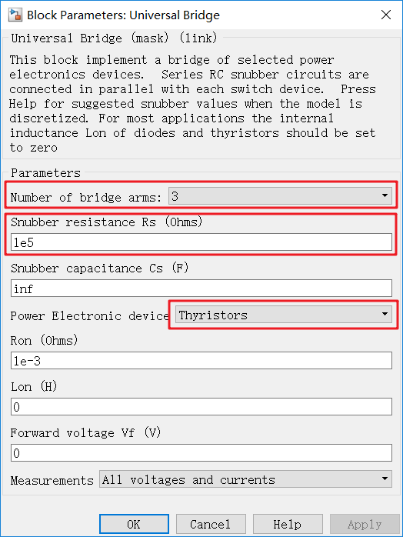

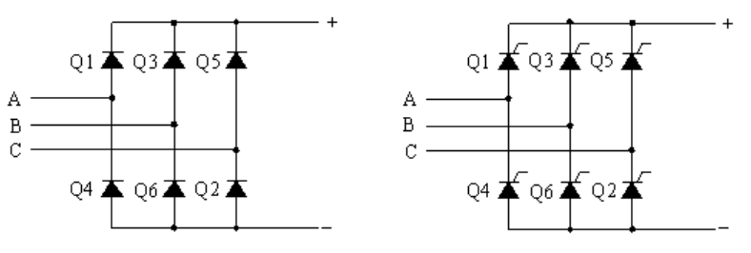

Snubber resistance Rs: The snubber resistance, in ohms (Ω). Set the Snubber resistance Rs parameter to inf to eliminate the snubbers from the model.

Snubber capacitance Cs: The snubber capacitance, in farads (F). Set the Snubber capacitance Cs parameter to 0 to eliminate the snubbers, or to inf to get a resistive snubber.

In order to avoid numerical oscillations when your system is discretized, you need to specify Rs and Cs snubber values for diode and thyristor bridges. For forced-commutated devices (GTO, IGBT, or MOSFET), the bridge operates satisfactorily with purely resistive snubbers as long as firing pulses are sent to switching devices.

If firing pulses to forced-commutated devices are blocked, only antiparallel diodes operate, and the bridge operates as a diode rectifier. In this condition appropriate values of Rs and Cs must also be used.

When the system is discretized, use the following formulas to compute approximate values of Rs and Cs:



where

Pn = nominal power of single or three phase converter (VA)  
Vn = nominal line-to-line AC voltage (Vrms)  
f = fundamental frequency (Hz)  
Ts = sample time (s)

1. The 3-phase souce

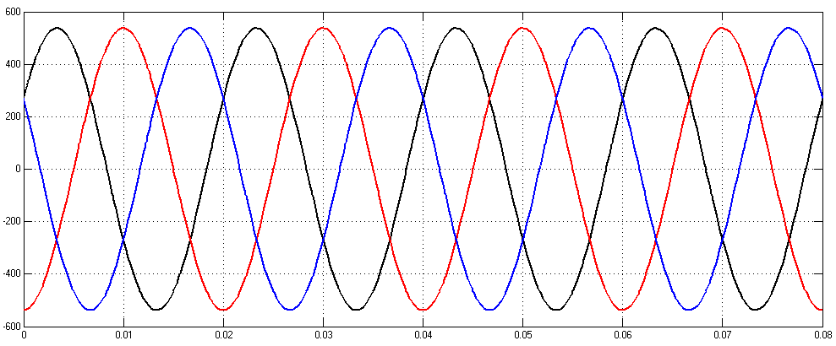

The AC side three-phase voltage source has the following specifications:

RMS Value of Phase-To-AC-Neutral-Point Voltage: 220V

(i.e. RMS Value of Line-To-Line Voltage: 380V)

Line Frequency: 50Hz

* 1. **The first simulation in part1**

Because the parameters is in the sheet:

|  |  |  |  |  |
| --- | --- | --- | --- | --- |
| **L** | **R** | **E** | **α1** | **α2** |
| 3mH | 2Ω | -430V | 70° | 130° |

So the Voltage measurement is like this:

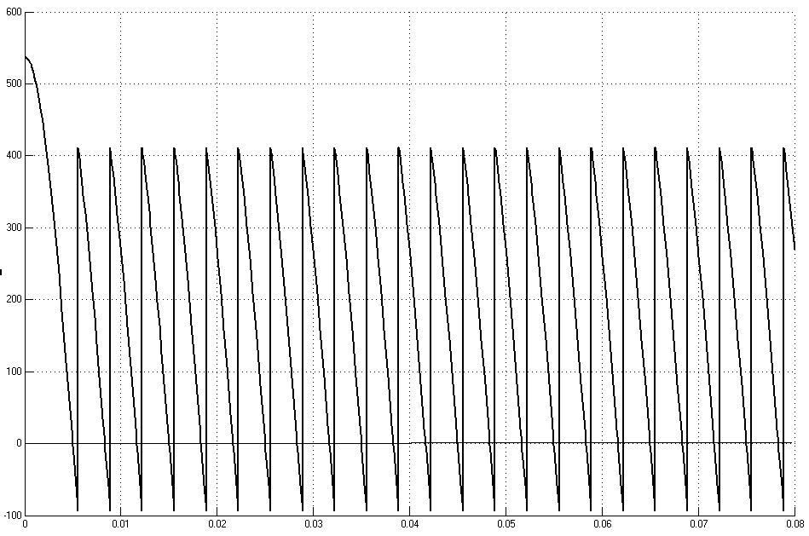

As we can see in this graph the first system is working under rectification mode.

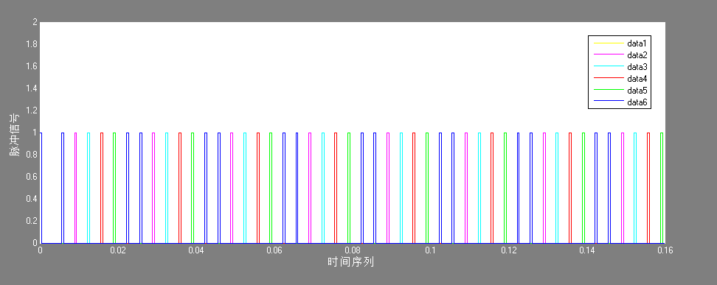

The sequence of driving signal of each thyristor is like this picture. When the **α=70°** the pulse would be delayed 70° and each pulse interval 60°.



The ON and OFF state of each thyristor can be reflected from the figure above.

**When $α=70$ °**

|  |  |  |  |  |  |  |
| --- | --- | --- | --- | --- | --- | --- |
| Phase angle | VT1 | VT2 | VT3 | VT4 | VT5 | VT6 |
| $100$ °~ $160$ ° | on |  |  |  |  | on |
| $160$ °~ $220$ ° | on | on |  |  |  |  |
| 220°~ $280$ ° |  | on | on |  |  |  |
| $280$ °~ $340$ ° |  |  | on | on |  |  |
| 340°~ $40$ ° |  |  |  | on | on |  |
| 40°~° |  |  |  |  | on | on |

* 1. **Theoretical calculations in first model and comparison**

1. Theoretical calculations results

Average value of DC-link voltage Vd

$Ud=\frac{1}{\frac{π}{3}}\int_{\frac{π}{3}+α}^{\frac{2π}{3}+α}{\sqrt{6}U2sinωt}d\left(ωt\right)=2.34U2cosα=$ 176.0719698 V

Average value of DC-link current Id

$Id=\frac{Ud}{R}=$ 88.03598489 A

RMS value of AC side current

$I_{2}=0.816I_{d}=$ 71.83736367A

RMS value of the current flowing through a Thyristor

$I=0.577I_{d}=$ 50.7967632850 A

1. The simulation results

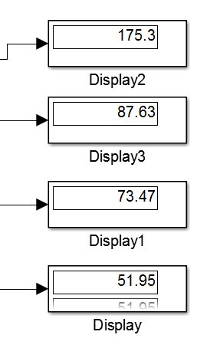

1. Comparison between the two data.

|  |  |  |
| --- | --- | --- |
| 理论值 | 仿真值 | 相对误差(%) |
| 176.072V | 175.3V | -0.438% |
| 88.036A | 87.63A | -0.461% |
| 71.8374A | 73.47A | 2.2727% |
| 50.7968A | 51.95A | 2.2703% |

As we can see above, the results of calculation is very approach to the simulation.

1. **three-phase full bridge rectifier with E in load**

**2.1 Simulation preparation**

(1)The model of the circuit



1(b) Active Inversion Mode

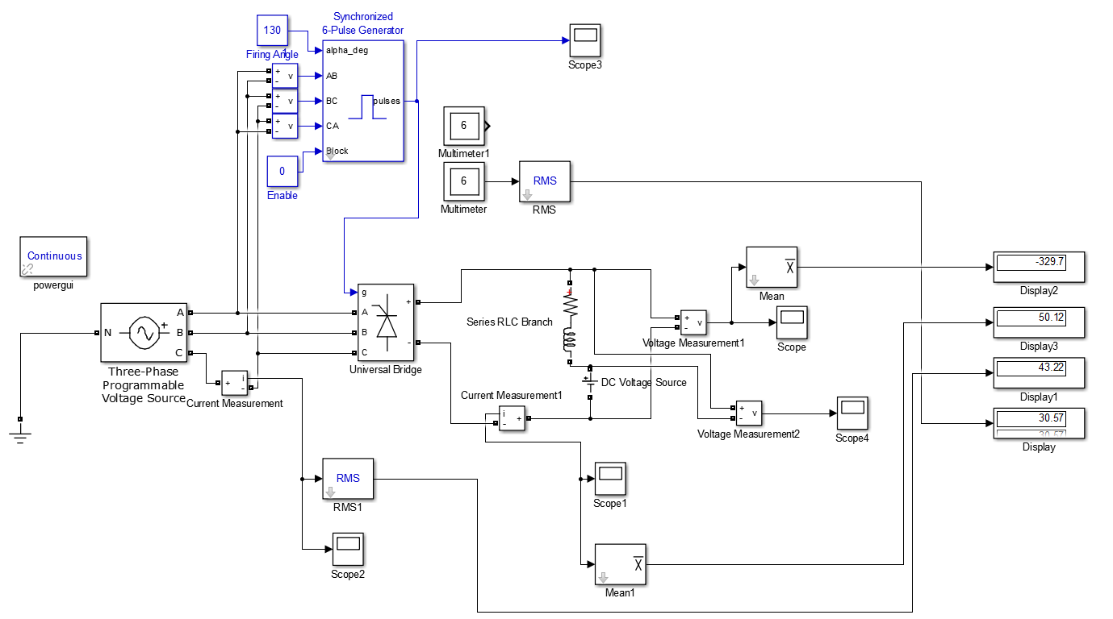

* 1. **The first simulation in part1**

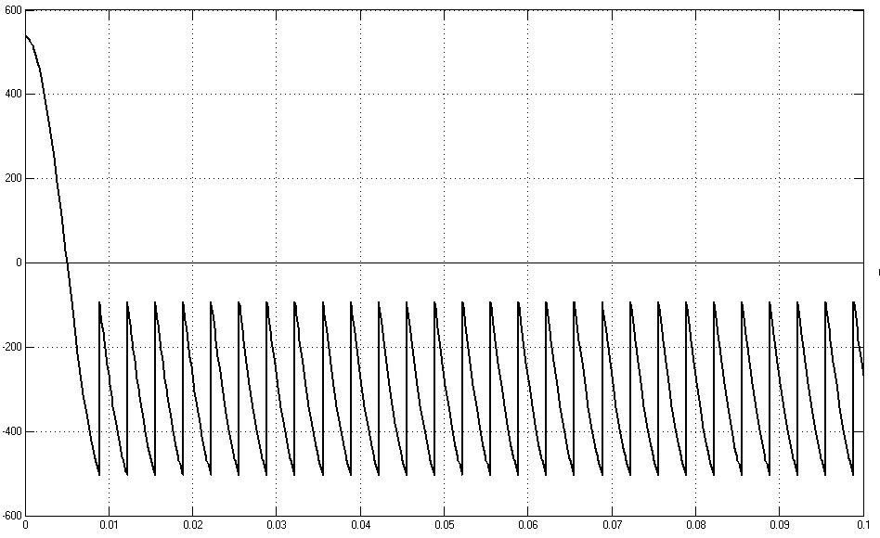

The system do work under Active Inversion Mode.

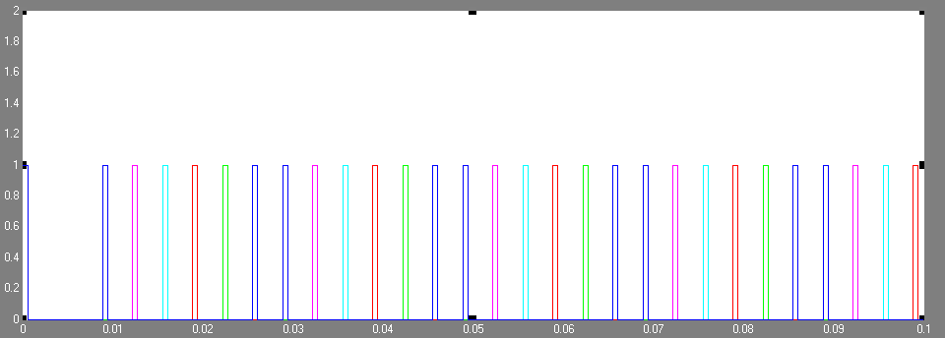

The sequence of driving signal of each thyristor.



The ON and OFF state of each thyristor can be figure out in the picture above.

**When $α=130$ °**

|  |  |  |  |  |  |  |
| --- | --- | --- | --- | --- | --- | --- |
| Phase angle | VT1 | VT2 | VT3 | VT4 | VT5 | VT6 |
| $160$ °~ $220$ ° | on |  |  |  |  | on |
| $220$ °~ $280$ ° | on | on |  |  |  |  |
| $280$ °~ $340$ ° |  | on | on |  |  |  |
| 3 $40$ °~ $40$ ° |  |  | on | On |  |  |
| $40$ °~ $100$ ° |  |  |  | on | on |  |
| $100$ °~ $160$ ° |  |  |  |  | on | on |

**2.3 Theoretical calculations and** **comparison**

1. Theoretical calculations

Average value of DC-link voltage Vd

$Ud=\frac{1}{\frac{π}{3}}\int_{\frac{π}{3}+α}^{\frac{2π}{3}+α}{\sqrt{6}U2sinωt}d\left(ωt\right)=2.34U2cosα=$-330.9070615 V

Average value of DC-link current Id

$Id=\frac{Ud-E}{R}=$ 49.54646927 A

RMS value of AC side current

$I_{2}=0.816I_{d}=$ 40.42991892 A

RMS value of the current flowing through a Thyristor

$I=0.577I_{d}=$ 28.58831277 A

2. simulation results

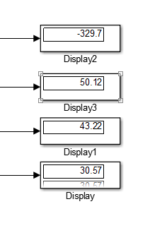

1. Compare and analyze

|  |  |  |
| --- | --- | --- |
| 理论值 | 仿真值 | 相对误差(%) |
| -330.91 | -329.7 | -0.36477 |
| 49.5465 | 50.12 | 1.157561 |
| 40.4299 | 43.22 | 6.901031 |
| 28.5883 | 30.57 | 6.931809 |

As we can see above, the results of calculation is very approach to the simulation.

**PART2 Three-Phase Full Bridge Rectifier (Power Diode)**

1. **Simulation for the Diode Bridge with Capacitive Load**



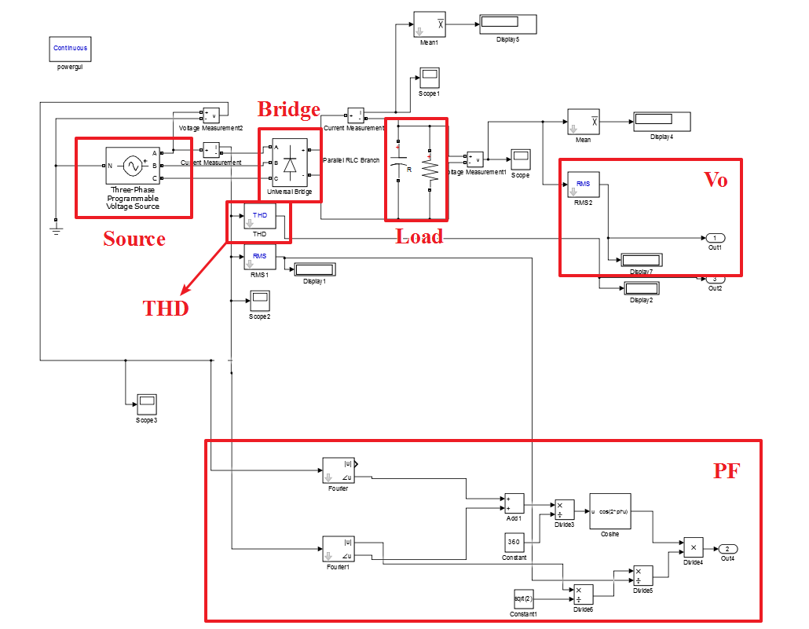



Fig1. Vo = f(RL) Fig2.The diff of the Vo



Fig3. PF = f(RL) Fig4.The diff of the PF



Fig5. THD = f(RL) Fig6. The diff of the THD

To analyze the influence of resistor, we can write a program to change load resistance from 1 to 100 and observe variations of Vo, THD and power factor.

From picture Fig1, when resistance of load grows up, output voltage will grow up quickly and then almost keep a fixed value. And from the Fig2 the diff of the Vo, the variation trend is more obvious. When the R is approaching 100 the trend of the curve is becoming slow and smooth.

From Fig3 we can see that when resistance of load grows up, PF will descend with a reducing slow rate. Based on the formula $PF=\frac{P}{S}=\frac{I_{1}}{I}cosφ$,Because $PF=\frac{cosφ}{\sqrt{1+{THD}^{2}}}$.

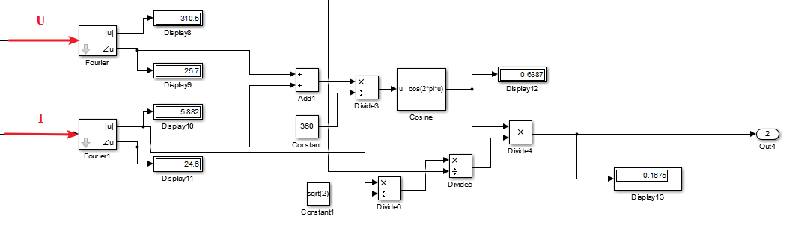

We can calculate the PF through the system above.

And THD increases when resistance grows up, we think the variation of power factor is reasonable.