**Homework3**

**3.12** In a 3-phase bridge fully-controlled rectifier with resistive load, if one of the thyristors fails to conduct, what would the waveform of rectified voltage **ud** be? And what if one of the thyristors was broken down to be shorted, how would the other thyristors be influenced?

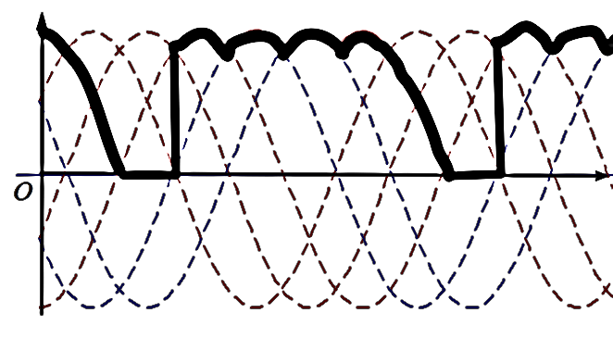

1. One of the thyristor fails to conduct the waveform would like to be this shape.
2. If there is a thyristor was broken down and it was forced to be shorted the other thyristor will face to the danger to be destroyed too.

**3.13** In a 3-phase bridge fully-controlled rectifier, U2=100V, with resistive and inductive load, R=5Ω, L is extremely large, when α = 60°, try to:

1. Plot the waveform of ***ud***, ***id*** and ***iVT1***.
2. Calculate the value of ***Ud***, ***Id***, ***IdVT*** and ***IVT*** .

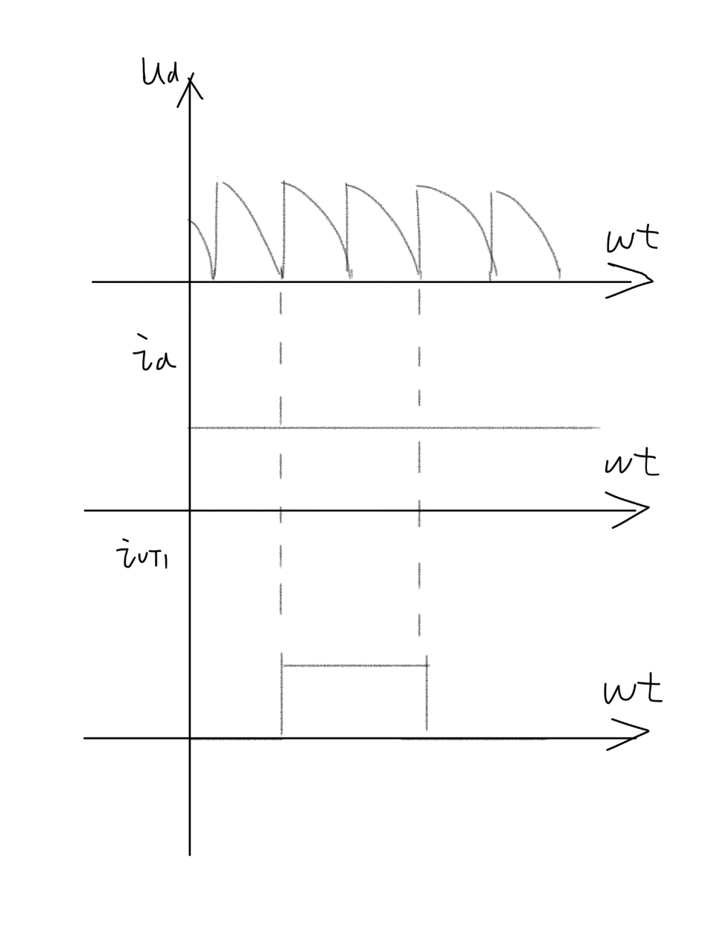



The waveform is shown like the graph above.

**3.15** A three phase half wave controlled rectifier with electro-motive-force, resistive and inductive load, U2=100V, R=1Ω, L = ∞, LB = 1mH, when α = 30°, E = 50V, try to derive the value of **Ud**, **Id**, and **γ**, meanwhile, plot the waveform of **ud**, **iVT1** and **iVT2** .

Because there is LB exsist.



Solve the equation and we can get the answer:



Because the two angle have equation like this :



And the waveform is as below:

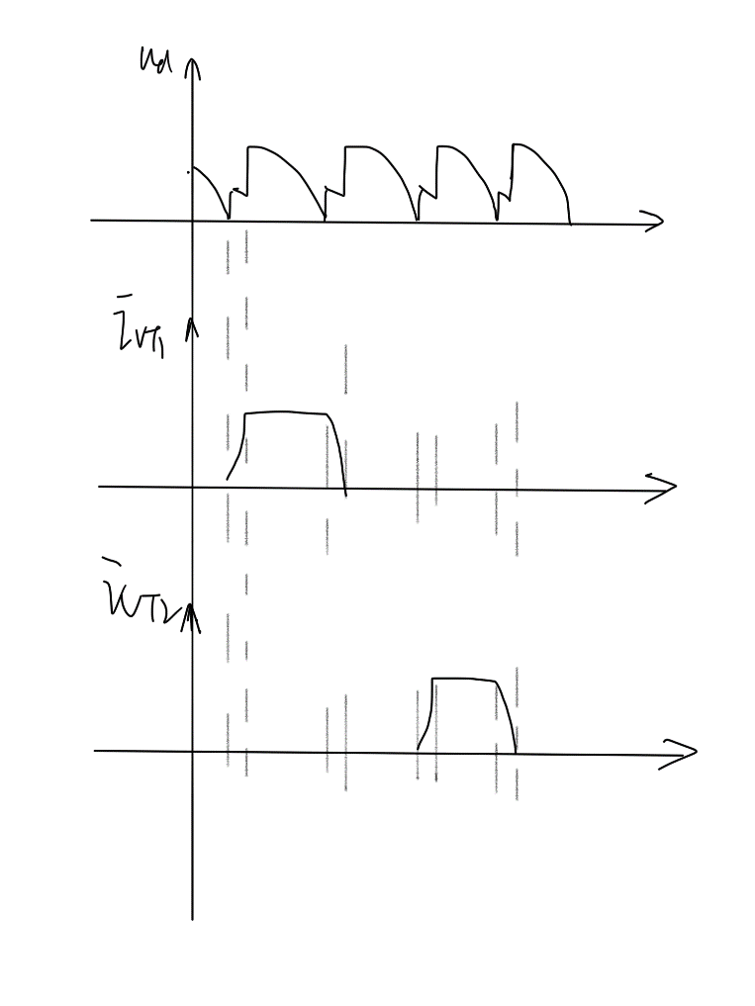

**3.16** A three phase bridge uncontrolled rectifier, resistive and inductive load, R=2Ω, L = ∞, U2=100V, XB=0.1Ω, try to derive the value of **Ud**, **Id**, **IVD**, **I2** and **γ**, meanwhile, plot the waveform of **ud**, **iVD** and **i2**.

The circuit and its Mechanism is like the 3-phase bridge controlled rectifier when its firing angle equal to zero.





And moreover the Commutation overlap angle can be solved by this equation.



Finally we can calculate the Ivd and the I2a by those equations below.



**3.27** For a three-phase bridge controlled rectifier with inversed electromotive force and resistive inductive load, its parameters are given as follows: R = 1Ω, L = ∞, U2 = 220V, LB = 1mH. Under the condition that EM=-400V and β=60°, please find the value of **Ud, Id, γ** and the active power back to the grid.

As usual we can build up an equation to describe the circuit.



And we can get the solution of the equation:



And moreover the commutation overlap angle can be solved by this equation.



Finally the Power is:

