Seminar3_report

1. Build up ***Series connection of 2 single-phase VSIs*** with **single-phase half-bridge inverter** **OR** **single-phase full-bridge inverter** in simulation.



Fig.1 Series connection of 2 single-phase VSIs with single-phase full-bridge inverter

1. Observe the single inverter’s time sequence waveform and input/output voltage relationships

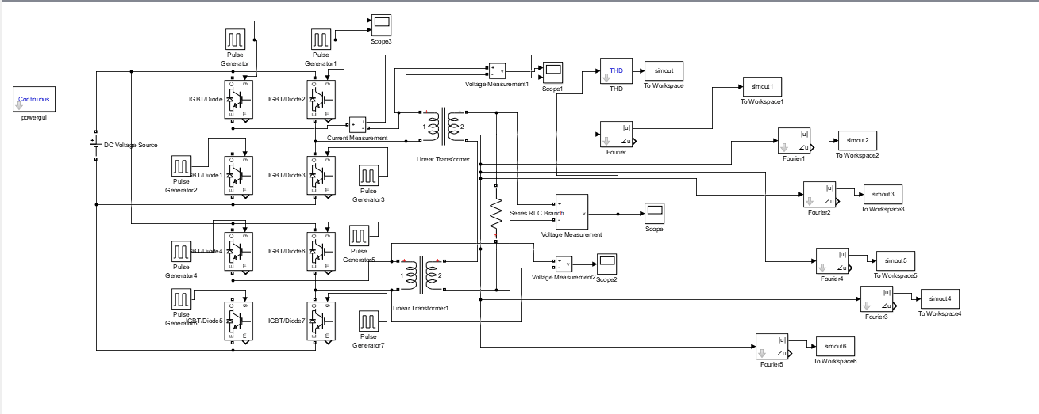

Through modeling and calculating, first of the trigger signal is like this:



The upper one is signal of V1 and another is V3, Theoretically, the  Consistent with the simulation.

And the single inverter’s time sequence waveform is like this: the upper waveform is the symbol of output voltage and under it is current.



1. Study the basic operating principle of ***Series Connection of Multiple Single-phase VSIs***

Supposed the external phase-shifting angle φ between inverters equal to 60°, another inverter’s waveform of output voltage is:



Two single-phase VSIs connected by series connection of multiple and two output voltage both are square waves with conduction angle equaling to 150°.

So we can get the final waveform of output voltage on secondary side:



Theoretically, if the conduction angle equal to 120°, because of phase-shifting equaling to 60°, The three harmonic of both two signals cancel each other so we’ve got  harmonic left.

1. Plot the curves characterizing the relationships between **phase-shifting angle** and:
   1. RMS value of the fundamental component in output voltage



When the external phase-shifting angle φ between inverters is 0, RMS value of the fundamental component in output voltage should be $2×\frac{2\sqrt{2}}{π}U_{d}=720V$ in theoretical caculation. The conduction angle turns to 0 with the increase of the external phase-shifting angle φ, so this will cause the decrease of the fundamental component in output voltage, this is consistent with the changes in the image.

* 1. output voltage THD



When the external phase-shifting angle φ between inverters is 60°, 3k(k=1,2,3…) harmonics can be eliminated by superposition, so the harmonic component is the smallest at this angle, and the THD reaches the minimum at 60°. When approaching to 180°, the THD approachs infinity due to the fundamental wave approaching to 0.

* 1. 3rd 5th 6th 7th and 9th harmonics components



When φ is 60° and 180°, the third harmonic stagger 180k degrees, so it will be eliminated to 0 by superposition.



When φ is 36°，108°and 180°, the fifth harmonic stagger 180k degrees, so it will be eliminated to 0 by superposition.



Even harmonic is very small and can be ignored.



When φ is 25.7°，77.1°，128.6°，180°, the seventh harmonic stagger 180k degrees, so it will be eliminated to 0 by superposition.



When φ is 20°，60°，100°，140°，180°, the nineth harmonic stagger 180k degrees, so it will be eliminated to 0 by superposition.

1. For three-phase bridge inverter:
2. Analyze the voltage across power switch and the current flowing through it

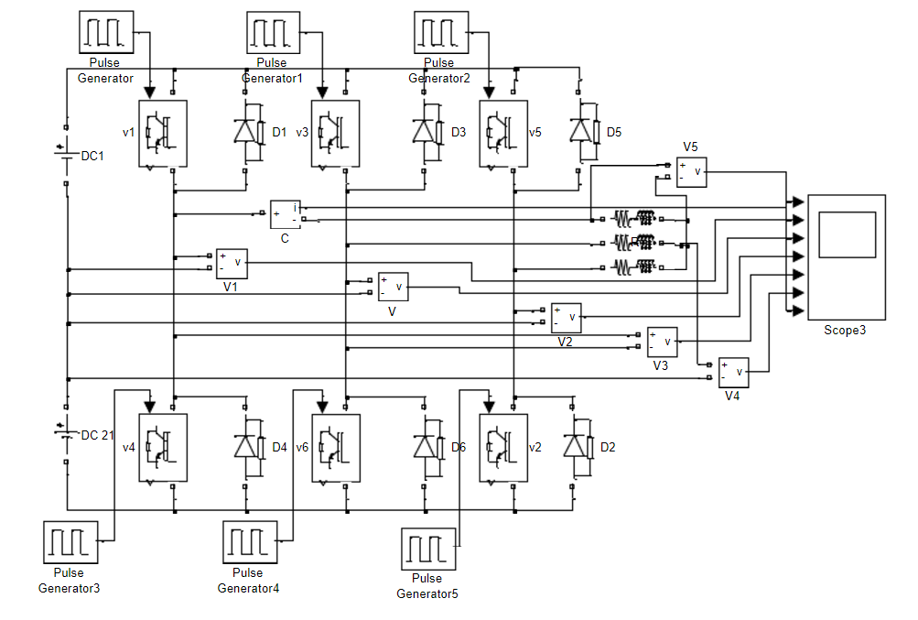

As a three-phase bridge inverter, it works in mode of “180° conduction” , two bridge arms are turned on in turns and the angle between two phase equal to 120°. So at every moment there are three arms on.

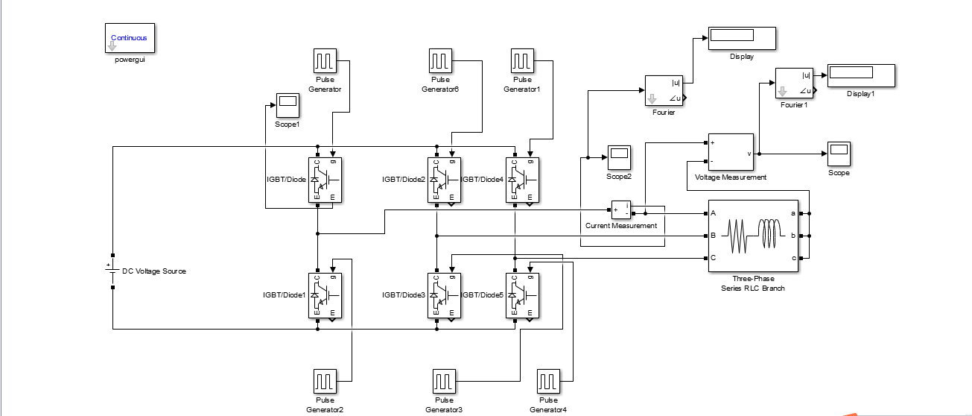

1. Calculate the 5th 7th 11th and 13th harmonics components in output voltage and output current. Then compare with simulation results.

The calculation formulation:



|  |  |  |  |  |  |  |
| --- | --- | --- | --- | --- | --- | --- |
|  | voltage | | | current | | |
|  | simulation | calculation | err | simulation | calculation | err |
| 5th | 25.23 | 25.46 | -0.009033778 | 1.37 | 1.367 | 0.002195 |
| 7th | 18.16 | 18.19 | -0.001649258 | 0.7599 | 0.7529 | 0.009297 |
| 11th | 11.46 | 11.58 | -0.010362694 | 0.3212 | 0.3186 | 0.008161 |
| 13th | 9.83 | 9.79 | 0.004085802 | 0.2754 | 0.2328 | 0.18299 |

The voltage and current of Igbt are like this graph.

