**Report of Seminar4**

**Group 2**

1. **Part1**

|  |  |  |
| --- | --- | --- |
| Group | Circuit | Parameters |
| 2 | Buck converter | Vin=400V, Vo=300V, RL=20Ω, fs=100kHz, L=1mH, C=50uF, |

* 1. For given input/output voltage and circuit parameters, calculate the theoretical value of ***inductor current ripple, capacitor voltage ripple*** and do simulations to verify the calculation results
  2. For **buck converter**, adjust the duty cycle ***D*** from 0 to 0.8, describe the relationships between duty cycle ***D*** and ***inductor current ripple, capacitor voltage ripple, voltage gain (G=Vo/Vin)*** and verify your results through simulation.

a)

(1) Theoretical calculations:

(2) Simulation results:

2.1 Circuit and program for simulation:

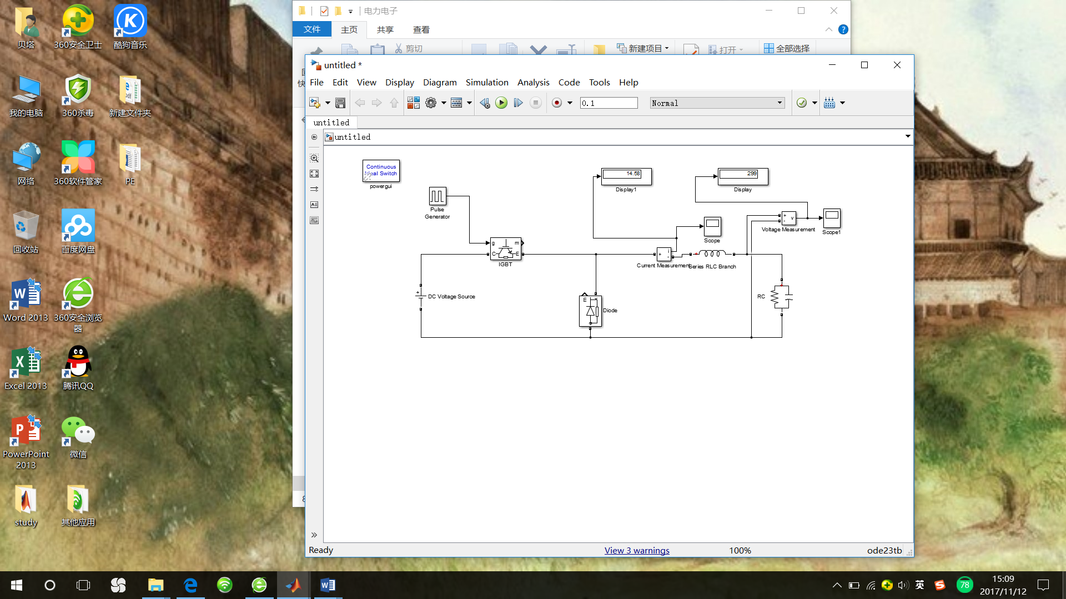

Program:

uo1=uo(:,2);

upp=max(uo1)-min(uo1)

io1=io(:,2);

ipp=max(io1)-min(io1)

Answer:

upp =0.0185

ipp =0.7496

2.2 Analysis

|  |  |  |  |
| --- | --- | --- | --- |
|  | Theoretical results | Simulation results | Relative error |
|  | 0.01875 | 0.0185 | 1.3% |
|  | 0.75 | 0.7496 | 0.05% |

From the table above, we can know that the relative error between theoretical and simulation is very small, so we can think the calculation results are right.

b)

(1) Circuit and program for simulation:

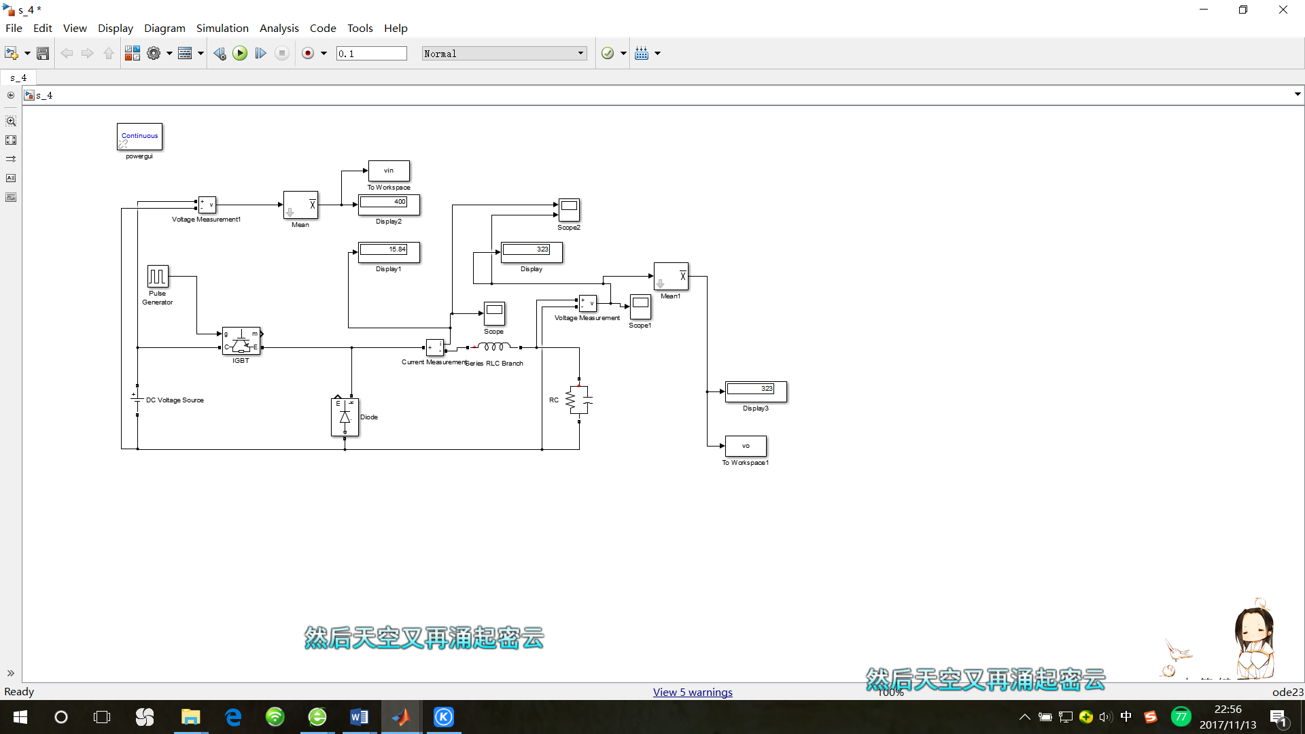

Program:

upps=[];uppt=[];

ipps=[];ippt=[];

gs=[];

for d=1:2:81

sim('s_4');

uo1=uo(:,2);

upp=max(uo1)-min(uo1);

upps=[upps,upp];

io1=io(:,2);

ipp=max(io1)-min(io1);

ipps=[ipps,ipp];

g=vo/vin;

gs=[gs,g]

end

d=1:2:81;

uppt=0.1.*(0.01.*d).*(1-(0.01.*d));

ippt=4.*(0.01.*d).*(1-(0.01.*d));

figure(1)

plot(d./100,upps,'r * -')

hold on;

plot(d./100,uppt,'b + -')

title('capacitor voltage ripple and duty cycle'); legend('simulation','theoretical')

figure(2)

plot(d./100,ipps,'r * -')

hold on;

plot(d./100,ippt,'b + -')

title('inductor current ripple and duty cycle'); legend('simulation','theoretical')

figure(3)

plot(d./100,gs,'r * -')

hold on;

plot(d./100,d./100,'b + -')

title('voltage gain and duty cycle'); legend('simulation','theoretical')

(2)The relationships between duty cycle ***D*** and ***inductor current ripple***

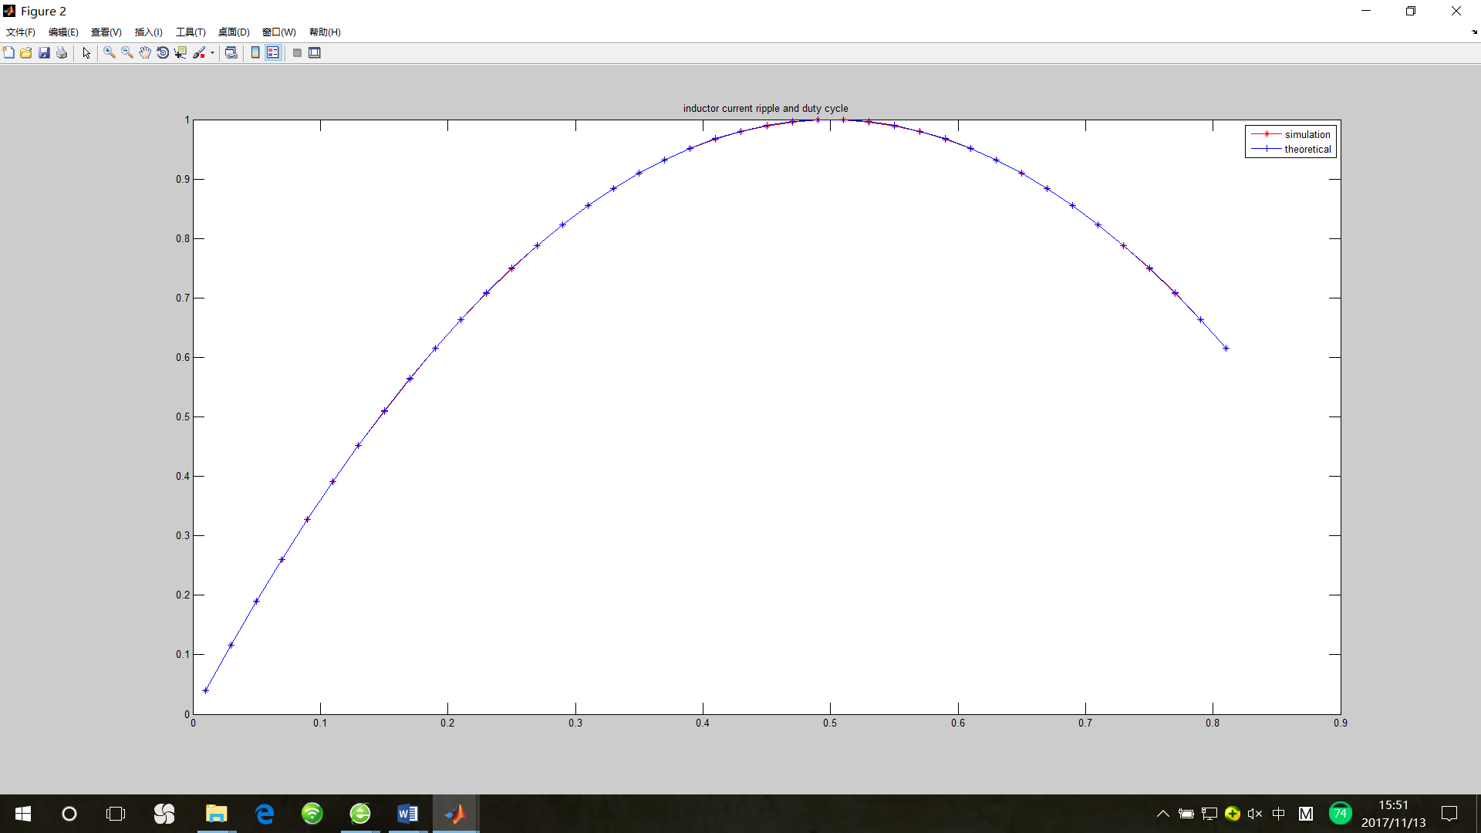

From the textbook, we can get the equation: . When , the function between D and should be a quadratic function. From theoretical analysis, we can infer that we D equals 0.5, will increase to peak value just like the blue curve showed in the diagram above. Besides, the red curve shows the result from simulation. The error between blue curve and red one is very small, so we can think the simulation successful.

(3) The relationships between duty cycle ***D*** and ***capacitor voltage ripple***

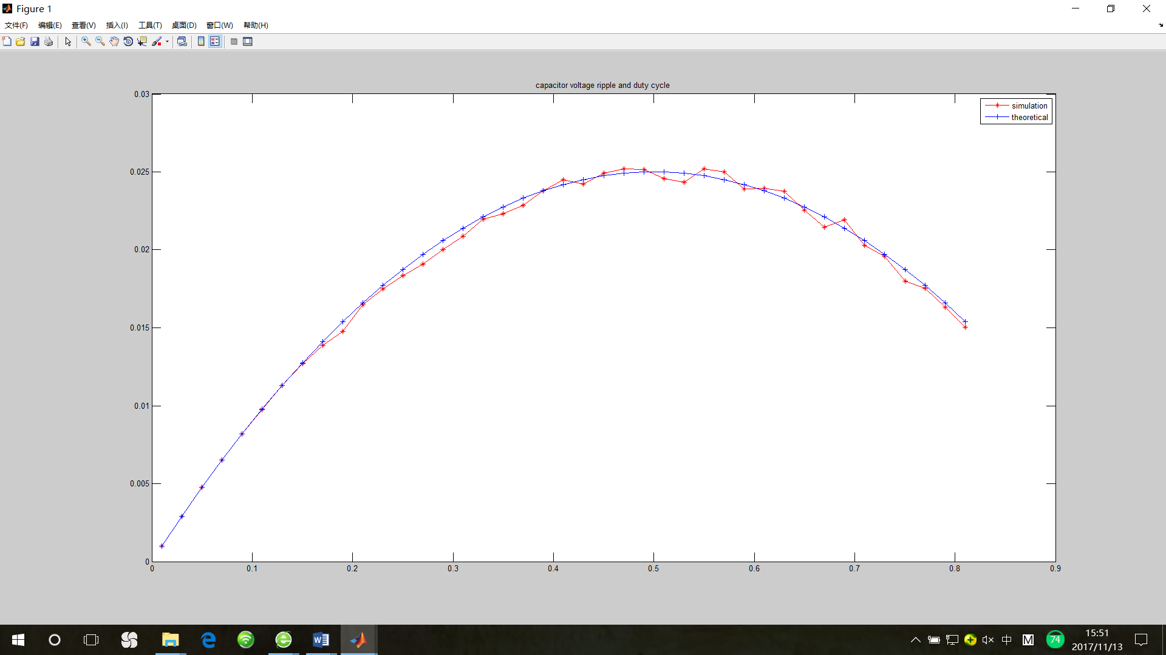

From the textbook, we can get the equation: . When , the function between D and should be a quadratic function just like the blue curve showed in the diagram above. Besides, the red curve shows the result from simulation. The error between blue curve and red one is very small, so we can think the simulation successful.

(4) The relationships between duty cycle ***D*** and ***voltage gain (G=Vo/Vin)***

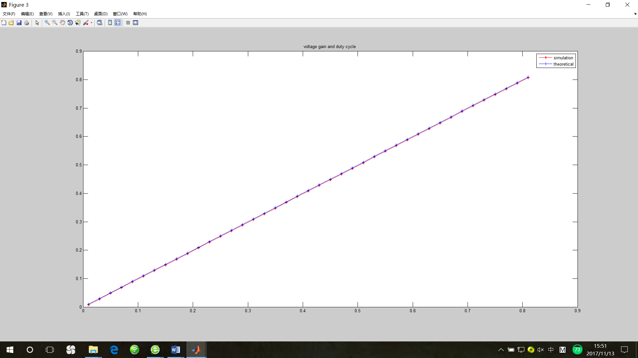

From the textbook, we can get the equation: . When , the function between relationships between duty cycle D and G should be a rising straight line whose slope is 1 just like the blue curve showed in the diagram above. Besides, the red curve shows the result from simulation. The error between blue curve and red one is very small, so we can think the simulation successful.

II . Take ***full-bridge inverter*** + ***full-wave rectifier*** structure as example:

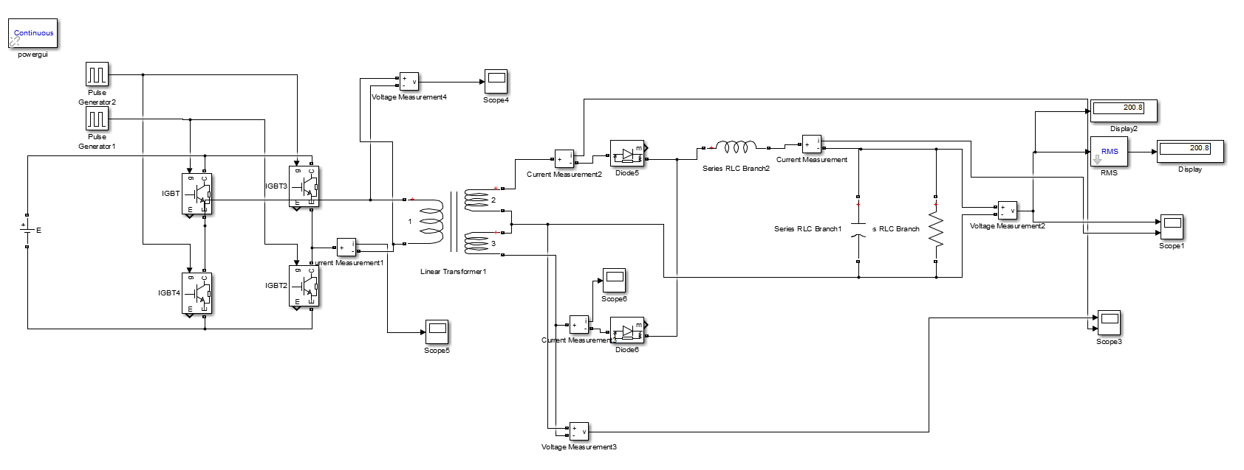

Fig1. The model of circuit in simulink

1. For given input/output voltage and circuit parameters, do simulations to study the operating principle and analyze the operating sequence.

TAB II. Parameters for Question

|  |  |
| --- | --- |
| Group | Parameters |
| 2 | Vin=500V, Vo=200V, T=2:1:1, RL=10Ω, fs=100kHz, L=1mH, C=100uF, |

1. Theoretical calculation

When the current is under continuous current mode:



So when the Vin=500V, Vo=200V, T=2:1:1



And obviously, when we put duty cycle equal to 40% (both two pulse generators) the Vo equals to 200V.

1. Modeling and Parameters setting

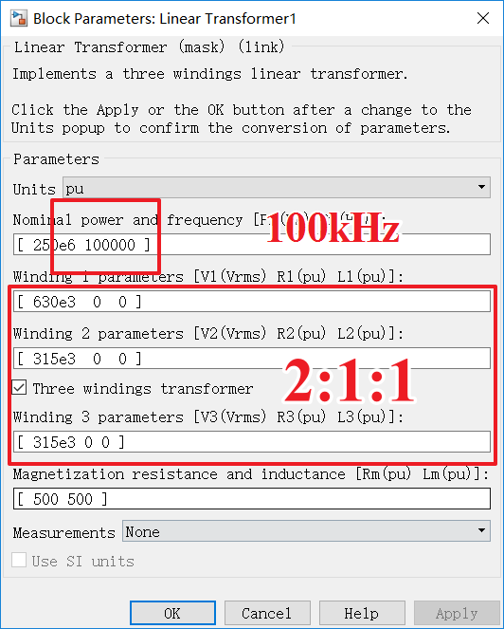

Fig . Parameters setting of the Linear Transformer

The Parameters setting is a key in all the setting and simulation.

Firstly set the frequency equal to 100kHz and the R and L of three windings equal to zero which is mostly approaching to the ideal state.

1. Simulation

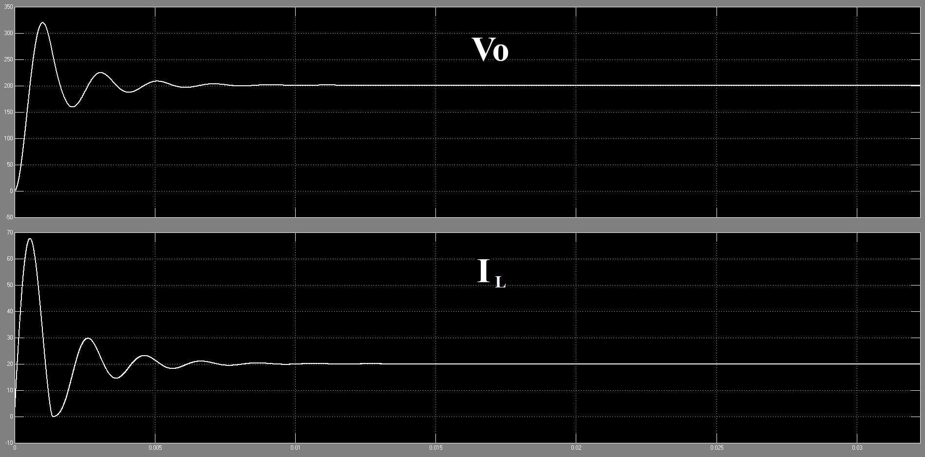

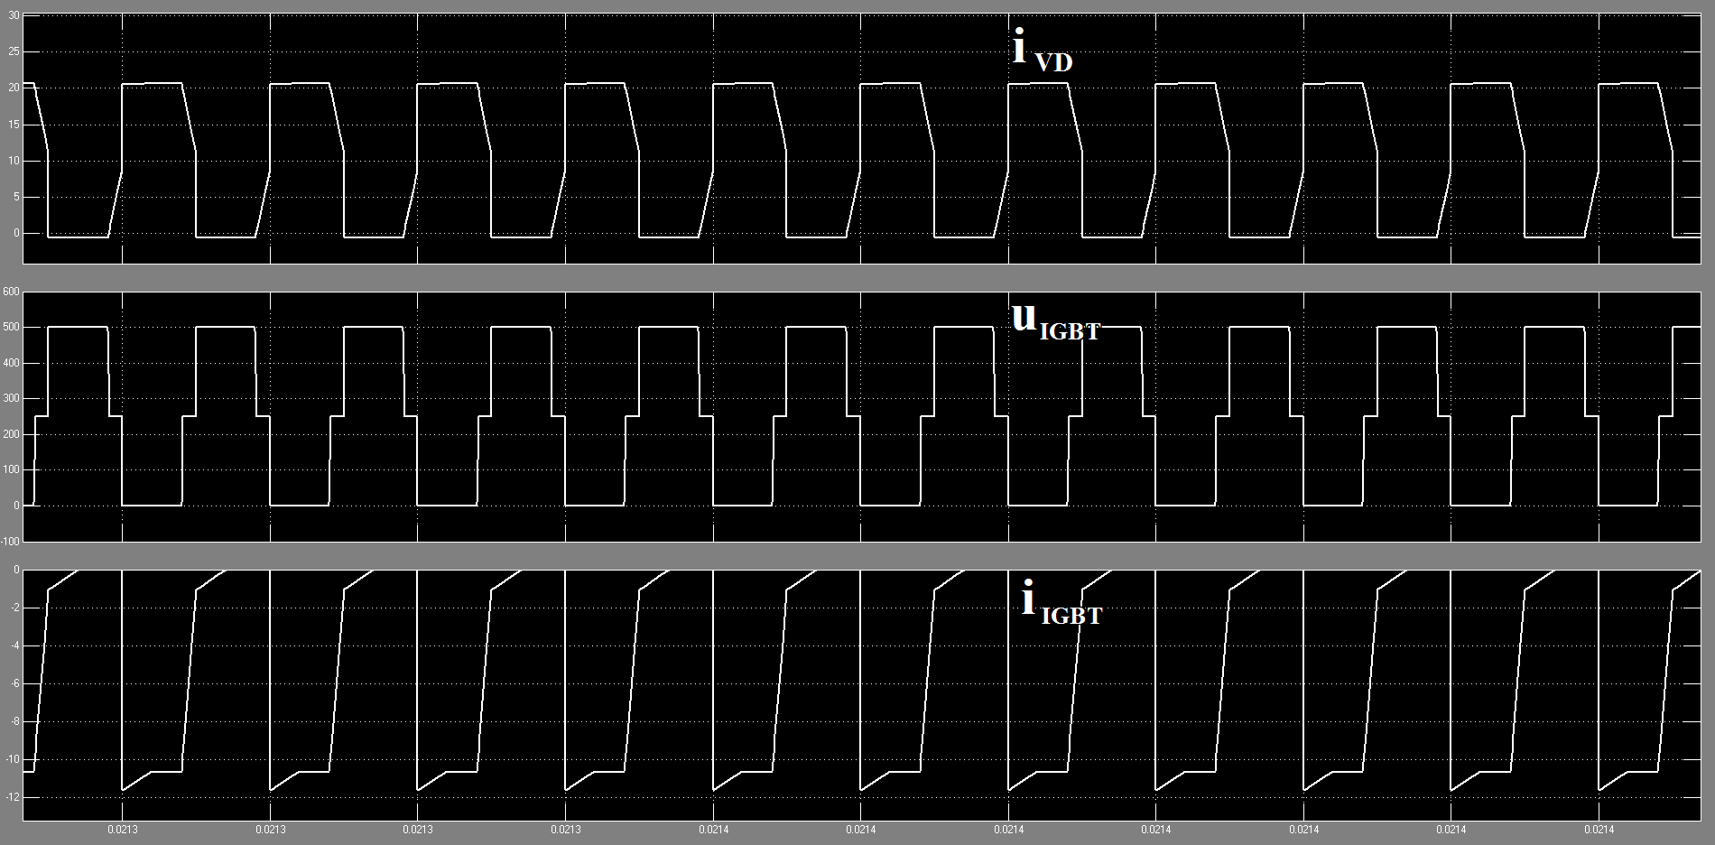

As we all know, in the Primary side there is a full-bridge inverter circuit which can take emf into a AC voltage through the transformer and go to the secondary-side. And there four IGBT to make sure the inverter go correctly which is loaded with pulse in 100kHz and different duty cycle.

With different duty cycle, the whole time is increasing which is made of two ton time.

In the secondary-side, there is a full-wave rectifier which can make the AC voltage be a DC current again with help of huge inductor and the capacitor.

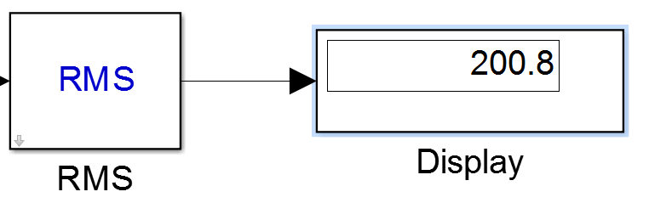

When the Pulse Width of Pulse Generator equal to 40%, and from the Theoretical calculation we can learn that simulation is very approach to calculation results.

1. Adjust the load resistor to realize ***continuous current mode*** (**CCM**) and ***discontinuous current mode*** (**DCM**) and verify through simulation.
2. The definition of continuous current mode (CCM) and discontinuous current mode (DCM).

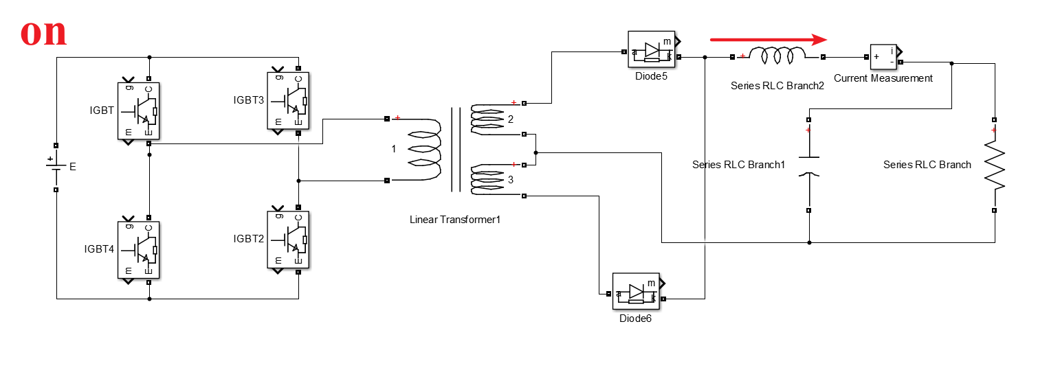

Continuous-conduction-mode (CCM) means that the current in the energy transfer inductor never goes to zero between switching cycles. In discontinuous-conduction-mode (DCM) the current goes to zero during part of the switching cycle. In buck derived converters the major effect is that when it changes from CCM to DCM, it goes from a second order system to first order system. In boost and buck-boost derived systems there is a right-half-plane zeroin CCM which is not present in the DCM. This makes it much more difficult to stabilize these converters with good dynamic response. There is much more, but it is covered in any basic text on switching-mode power supplies such as the ones recommended in my personal power supply design library.

Much information is in application notes and reference designs from vendors who make power transistors and controllers, such as TI, On Semiconductors, International Rectifier, etc. You can find some of these by searching on semiconductors on my vendors page.

1. Finding the R which makes the mode change.



Because when the R load’s change makes the CCM turn to DCM the Vo would increase surely and we can calculate this value to confirm which load can make the DCM be realized.

I put the step equal to 10 and begin with 100 end in 300 and get the graph like this.

So we can find that the turning point is between 210~220 ohm.

1. Adjust duty cycle D and analyze the relationships between D and voltage gain (G=Vo/Vin)

Take the D, which equals to  , change from 1 to 49 stepping 1 so get 49 datas to analyze the relation between the D and the G, which equals to .



From 3.65% to 49.08%, the 49 points are lined to a line which has a curve fitting processing.

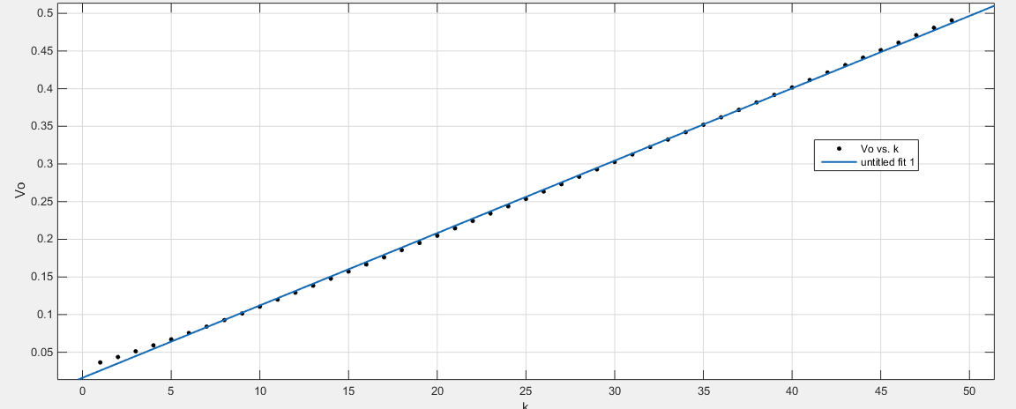

And the results of curve fitting is :

Linear model Poly1:

f(x) = p1*x + p2

Coefficients (with 95% confidence bounds):

p1 = 0.009609 (0.009543, 0.009675)

p2 = 0.0161 (0.01421, 0.018)

So the function between of the two variblies :



Goodness of fit:

SSE: 0.0004943

R-square: 0.9995

Adjusted R-square: 0.9994

RMSE: 0.003243