**Seminar5**

1. For single-phase ***AC voltage controller*** (**phase control**) with fixed load:
2. Varying **delay angle**, simulate to observe **output voltage waveform** and **input current waveform** with grid voltage as reference
3. Study the relationships between the **RMS value of output voltage** and **delay angle**
4. Study and verify the conditions of CCM (continuous current mode)

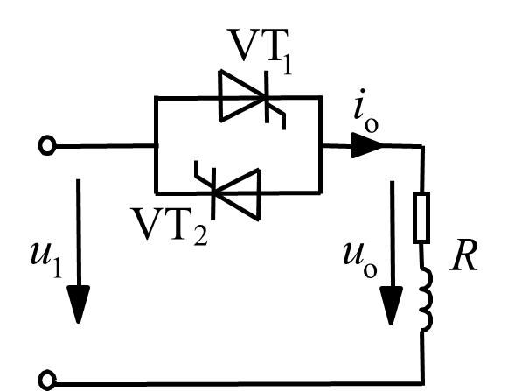

**Fig.1 AC Voltage Controller**

1. For single-phase ***AC chopper*** (**chopping control**) with the same load and input voltage as shown in 1):
2. Varying **duty cycle**, simulate to observe **output voltage waveform** and **input current waveform** with grid voltage as reference
3. Analyze ***commutation process***
4. Study the relationships between the **RMS value of output voltage** and **duty** **cycle**

*(It is recommended to use IGBT model in the library and to set switching frequency to 1kHz for simulation.)*

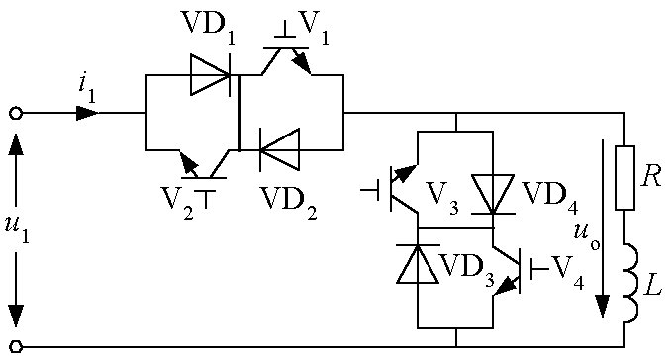

**Fig.2 AC Chopper**

1. Given that the above two converters share ***the same fundamental component of output voltage***, compare and analyze the differences of output voltage’s harmonic components.
2. It is recommended to use Simulink.