**Seminar5**

1. For single-phase ***AC voltage controller*** (**phase control**) with fixed load:

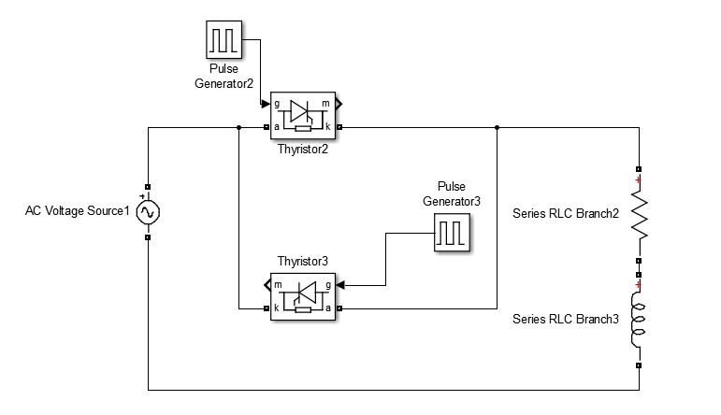

|  |  |  |  |  |
| --- | --- | --- | --- | --- |
| Group | RMS Value of Input Voltage | Frequency of Input Voltage | Load Inductance | Load Resistance |
| 7 | 220V | 50Hz | 22.3mH | 10Ω |

1. Varying **delay angle**, simulate to observe **output voltage waveform** and **input current waveform** with grid voltage as reference
2. Power factor angle(Impedance angle) / delay angle / Conduction angle

Power factor angle  is a parameter of load used to describe inductance obstruction load.

°

delay angle  is responsible for the thyristor’s conduction time.

Conduction angle  is used to describe the conduction period in whole cycle.

1. Waveforms

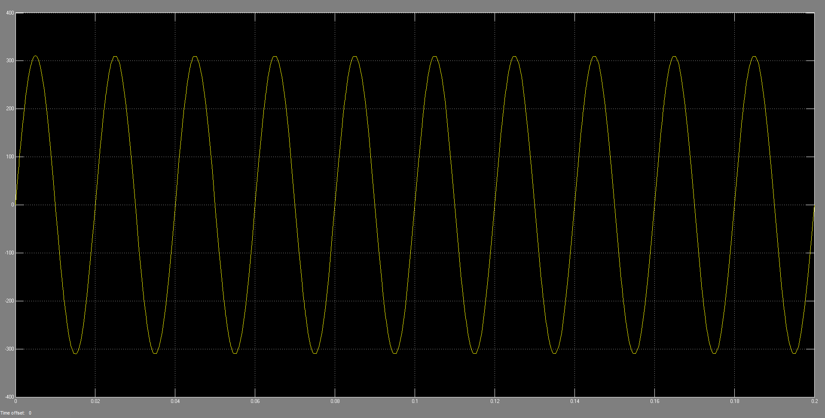

Fig0. Grid voltage

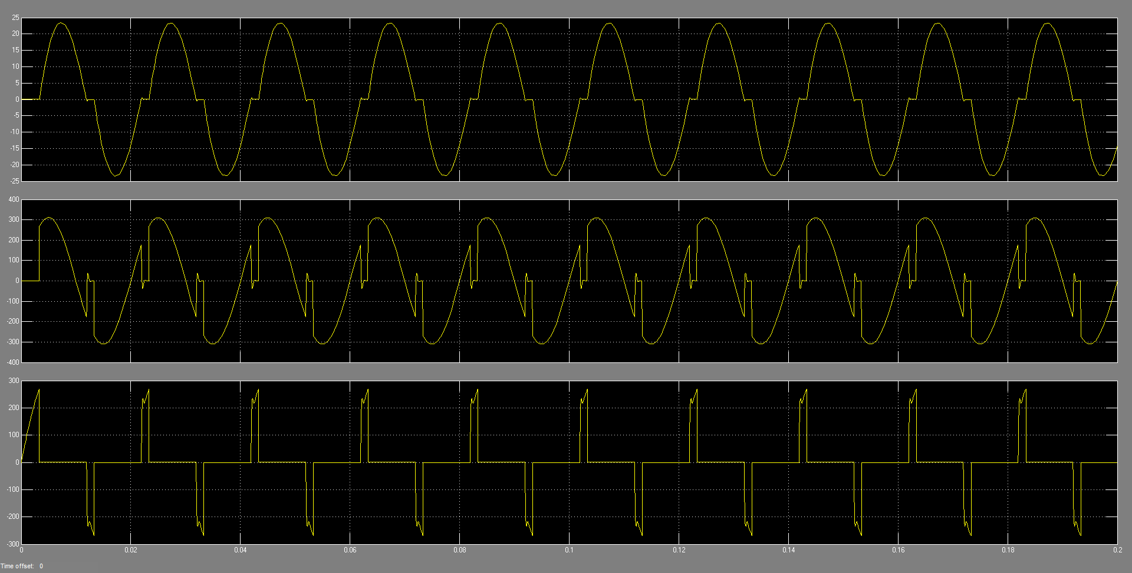

Fig1. =60° , Pulse Width=10%

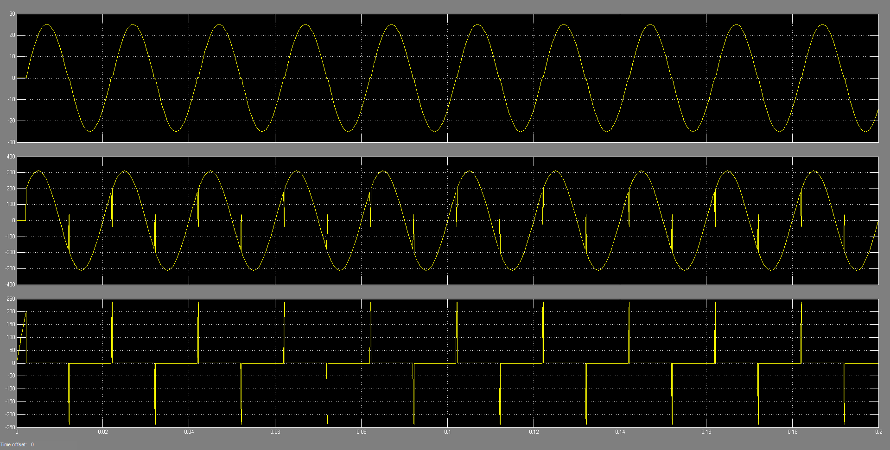

Fig2. =40° , Pulse Width=10%

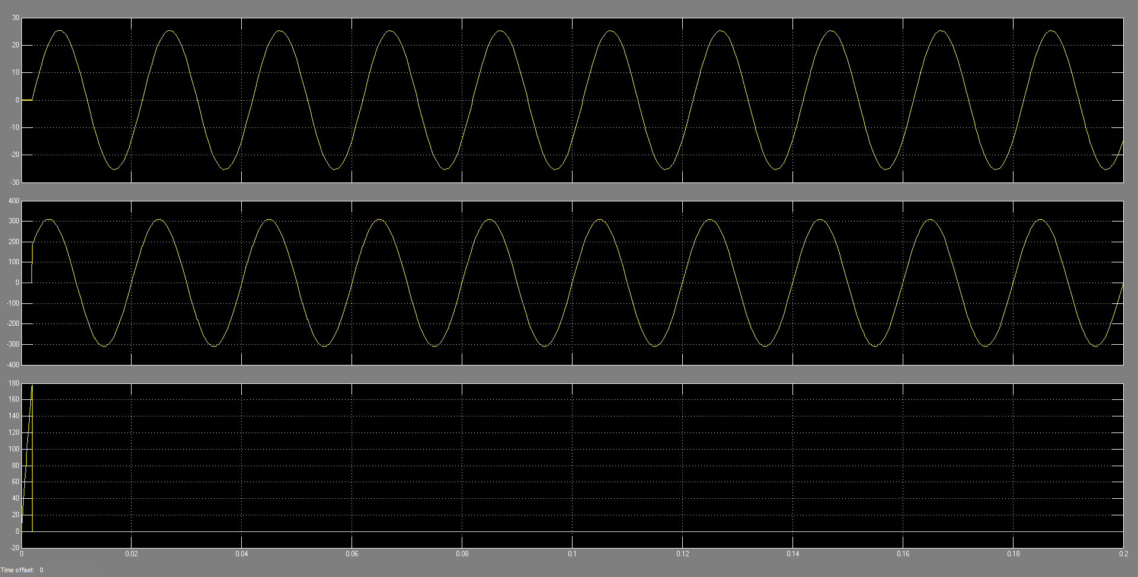

Fig3. =34.01413° , Pulse Width=10%

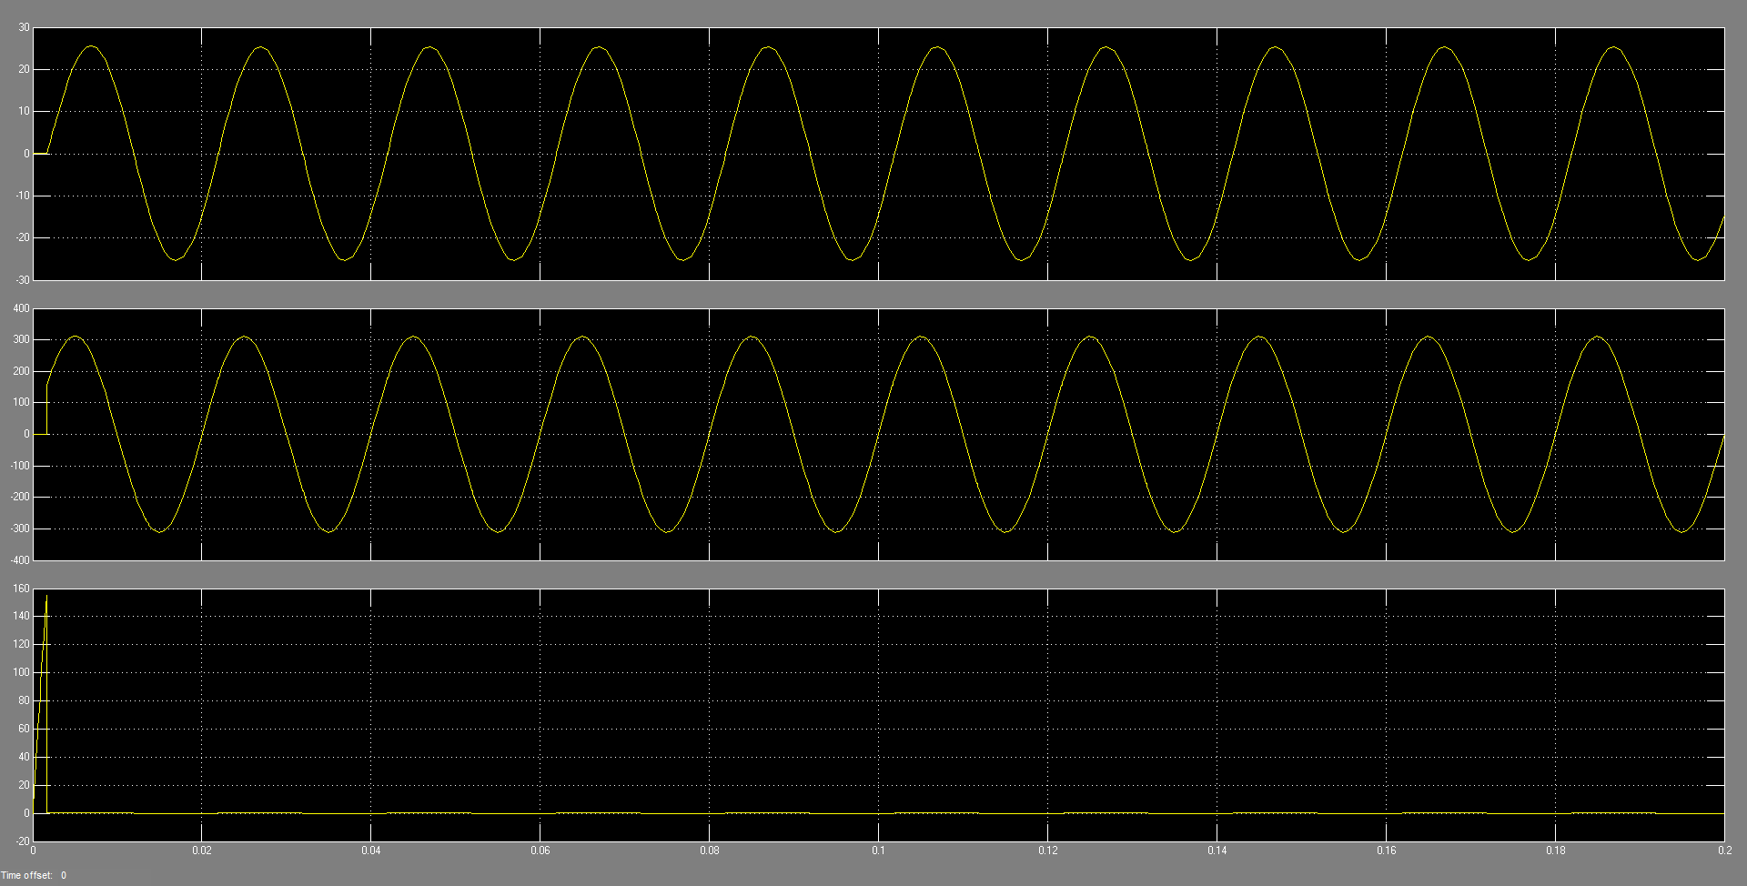

Fig4. =30° , Pulse Width=10%

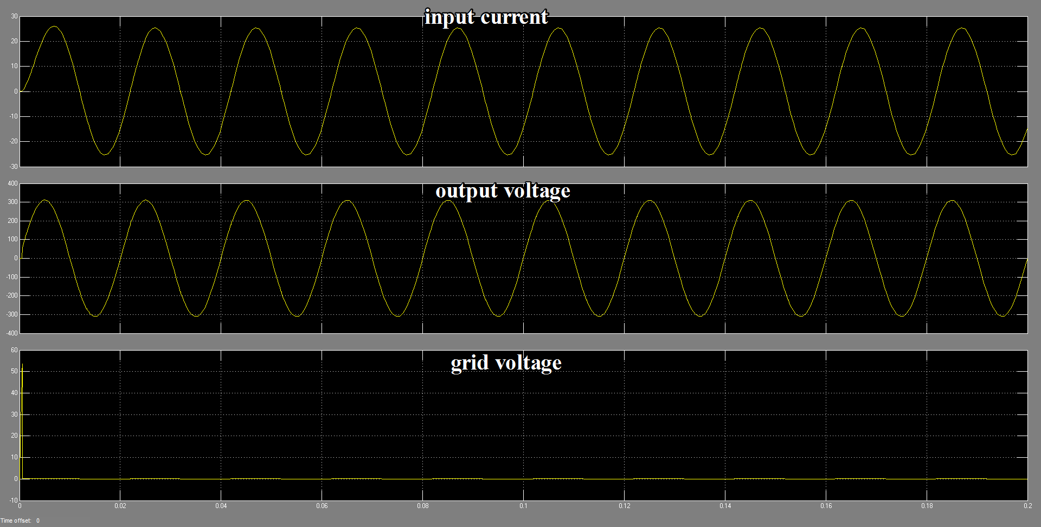

Fig5. =10° , Pulse Width=10%

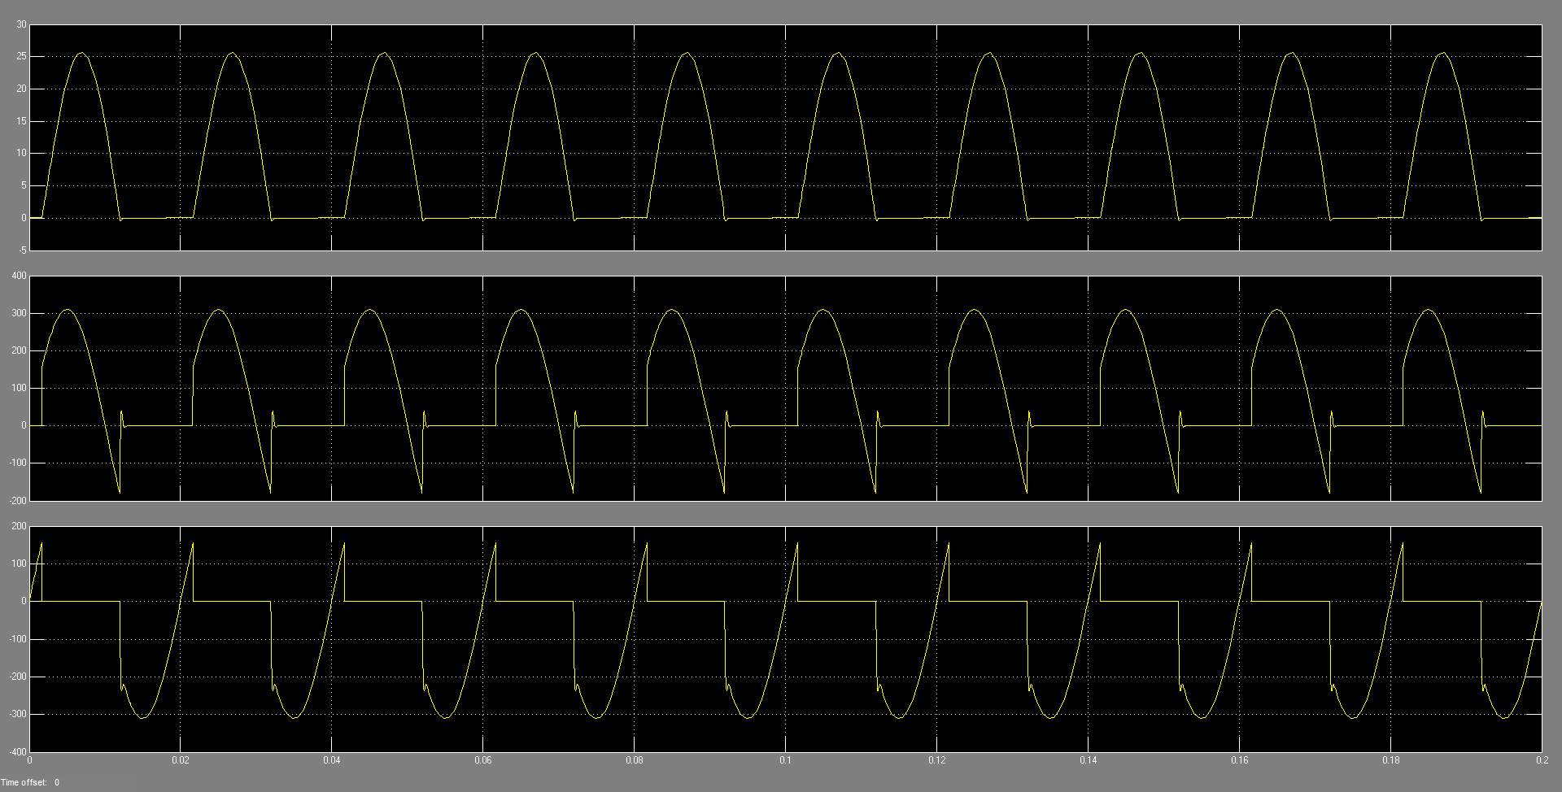

Fig6. =30° , Pulse Width=1%

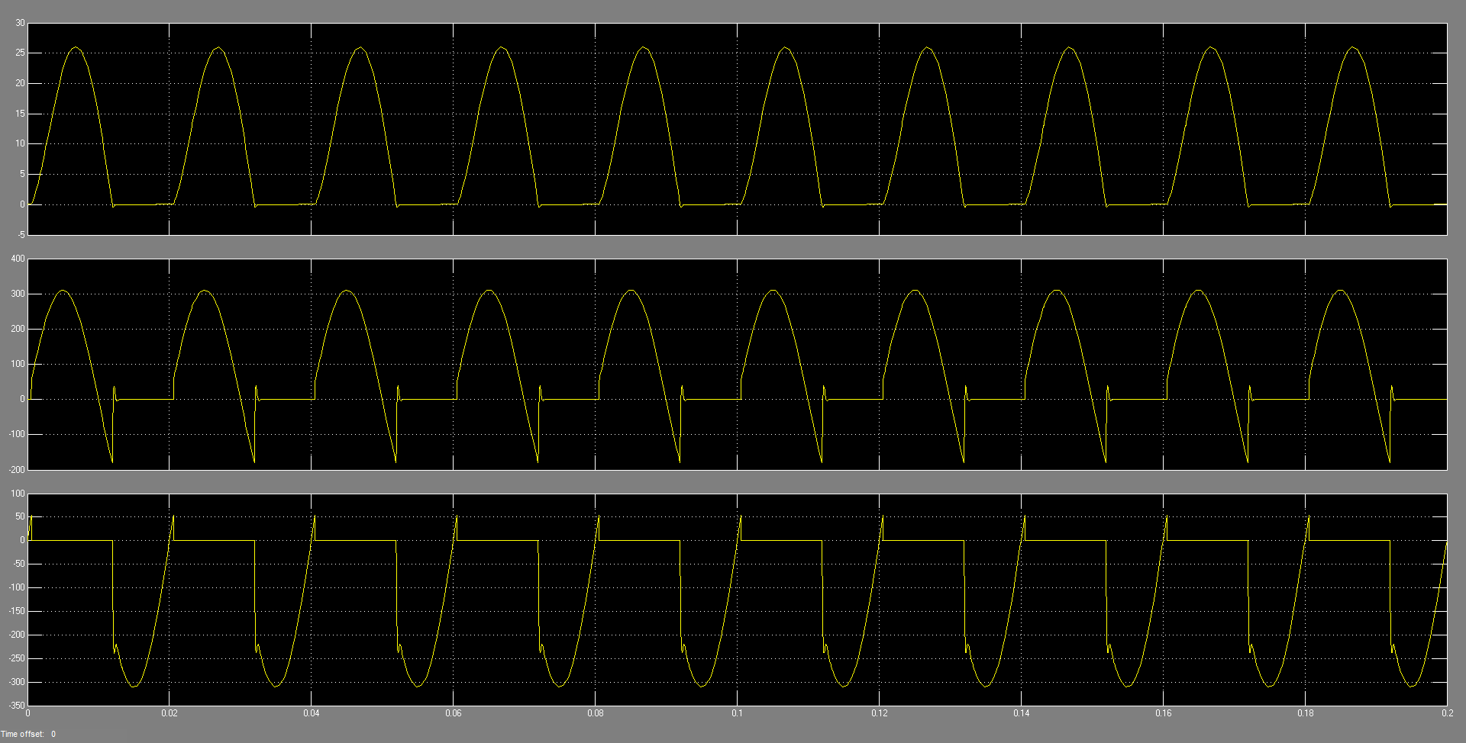

Fig7. =10° , Pulse Width=1%

As shown above seven graphs describing when the  changes a lot how the waveforms vary from time to time.

And we can summary three situations:

1. 

The AC voltage controller is working normally and the waveform of current is discontinuous.

1. 

At this moment the conduction angle is equaling to 180° and the current is continuous while two thyristors are not working at all.

1. 
   1. Pulse Width is narrow

When , the  and while VT2 generates a pulse VT1 isn’t shut down yet and VT2 is not able to be on under a reverse voltage.

And when the VT1 is shut down there is no pulse putted on VT2 so there is only one thyristor turning on or off.

* 1. Pulse Width is wide

The circuit can work with current continuous.

1. Study the relationships between the **RMS value of output voltage** and **delay angle**



Fig8. The RMS- relation



Fig9. Impedance angle



Fig10. The First order difference of RMS-

As we can see, when the pulse width is wide, AC voltage controller can work normally when .

1. Study and verify the conditions of CCM (continuous current mode)

As shown above.

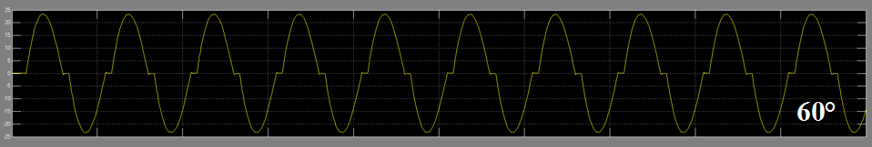

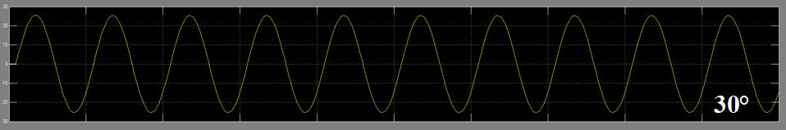

When the , the inductor is under DCM.

When the , the inductor is under CCM.

1. For single-phase ***AC chopper*** (**chopping control**) with the same load and input voltage.

This is our simulation circuit.

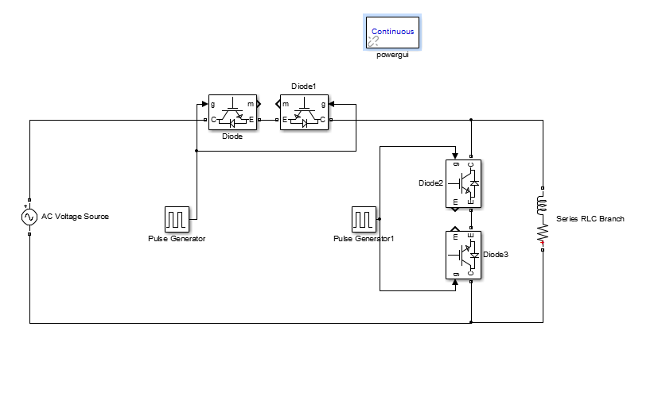

1. Varying **duty cycle**, simulate to observe **output voltage waveform** and **input current waveform** with grid voltage as reference.

The duty cycle is set to 10%, 20%, 30%, 40%, 50%, 60%, 70%, 80%, 90%, , and then the simulation is carried out to obtain the input voltage, input current and output voltage waveform. Here are the results.

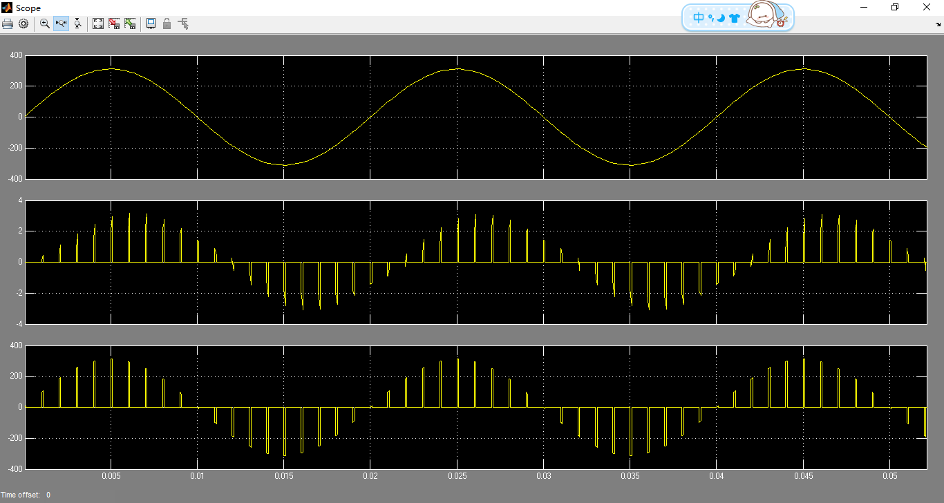

D=10%

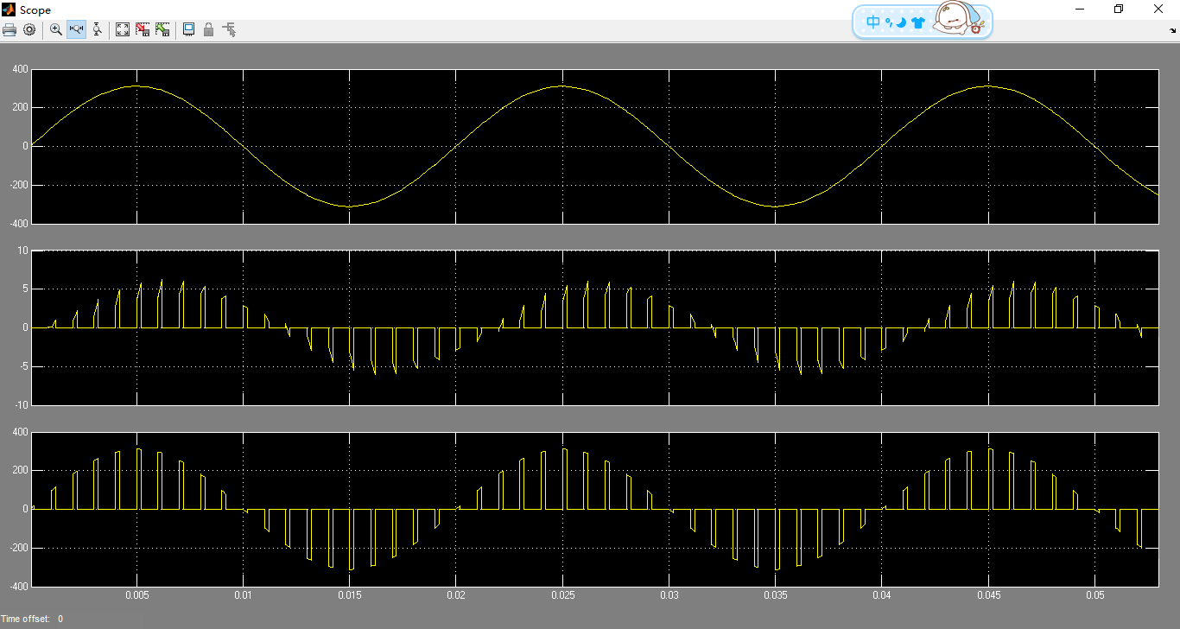

D=20%

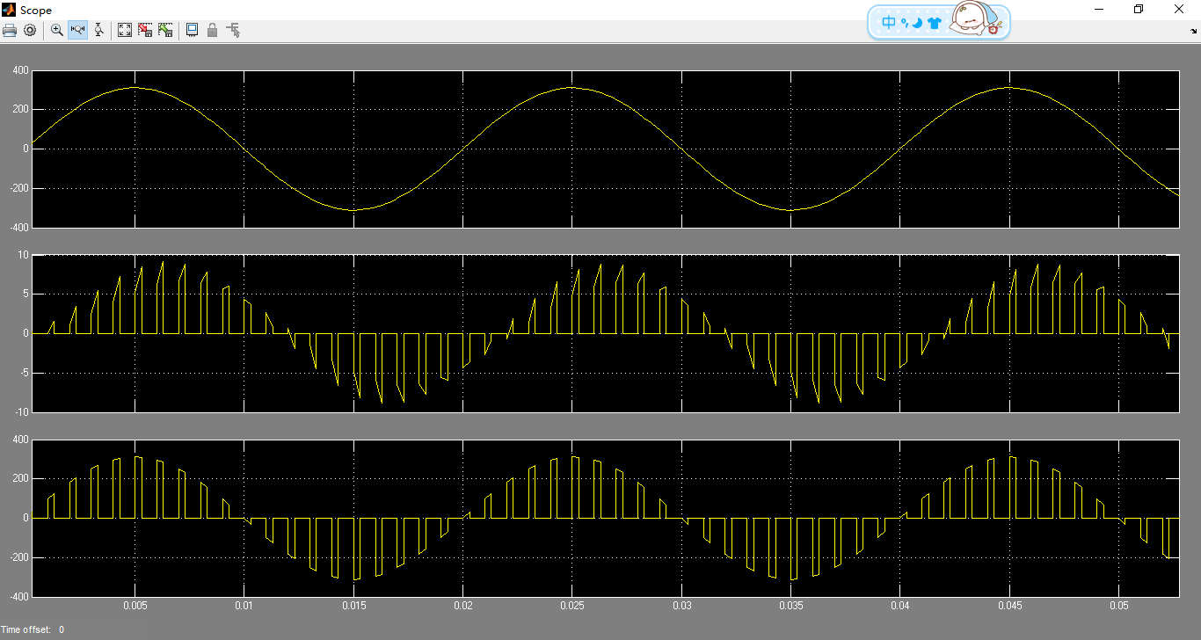

D=30%

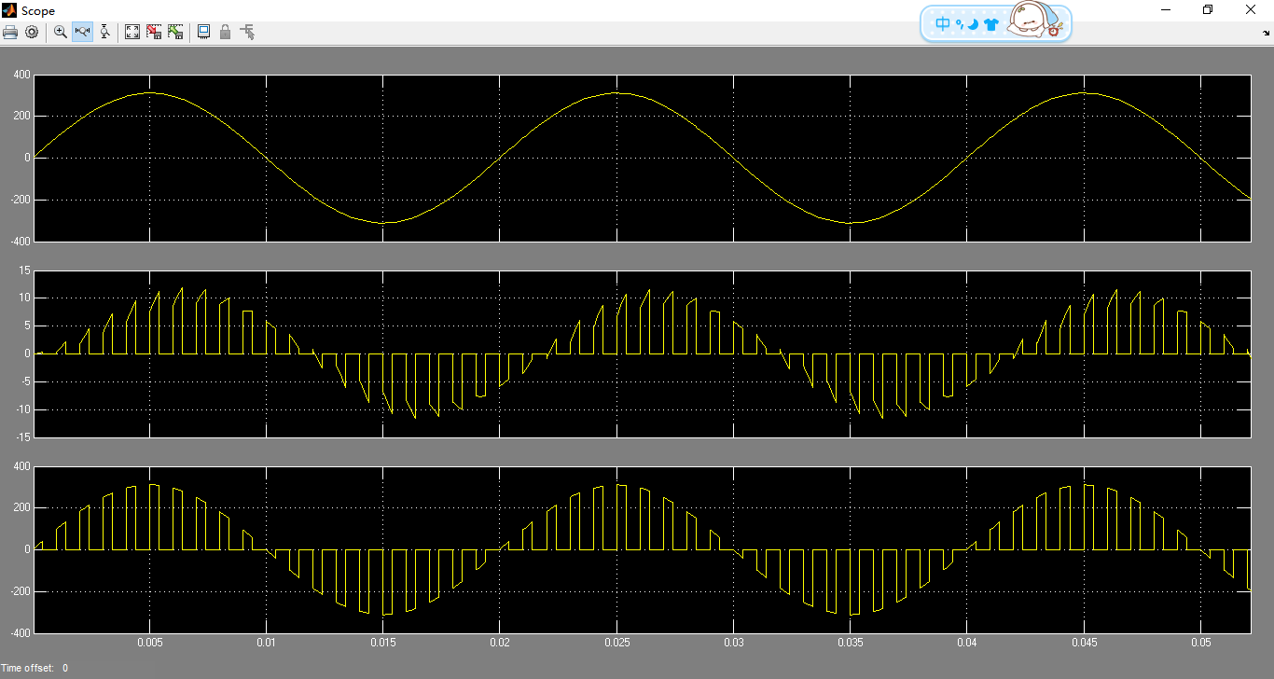

D=40%

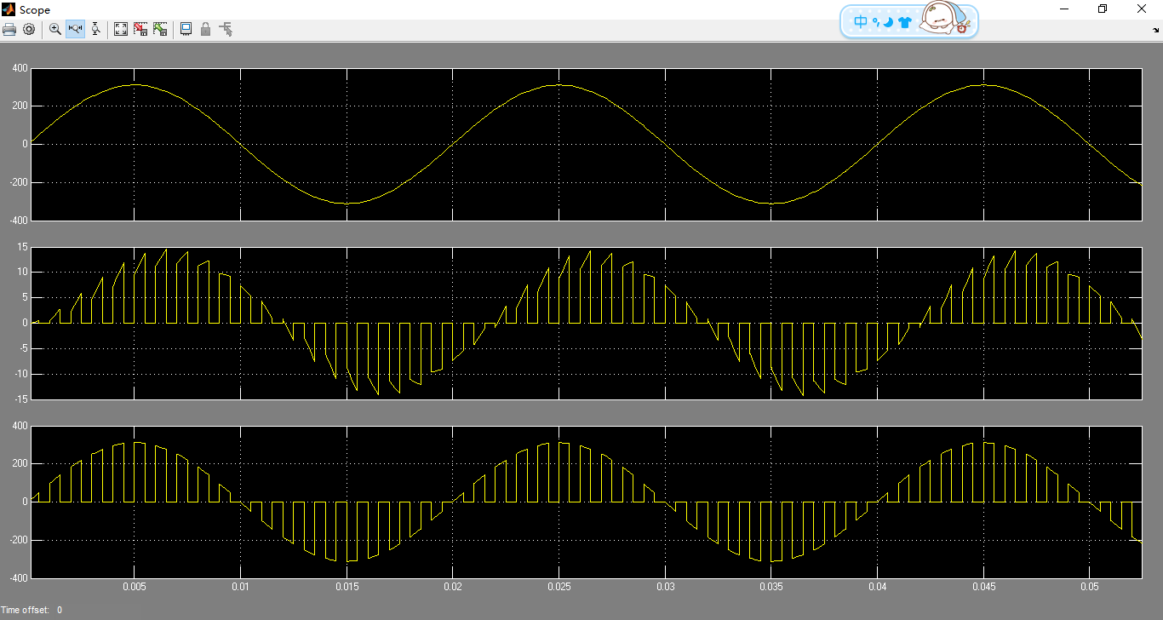

D=50%

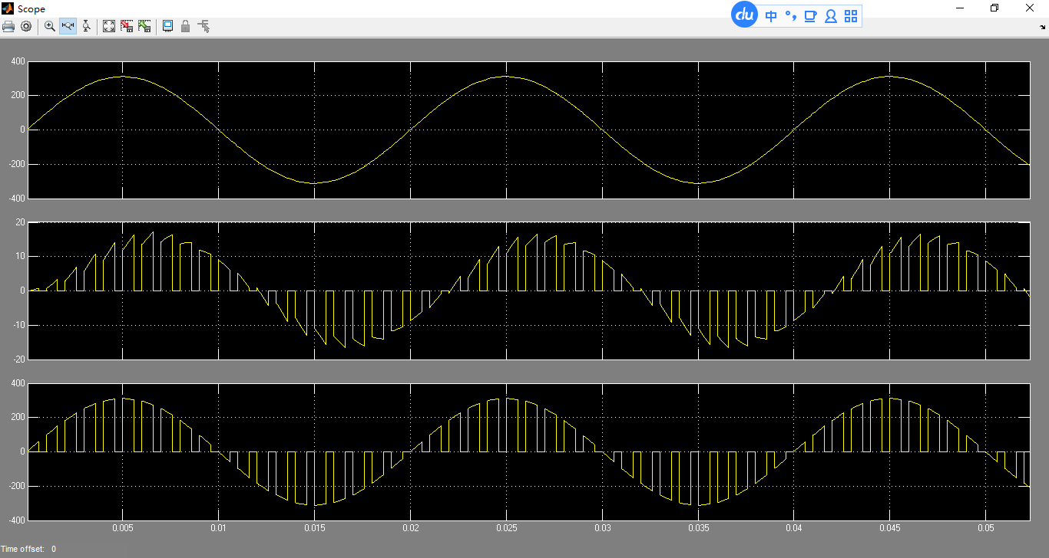

D=60%

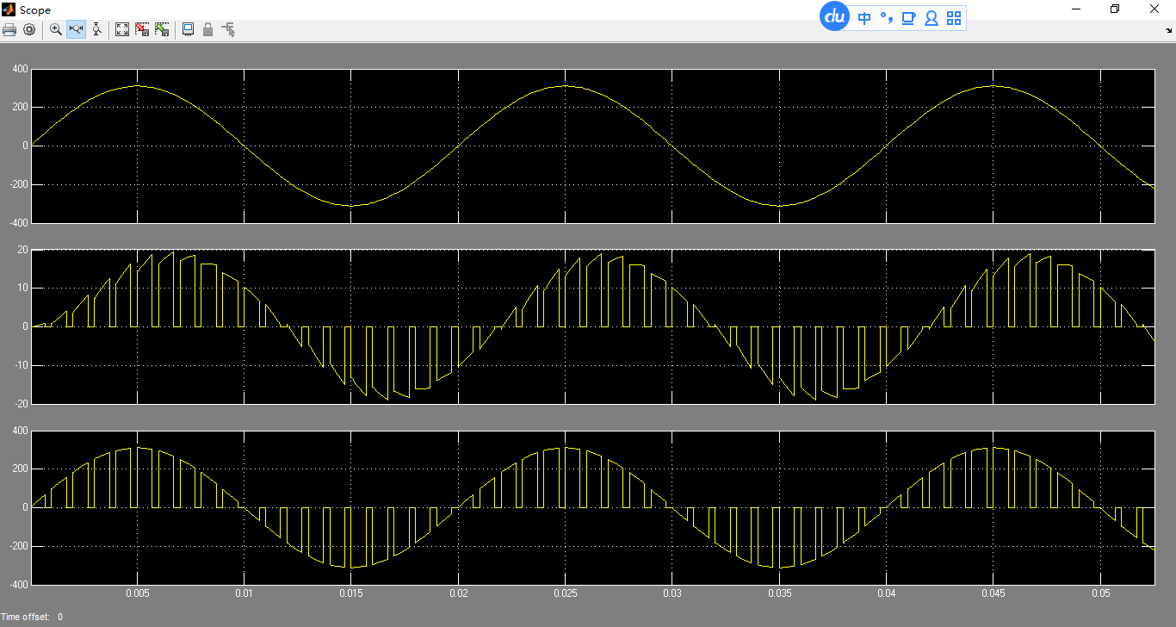

D=70%

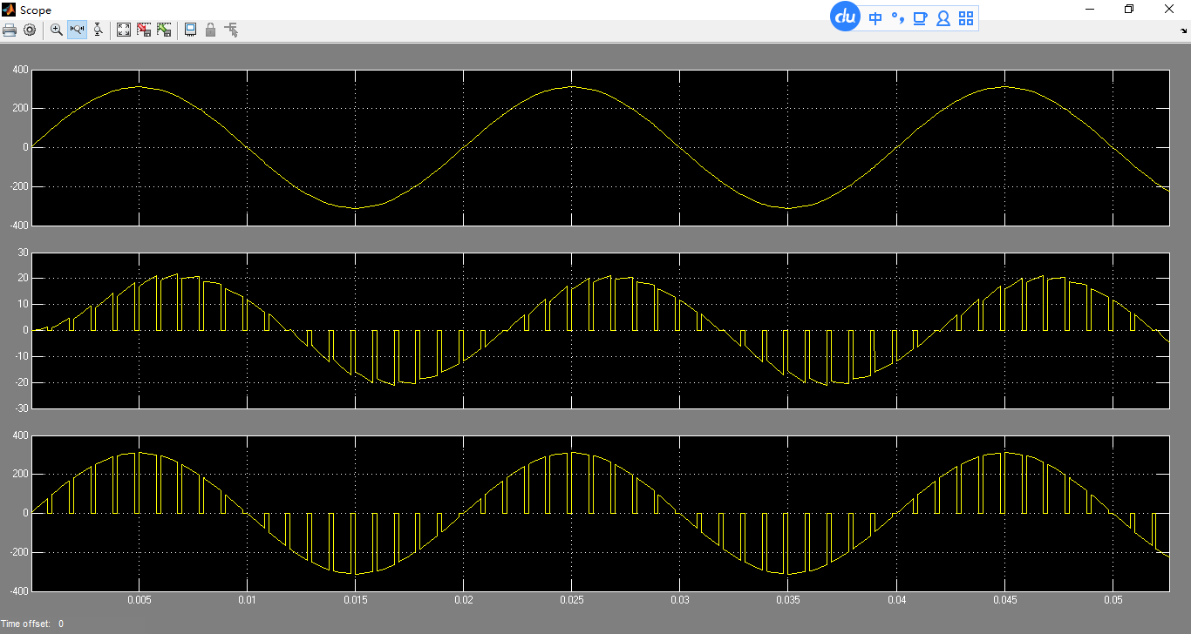

D=80%

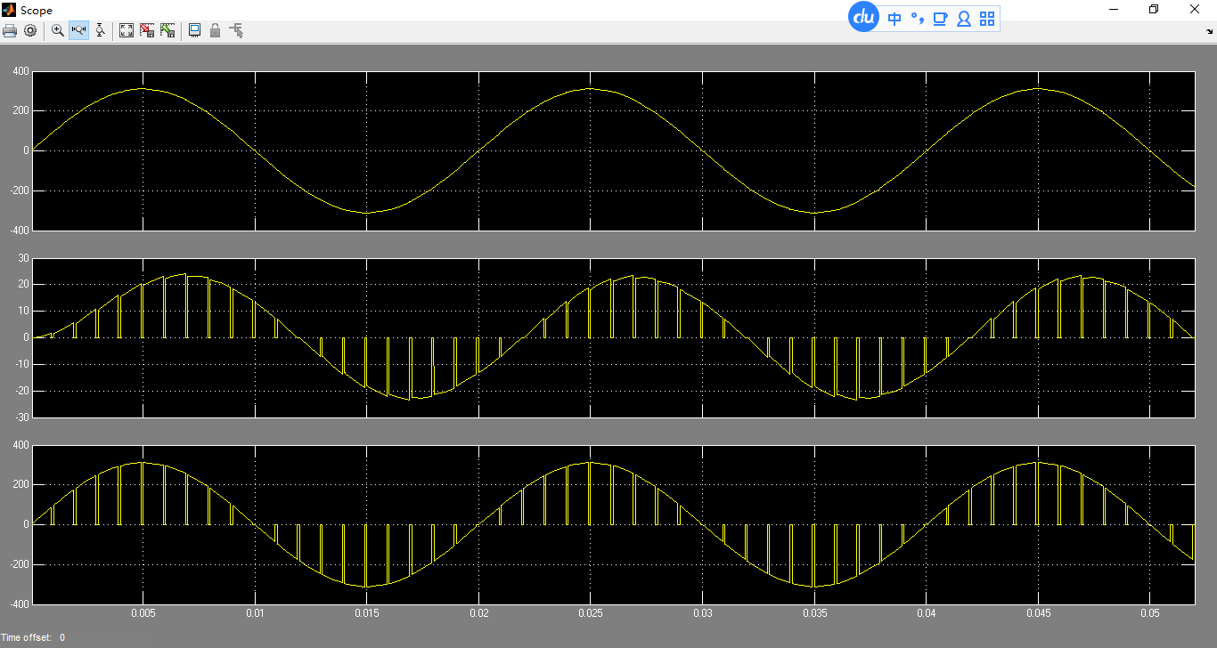

D=90%



From the image we can observe that the peak to peak value of the input current increases with the increase of duty cycle. This is because when the duty cycle increases, the duration time of the current flowing through the load increases, the energy stored by the inductor increases, and the peak to peak value of current increases.



As we can see from the diagram, with the increase of the duty ratio, the peak peak of the output voltage is basically the same. Small fluctuations may be affected by the inductance.

1. Analyze commutation process.

Switch S1, S2 control stage signals are complementary. The effective value of the output voltage can be easily adjusted by the phase control of the IGBT in every half cycle. When the switch S1 closes, the switch S2 disconnects the current starts from the power supply, flows through the S1, the load, and back to the power supply. When the switch S2 is closed, the switch S1 is switched off, and the current in the load flows through the S2 to complete the freewheeling.

1. Study the relationships between theRMS value of output voltage and duty cycle.



Form the picture; we can see that when the duty cycle increases, the RMS of output voltage increases too. With the increase of duty ratio, the relationship between the two is closer to the relationship of primary function.

We think the reason is that when the duty cycle increases, the fundamental component of the output voltage increases, so that the influence of the harmonic component is reduced, and the effective value of the voltage is raised.

1. Given that the above two converters share ***the same fundamental component of output voltage***, compare and analyze the differences of output voltage’s harmonic components.









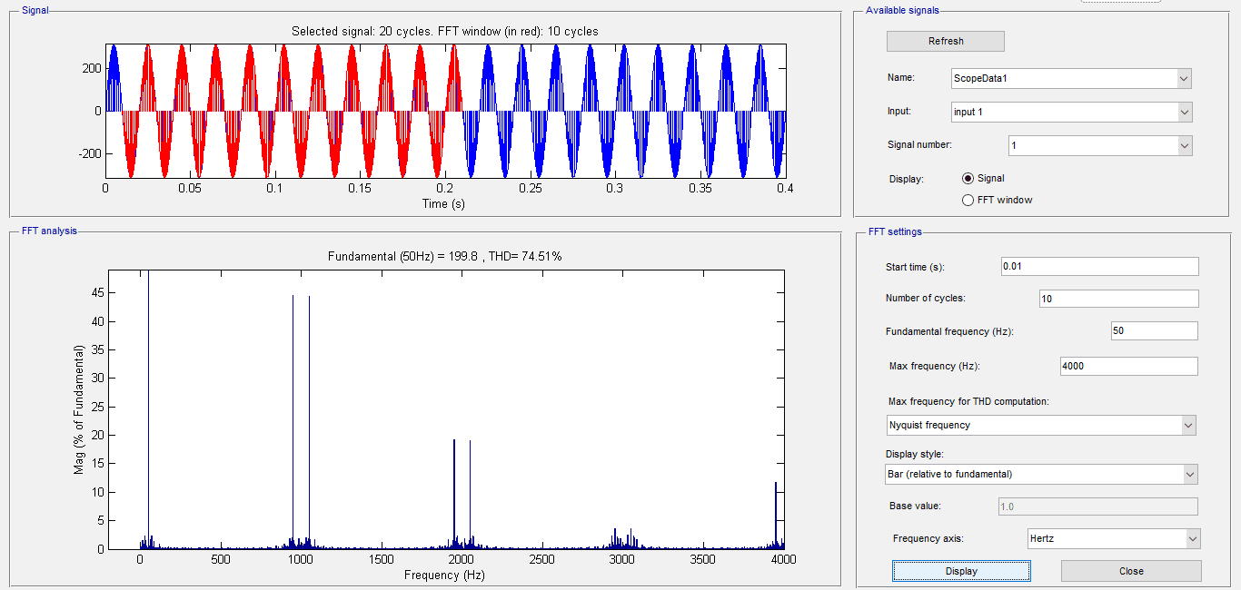

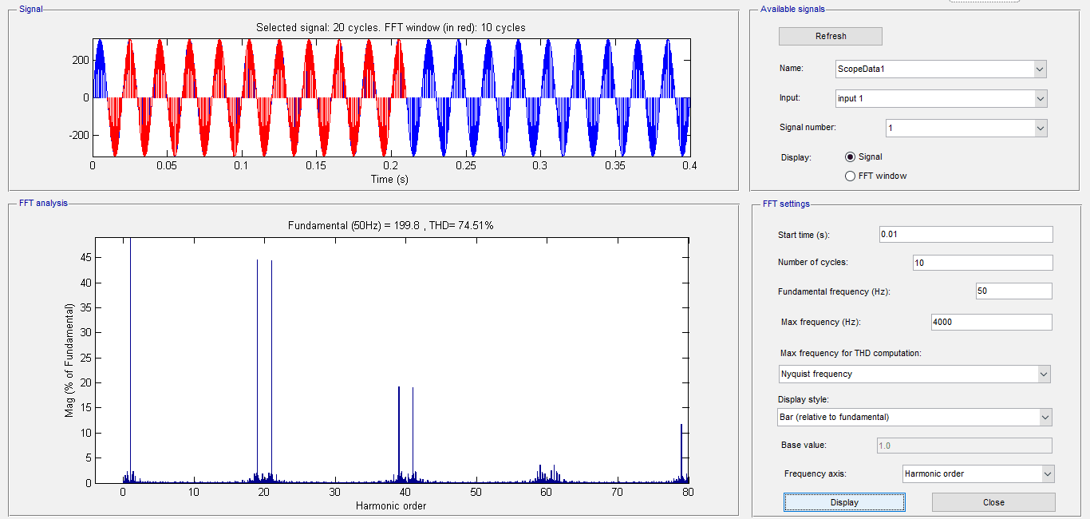

As we can see above, output voltage of the second circuit contains less harmonics. When we set the amplitude equal to 200V and we get the result which declares that the first circuit contains more low order harmonics and the second circuit contains more high order harmonics.

By contrast we can find that:

For single-phase AC voltage controller, the output voltage harmonic component is big. From the figure we can see that the low harmonics are large, but the high harmonics are small. But for single-phase AC chopper, the output voltage harmonic component is small. From the figure we can see that the low harmonics are very small, and it only have the large harmonics which are related to the switching cycle such as 1000Hz, 2000Hz.

So, we can conclude that the single-phase AC chopper is more effective to reduce the output voltage harmonic component.