**Seminar6**

1. For three-phase PWM *voltage-source inverter*(VSI):

* Study how **frequency spectrum of output voltage** changes with respect to the **variation of amplitude modulation ratio m**

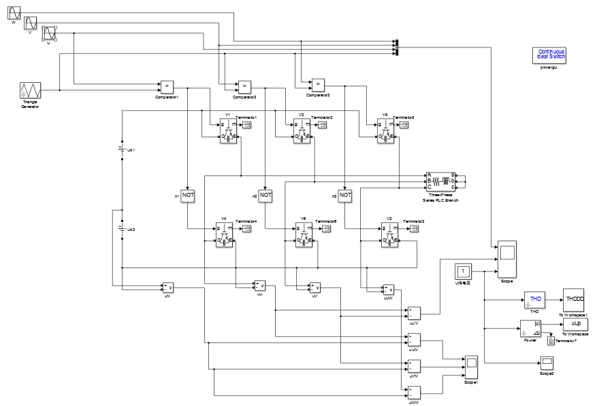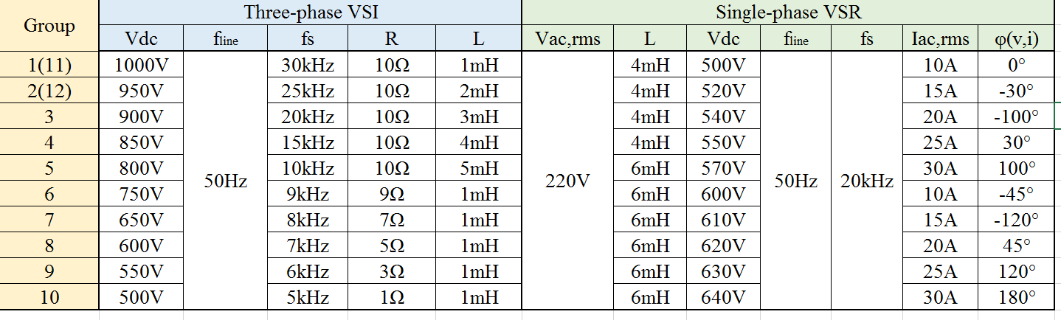

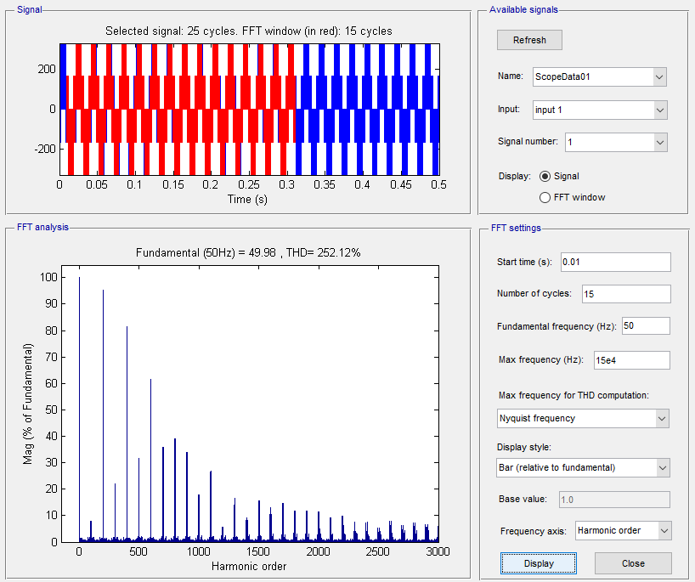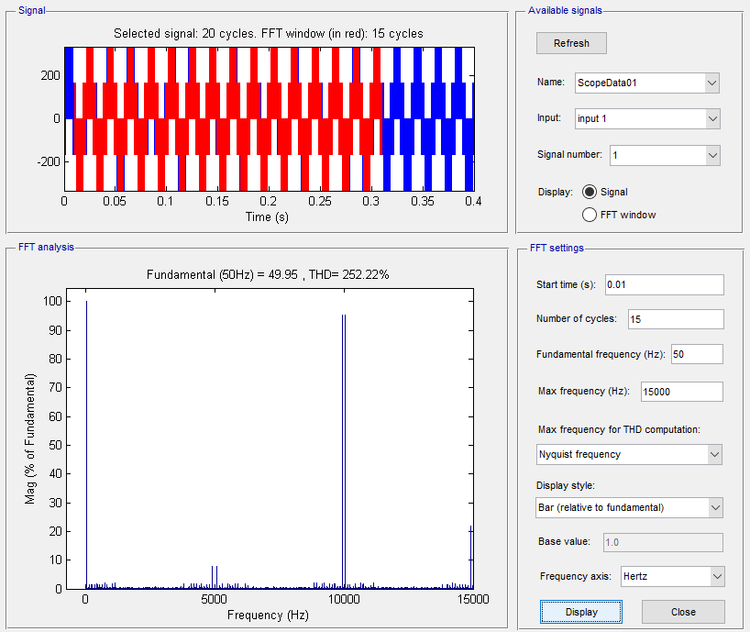

m=0.2

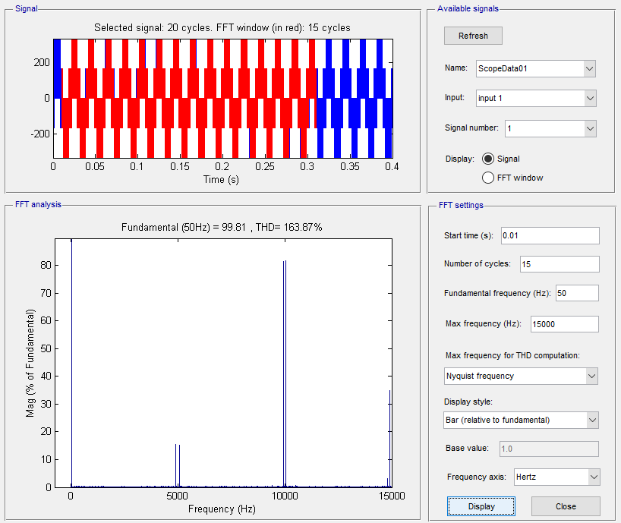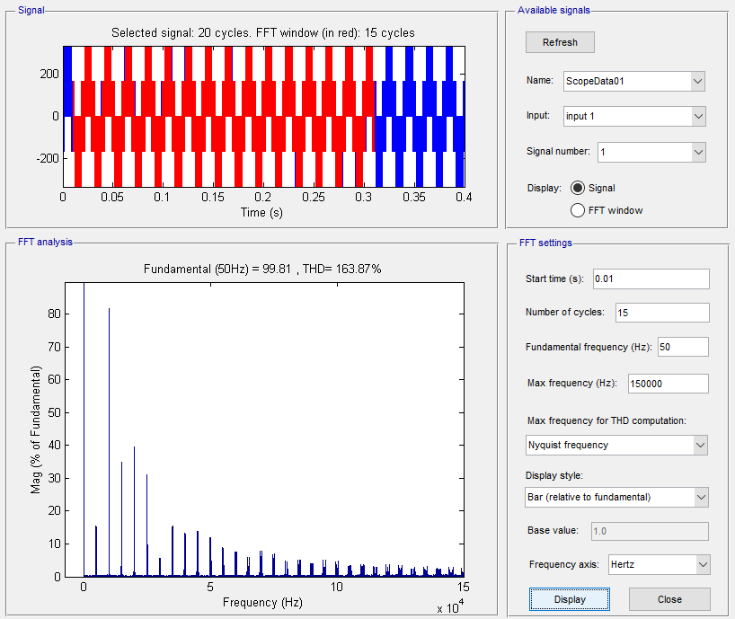

m=0.4

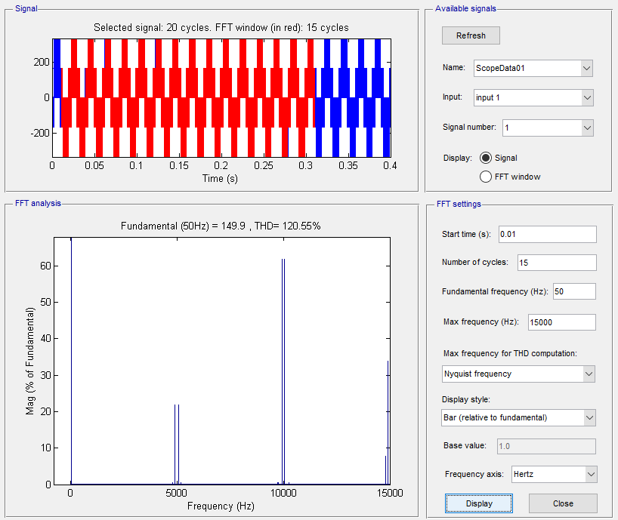

m=0.6

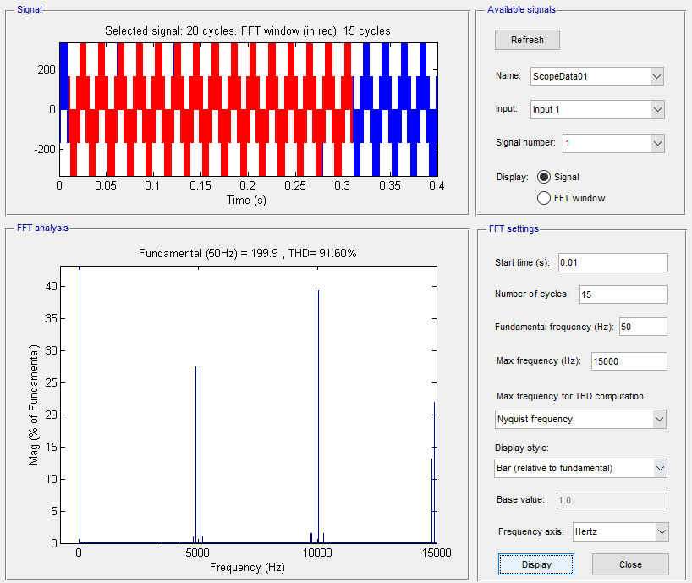

m=0.8

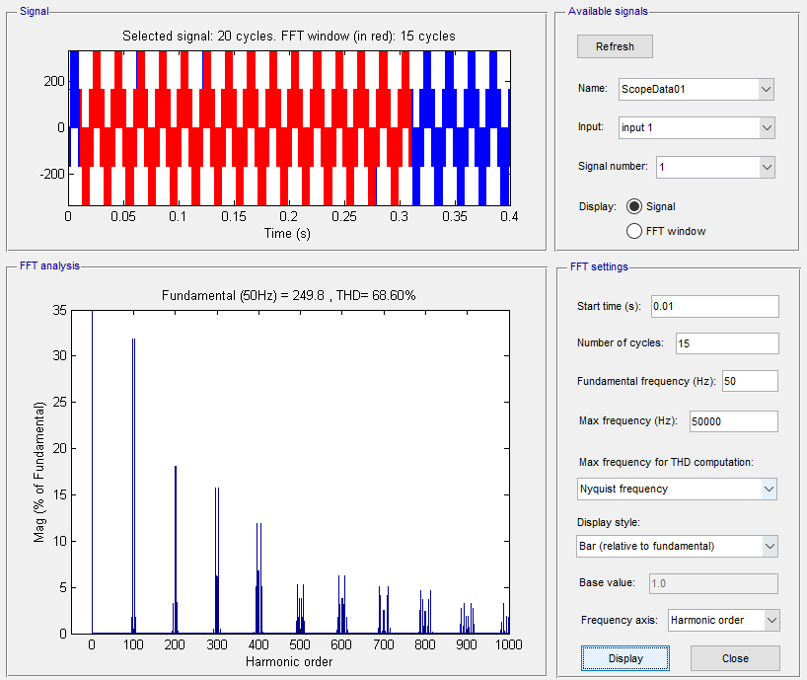

m=1

* Analyze the operating sequence according to simulation waveforms

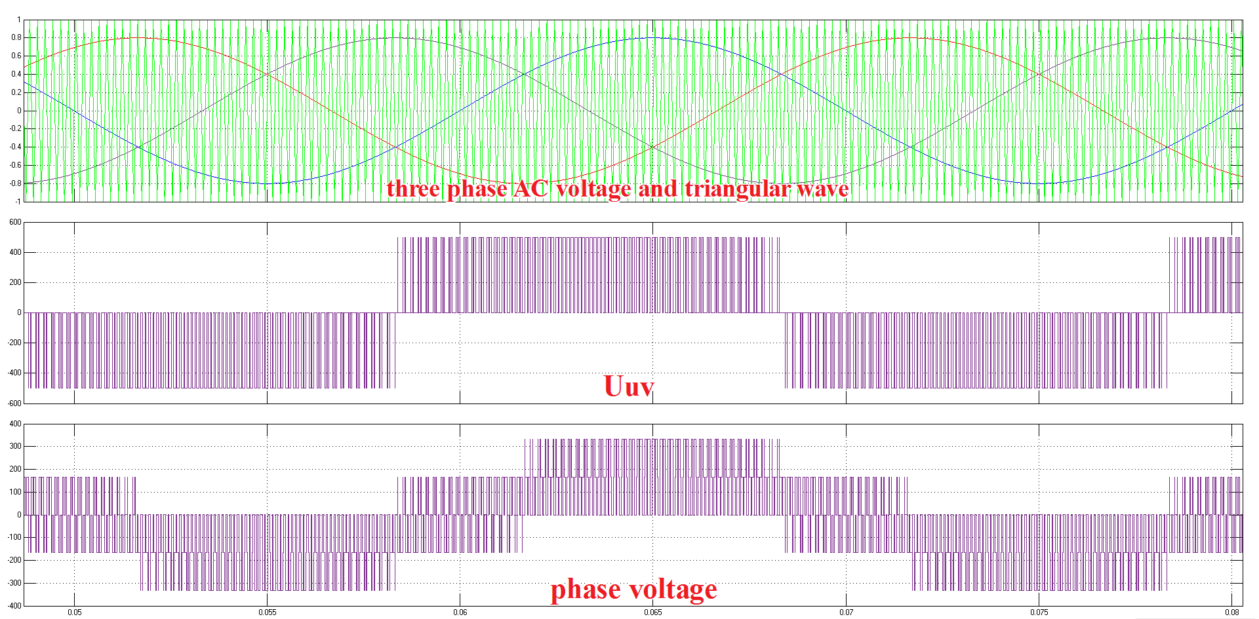

Fig. operating sequence

1. Voltage analsis

According to the simulation graphs, we can find that the IGBTs and the diodes excute such operation.

Take the U phase into account, the voltage ,,of the load line can be calculated from this:



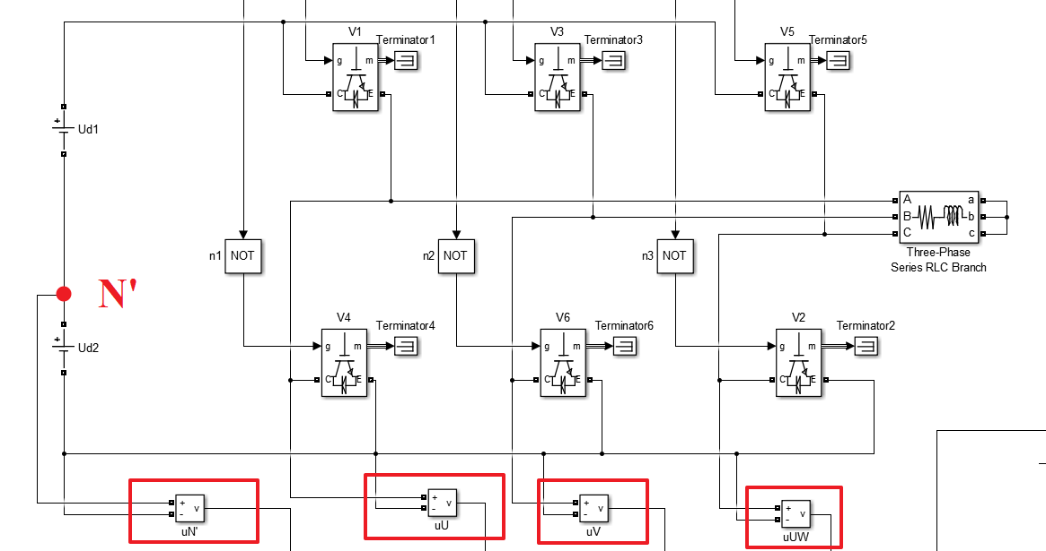

The voltage between the middle point of the load N and the mid point N’ is .



And



So



The PWM wave of the output line voltage is composed of three kinds of levels:  and 0.

And the phase voltage, contains five steps : .

1. Triger analsis

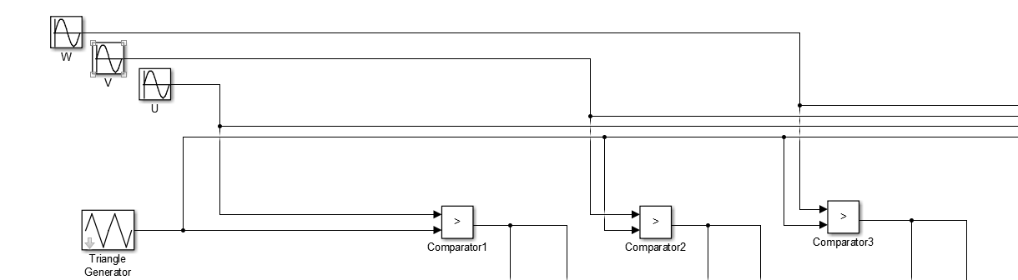

Take comparator to do this job and we can get a duplicated sine wave which is divided into amount of fragments and this is the triger signals to the IGBT.

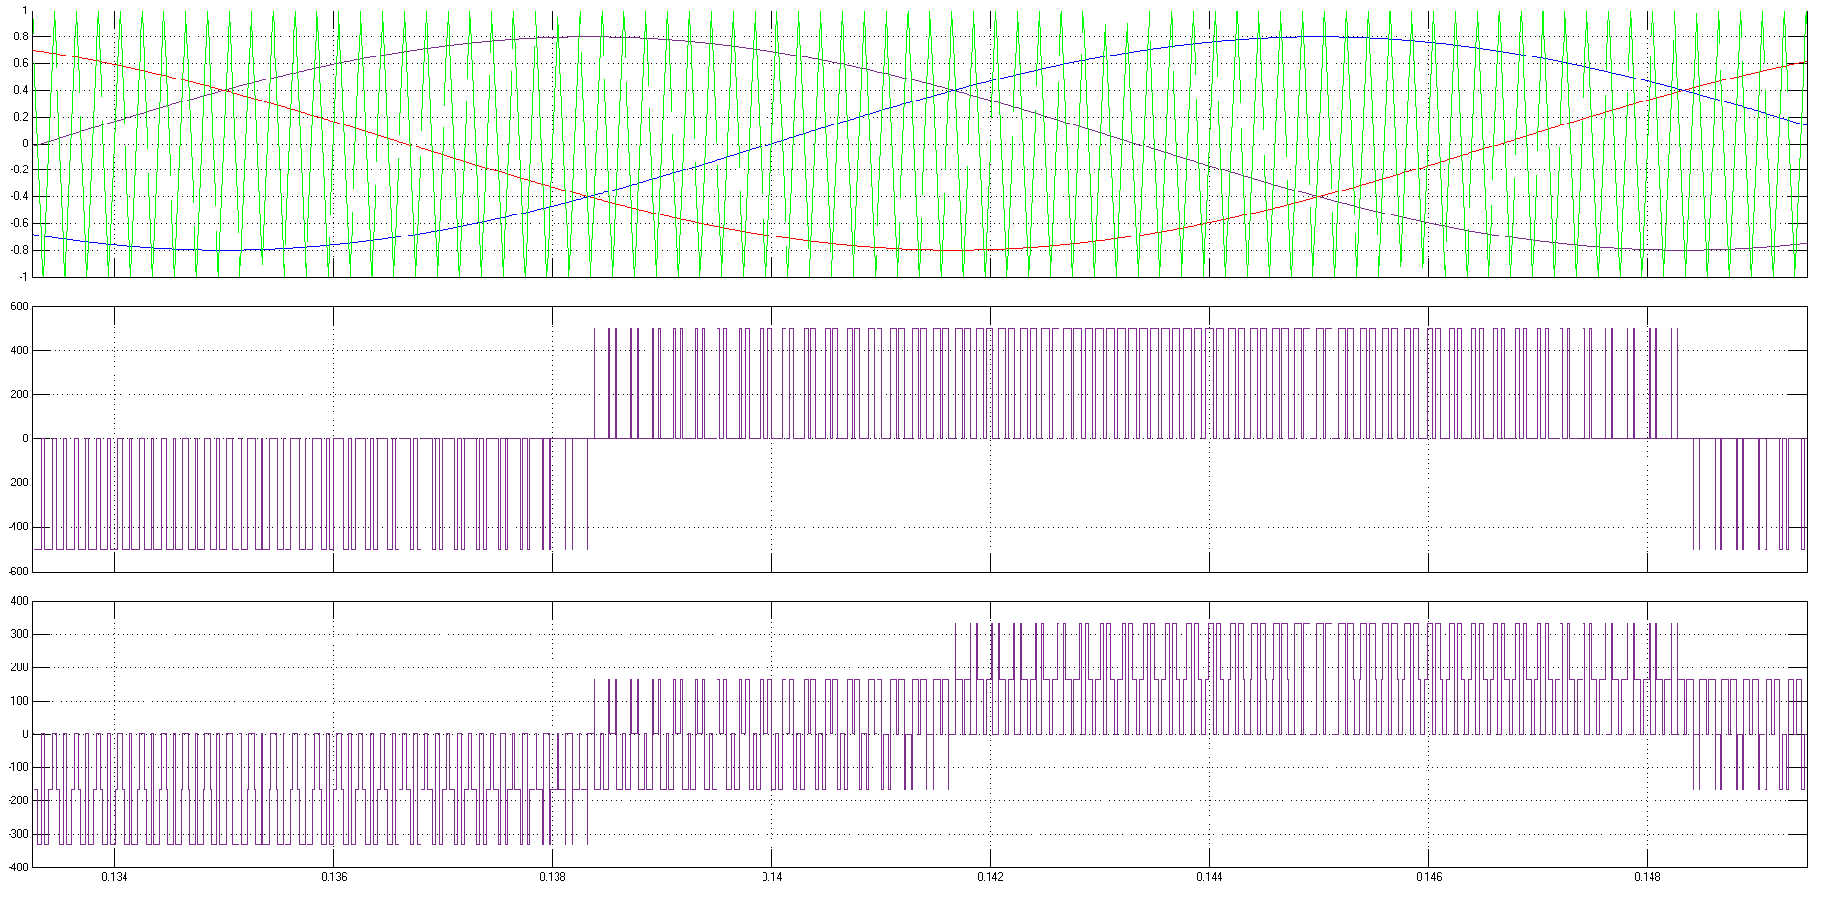

2）For single-phase PWM full-bridge *voltage-source converter*(VSC):

* Control the power stage so that the requirement of **AC side current amplitude** as well as **phase difference between AC side voltage and current** could be satisfied

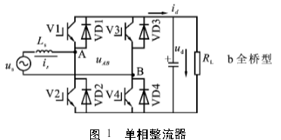

Schematic diagram

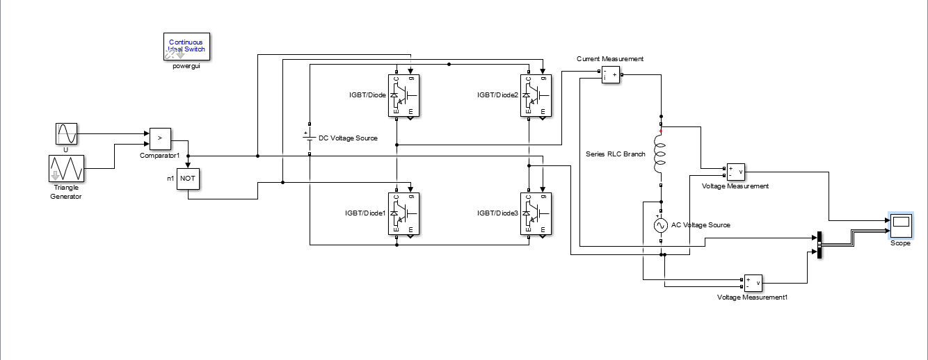

Simulation diagram

**Principle:**

The commutation process is not considered. At any time, the four bridge arms of the voltage type single-phase bridge type PWM rectifier should have two bridge arms. In order to avoid the output short circuit, the 1 and 2 bridge arms are not allowed to pass at the same time, and the same 3 and 4 bridge arms are not allowed to pass at the same time. The PWM rectifier circuit has four operating modes. According to the direction of the AC side current iS, there are two working states in each mode of operation.

The input voltage of uS in the positive half cycle, the working mode of

The operation mode of 1:1,4 bridge arm conduction, LdiS/dt=US - Uab

When the current is VD1, and VD4 conduction, AC power output energy, DC absorb energy, in the state of the rectification circuit; current is negative, V1 and V4 are turned on, the AC power supply of energy absorption and release energy in the DC side, energy feedback state.

Run: 2 2, No. 3 bridge arm conduction, LdiS/dt=US - Uab

The current is positive, V2 and V3 conduction, AC power supply and DC side output energy, L energy storage; current is negative, VD2 and VD3 conduction, AC power supply and DC side of energy absorption and energy release of L.

The operation mode of 3: 1, No. 3 bridge arm conduction, LdiS/dt=US

There is no energy exchange between the DC side and the AC side, the power is short, the current is positive, VD1 and V3 are connected, and L stores energy; when the current is negative, V1 and VD3 are connected, and L releases energy.

The operation mode of operation mode 4: 2, No. 4 bridge arm conduction, LdiS/dt=US

There is no energy exchange between the DC side and the AC side, the power is short, the current is positive, V2 and VD4 are connected, and L stores energy; when the current is negative, VD2 and V4 are connected, and L releases energy.

The input voltage of uS in the negative half cycle is half similar.

**Anwser：**

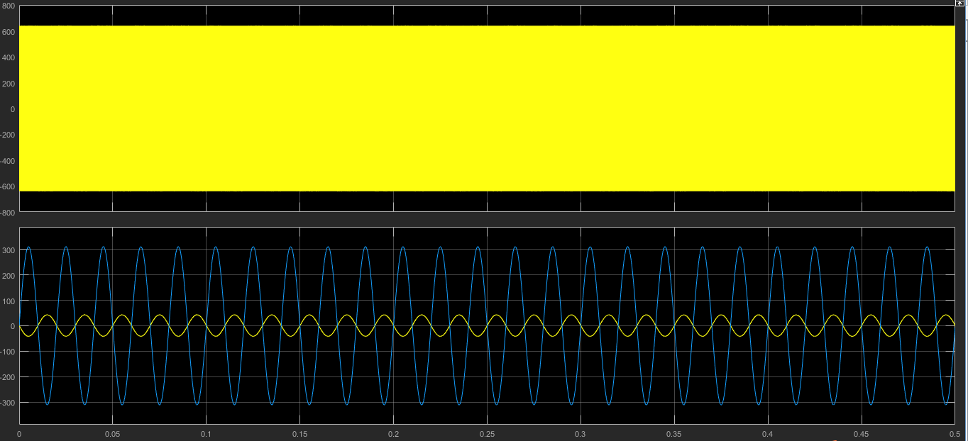

The image 1 is an image of the Uab. In image 2, the blue is the current image, and the yellow is a very obvious phase difference of 180 degrees in the image of the voltage image.

The analysis of the vector graph is as follows:

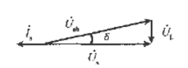

List the equations:



The effective values of the current, that is, the current of the AC side, are given on the basis of the title, and the effective value of the inductance voltage is obtained. So

，。

The amplitude and phase of the sinusoidal modulation wave are adjusted according to the above results. The phase of the sinusoidal modulation wave is the same, the amplitude of the sine wave is as follows:

